**COM S 319**

**Construction of User Interfaces**

**Final Project Documentation for Team 47**

Prepared for

Dr. Abraham Aldaco

Prepared by

Randy Nguyen

[rvnguyen@iastate.edu](mailto:rvnguyen@iastate.edu)

Matthew Duncan

[mlduncan@iastate.edu](mailto:mlduncan@iastate.edu)

May 10th, 2023

**Table of Contents**

Introduction……………………………………………………………………………………….3

Objective………………………………………………………………………………………….4

Organization………………………………………………………………………………………5

**Description**

We have had a previous interest in Raspberry Pis and we thought this would be a great opportunity to learn more about it while learning what this course is originally about: the construction of user interfaces. Creating a website using the data collected directly by us feels more rewarding than using data from outside sources. And beyond that, learning to work with a platform such as the Raspberry Pi will give us knowledge, we can iterate upon to make more interesting technology in the future.

With that in mind, our final project is a web application that displays the temperature and humidity of a room. We utilized a Raspberry Pi and a DHT11 to collect the data, and used React, HTML, CSS, and JavaScript/Express, and MongoDB to create the web application. There are many ways to view this information within our web application such as simply viewing the numbers, analyzing through a graph, or looking at a gauge. There is also a feature to save current temperatures with timestamps, so the user can keep information about previous times. They also have the ability to add a note to the record. With the multitude of ways to view the information in an interesting way, we believe we have created a great experience for the user.

**File and Directory Architecture**

Our project is split up into two different folders. The backend and the frontend.

The frontend is a React Project that utilizes multiple components for our single view project.

The backend is a simple express project that holds all the endpoints needed for the frontend and the mongodb.

With it all together this is general idea of how our files and directories are interacting.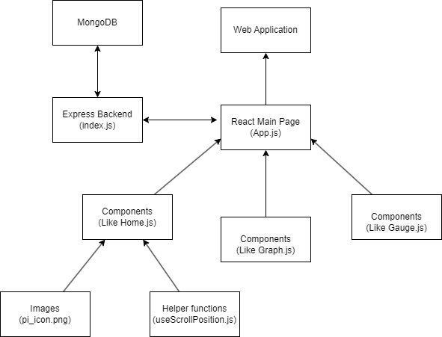

**Server Architecture**

The server application used in our project is MongoDB. It’s a simple and great application to hold information about temperature and humidity for our project. We have a simple database “final” with 2 collections “data” and “records”. The data collection holds one json object which is the current temperature and humidty which would be consistently updated by the raspberry pi. The records collection holds the current saved information that the user saved. 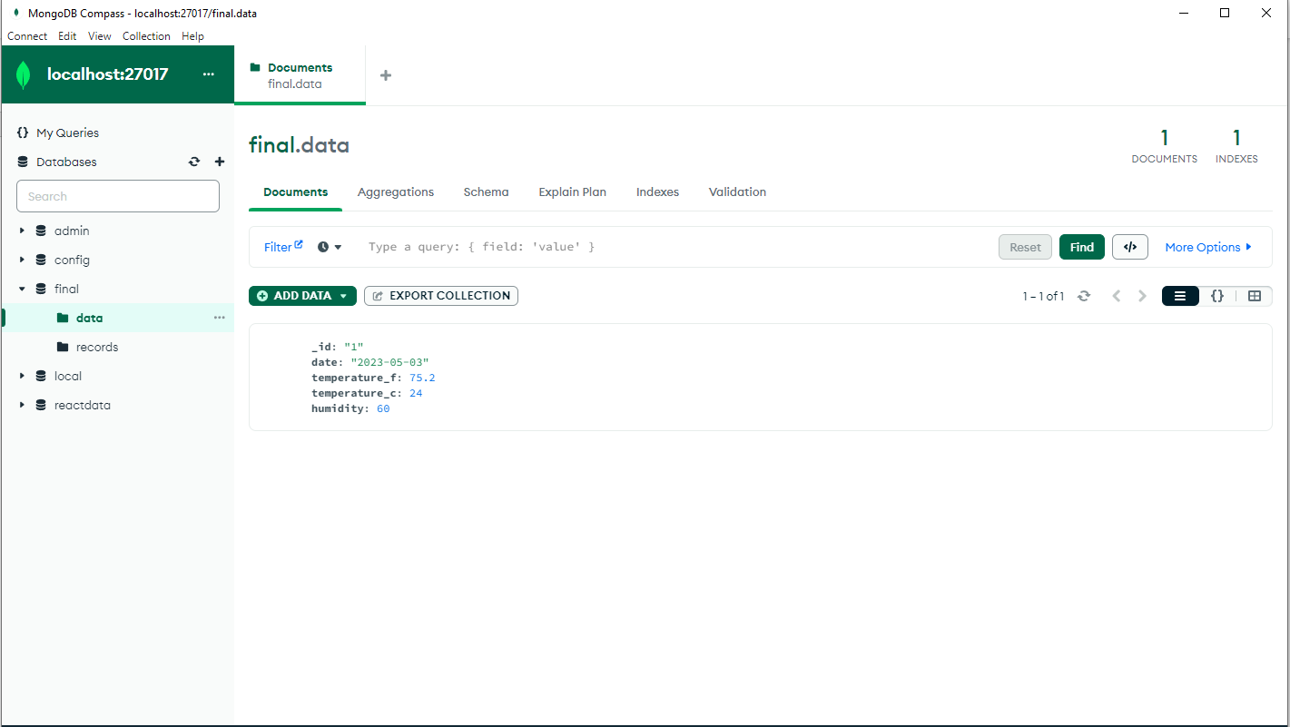

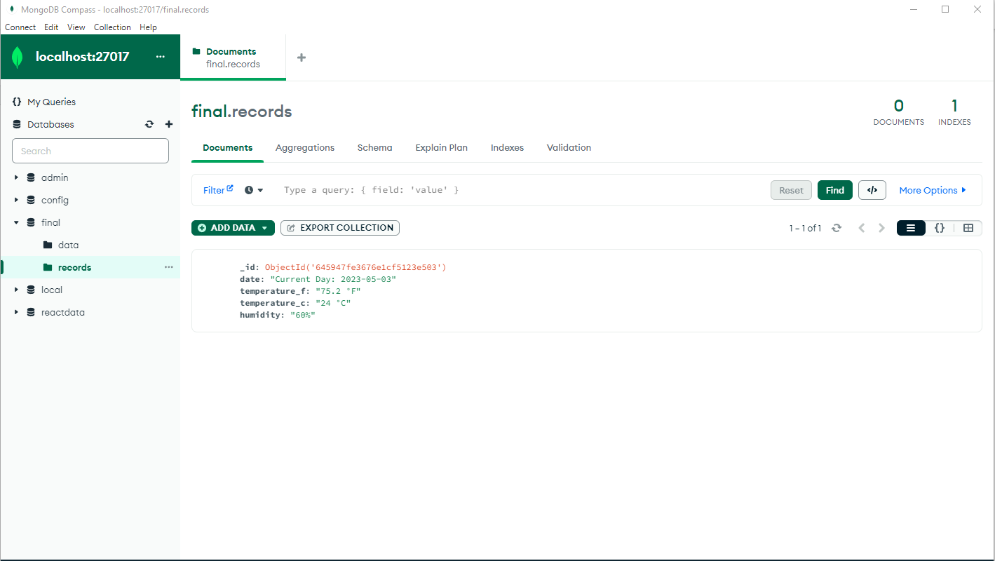

**Logical Architecture**

There are many ways that the frontend and raspberry pi interacts with the backend to change information on the database.

On start the application send a get request (/getData) to the data collection to get the current temperature and humidity. The raspberry pi would send a post request (/addData) to update the current temperature and humidity.

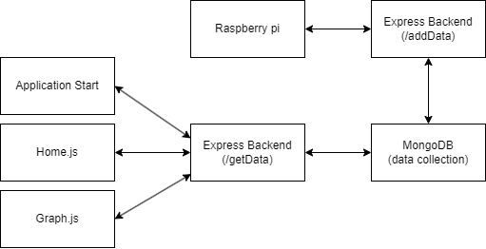

In the frontend the user can also interact with the backend/database by using the reports. In the home page the user can add a new report to the report. Within the reports view the user can update and delete records. This flow sends multiple types of request to the backend such as get (/records), post (/record/), put (/records/:rid), delete (/record/:rid).

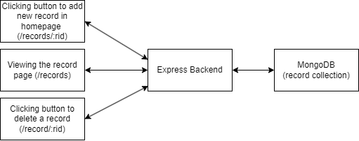

**Views**

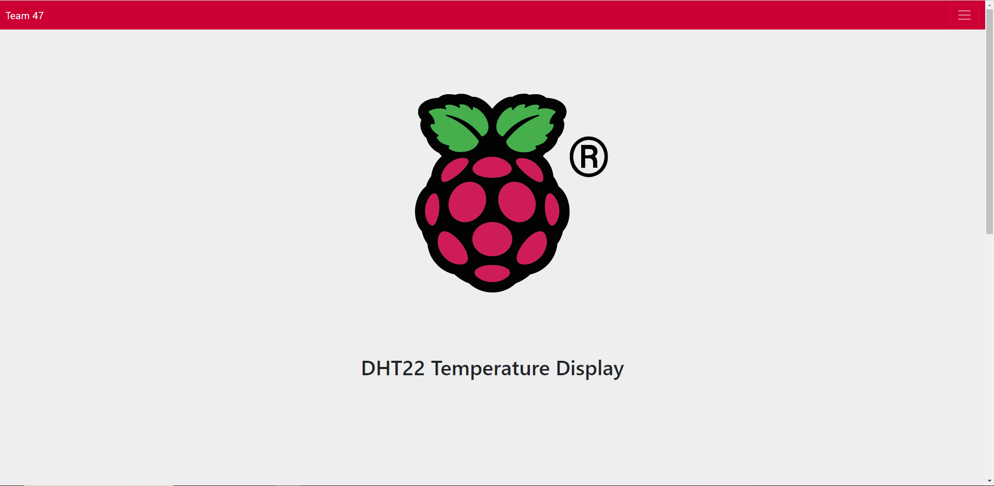

This is the home view that the user first sees when they open the web application. They can scroll down to view the temperature and humidity.

The user can record the current information and it will be displayed in Reports view. 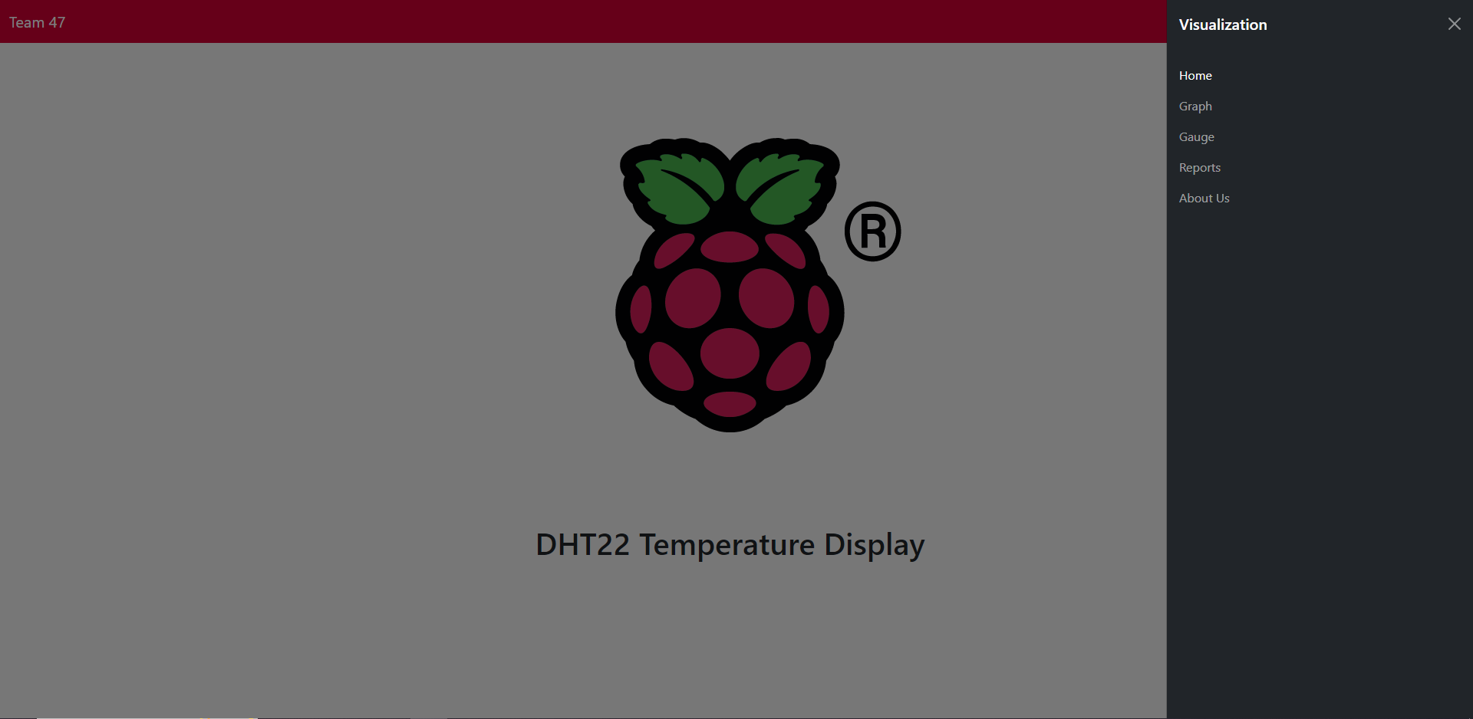

The user can access the navbar at any time and change views. 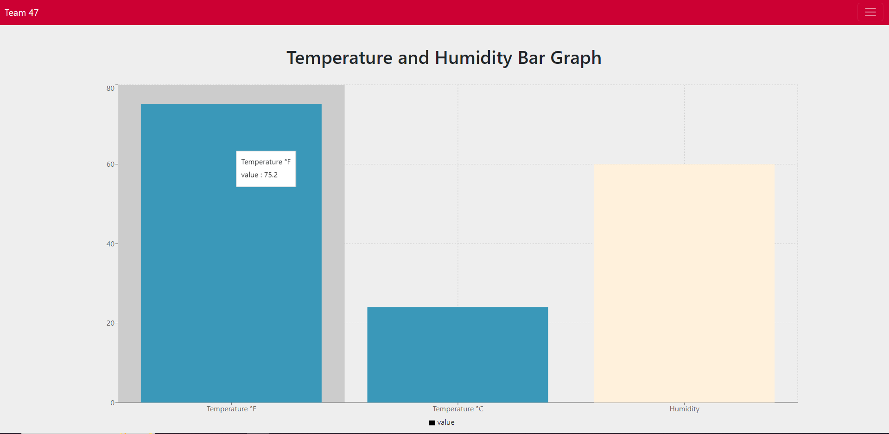

This is the graph view where the user can view the information in a graph format. Hovering over each bar graph will display the actual value. 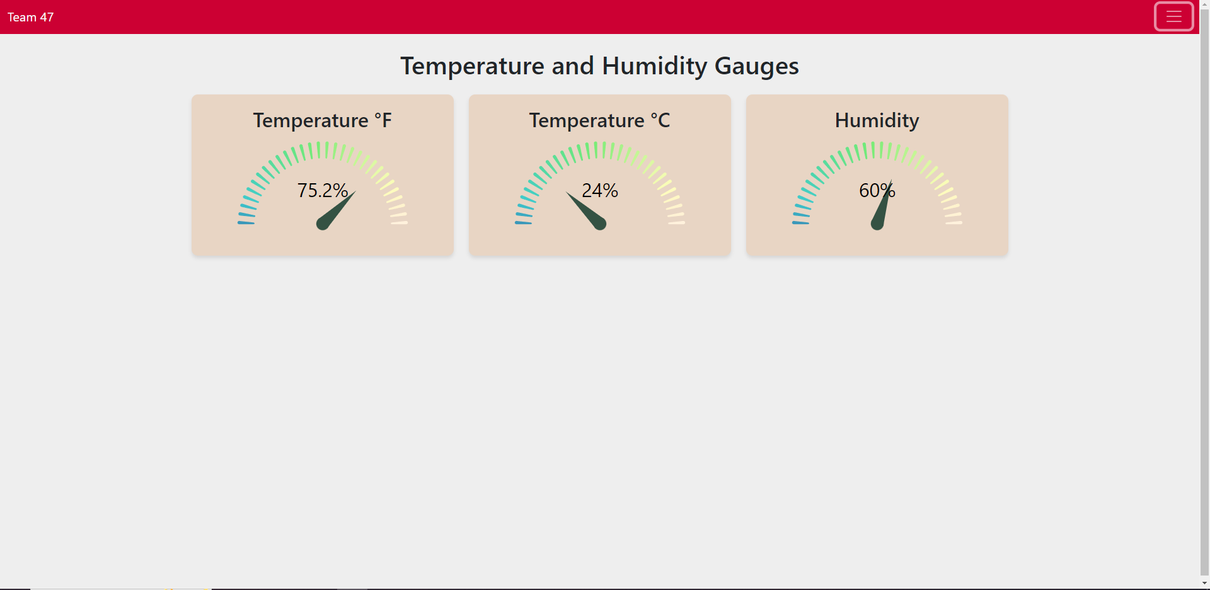

This is the gauge view where the user can view the information in a gauge format. There is an animation that plays when viewing these gauges. 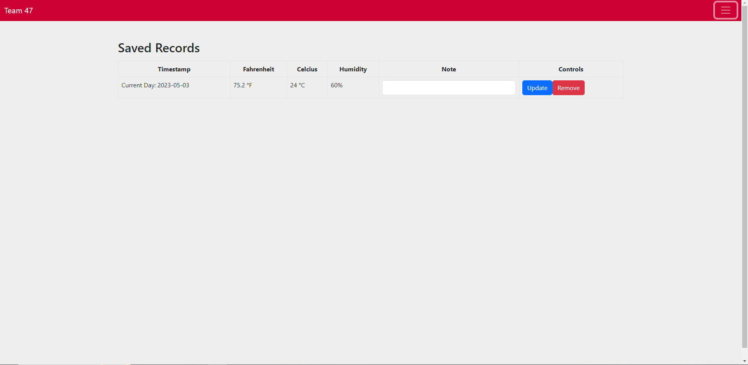

This is the reports view where the user can view the saved information they have. In the homepage if the user clicks the button to save the record, it will be viewable here.

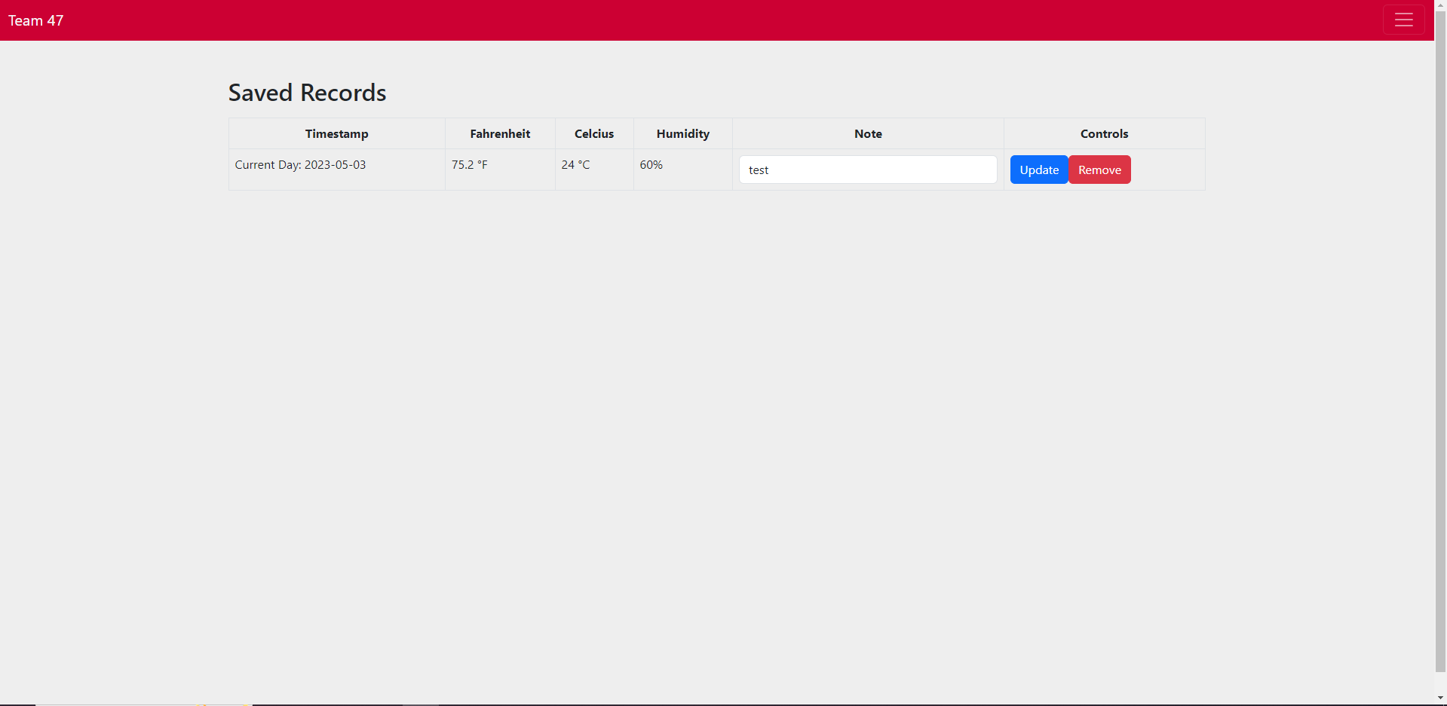

The user can add a note to the record by typing it in the note section and then clicking update. 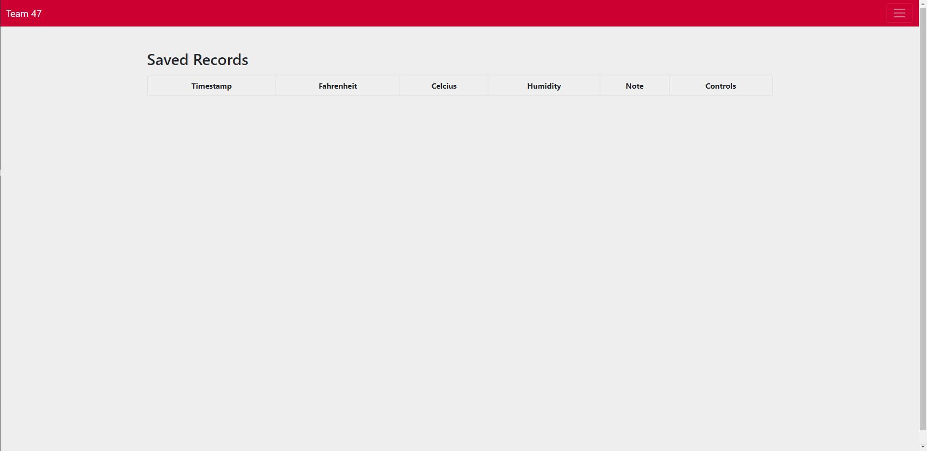

The user can finally remove a record by click the remove button. 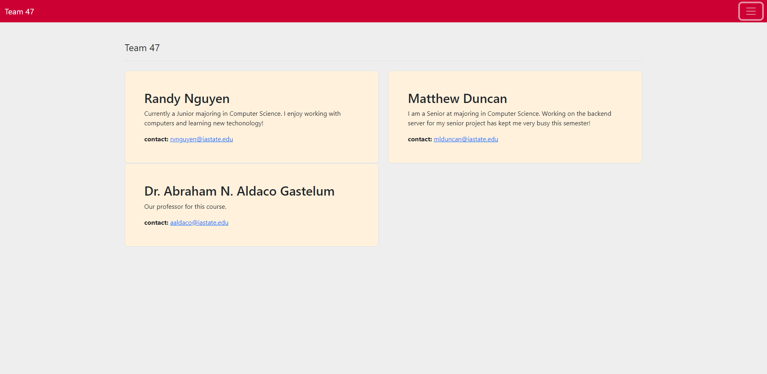

Finally we have a simple view of our information.

**Installation**

Installation is simple as it utilizes many of the tools, we have learned in class so far.

To run the backend use the command:  
**node index**

If there are errors of missing packages, you may need to npm install a couple packages. The required packages for the backend are:  
**npm install express**

**npm install cors**

**npm install body-parser**

**npm install mongodb**

You should see this message if its running correctly:  
“App listening at http://localhost:8081”

To run the frontend use the command:  
**npm start**

If there are errors of missing packages, you may need to npm install a couple packages. The required packages for the backend are:

**npm install react-scroll**

A MongoDB client is required to run the web application.

Create a new database called final and have 2 collections: data, and records. In the data collection, if you want to quickly test the web application without the raspberry pi, you can grab an example input from data.json in the backend project. Just manually place that input in mongodb. It should look something like this.  


The records collection needs nothing to be done as it will change when the user interacts with the web application.