The Southern Strategy
Randall Reed, Ph.D

Introduction
The Emerging Church is one of the most interesting movements in Western Christianity today. A movement that sees itself as specifically attuned to the postmodern world, the Emerging Church has staked out positions that are pro-gay, socially and economically progressive, and religiously inclusive. This might seem a movement tailor made for millennials who generally hold these same values. Studies that have looked at the Emerging Church have often commented on the progressive nature of the movement. However, none of these studies have focused on millennials or have been centered in the South. This deficiency I hope to begin to correct in this paper. The Emerging Church is often characterized as a post-evangelical movement. Many of the leading voices in the Emerging Church, Brian Mclaren, Rob Bell, Peter Rollins, Nadia Boltz-Weber have Evangelical backgrounds. Evangelical categories and concerns often are particularly at issue for Emerging Church leaders (e.g. Rob Bell’s rethinking of Hell in “Love Wins”) and Evangelical leaders have often targeted Emerging Church thinkers (e.g. Ron Piper’s “Farewell Rob Bell” tweet that precipitated much of the controversy around the Love Wins book). 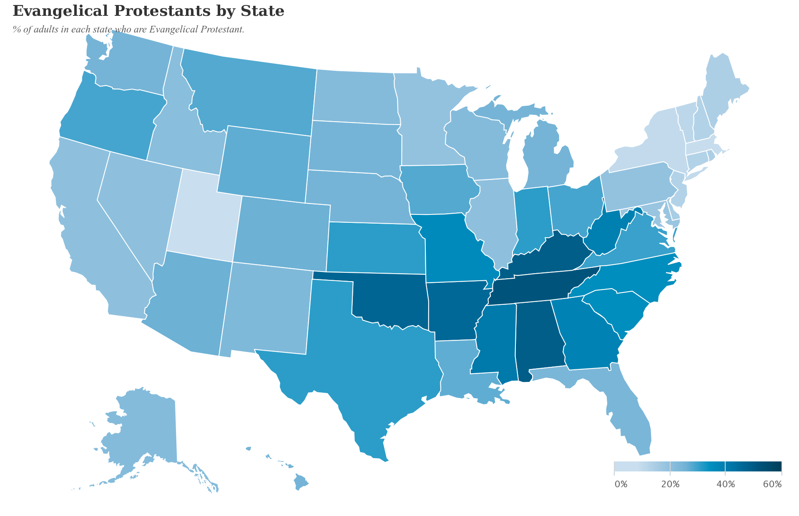
At the same time it is the south that remains the bulwark of evangelicalism. Whereas Evangelicals make up 26% of the U.S. Population, in the South Evangelicals range from 31% in Louisiana to 53% in Arkansas. A look at the Pew Map shows a clear clustering of Evangelicals in the South and while other regions have Evangelical populations, none have a larger percentage than the South. If the Emerging Church, then, is to change Evangelical Protestantism as we know it, then its mission field (if you will pardon the phrase) must be the South.
The other aspect that is key here is millennials. The millennial generation has made headlines by its abandonment of traditional institutional church with the rise of the millennial “nones.” While the implications of the category of “none” has been questioned by some, there is no doubt that there has been a loss of membership in both mainline and Evangelical Churches. Millennials are dropping out of church, and whether they are taking the moniker of “none” or not, their absence in church pews is a real phenomena charted both by national surveys as well as by denominational reports.
Which brings us to the question at hand, which is in two parts. First, is there a trend toward evangelical defection in the South like there is in other regions of the country and what implications can be drawn from the answer to that question? Second, is their a receptivity that can be seen towards the message of the Emerging Church and what are the openings and barriers to its acceptance by southern millennials.
To answer the first question about church defection in the south, I will look at the data provided by the General Social Survey which allows the disaggregation of data by region in conjunction with other surveys that have also touched on this issue. To answer the second question about the receptivity of millennials to the message of the Emerging Church I will draw upon qualitative research that I have been conducting with focus groups of Southern Millennials. I must caution that this research is on-going and thus incomplete, but I believe that at this point I can make some preliminary observations that are relevant to this question.

Evangelicals
Let us begin with the question regarding the presence of Evangelicals in both millennial and non-millennial populations. The General Social Survey puts the national percentage of Evangelicals at 40% which is slightly higher than Pew (and probably overstated) but will act as a baseline for comparison. Here we can see among the general population non-evangelicals outnumber Evangelicals.
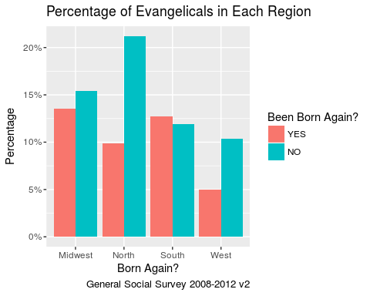
Our understanding becomes more nuanced when we look at this same data from a regional perspective. The Midwest and the South have the most individuals who have had a Born Again experience. But also only in one part of the country do those who have had a Born Again experience outnumber those who have not, that is the South.
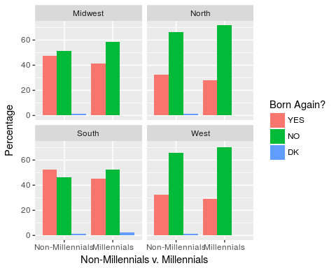
However when we compare non-milennials and millennials by region, once again the south stands out.
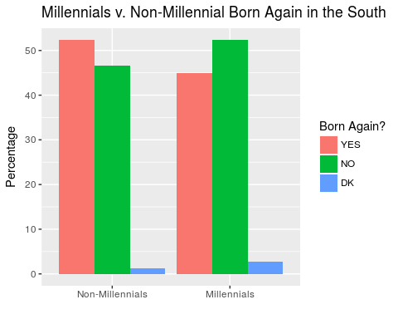
In the south more non-millennials claim to have had a born again experience than not. However for millennials this is reversed, more millennials claim not to have had a born again experience than those who say they have. While the gap between the “yes”es and the “no”s increases across all regions: more millennials say “no” than non-millennials. It is only in the South where there is this kind of reversal.
This leads us to the question of the religious “nones.” There has been much made of the advent of the “nones” and some criticism about the category as well. As a category it is neither all meaningful nor meaningless as different people have alternatively exalted or decried. It is ultimately a variable and as a variable it can tell us whether more or less people are rejecting institutional religious labels, but it cannot tell us why or what it is that these “nones” actually believe. These questions are left to other variables, more focused surveys and most importantly qualitative work still to be done. Nevertheless it is worth exploring the religious identification variable for what it can tell us.
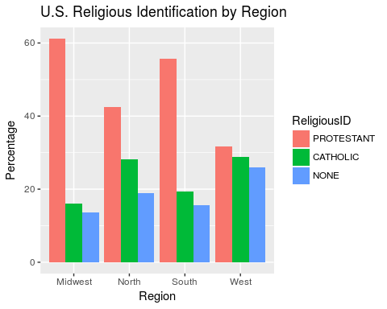 ## Nones
If we go a little further and compare millennial nones to non-millennial nones what we see is the millennial nones significantly outpace non-millennial nones in every region. Millennial nones are a distinctive reality. Again we may not be able to say what this means, but it is certainly a phenomenon that requires further study.
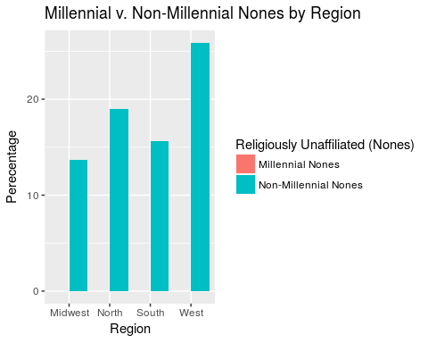
So the next question is where are these nones coming from? This chart is a little difficult to read so I apologize for that. The x axis indicates the original religious identification of the individual when they were 16 (protestant, catholic or none). The color indicates the current religious identification at the time of the survey (Red=Protestant, Green=Catholic, Blue=None). What is important is that you can see who is going where. For instance. in the midwest, the majority of protestants who are converting, are converting to none, a few are converting to catholicism. This is likewise true of catholics, about 10% convert to protestantism, and the larger share convert to none. Nones are converting (about 18%) to protestantism. Now a couple observations that are appropriate here. First, there is conversion both ways. Protestant and Catholics are becoming Nones, but Nones are also becoming Protestant and sometimes Catholics. Second, what you don’t see in this chart (because it made it even more complicated) is religious retention, all religious identifications are also keeping a majority of their millennials, even in the north where over 30% of protestants are defecting, the reality is almost 70% are staying put. Third, none’s are not strictly the product of conversion, there are a group of them that are nones to begin with, perhaps better: “cradle nones”. Some of the growth of the nones is second generation nones, nones made the old fashion way, what we might call (drawing on my Quaker background) “birthright nones.” Among Millennials, birthright nones constitute about upwards of 70% of the nones population (depending on region).
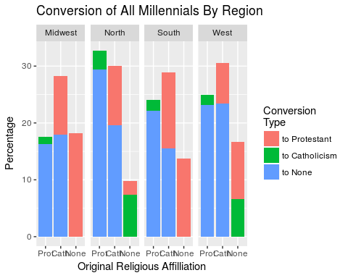
However, I do not want to give the impression that the trade between, say, protestants and nones is even, both swapping 20% so it comes out a wash. Thus it is helpful to look at actual numbers, and when we do that we see that trade is significantly disproportionate whereby the Protestant and Catholics are giving up significantly more people to the nones than vice-versa. So the growth of the None’s is neither insubstantial nor regionally specific. It spans the nation, with some regional variation, but it is present in all regions.
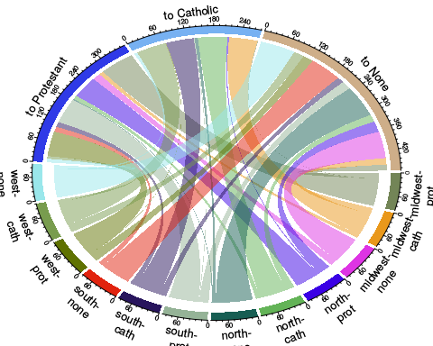
But to turn from national trends but to focus on a particular region -- the South, two conclusions can be summarized that are of relevance: First, fewer millennials in the south are identifying with evangelicalism by claiming a born again experience. Second, Protestant millennials in the south are shedding their protestant identification in significant numbers.
Given the reality then of the millennial defection from institutionalized church, the natural next question is what is driving millennials away from church? This is a question which has occupied David Kinnaman and the Barna Group. Kinnaman has concluded that there are several factors involved: The church is perceived as judgemental, homophobic and too political. Likewise the concerns of the church are not seen as relevant to the lives of millennials. The Public Religion Research Institute has additionally shown that part of the millennial negative perception of the Evangelical church stems from its stance against homosexuality.
In to this environment comes the Emerging Church. By all accounts it would seem that the Emerging Church would be ideally suited to appeal to millennials. Its emphasis on openness, tolerance and focus on discussion over doctrinal purity seems tailor made for the millennials. My own research has focused particularly on this question but with a regional emphasis precisely because of the aforementioned strength of evangelicals in the south: Are southern millennials receptive to the Emerging Church? Using a series of focus groups of millennials I have posed this and related questions in an attempt to provide some insights unavailable in survey data. The results so far are preliminary, but begin to speak to some of these issues.
My research indicates that Southern millennials are potentially receptive to the Emerging Church. During the focus groups, the participants made roughly twice as many statements that were positive versus negative when introduced to statements from leaders of the Emerging Church. When we dig a little deeper into the areas that southern millennials saw that were positive about the Emerging Church the picture becomes clearer.
Gerardo Marti and Gladys Ganiel’s recent study emphasizes that openness is key aspect of the Emerging Church (2014, 34). My research confirms this, as there was a generally positive view of the openness of the Emerging Church. As one participant stated “I would go towards the emerging church because it’s more open-minded and progressive and gives me a little bit of freedom to think.” Another person echoed this perspective, contrasting it with her other experiences of church agreeing, “ It would definitely give a person more freedom to think for themselves and [from] my personal background, you could not really think for yourself and could not question why you believe what you believe, so that is probably why I would join...” Here an openness to questioning is seen as an important attractor and the converse is likewise seen as a failing of the institutional church.
Additionally, focus group members saw a significant need for change in the church. This was reflected on the one hand in a pre-survey which while not representative of all millennials supports other survey research by indicating that the vast majority of participants were “dissatisfied” or “very dissatisfied” with the church, this includes individuals who indicated they were still attending church regularly. But likewise participants voiced this need for change in the Church in the focus group. One participant stated bluntly, “I do think that religion, especially Christianity, will die out if nothing changes.” On the other hand the change that the Emerging Church represents caused some excitement, as one participant noticed, “[in] one of the videos, the guy was talking about a change in the church and he said ‘I really think this can happen’ and he was really confident in it. And when I hear something like that, I get really excited....” In each of these cases there is a recognition that from the perspective of these millennials the church is broken and the Emerging Church offers for these southern millennials one avenue for change.
The most contested category for these participants was the Bible. The Emerging Church take on Biblical Authority was both the largest asset for southern millennials and also the biggest liability. The focus groups were shown a short video of Brian McLaren talking about the difference between viewing the Bible as a library versus a constitution. Libraries have a variety of opinions whereas the constitution is more a place to find answers. Some participants were quite taken in a positive way by this distinction. One participant stated clearly, “As far as my reception to the emerging church... this is kind of a breath of fresh air for [me]...” Another returned to the issue of openness, “I think it gives our generation more freedom to form their own thought with [the Bible]. As more like... guidance rather than an end-all to end all,” Those participants who were attracted to this way of thinking found the lack of fixity, the lack of a single answer, a refreshing change.
On the other hand, different participants found this approach to the Bible problematic, one participant said plainly “ it’s editing the Bible, in a way, that[‘s]... taking away from what’s written in it. ...you’re actually changing Christianity you’re changing the word of God…” Another voiced an opinion that asserted a single interpretation, “I feel like... at some level there is going to be... a correct answer. You just have to figure out what it is.” Here we see push back against an Emerging notion of Biblical interpretation.
But more problematic than just the response to McLaren was that many of these participants still saw the evangelical understanding of the Bible with its legacy of Scottish Common Sense Realism as the touchstone for their own ways of sorting out issues. Even when not talking specifically about the Bible, often the reference point was the Bible. For instance in response to a video where Jay Baker talks about his support of Gay Marriage in a interracial congregational setting, one participant said, “I feel like that he should of gone into certain passages of the Bible ... It think that might’ve been helpful for his argument.” Other participants connected the immutability of God with Biblical interpretation. One participant recoiling against the idea of parts of the Bible being outdated said, “ To say the Bible is outdated but that God isn’t [is problematic] because if the Bible is God’s word [then] God’s word isn’t going to be outdated.” Another participant was concerned since for them the Bible was the “cornerstone of Christianity.” Criticizing McLaren another interlocutor complained, “ So he never really answers, like, ‘Is the Bible the ultimate authority?’ And he says that [all] people [are] interpreting it... But then you’re opening Christianity to be anything.” In each of these cases the Bible is the immovable touchstone to which everything must be subject.
This then seems to me to be the place where the Emerging Church has its greatest challenge among southern millennials. There is a culture of significant reverence for the text. Those millennials who have this perspective need every position justified from the Bible or they see such positions as unacceptable. For these millennials the Emerging Church will need to engage with the text in a way that either can convince these millennials that there is room for the sort of interpretive freedom the Emerging Church envisions or somehow shake their interpretive commitment to the text.
And yet with this proviso, even the more conservative millennials indicate that they are dissatisfied with the church. So while their commitment to the text is undiminished their commitment to the institutional church seems waning. Thus the potential to find a way to speak to these millennials remains. They are not generally happy with the church as it stands.
Yet the data here brings up a more important issue and that is the question of the instantiation of authority. Kosmin’s American Religious Identification Survey (Kosmin and Keysar 2013) showed a significant division on the question of whether the Bible is an appropriate moral guide. My study confirms this conclusion. And yet the question of what can challenge the Bible as an authority is a larger question about the construction of authority in general and its possible failure. The mixed nature of the data indicates at this point a contestation of authority without a new center. Bruce Lincoln’s theory of Authority (1995) suggests that multiple factors play into its construction, from audience to environment to message. Yet such a theory only begins to scratch the surface of the problem. What is needed is a theory of religious change.
Some helpful work in this area has been done in the sociology of conversion. As time does not permit a lengthy discussion I will simply make some observations based on the insights of these studies. What seems clear from this literature is that individual religious change is dependent upon a failure of religious identity.(Rambo 1995) The problem with identity is that it is dependent on significant investment in upkeep. Identity requires constant reaffirmation both at the individual and social level. The basic problem with the number of millennials leaving and being disaffected with the institutional church is that it lessens the potential for religious identity reaffirmation. Such weakening of reinforcers ultimately leads to identity insecurity.
Authority plays an important part in the formation of identity. Authority becomes the center point for identity, whether that authority be a community, a tradition or a text. Appeals to that authority are a strategy for shoring up identity. Challenges to that authority likewise can constitute a challenge to the identity associated with it as well.
However making a text the locus of authority is actually problematic as the text is not self-interpreting. It requires a community to extract authorized meaning and foreclose unacceptable interpretations. What appears then to be the locus of authority grounded in the text in reality is community authority masquerading as textual authority. Such insights go far in explaining why the central point of contestation is the Bible for these millennial protestants. The Evangelical championing of the Bible, is really a championing of a particular and communally driven interpretation of the Bible.
Yet with the millennial distrust of institutional religion and consequent disaffillation, there is a weakening of interpretive reinforcement. The allegiance to the Bible still remains and yet the concomitant communal interpretive stricture has been abandoned. It is possible that such might precipitate an opening for the Emerging Church and we saw just such an opening in our study.
Thus the issue for southern millennials reduces to the Bible. It would seem that attempts to simply ignore or sideline the text as some mainline denominations have done, will ultimately not be effective for these millennials. The data presented here indicates that if the Emerging church were to reclaim the Bible in such a way that they still encourage the openness that millennials value there may be receptiveness from southern millennials. The “Bible as Library” approach of McLaren shows some promise in this regard. Whether the Emerging Church can build on that in the South has yet to be seen.

References

Scot McKnight et al., Church in the Present Tense (ēmersion: Emergent Village Resources for Communities of Faith): A Candid Look at What’s Emerging, Pap/DVD edition (Brazos Press, 2011). Tony Jones, The Church Is Flat: The Relational Ecclesiology of the Emerging Church Movement (Minneapolis, MN: JoPa Group, 2011).
James S. Bielo, Emerging Evangelicals: Faith, Modernity, and the Desire for Authenticity (NYU Press, 2011).

