Copyright S. Ikenaga 1998
All rights reserved

EE 4343/5329 - Control System Design Project
LECTURE 10

EE 4343/5329 Homepage
EE 4343/5329 Course Outline

Design of Phase-lead and Phase-lag compensators using Bode Plot Method

Phase-lead compensator design using Bode Plot Method

Goal: Design a phase-lead compensator for the system 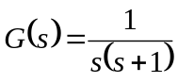, such that the steady-state error is less than 0.1 for a unit ramp input and a % overshoot less than 25%.

Steady-state error specification
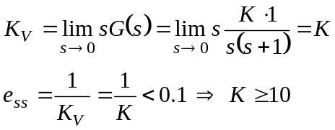

% overshoot specification

Recall the relationship between % overshoot and damping ratio () which is given by
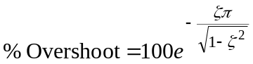
and is shown in Figure 1.

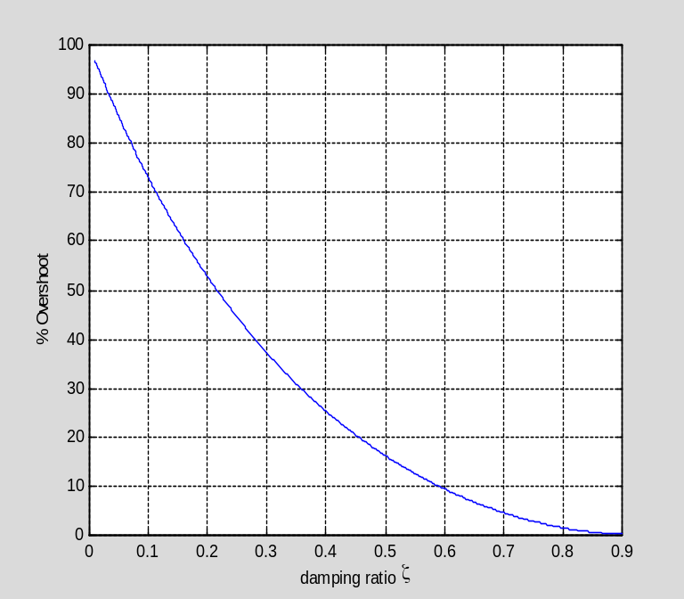
Figure1. % Overshoot vs. Damping Ratio.

Then, the relationship between phase margin (PM) and damping ratio () for the special case of open-loop transfer function 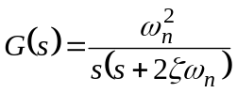 which is given by
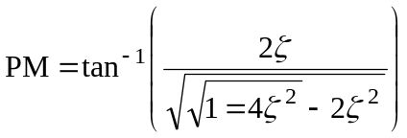
maintains that the phase margin of the compensated system should be greater than 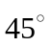 to obtain a percent overshoot less than 25% and is shown in Figure 2.

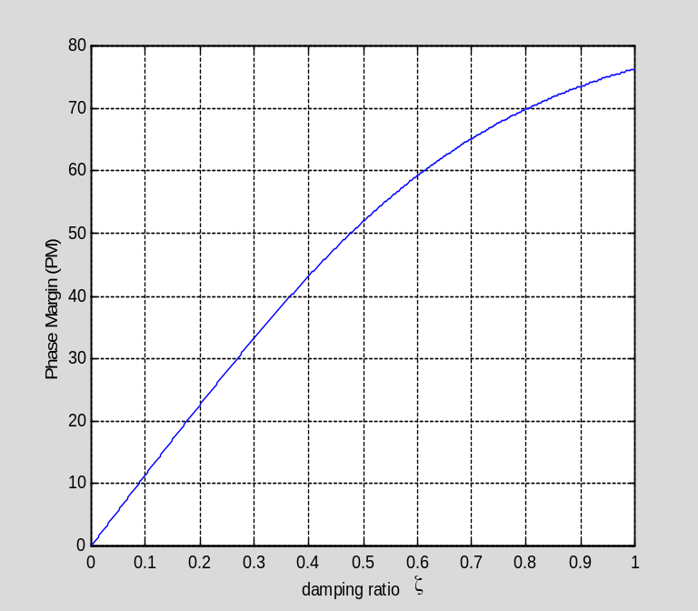
Figure2. Phase Margin vs. Damping Ratio.

Phase-lead design procedure:

- Choose the DC gain constant  such that the steady-state error specification is met. From above, we know must be greater than or equal to 10, so let 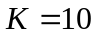.
- Obtain the gain margin and phase margin plots of the uncompensated system along with the DC gain constant found in (i.) to determine the amount of phase lead 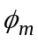 needed to realize the required phase margin so that the percent overshoot specification is met.

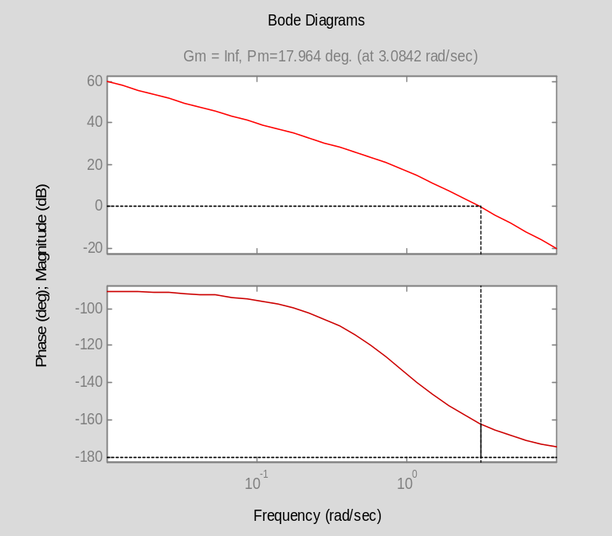

Figure 3. Bode plot of uncompensated system 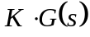.

From Figure 3., the PM of the uncompensated system 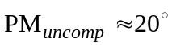. Thus, choosing the PM of the compensated system as 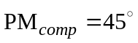, then the additional amount of phase lead 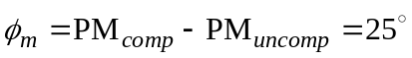. Now that has been determined, the parameter of the phase-lead compensator can be chosen from Figure 2.14 in Appendix A, which has been chosen to be 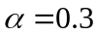 which corresponds to a maximum phase lead of 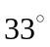.
- The maximum phase lead must be added around the new gain-crossover frequency 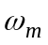. The phase-lead compensator contributes a gain around 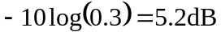 at the new ; therefore, one must determine the frequency at which the uncompensated system has a magnitude 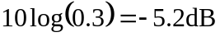. Thus, should equal this frequency so that it becomes the new 0-dB crossover frequency in the compensated system. From inspection of Figure 3, the magnitude of the uncompensated system equals –5.2dB at the frequency 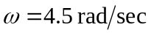. Let 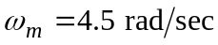.

- Calculate the parameters of the phase-lead compensator based on the values obtained in steps (i.) thru (iii.). The transfer function of a phase-lead compensator is given as
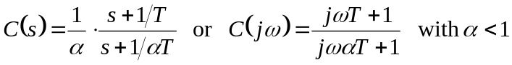
where 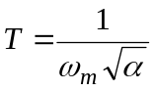. Thus, for , 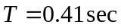. This leads to a phase-lead compensator design of the following:
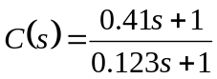

Phase-lead compensator simulation results:

Matlab Simulation
clear all;

wm = 4.5; % gain-crossover frequency
alpha = 0.3; % phase-lead compensator parameter
T = 1/wm/sqrt(alpha); % phase-lead compensator time constant
K = 10; % DC compensator gain

% Phase-lead compensator C(s)
cnum = K*[T 1];
cden = [T*alpha 1];

% Open-loop sys G(s)
gnum = [1];
gden = [1 1 0];

% Unity-Gain Feedback Loop H(s)
hnum = [1];
hden = [1];

% Open-loop sys C(s)*G(s)
numo = conv(cnum,gnum);
deno = conv(cden,gden);

% Closed-loop sys
[gnumc,gdenc] = feedback(K*gnum,gden,hnum,hden,-1);
[numc,denc] = feedback(numo,deno,hnum,hden,-1);

bode(cnum,cden);

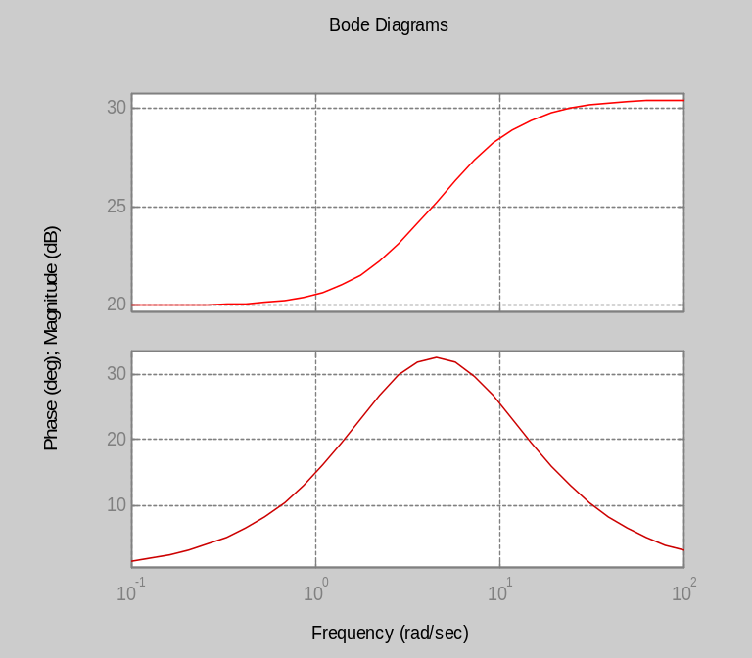

Figure 4. Bode plot of phase-lead compensator 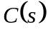.

sys1 = tf(K*gnum,gden);
sys2 = tf(numo,deno);
[mag1,ph1,w]=bode(K*gnum,gden,logspace(-1,2,500));
[mag2,ph2,w]=bode(numo,deno,logspace(-1,2,500));
subplot(211); semilogx(w,20*log10(mag1),'r', w,20*log10(mag2),'b');
title('Bode Diagrams'); ylabel('Magnitude (dB)');
legend('uncompensated','compensated', -1);
subplot(212); semilogx(w,ph1,'r', w,ph2,'b');
ylabel('Phase (deg)'); xlabel('Frequency (rad/sec)');
legend('uncompensated','compensated', -1);

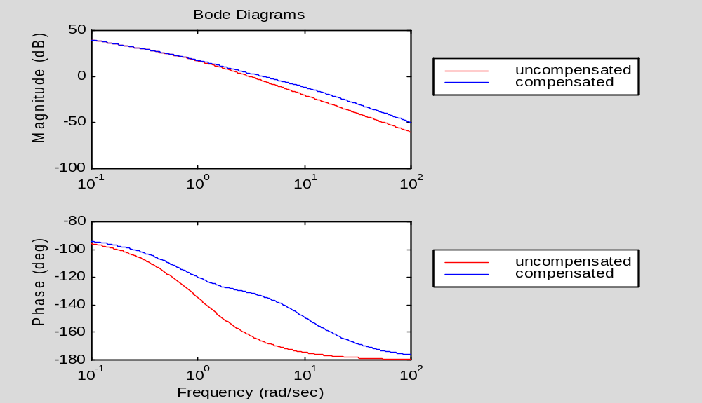
compensated
system
uncompensated system
Figure 5. Bode plots of uncompensated and compensated systems.

figure;
sys1c = tf(gnumc,gdenc);
sys2c = tf(numc,denc);
step(sys1c,sys2c);grid;
legend('uncompensated','compensated',-1);

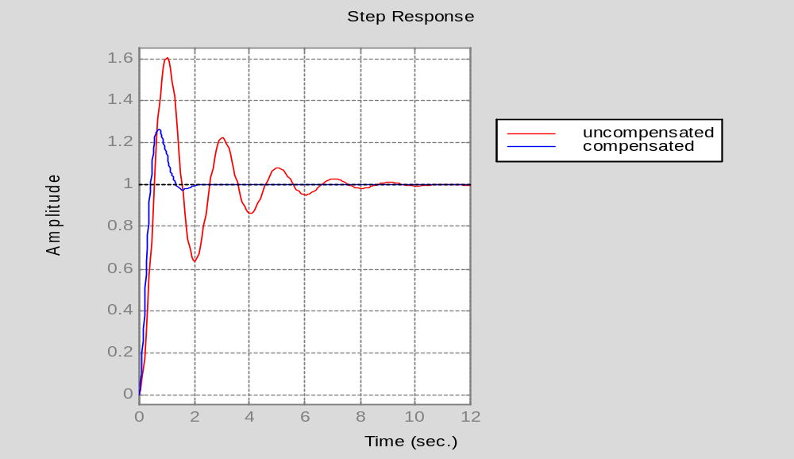
Figure 6. Step response of uncompensated and compensated system.
t=0:0.01:5;
y = t;
[y1,x1]=step(gnumc,conv(gdenc,[1 0]),t);
[y2,x2]=step(numc,conv(denc,[1 0]),t);
[y3,x3]=step(numc,denc,t);
[y4,x4]=step(gnumc,gdenc,t);
plot(t,y1,'r',t,y2,'b',t,y,'g');grid;
xlabel('Time (sec)');
title('Unit Ramp Input response');
legend('uncompensated', 'compensated', 'desired',-1);

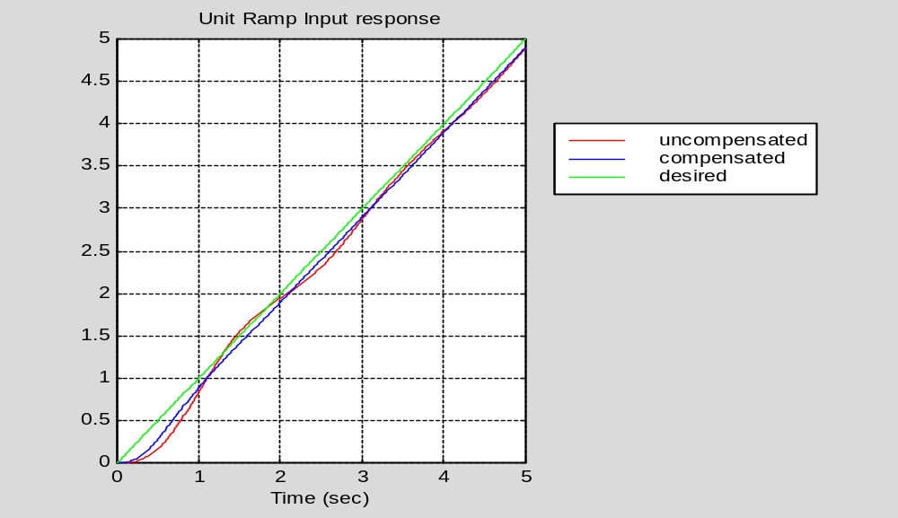
Figure 7. Response of uncompensated and compensated systems due to unit ramp input.

Phase-lag compensator design using Bode Plot Method

Goal: Design a phase-lag compensator for the system , such that the steady-state error is less than 0.1 for a unit ramp input and a percent overshoot less than 25%.

Steady-state error specification
As computed in (1.), 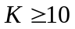.

Percent overshoot specification
As obtained in (1.), 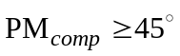.

Phase-lag design procedure:

- Choose the DC gain constant such that the steady-state error specification is met. From above, we know must be greater than or equal to 10, so let .
- Obtain the gain margin and phase margin plots of the uncompensated system along with the DC gain constant found in (i.) to estimate the frequency at which the PM of 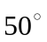 occurs. Denote this frequency as the new gain-crossover frequency . From Figure 8., let 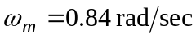.

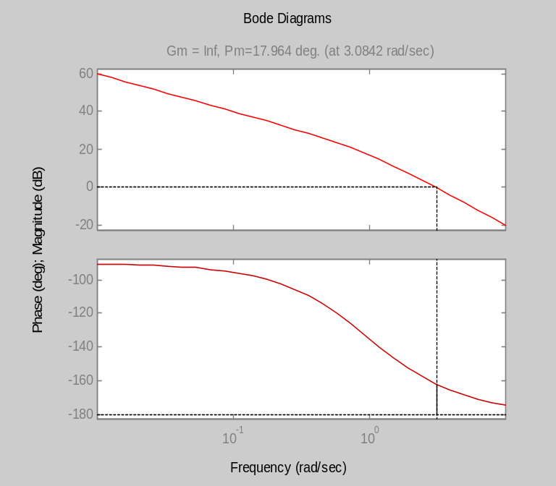
Figure 8. Bode plot of uncompensated system .

- Determine the magnitude of uncompensated system at . From Figure 8., the magnitude of the uncompensated system at is 20 dB. To bring the magnitude curve down to 0 dB at , the phase-lag compensator must provide 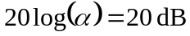 or 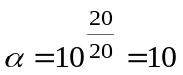.
- Calculate the parameters of the phase-lag compensator based on the values obtained in steps (i.) thru (iii.). The transfer function of a phase-lag compensator is given as
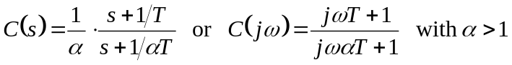
where 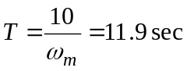. This is to ensure that the frequency at 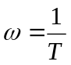 is one decade below the new gain-crossover frequency . This leads to a phase-lag compensator design of the following:
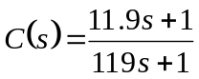.

Phase-lead compensator simulation results:

Matlab Simulation
clear all;

wm = 0.84; % gain-crossover frequency
alpha = 10; % phase-lag compensator parameter
T = 10/wm; % phase-lead compensator time constant

K = 10; % DC compensator gain

% Phase-lead compensator C(s)
cnum = K*[T 1];
cden = [T*alpha 1];

% Open-loop sys G(s)
gnum = [1];
gden = [1 1 0];

% Unity-Gain Feedback Loop H(s)
hnum = [1];
hden = [1];

% Open-loop sys C(s)*G(s)
numo = conv(cnum,gnum);
deno = conv(cden,gden);

% Closed-loop sys
[gnumc,gdenc] = feedback(K*gnum,gden,hnum,hden,-1);
[numc,denc] = feedback(numo,deno,hnum,hden,-1);
bode(cnum,cden);

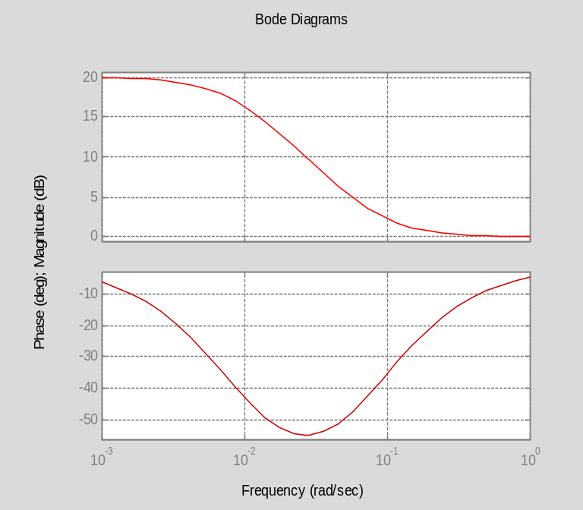
Figure 9. Bode plot of phase-lag compensator .

sys1 = tf(K*gnum,gden);
sys2 = tf(numo,deno);
[mag1,ph1,w]=bode(K*gnum,gden,logspace(-1,2,500));
[mag2,ph2,w]=bode(numo,deno,logspace(-1,2,500));
subplot(211); semilogx(w,20*log10(mag1),'r', w,20*log10(mag2),'b');
title('Bode Diagrams'); ylabel('Magnitude (dB)');
legend('uncompensated','compensated', -1);
subplot(212); semilogx(w,ph1,'r', w,ph2,'b');
ylabel('Phase (deg)'); xlabel('Frequency (rad/sec)');
legend('uncompensated','compensated', -1);

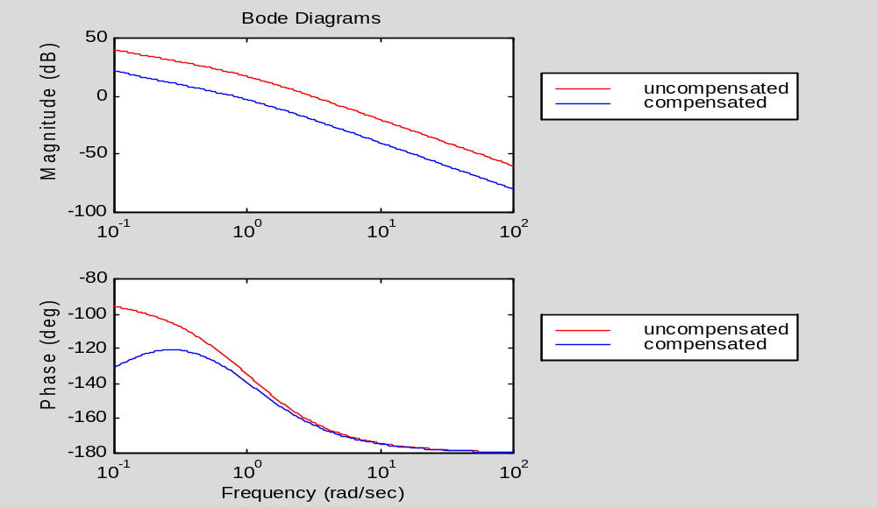
uncompensated system
compensated system
Figure 10. Bode plots of uncompensated and compensated systems.

sys1c = tf(gnumc,gdenc);
sys2c = tf(numc,denc);
step(sys1c,sys2c);grid;
legend('uncompensated', 'compensated',-1);

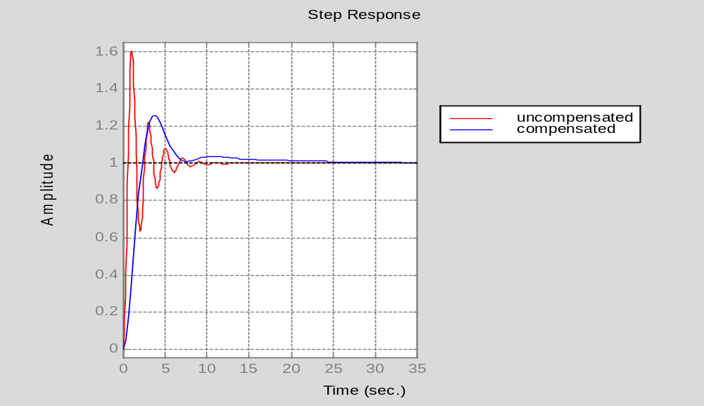
Figure 11. Step response of uncompensated and compensated system.

t=0:0.01:5;
y = t;
[y1,x1]=step(gnumc,conv(gdenc,[1 0]),t);
[y2,x2]=step(numc,conv(denc,[1 0]),t);
[y3,x3]=step(numc,denc,t);
[y4,x4]=step(gnumc,gdenc,t);
plot(t,y1,'r',t,y2,'b',t,y,'g');grid;
xlabel('Time (sec)');
title('Unit Ramp Input response');
legend('uncompensated', 'compensated', 'desired',-1);

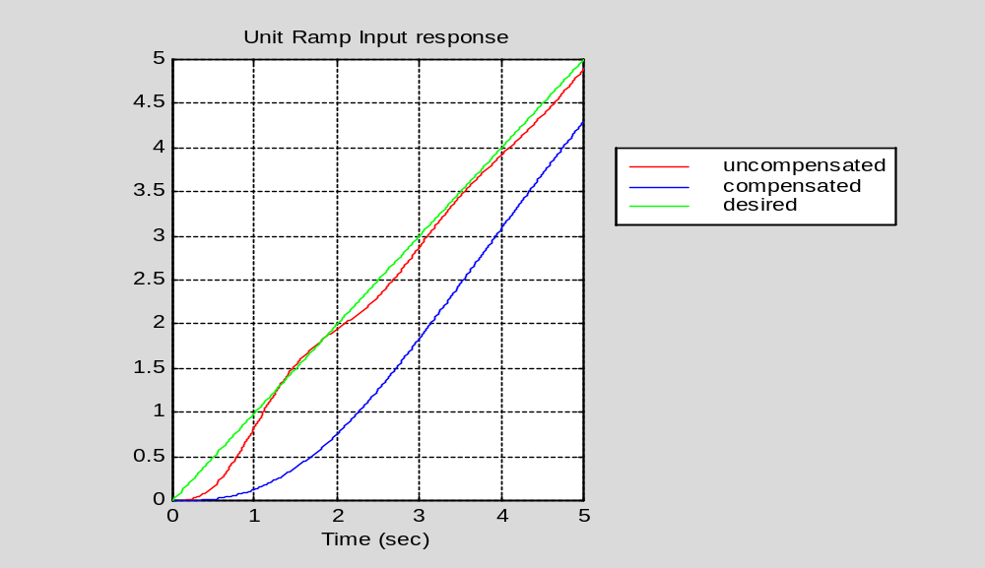
Figure 12. Response of uncompensated and compensated systems due to unit ramp input.

