* **Prerequisites Software Screenshots**

**Sceenshot 1** : Launch ubuntu EC2 instance and and connect to it .

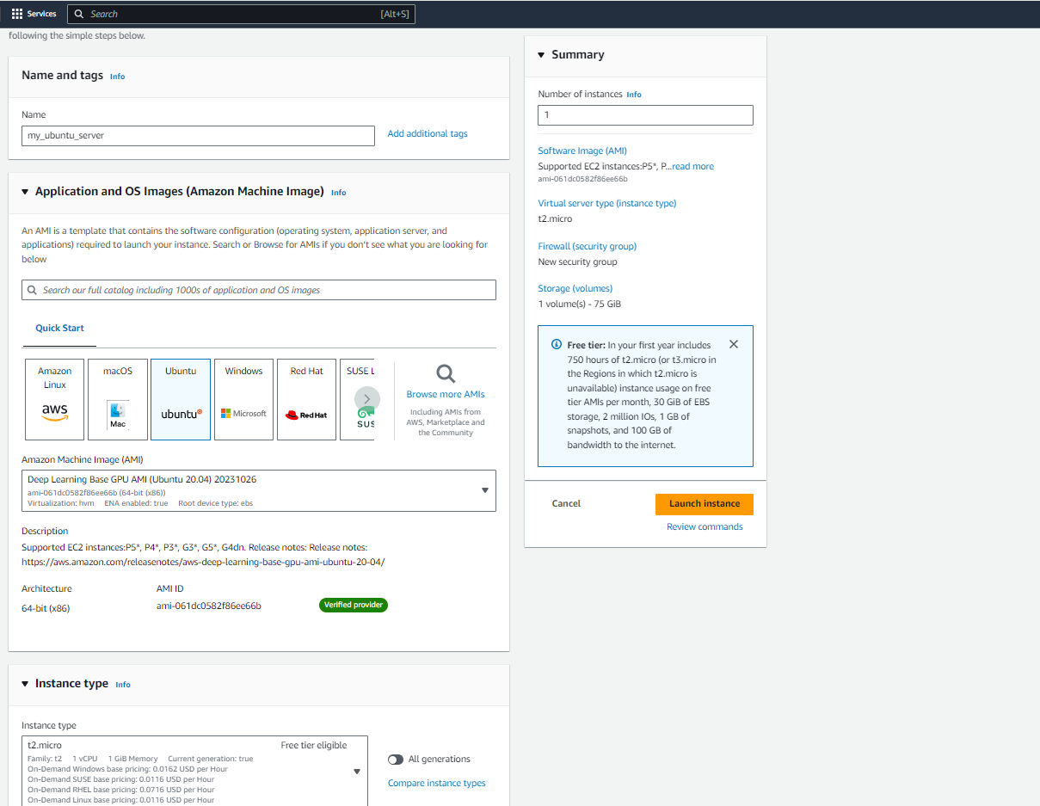

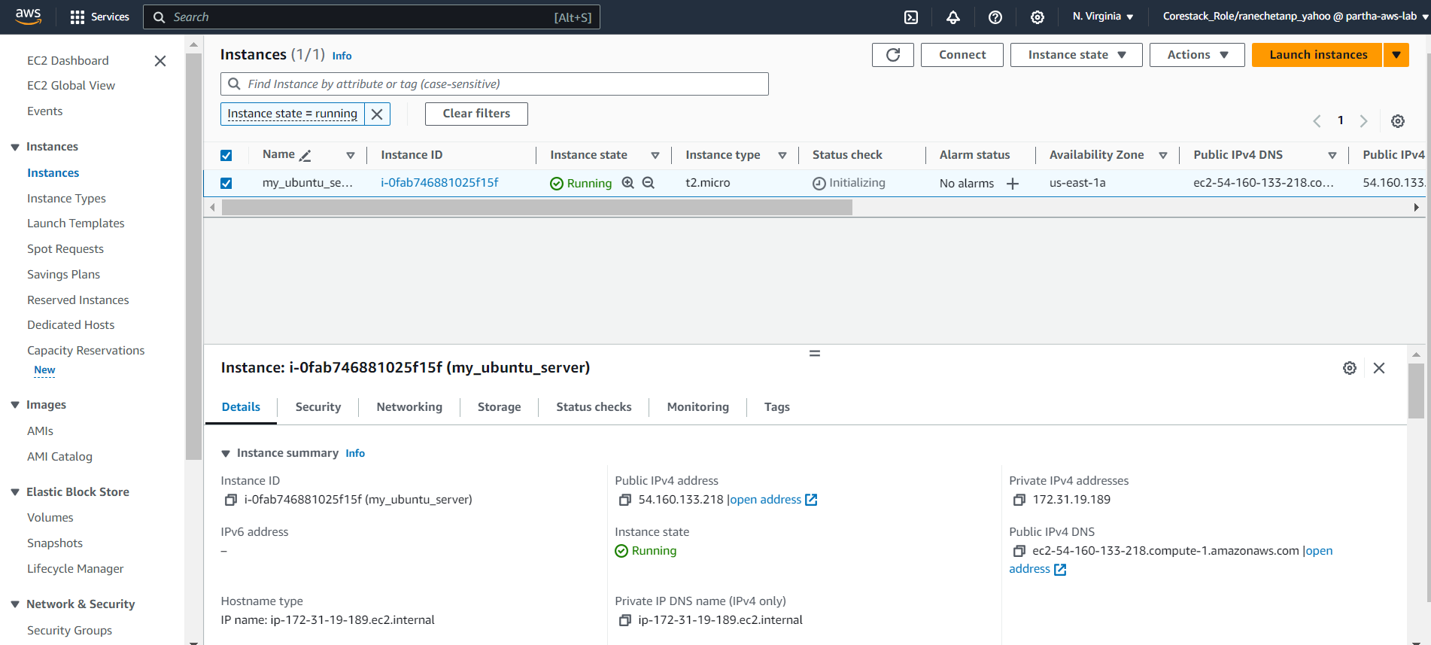

**Sceenshot 2 :** Git installation status.

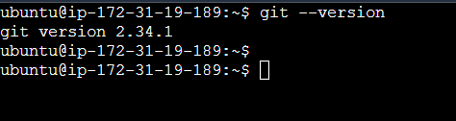

**Sceenshot 3 :** Docker installation status.



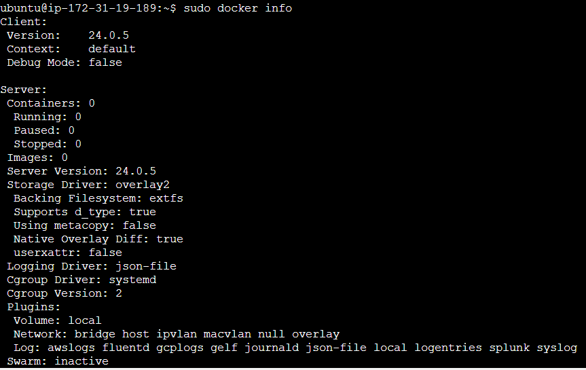

**Sceenshot 4 :** Java installation status.

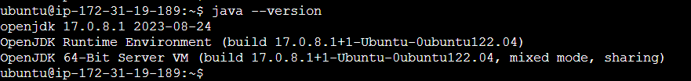

**Sceenshot 5 :** Jenkins installation status.

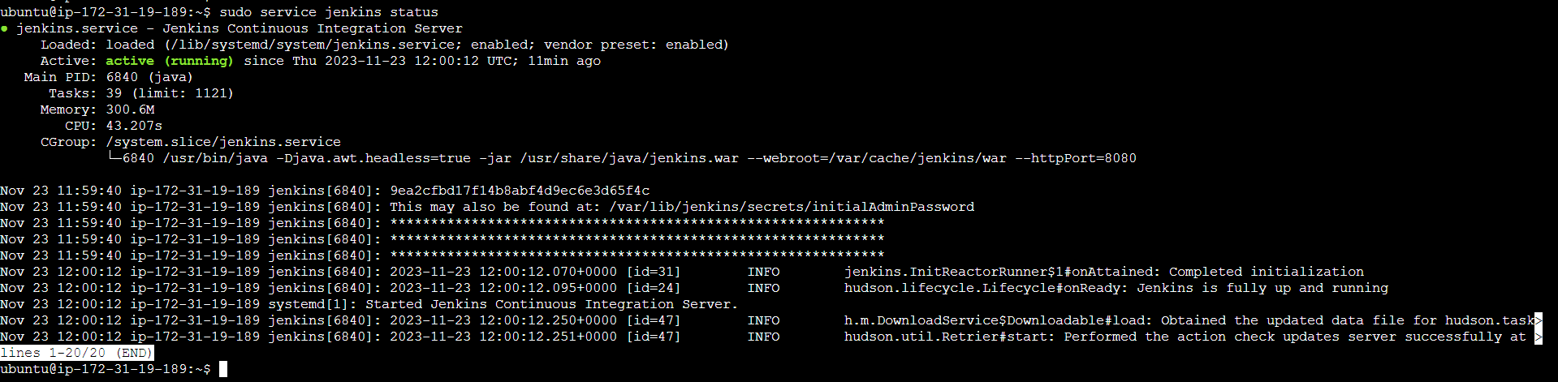

**Sceenshot 6 :** Login the Jenkins.

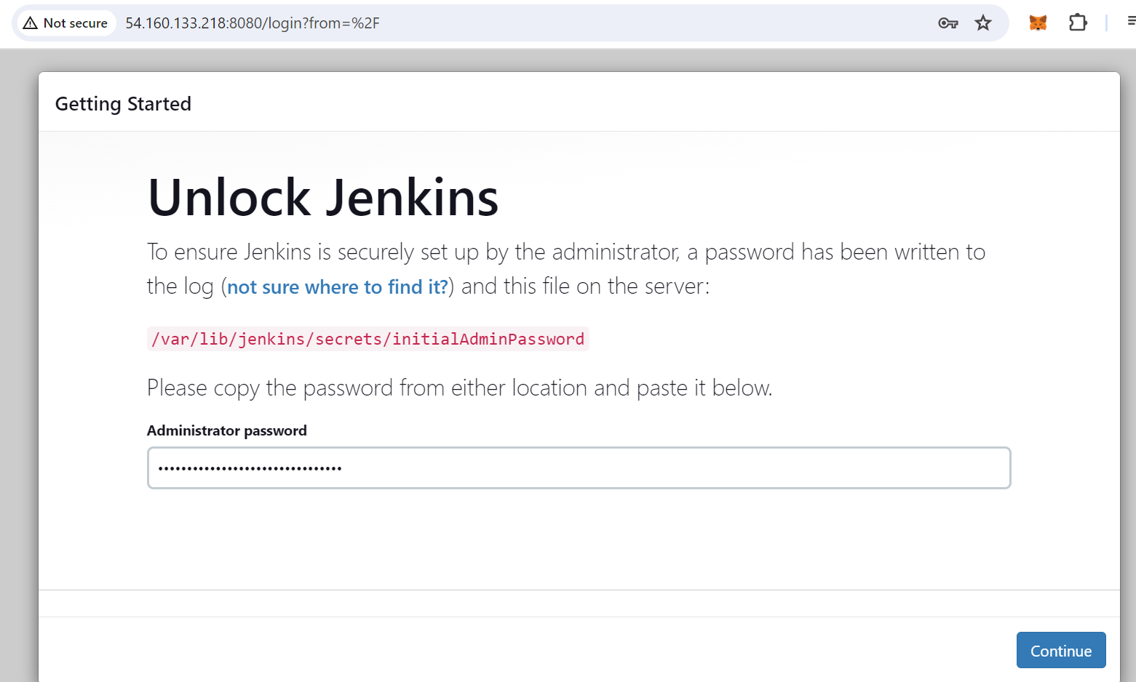 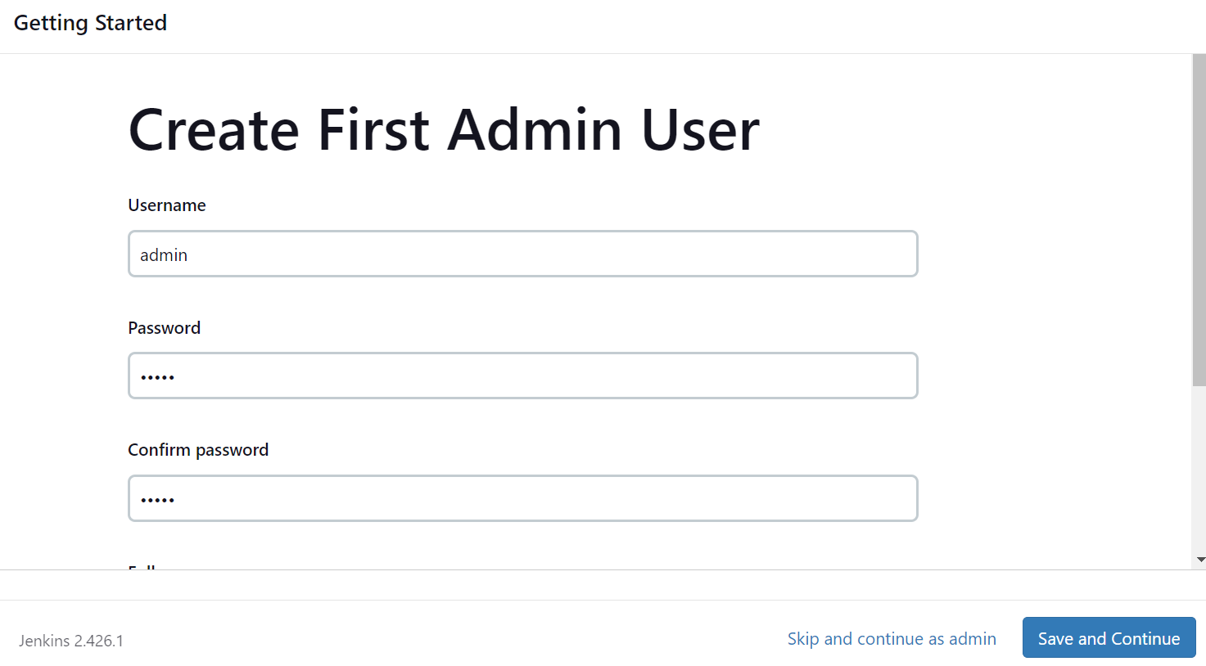

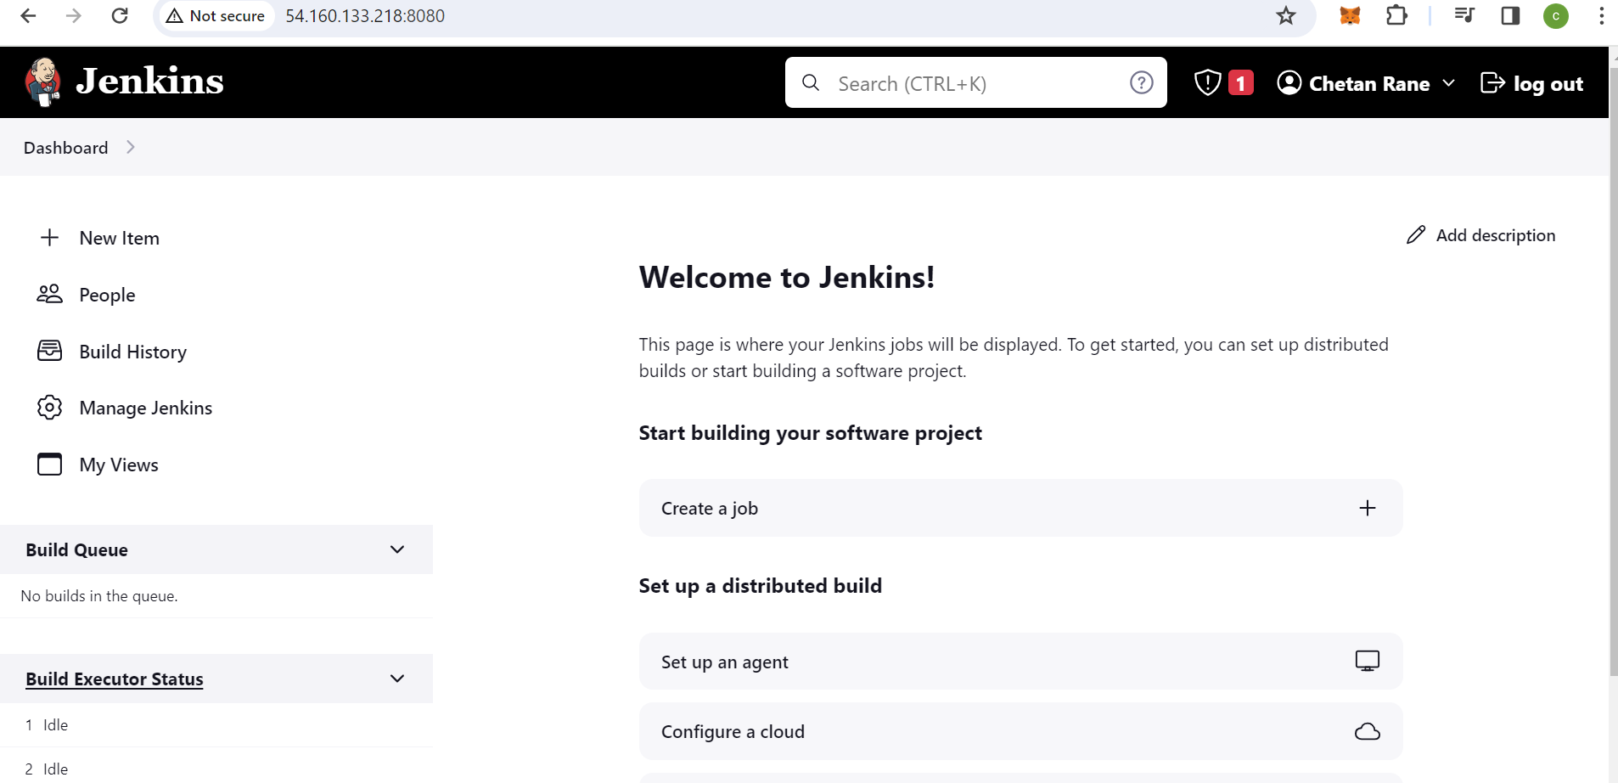

* **Creating Git Hub repository for availability and version tracking of application code.**

**Sceenshot 1 :** Create git hub repo ‘devops_project’. 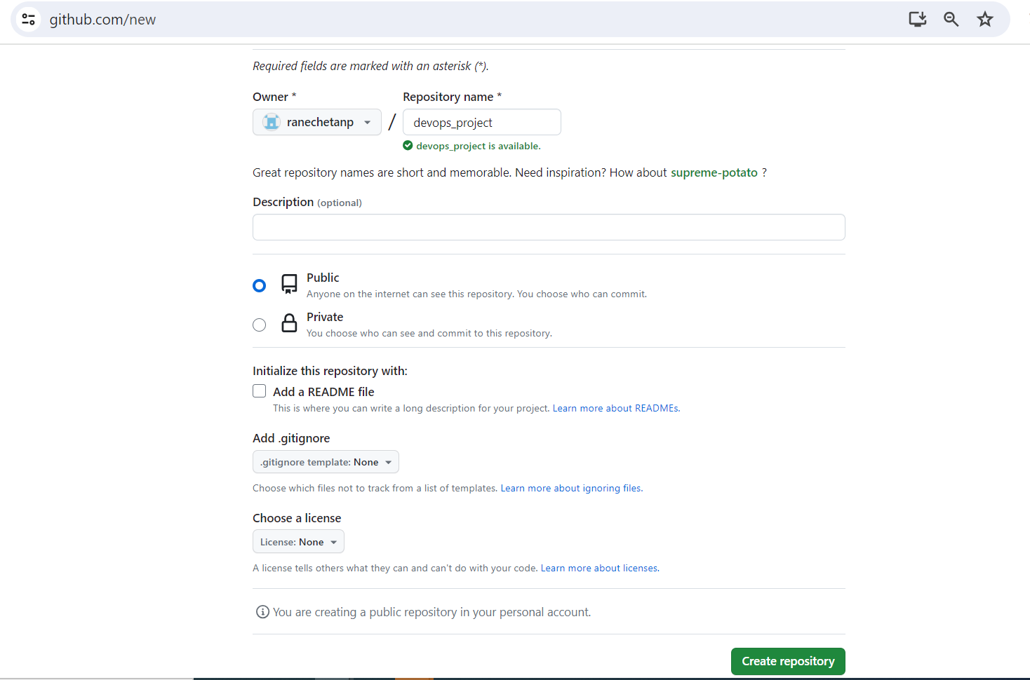

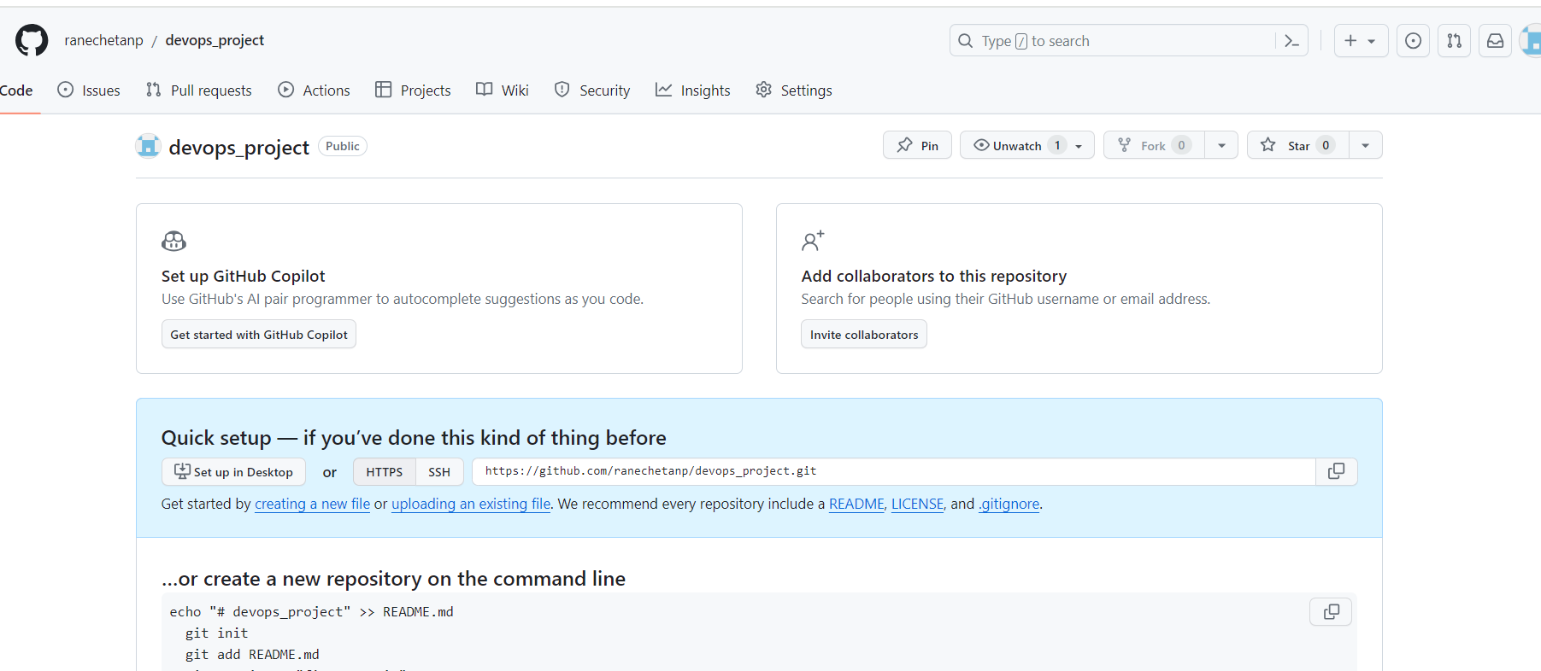

**Sceenshot 2 :** Local machine repo status and remote repository .

