**Name**: Raneem Wael Muhammed

**B.N**: 352

**Topic**: Artificial Intelligence

**GitHub Link: https://github.com/raneemwael2002/ECE001**

**GitHub Pages:**

<https://raneemwael2002.github.io/ECE001/>

*Artificial Intelligence and its applications:*

The simulation of human intelligence processes through machines, in particular computer systems, is an AI or artificial intelligence. This includes learning, thinking and self-correction. In the beginning it was like a dream but it came true and it is supposed to affect our life greatly in the few coming years, the most popular application for AI or artificial intelligence is the robot, and it’s expected that robots will be in charge for so many things instead of the human being and it will end many careers but it will make much more developed jobs. AI can get in many fields that you can’t even imagine such as marketing and banking and health care and finance and space exploration and gaming and agriculture and autonomous vehicles and many other fields.

With the growing growth of AI, consumers on the web can purchase products by snapping a picture in the near future. This is already experienced by companies such as CamFind and its competitors, also some banks used AI to make a bot to deal with customers and apply their needs, the interesting part is that the AI applications are much faster than the human being and it is also more accurate than the best human can be.

And many other applications in many fields just to help the human.

*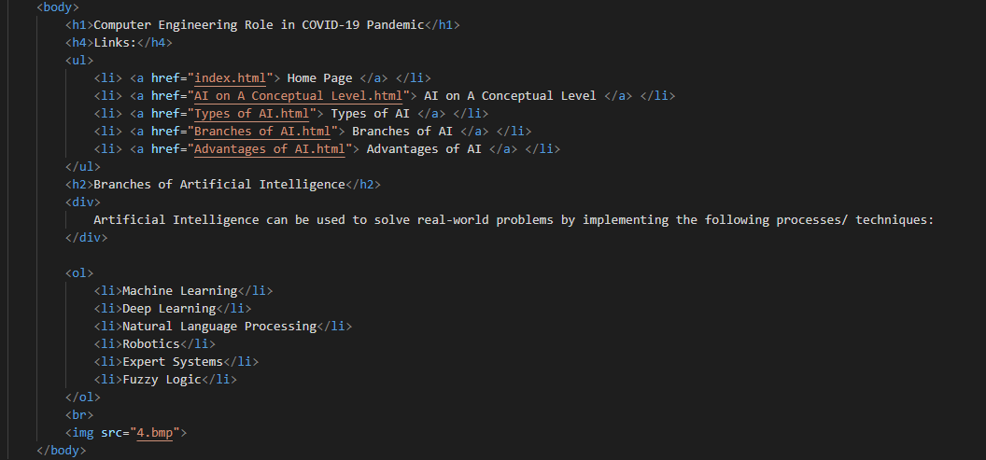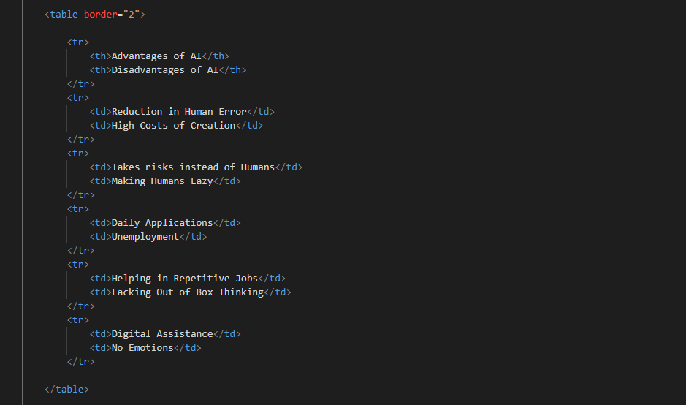Source Code:*

*Screenshots:*

