VIDEO GAME SALES DASHBOARD
Data Analytics Task 2 | ApexPlanet Internship

Made by: Jai Rane
Post: Data Analytics Intern
SECTION 1: KEY METRICS
Total Sale | Top Genre | Top Platform
Average = 0.35 | Sports | PS2(PlayStation 2)

SECTION 2: VISUALIZATIONS
1. Top Genres by Sales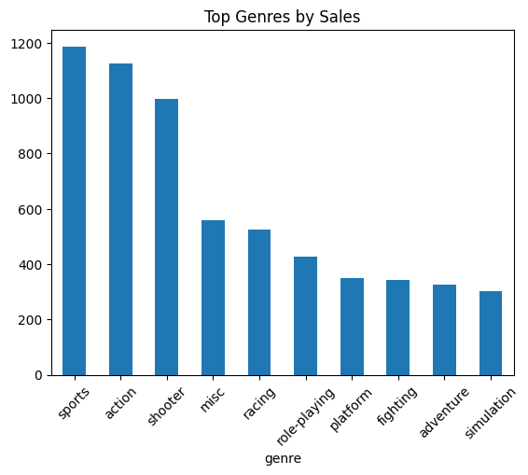

2. Top Platforms by Sales
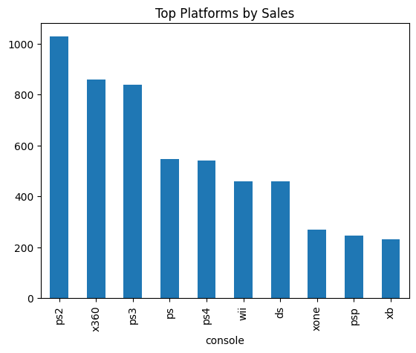

3. Sales Distribution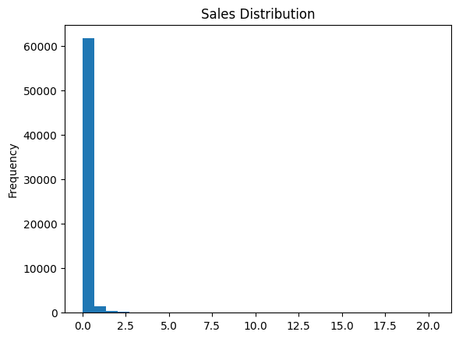
4. Critic Score vs Sales
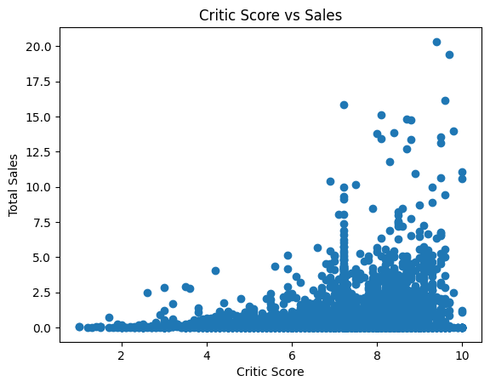
SECTION 3: KEY INSIGHTS
- Sports is the highest-selling genre
- PS2 is the top-performing platform
- Most games have low sales
- No strong relationship between critic score and sales
- Game releases increased over time

SECTION 4:CONCLUSION
This dashboard highlights key trends in video game sales.
It shows that market success is driven more by platform and popularity
than critic ratings, with most games contributing to low overall sales.

