VIDEO GAME SALES ANALYTICS DASHBOARD
Task 3 – KPI Analysis & Dashboard | ApexPlanet Software Pvt. Ltd.
Made by: Jai Rane
Position: Data Analytics Intern

Objective: To analyze video game sales data using KPIs and build a dashboard that highlights key trends, performance metrics, and business insights.

SECTION 1: KPI TABLE
Sr. No. | Metric Name | Metric Value
1 | Total Sales | 6605.910000000001
2 | Average Sales | 0.10319154586353413
3 | Top Genre | Sports
4 | Top Platform | PS2
5 | Average Critic Score | 7.220440251955388

SECTION 2: VISUALIZATIONS
1. Top Genres by sales
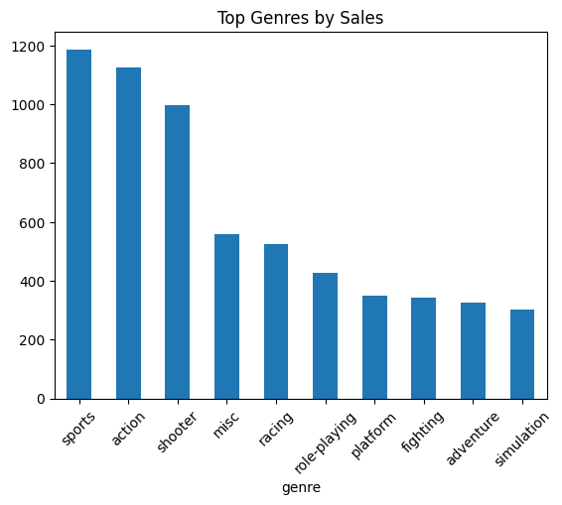
2. Top Platforms by sales
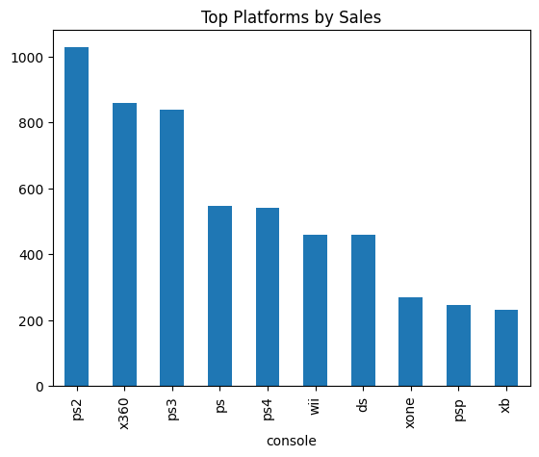

3. Sales Distribution
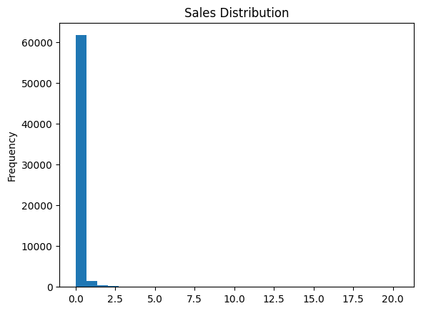
4. Critic Score vs Sales
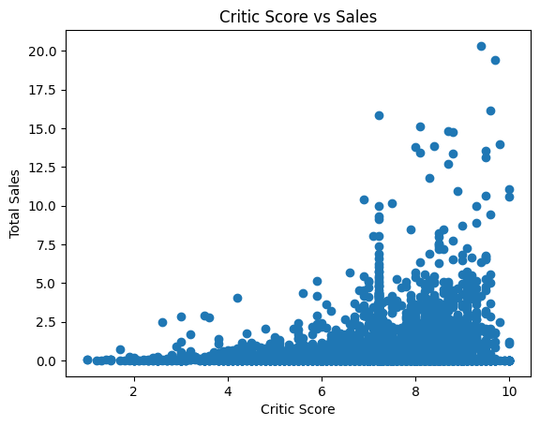
Business Insights:
- Sports games dominate the market in terms of sales
- PS2 platform has the highest market contribution
- Majority of games generate low sales (long-tail trend)
- Critic scores do not strongly influence sales performance

Recommendations:
- Focus on developing sports-based games due to high demand
- Target popular platforms like PS2-type ecosystems for better reach
- Improve marketing strategies instead of relying only on critic ratings
- Analyze low-performing games to understand failure patterns

Conclusion:
- This dashboard provides a comprehensive overview of video game sales performance by analyzing key metrics such as total sales, genre popularity, platform dominance, and critic scores. The analysis reveals that the Sports genre and PS2 platform lead in overall sales, while most games contribute to lower sales figures, indicating a long-tail distribution.

- Additionally, the lack of strong correlation between critic scores and sales suggests that external factors such as marketing, brand value, and audience reach play a significant role in a game’s success.

- Overall, this analysis demonstrates how data-driven insights can be used to understand market trends and support better decision-making in the gaming industry.

______________

