Create one repository for parameterized jenkins job

And add file in that Jenkinsfile with this name and add the below pipeline code in it

Code:

//this is first parameterized jenkins job

pipeline {

agent any

parameters {

string(name: 'maven_version', defaultValue: '3.9.6', description: 'Pass the version of Maven')

string(name: 'terraform_version', defaultValue: '1.8.5', description: 'Pass the version of Terraform')

}

stages {

stage('Download Maven') {

steps {

sh '''

cd /var/lib/jenkins

sudo wget https://archive.apache.org/dist/maven/maven-3/3.9.6/binaries/apache-maven-3.9.6-bin.tar.gz

'''

}

}

stage('Download Terraform') {

steps {

sh '''

cd /opt

sudo wget https://releases.hashicorp.com/terraform/${terraform_version}/terraform_${terraform_version}_linux_amd64.zip

'''

}

}

}

}

Make sure your gihub webhook is active as per jenkins global IP

Start the jenkins from ec2 instance

Take the ip and go jenkins global

Create new item add the name as below and select pipeline

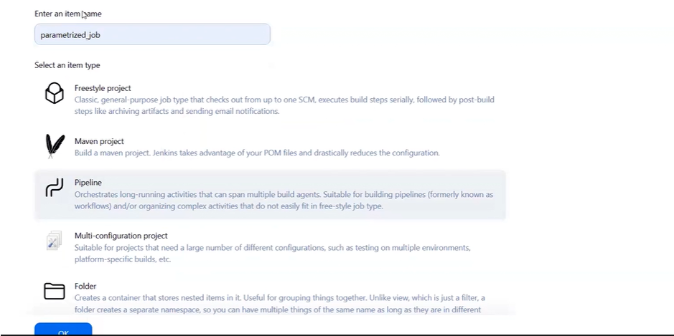

After this add description

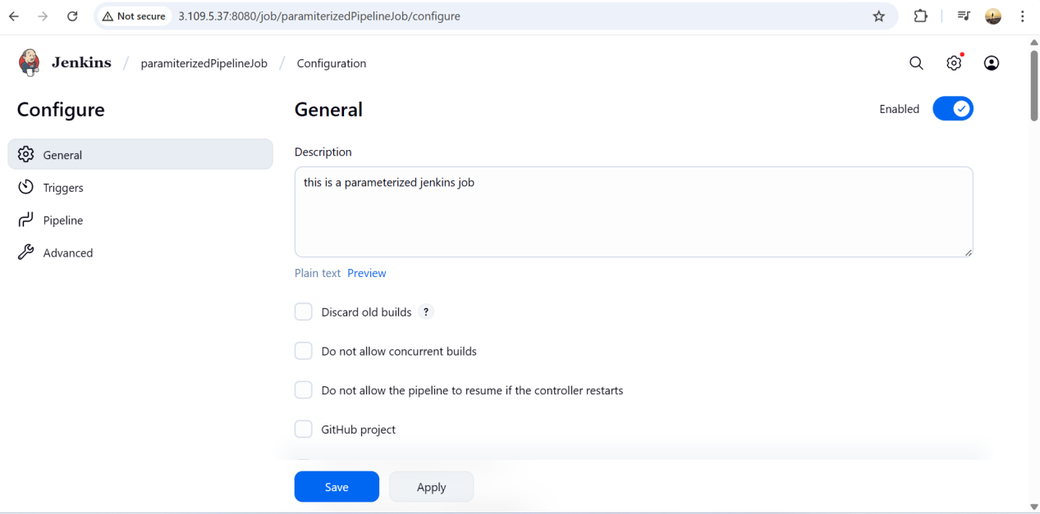

Select the Checkbox This project is parameterized

And add string parameter as given below and this should also mention in jenkins pipeline you will see ahead in screen shot 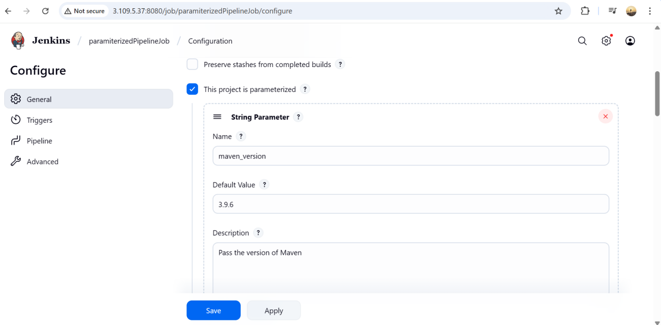

2nd parameter

Below you can see and add to download on instance

Explanation to understand

when github hit any commit then from that repository Jenkinsfile will auto execute the pipeline

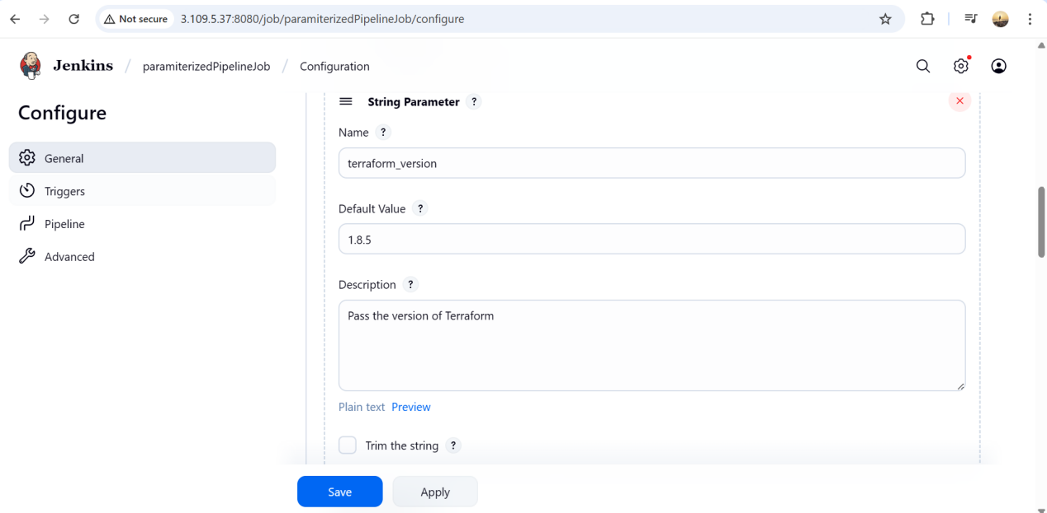

Select this checkbox as well

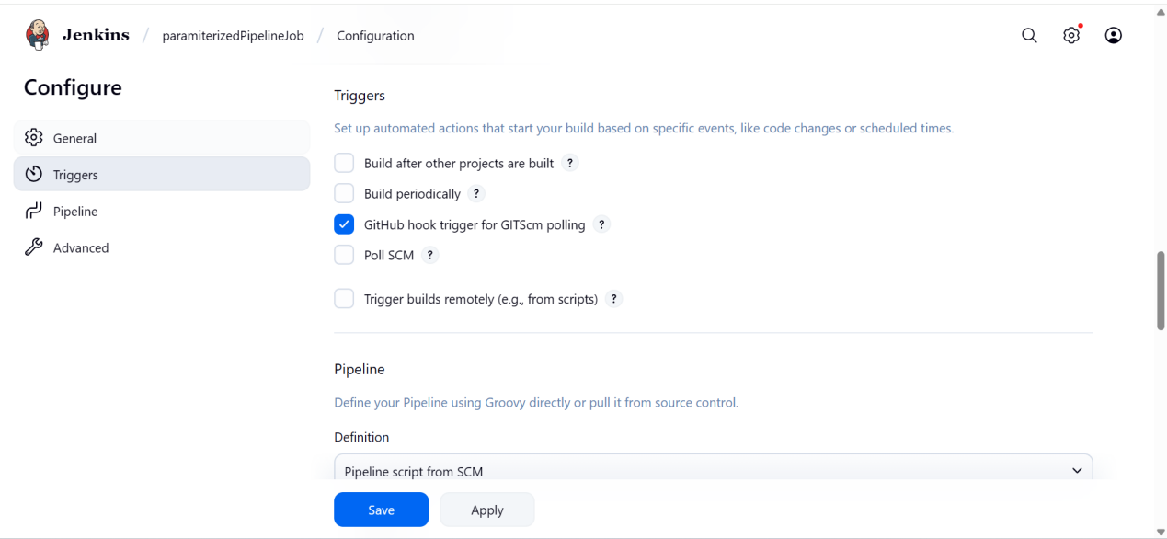

Select pipeline definition and as well mention thing from which repo you have to run the Jenkinsfile

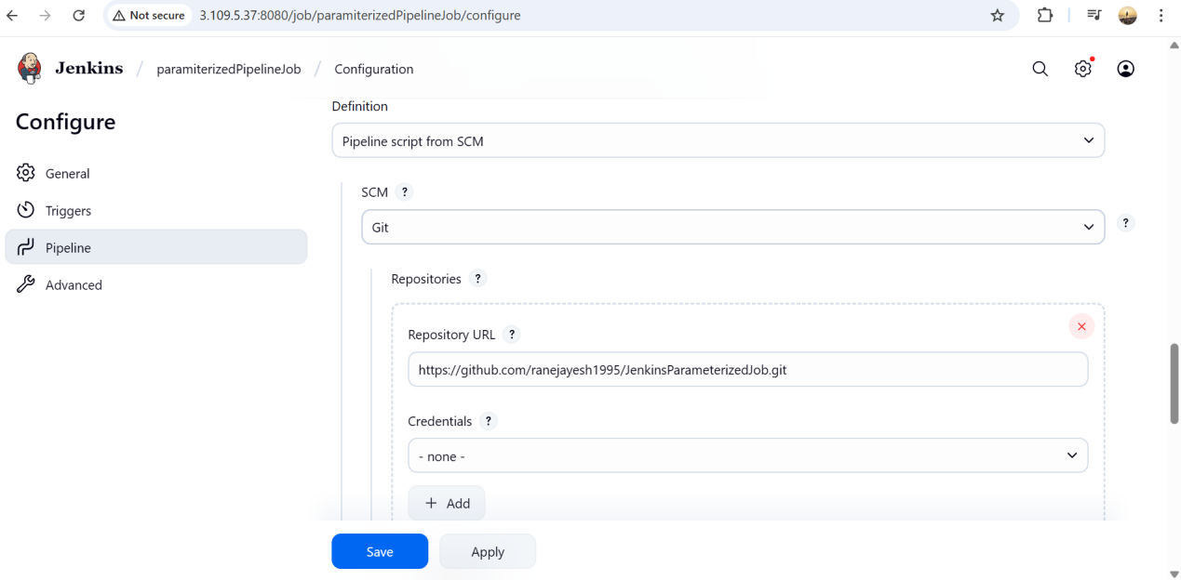

Which branch mention that also

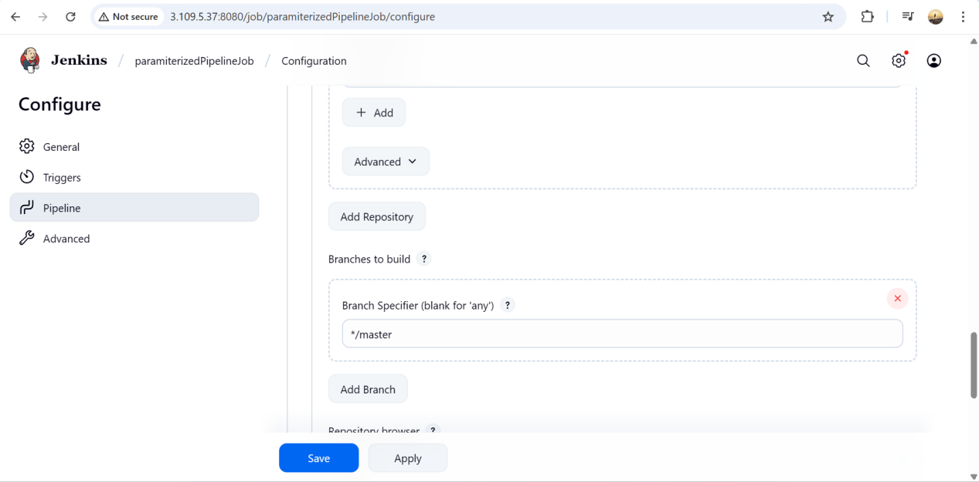

After selecting lightweight checkout save it

