Results of OCR conversion

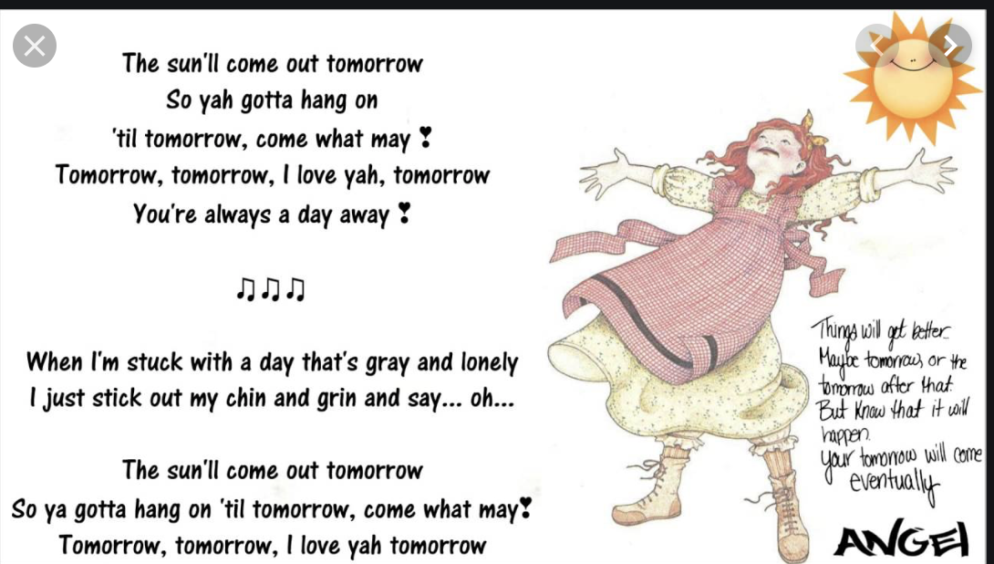

The sun'll come out tomorrow  
So yah gotta hang on  
‘til tomorrow, come what may %  
Tomorrow, tomorrow, | love yah, tomorrow  
You're always a day away %  
  
   
  
444)  
  
   
  
wil off beer  
ope,  
>) bron ofler that  
ene tll  
  
cote  
Poms  
  
When I'm stuck with a day that's gray and lonely  
| just stick out my chin and grin and say... oh...  
  
The sun'll come out tomorrow  
So ya gotta hang on ‘til tomorrow, come what may?  
Tomorrow, tomorrow, | love yah tomorrow