Design & Creative Thinking for Innovative Teaching – Leveraging AI in Teaching & Learning
TEAM # 2
Problem Context:
The school management mandated timely syllabus completion with expectations of high academic results. Despite completing the syllabus within deadlines, the class exhibited poor performance. This highlighted a critical gap between syllabus coverage and actual learning outcomes.

Part A: Teaching–Learning WITHOUT Design Thinking
Approach:
- Fixed yearly and weekly lesson plans
- Lecture-dominated classroom
- Uniform pace for all learners
- Summative, memory-based assessments

Improvements Possible WITHOUT Design Thinking
- Faster syllabus coverage
- Administrative compliance
- Short-term exam preparedness

Limitations & Impact on Learning
- Learning restricted mostly to Bloom’s lower levels (Remember, Understand)
- Minimal focus on Apply, Analyze, Evaluate, Create
- Ignores learner diversity (violates NEP 2020 learner-centric vision)
- No personalization or competency-based progression
- AI tools underutilized or used only for content delivery
- Results remain inconsistent despite effort

Part B: Teaching–Learning WITH Design Thinking
Design Thinking Goal:
Understand the Problem Space → Explore the Solution Space
Phases Applied:
Scope → Empathize → Define → Ideate → Prototype → Test → Implement

Empathy & Stakeholder Alignment (SIP)
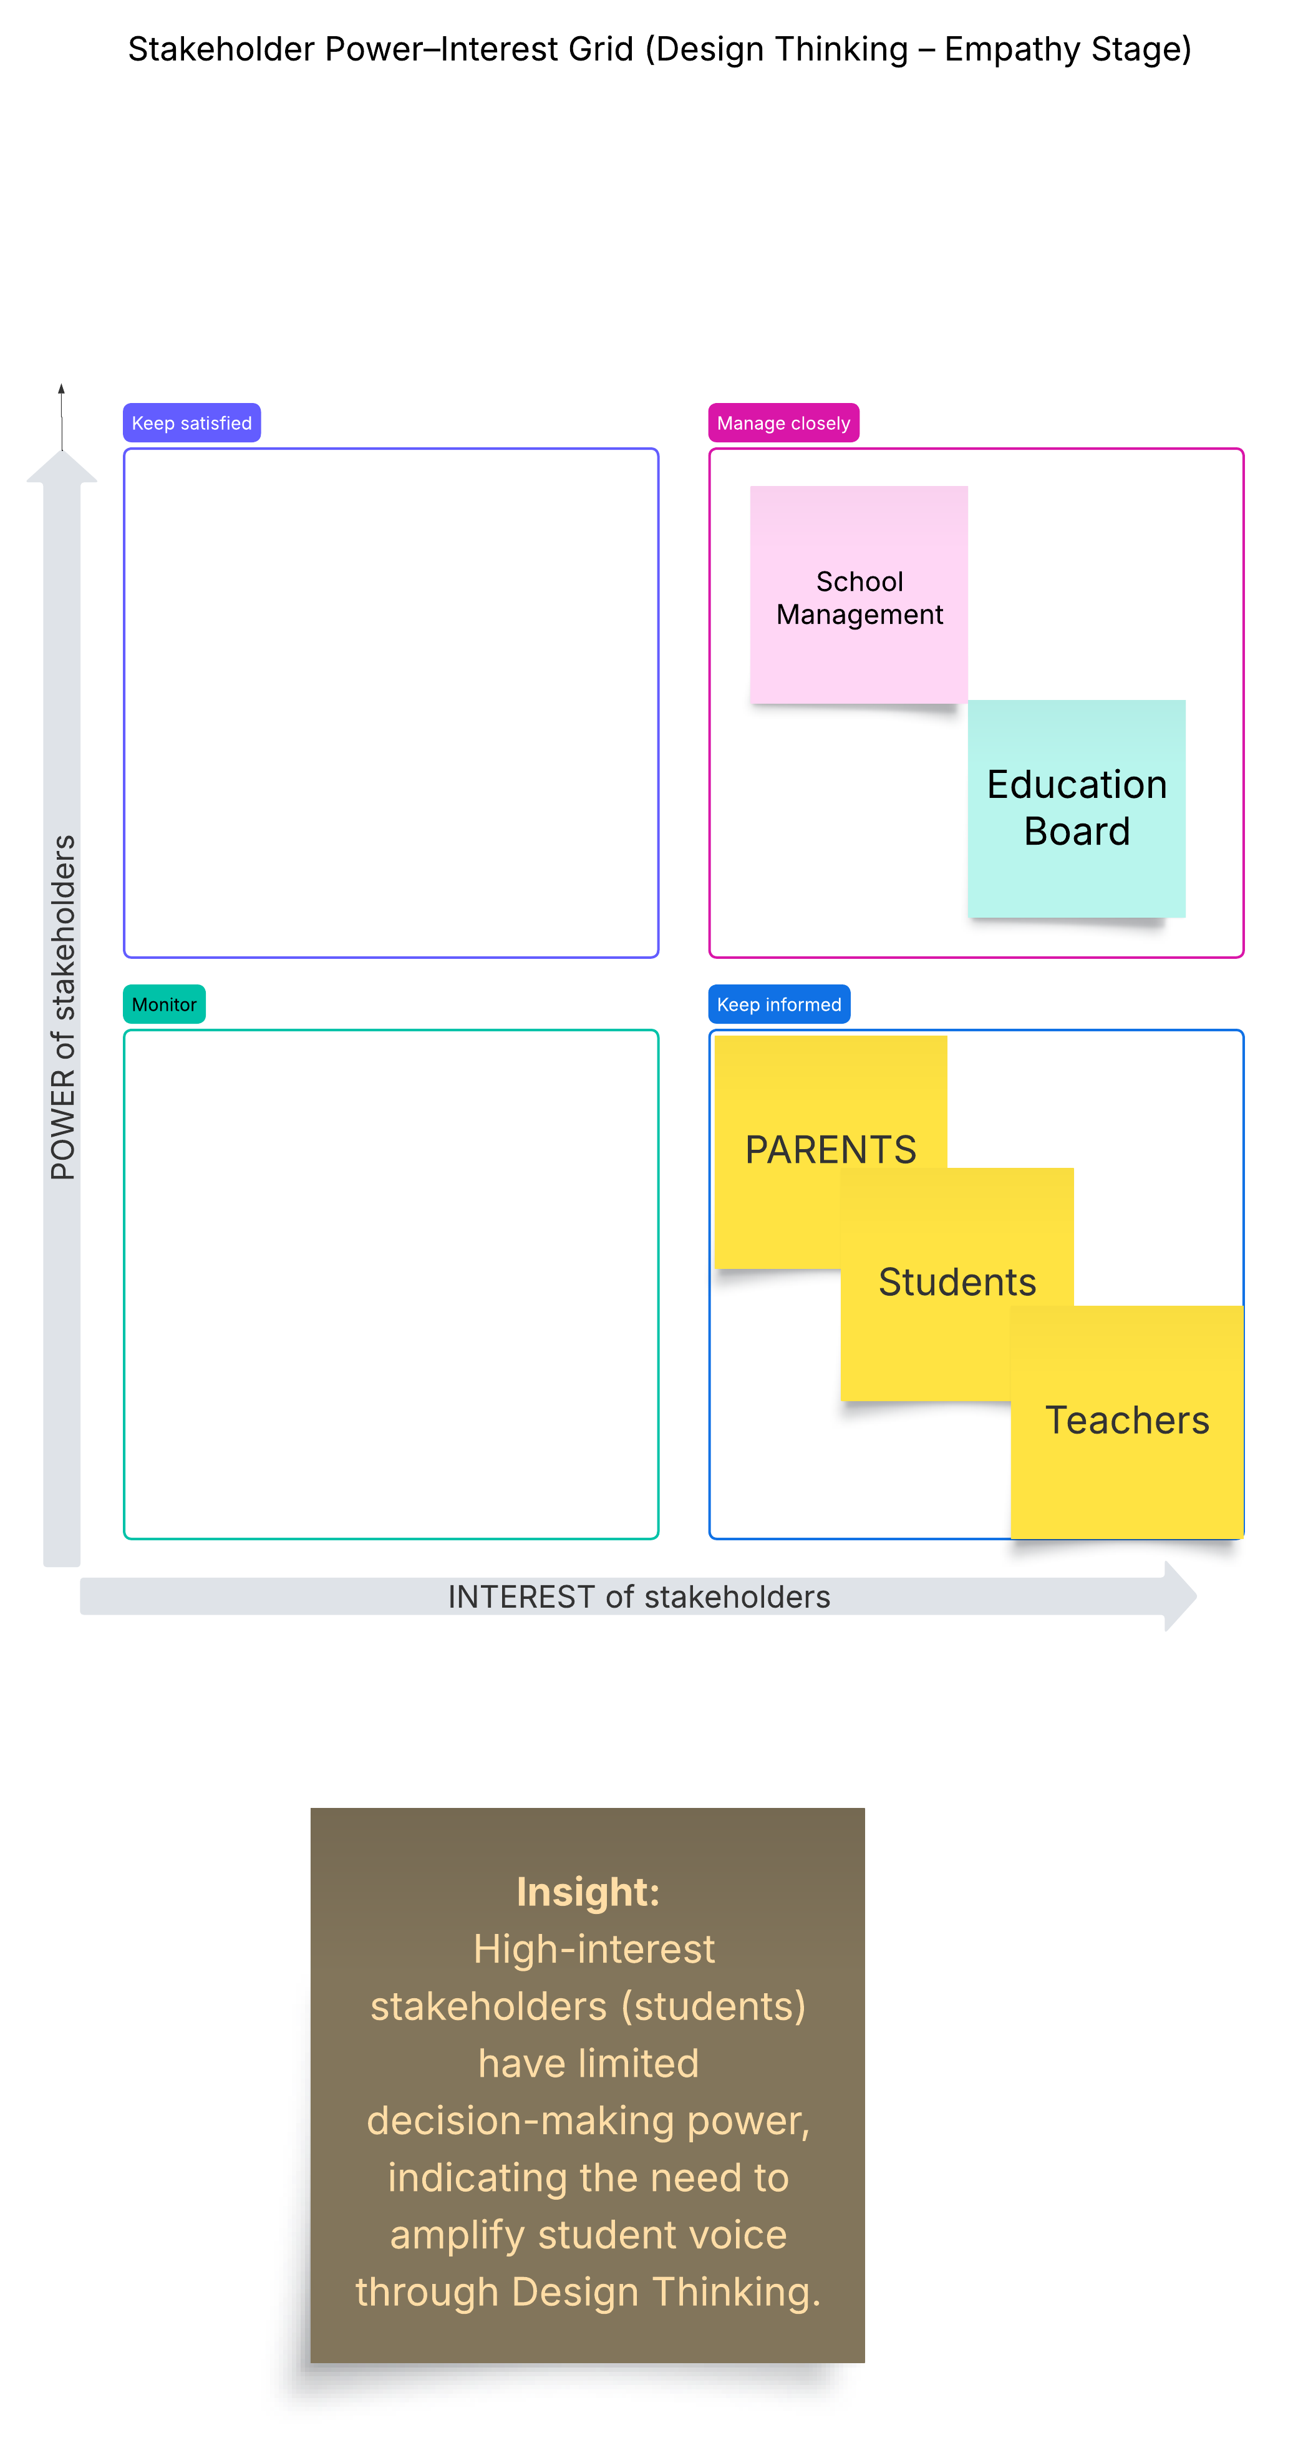
- Primary Stakeholder: Students (learning needs, stress, motivation)
- Secondary Stakeholders: Parents, Teachers
- High Power Stakeholders: Management, Education Board
Insight: High-interest stakeholders (students) needed greater voice in planning.

Improvements WITH Design Thinking
1. Alignment with NEP 2020:
- Shift from rote learning to competency-based education
- Learner-centric and flexible pedagogy
- Continuous formative assessment
- Focus on critical thinking, creativity, and well-being
2. Alignment with Bloom’s Taxonomy:
- Remember & Understand: AI-powered micro-content
- Apply & Analyze: Case studies, simulations, problem-based tasks
- Evaluate: Peer assessment, reflective questioning
- Create: Projects, presentations, AI-supported content creation
3. Use of AI Tools:
- AI lesson planners for outcome-based teaching
- Adaptive quizzes to identify learning gaps
- AI analytics for tracking progress
- Chatbots and tutors for personalized support

Prototype & Validation
- Concept-wise micro lesson plans
- AI-based formative assessments
- Student feedback and reflection journals
- Comparison of pre-test and post-test performance

Observed Improvements (With Design Thinking)
- Improved conceptual clarity and retention
- Enhanced student engagement and confidence
- Movement towards higher-order thinking skills
- Reduced stress and better classroom inclusivity
- Improved academic performance without compromising syllabus timelines

Comparative Summary: With vs Without Design Thinking

Aspect | Without Design Thinking | With Design Thinking
Focus | Syllabus completion | Learning outcomes & competencies
Bloom’s Levels | Lower levels | All levels incl. Create
NEP 2020 Alignment | Low | High
Role of AI | Content delivery | Personalization & analytics
Student Engagement | Low to moderate | High
Performance Outcome | Inconsistent | Improved & sustainable

Conclusion
Design Thinking transformed the teaching–learning process from a coverage-driven model to a learner-centric, outcome-oriented system. When integrated with NEP 2020 principles, Bloom’s Taxonomy, and AI tools, it ensured both syllabus completion and meaningful learning, leading to sustainable academic improvement.

*****************

