Notes

git: cannot open git-receive-pack

If your git configured with SSL cert or it is outdated, We are getting such an error.

Solution:

From terminal - > git config http.sslVerify false

If you are using eclipse, then

1. open preferences via application menu Window => Preferences (or on OSX Eclipse => Settings).
2. Navigate to Team => Git => Configuration
3. click Add entry..., then put **http.sslVerify** in the key box and **false** in the value box.

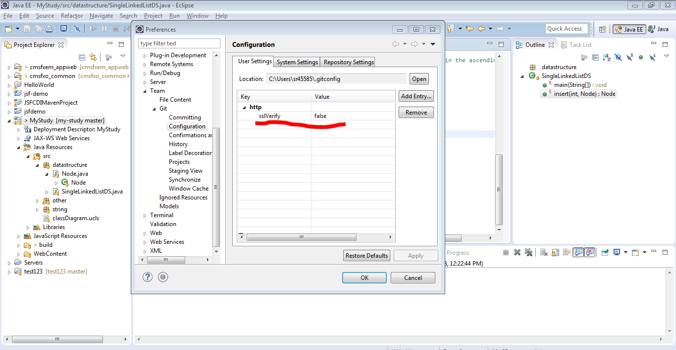

Its done!!!