HW Assignments:

1. **Add color to heading tag without external css**
2. **Change background color of web page without external css**
3. **Change background color of web page with external css and Add color to heading tag with css**
4. **Change the color of all <p> elements to "red",<h1> elements to green,<h3> elements to blue using id selector, Type Selectors , child selectors**
5. **Center align the <h1> element**
6. **With the outline property: Set the outline for p to "red", "dotted" and "10px".**
7. **Set the padding in <th> elements to "15px".**
8. **Set the background color of <th> elements to "lightblue".**
9. **Set the border of the div to "25px solid navy".**
10. **Set the width of the div to "300px".**
11. **Change the color of all <p> elements, that are descendants of <div> elements, to "red".**
12. **Padding and element width (with box sizing) refer below image**

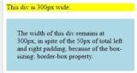

1. **Make Round Corner to div tag and div containing Text**

hint: use border-radius shorthand property

14. **Make Round Corner on the bottom left side div tag and div containing Text**

**hint: use border-bottom-left-radius**

15. **Apply Image to body using external css**

hint: background-image

**16. Apply Box model to Div tag refer below image**

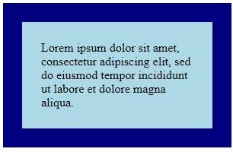

17 **Set the any .gif image as the list item marker for the unordered list.**

**18 Add a horizontal scrollbar to <div>.**

19 **Style text in <h3> to uppercase letters, and text in <h1> to capitalized letters.**