HW Assignments:

1. **Design Sign in page & apply external css. Apply attractive color, font to the page, also use div tag for combination of label & text input**
2. **Continue with sign in page design in above question add tooltip to password field to show the message "Password must be 8 characters long"**
3. **Remove the transparency/opacity of the image using external css when the user hovers over it with the mouse pointer refer below image**

** **

**Before hover After Hover**

**4. On hover over image its corner must be rounded refer image**

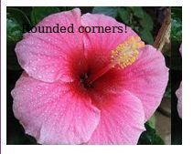 

Before Hover After Hover

**5. Animate Rectangle box contain Text clock wise direction & anticlockwise direction.**

6. **Animate circle in clock wise direction & anticlockwise direction, continuously animation required**

**7 Static Text display in multiple Columns like News paper with appropriate alignment and gap between the column**

8 Animate Rectangle box (minimum 4) at different speeds horizontally from left to right

hint: use animation-timing-function

9 **Apply styling to image tag to show image in round circle**

**10 Center the image without using centre tag use css style**11 **Flip the Image on mouse hover**

hint: use transform property in css

12 Design A web Page as below.

