**MIDLANDS STATE UNIVERSITY**



FACULTY SCIENCE AND TECHNOLOGY

DEPARTMENT COMPUTER SCIENCE AND INFORMATION SYSTEMS

NAME MUKANHAIRI RANGANAI

REGISTRATION NUMBER R1813135C

MODULE CODE HCSCI 223

MODULE NAME MINI PROJECT

YEAR 2020

LEVEL 2.2

PROJECT TITLE ATTENDANCE SYSTEM USING FACE RECOGNITION

**ABSTRACT**

Automatic face recognition technologies have made many improvements in this era. Students Attendance using Face Recognition is a real-world solution which comes with day to day activities of handling student attendance system. Face recognition-based attendance system is a process of recognizing the students face for taking attendance by checking for their face and marking their attendance automatically. In my face recognition project, a computer system will be able to find and recognize human faces fast and precisely in videos that are being captured through a surveillance camera. Numerous algorithms and techniques have been developed for improving the performance of face recognition but the concept to be implemented here is HaarCascade methods. It helps in conversion of the frames of the video into images so that the face of the student can be easily recognized for their attendance so that the attendance database can be easily reflected automatically

**DEDICATION**

This project is dedicated to the men and women who aspire to change the world with the power of programming.

**ACKNOWLEDGEMENTS**

Entirely the work prepared in this theory cannot be credited to any precise individual, consequently I would like to offer a vote of thanks to all the writers cited and not, since citing all of them exclusively would be unbearable meanwhile several of the ideas have backed to the final document. Not forgetting the resounding efforts of my supervisor, he is on the top of my acknowledgements, as he made it possible to reach this stage. Also I give credit to my close friends who encouraged me to through each and every process.

**Declaration**

I **RANGANAI MUKANHAIRI,** Registration Number R1813135C state that I am the sole author of this dissertation STUDENT ATTENDANCE USING FACE RECOGNITION will therefore allow only other scholars and Educational institutions to merely use this for study purpose alone, or else any broadcast in automated means or otherwise is reflected illegal

Contents

**Declaration** 5

**CHAPTER 1: INTRODUCTION** 7

**1.1 INTRODUCTION** 7

**BACKGROUND OF THE STUDY** 8

**1.3 PROBLEM STATEMENT** 9

**1.4 AIM** 9

**1.5 OBJECTIVES** 9

**1.6 METHODS AND INSTRUMENTS** 9

**1.7 LIMITATIONS** 9

**1.9 JUSTIFICATION** 9

**1.10 CONCLUSION** 9

**CHAPTER 2: PLANNING PHASE** 10

**2.1 INTRODUCTION** 10

**2.2 BUSINESS VALUE** 10

• Automated and Accurate – the system accurately reports all the aspects of attendance and absence. 10

**2.3 FEASIBILITY STUDY** 10

**2.3.1TECHNICAL FEASIBILITY** 10

**2.3.2 ECONOMIC FEASIBILITY** 11

**2.3.3 OPERATIONAL FEASIBILITY** 11

**2.4 WORK PLAN** 13

**2.5 CONCLUSION** 13

**CHAPTER 3: ANALYSIS PHASE** 14

**3.1 INTRODUCTION** 14

**3.2 INFORMATION GATHERING** 14

**3.2.1 INTERVIEWS** 14

***Conclusion from interviews held:*** 15

**3.2.2QUESTIONNAIRES** 15

Findings from Questionnaires 16

**3.2.3OBSERVATION** 16

**3.3 WEAKNESSES OF THE CURRENT SYSTEM** 17

**3.4 RATIONALE OF THE PROPOSED SYSTEM** 17

**3.5 EVALUATE ALTERNATIVES** 19

**3.5.1 OUTSOURCE** 19

**3.6 REQUIREMENTS ANALYSIS** 20

**3.6.1 FUNCTIONAL REQUIREMENTS** 21

**3.6.2 NON-FUNCTIONAL REQUIREMENTS** 24

**3.7 CONCLUSION** 25

**CHAPTER 4: DESIGN PHASE** 25

**4.1 INTRODUCTION** 25

**4.2 SYSTEM DESIGN** 25

28

**4.3 ARCHITECTURAL DESIGN** 28

**4.4 PHYSICAL DESIGN** 30

**4.5 DATABASE DESIGN** 30

**4.6 PROGRAM DESIGN** 33

**4.7 INTERFACE DESIGN** 39

**4.8 PSEUDO CODE** 46

**4.9 SECURITY DESIGN** 47

**4.10 CONCLUSION** 47

**CHAPTER 5: IMPLEMENTATION PHASE** 48

**5.1 INTRODUCTION** 48

**5.2 IMPLEMENTATION & CODING** 48

**CODE SNIPPETS** 49

**5.3 TESTING** 52

**5.5 MAINTENANCE** 54

**5.7 CONCLUSION** 56

REFERENCE 57

# **CHAPTER 1: INTRODUCTION**

# **1.1 INTRODUCTION**

Students attendance monitoring system is an important task and if taken manually it takes a lot amount of time. There are a couple of methods on how this is done which include traditional one where students sign the attendance sheet as it is passed around or the method where students scan their student’s IDs to notify their presence. This takes time as students have to queue to scan their cards. This system uses face recognition for automatic attendance as the lecture is going without any disturbance. This system uses a camera which is placed in front of a classroom to capture the video of the classroom lecture. Firstly, the faces of students who attend the class are captured and saved in a database along with the student details. When the class start, the camera identifies all the faces in its view and compares with the faces in the database. If there is a match, that student is marked present.

# **BACKGROUND OF THE STUDY**

Institutions use a manual attendance system which involves students signing an attendance sheet.

This system is not secure and accurate. The proposed system will have user friendly GUI and will have interactive interface along with a secure management.

**EXISTING METHODS USED FOR CAPTURING ATTENDANCE**

1. **MANUAL METHOD**

This type of method is whereby the lecturer calls out a student and the student respond to confirm that they are present. With classes having students ranging from fifty and some up to a hundred students, this type of method tends to be a very long process. Not only is this time consuming, the results from this attendance capture might be biased as some students can just respond for a friend who is absent since the lecturer is high likely not able to know every student in his class [1].

1. **FORM METHOD**

In this method, a form with all student’s name for the particular class is printed. During the lecture this form is passed around and the students sign off against their name to show that they have attended the lecture. The lecturer then uses this form to update his/her Excel Spreadsheet to keep the attendance sheet computerized. This type of method saves a lot of time compared to the first one because people sign the form as the lecture is going. The problem with this type of method is almost the same with first method, students can sign off on each other’s behalf. There’s no verification on the signatures so a student may be absent for a week but still recorded present.

1. **USING STUDENT CARD**

Due to the incompetence’s of the previous methods, attendance using student ID cards was introduced. Each student has a unique school identification card, they scan at the door as they enter the classroom and their attendance is recorded. This type of system produces better results than the previous two but as people scan their ID’s one by one, large queues may emerge by the door and slows the process [2].

# **1.3 PROBLEM STATEMENT**

With the average number of students in colleges and universities classes ranging from 70 to 90, a lot of time will be wasted on marking the attendance. The traditional method captures student’s attendances manually using attendance forms given by the teacher. In the other method, the teacher or lecturer would call the student name and they would verify their presence by shouting present. The problem with these two methods is that it is not accurate. Someone can sign the attendance form for an absent friend or can they yell present for an absent person.

# **1.4 AIM**

* The aim of this project is to automate the way in which class attendance by using face recognition which saves time and promote authenticity of the results.

# **1.5 OBJECTIVES**

* Individual detection of a face in a crowd
* Detection of a face among other materials and backgrounds such as walls
* Detection of a unique characteristic of a face for face recognition
* To automatically update the spreadsheet without any human intervention

# **1.6 METHODS AND INSTRUMENTS**

* Python OpenCV – Python will be used as the core language with the OpenCV library for image processing.
* Camera – for capturing images
* Microsoft Excel – for students records

# **1.7 LIMITATIONS**

* The system cannot recognize properly in places with low lighting so may give false results
* It can only detect a face from a limited distance

# **1.9 JUSTIFICATION**

An automating the attendance management system is necessary in any learning management schools. Most of the existing systems are time consuming and require a semi manual work from the teacher or students. Our approach aims to solve the issues by integrating face recognition in the process

# **1.10 CONCLUSION**

This automated attendance system is a novel system which will be implemented to solve problems of forgery, inaccuracy in the existing system. This system is developed for an institution that would like to automate the way they mark attendance. As this system is scalable this can be further developed manage and monitor people in great halls and huge functions.

# **CHAPTER 2: PLANNING PHASE**

# **2.1 INTRODUCTION**

This chapter will give insight to the reader on the business value of the proposed system which justify why the system need to be implemented, technical feasibility study of the project, economic feasibility study of the project, organizational and schedule feasibility study of the project. It also outlines the project plan, which will be necessary to enable management and monitoring of the progress of the project.

# **2.2 BUSINESS VALUE**

* Security – only authorized users can use the system and access the data
* Lecture Productivity – instead of time been wasted on attendance marking, the system just does its work without any human intervention
* Automated and Accurate – the system accurately reports all the aspects of attendance and absence.

# **2.3 FEASIBILITY STUDY**

A controlled process for identifying problems and opportunities, determining objectives, describing situations, defining successful outcomes and assessing the range of costs and benefits associated with several alternatives for solving a problem

# **2.3.1TECHNICAL FEASIBILITY**

Table 2.1 ***Hardware requirements***

|  |  |  |
| --- | --- | --- |
| **Item** | **Minimum specifications** | **Maximum specifications** |
| Memory | 2GB | 8GB |
| Hard Drive Disk | 100GB | 1TB |
| Web Camera |  |  |

#### Table 2.2: Database Server properties

|  |  |
| --- | --- |
| **Item** | **Recommended** |
| Processor | 1.2Ghz |
| Memory | 1GB |
| Hard Drive Disk | 80GB |
| Network Card | 10/100LAN |

#### Table 2.3: Client Computer Specifications

|  |  |
| --- | --- |
| **Software** | **Description** |
| Microsoft Excel | Microsoft Excel software, it has various spreadsheet application capabilities that includes having students records in rows and columns |

# **2.3.2 ECONOMIC FEASIBILITY**

* **Faster processing -** The process of recognizing a face takes a second or less and this is incredibly beneficial for the companies.
* **Seamless integration -** This is probably one of the biggest benefits for institutions. The system technology is quite easily integrated so it’s a perfect choice. It does not require spending additional money on its integration and most facial recognition solutions are compatible with the majority of the computers [3].
* **Automation of identification -** Before, lecturers had to perform manual attendance marking of students that took too much time and did not boast high accuracy. But today, facial recognition is completely independent in the identification process and not only takes seconds but is also incredibly accurate.

# **2.3.3 OPERATIONAL FEASIBILITY**

Operational feasibility is the measure of how well a proposed system solves the problems and takes advantage of the opportunity identified during the scope definition and problem analysis phases and how well it satisfies the system requirements identified in the requirements analysis phase Bentley and Whitten (2007).Castro (2002) suggested that the operational feasibility can be evaluated using The PIECES Framework which can help in identifying problems to be solved and their urgency as follows:

* Performance: Does current mode of operation provide adequate throughput and response time?
* Information: Does current mode provide end users and managers with timely, pertinent, accurate and usefully formatted information?
* Economy: Does current mode of operation provide cost-effective information services to the business? Could there be a reduction in costs and/or an increase in benefits?
* Control: Does current mode of operation offer effective controls to protect against fraud and to guarantee accuracy and security of data and information?
* Efficiency: Does current mode of operation make maximum use of available resources, including people, time and flow of forms?
* Services: Does current mode of operation provide reliable service? Is it flexible and expandable?

To determine the operational feasibility of the project, a comparison will also have to be done between the current system and proposed system. This comparison is however compared in terms of:

* Timeliness: How much time do processes take to be achieved within the system
* Speed: how fast are results produced and how fast are queries answered?

There are some risks that would be associated with the development of the system like hardware failure. Since some users within the current manual system were used to the traditional file-based system, it can be hard to convince them that the new system will still do the same things for them in an even faster, reliable and more efficient way. Some people are just resistant to change and so it can take them time to appreciate the technology being introduced.

Overall Recommendation

In relation to this willingness to use the system, the project is worth to be done. The system suits the organization since the user requirements go hand in hand with the system objectives.

The organizational polices support the development of different systems within the organization and even from outside.

# **2.4 WORK PLAN**

|  |  |  |  |  |  |  |  |  |  |
| --- | --- | --- | --- | --- | --- | --- | --- | --- | --- |
| ACTIVITY | WK  1 | WK  2 | WK  3 | WK  4 | WK  5 | WK  6 | WK  7 | WK  8 | WK  9 |
| Project proposal |  |  |  |  |  |  |  |  |  |
| Planning |  |  |  |  |  |  |  |  |  |
| Analysis |  |  |  |  |  |  |  |  |  |
| Design |  |  |  |  |  |  |  |  |  |
| Implementation |  |  |  |  |  |  |  |  |  |
| Maintenance |  |  |  |  |  |  |  |  |  |
| Documentation |  |  |  |  |  |  |  |  |  |

#### Table 2.1 Gantt chart

# **2.5 CONCLUSION**

From the analysis carried out on feasibility, it shows that it is very feasible to develop an Attendance System Using Face Recognition techniques. The resources have been assessed and matched to the goal to be achieved. The planning phase has shown us how the project is going to be worked out highlighting the time periods and the risks involved. It has also helped us look at the feasibility part of our project and help us project-check on the feasibility status of the project. After serious enquiries, we have concluded that the project is very feasible and we were given the green light to continue with the project to the next stage.

# 

# **CHAPTER 3: ANALYSIS PHASE**

# **3.1 INTRODUCTION**

In this section we look at the detailed study of the current system. The current system was studied and the respective logical descriptions of the system were analyzed. These include the dataflow diagrams and the context diagrams. The analysis phase is a crucial activity whose main objective is to understand the complexity and scope of the problems that exist with the current system, to provide a clear insight of how the current system operates, and how it is to be integrated into the proposed solution Information of the current system is provided in this phase and the information is about the users of the current system, how data is processed, type of data used in the current system [4]. The phase’s main objective is to understand or determine the importance, complexity and the scope of the problems that exist in the current system giving a go ahead to logical design of the proposed system.

# **3.2 INFORMATION GATHERING**

Arora (2007) describes fact finding as a formal process that is used by the researcher who makes use of research, meetings, interviews, questionnaires and other techniques to collect information about system problems, requirements and preferences. The facts when expressed in quantitative form are termed as data and the success of any project is depended upon the accuracy of available data. A number of strategies were put in place with the main aim of finding out:

* More about the system that is currently in place.
* Problems with the current system.
* The process, activities and procedures involved in the current system.
* More about what the new system should be able to do.
* Requirements and limitations present.
* The expectations of the new system from various stakeholders.

The information gathering techniques used include:

1. Interviews
2. Observations
3. Questioners

# **3.2.1 INTERVIEWS**

Bentley and Whitten (2007) define interviews as “a fact-finding technique whereby the systems analyst collects information from individuals through face to face interaction”. As Kvale (2010) elaborate, he says interviews are a way to get in-depth and comprehensive information by asking face to face questions. There are different set of questions that may be asked in an interview, which are those that are already prepared and those that just came in depending with the way the respondent has answered the questions.

Advantages of interviews

* Interviews allow direct communication with the people who manage and operate and work with engines.
* Interviews gave direct communication between interviewee and interviewer hence the interviewer clarified where the interviewee did not understand.
* The interviewee’s responses to questions were immediate and interviews ensured that the interviewee answered all the questions.
* The interviewer took note of the non-verbal response of interviewee.
* Interviews were more personal and familiar than the other information gathering methodologies.
* The interviews were private and confidential hence there was no fear of victimization.
* Interviews provided the ability to ask further questions as a follow up to an answer given unlike with questionnaires.
* Body language could be read and translated

Disadvantages of interviews

* It can be very costly due to time intensive nature.
* Intercept interviews can be subject to bias if not carefully recruited.

### ***Conclusion from interviews held:***

I approached the lecturers at Midlands State University as they are the main users of the system, they seemed delighted with the idea behind the proposed system. They reviewed that the current system of attendance was a bit out of date and handling with data manually is prone to errors. The proposed system shades light on some problems that they were facing with the system.

# **3.2.2QUESTIONNAIRES**

A questionnaire is a set of printed questions, usually with a choice of answers, devised for a survey or statistical study again according to the (Concise Oxford Dictionary2001). The questionnaire has high integrity because the researcher cannot influence the subject hence there is no bias***.***

**Closed-ended**

Closed-ended questionnaires with questions for which a researcher provides a suitable list of responses (for example **Yes / No**). These produce mainly quantitative data.

**Open-ended**

Open-ended questionnaires with questions where the researcher does not provide the respondent with a set answer from which to choose. Rather, the respondent is asked to answer in their own words. These produce mainly qualitative data.

**Advantages of questionnaires**

* Respondents have time to consider their responses before writing them down on the questionnaire.
* Data can be gathered quickly and cheaply in large quantities
* Researchers can gather information in a short period of time.
* Questionnaires are free from bias when it comes to interviews.
* we can get fair probability in terms of statistically.

**Disadvantages of questionnaires**

Besides the advantages of the questionnaires, we also have the drawbacks which include

* There is lack of personal communication between the researcher and the respondent which results in variations in interpretations of questions. This compromises the validity of the information given by the respondents.
* Some respondents refuse to cooperate and do not answer the questionnaires as they are not motivated enough.
* The questionnaire limits questions to those on questionnaire only therefore, the respondent cannot express other views in full or explain further.

### Findings from Questionnaires

From the questionnaires provided the responses indicated that the stakeholders felt that the current’s system processes were very slow and results were sometimes inaccurate and hence needed improvements.

# **3.2.3OBSERVATION**

Observation involves a direct interaction and observing how people work in the existing system and how the existing system itself works as defined by Kumar (2008).Kvale (2010) also said observation sessions as a data collection method involves looking and listening very carefully in order to gather detailed information about a situation or event. Questionnaires were distributed around the whole organization at MSUto gather information on how different stakeholders feel with the existing system. These are a research technique consisting of a series of questions and other prompts to serve the purpose of gathering information from respondents. They can be used to collect both qualitative and quantitative data and are often designed for statistical analysis of the responses.

**Advantages of Observations**

* The researcher experienced first-hand situations both at the plant and outside hence this gave him a better insight of how the engine is serviced.
* Most information gathering techniques allowed one individual to be queried at a time, but observations enabled one to study large groups of people at the same time.
* It used basic equipment hence the researcher had an understanding of the processes, functions and operations on how the things take place on both ends without any bias.
* It was non- interfering and therefore did not disrupt the work of those being observed
* Better chance of retaining naturalness during the handling of their work.

**Disadvantages of Observations**

* Tendency of behavioral change in the performance of workers when they note that they are being observed.
* Demanding in terms of commitment in order not to miss anything.
* Incorrect data recorded since some of the work may be done in areas that the observer failed to see.
* Observations did not increase the observer’s insight on how the service or maintenance is properly done.
* Not all activities were easily observed hence it was difficult to gather facts.
* Some workers under observation changed their normal attitude as they realized that they were under observation.

# **3.3 WEAKNESSES OF THE CURRENT SYSTEM**

1. The system is manual, hence there is great risk of errors
2. It is difficult to search for particular data from the system
3. There is a chance of forgery i.e. one person signing the presence of another student
4. There is a need for man power i.e. someone has to take the attendance
5. It is difficult to maintain the database or register in a manual system
6. It is difficult to search for particular data from the system
7. The attendance process takes time

\

# **3.4 RATIONALE OF THE PROPOSED SYSTEM**

The application program is developed with Python programming language using:

1. OpenCV library for image processing
2. OPENPYXL library to integrate the application with the Excel Spreadsheet
3. Tkinter library which provides a user interface for the Attendance Management System.

The advantages of Python programming language are its robustness, easy to program, has an excellent database connectivity, runs on the two most common operating system platforms (Windows and Unix) and it has a larger user community that provides online support

The proposed system has been implemented with the help of three basic steps:

1. Detect and extract face image and save information in a xml file to train the program
2. Learn and train the face image
3. Recognize and match face images with existing face images information stored in the xml file (training database) during the mark attendance process.

**Student face images detection and extraction**

Images of students are uploaded into the program, three of four for each student to train the system to recognize. The frontal face of a person in the image is extracted by an OpenCV function which uses HaarCascade method as a classifier. This method is used to detect objects in an image, which in this case is the face. We take individuals different frontal postures so that the accuracy can be attained to the maximum extent. After a frontal face has been detected, it is converted into a grayscale image of 50x50 pixels.

**Learn and train face images**

In this step, a function is called which performs Principal Component Analysis (PCA) which is a technique in finding patterns on the face. The frontal faces detected in the first step will be the training data. This is the training database in which every student has been classified based on labels. For the captured image in the previous step we detect only frontal faces from viola-jones algorithm which detects only faces and removes every other part as the priority feature is the face. Using OpenCV library, the training data will be processed and student will be associated with his/her images and the training information is saved

**Recognize and match face images**

When the mark attendance program is executed, a new column is appended in the excel spreadsheet with a date at the top. Execution starts and if they are faces in the video frame, they are detected and they are compared with the ones in the training database. If there is a match, the corresponding student is marked present in the newly created column against their name

# **3.5 EVALUATE ALTERNATIVES**

Different system alternatives were considered and weighed for developing an automated attendance system and costing System. The alternatives with minimum cost were chosen. The alternate solution should be economically and technically feasible. The alternatives are outlined below:

1. Attendance Using Biometrics
2. Attendance System using Student IDs

# **3.5.1 OUTSOURCE**

This is the strategic use of outside resources to perform activities traditionally handled by internal staff and resources.

**Advantages**

* The process of changing the current system would take a shorter time to implement.
* Requires less technical staff.
* There is low development cost
* It facilitates the development of information systems and computer applications by bridging the communications gap that exists between non-technical system owners, users, and the system analyst and designers.
* It is documented.

**Disadvantages of Outsourcing**

* Uncertainty about information confidentiality which is a major concern
* Lack of customer focus as the outsourced vendor may be catering to the expertise-needs of multiple organizations at a time thus the vendors may lack complete focus on the organization’s tasks
* If the terms are a fixed contact the vendors may be inflexible to changes in the middle of development.
* The organization will be at the mercy of the vendor for future upgrades
* Lack of proximity to staff.
* High maintenance results in more costs being incurred thereby defying the purpose avoiding unnecessary costs by applying an efficient and reliable system to our problems
* High maintenance costs

**3.5.2 IMPROVEMENT**

Improvement would not make a really noticeable change as the continual use of paperwork still mean the results will take time to come out if data is needed.

**Why not improve the current system**

* Most problems faced would still remain unsolved by the improved manual system.
* The system can continue to function unreliably and inefficiently.
* Student would likely still forge signatures for others
* New technological features cannot be incorporated into the current manual system.
* Problem Inheritance **–** existing problems might creep into the system unnoticed and might cause undesired results later on.

**3.5.3 DEVELOPMENT**

Lewis (2006) identified in-house software development as a software package developed to handle information requirements for a specific type of business. This proved to be the best option since the company has a fully functional IT department packed with the developer, programmers, analysts and system testers.

**WHY DEVELOP**

By adopting this approach to develop the computerized system, the following merits will be realized:

* Attendance will be marked automatically without human intevention
* Optimum configuration is possible and is limited to what is needed
* Solves unique user requirements and can be tailor made to function in a way all users can understand.
* It also offers more effective user training.
* System Ownership: - system users assume complete ownership of the system as system specifications are based on user requirements during system development.
* Employee development: - although in house development is challenging the organisation will continue to build its employee skill base through in house development and training of staff.
* Technical Expertise: - system will be developed in python programming language. There is expected extensive support from other IT staff members who are also knowledgeable in that area.

# **3.6 REQUIREMENTS ANALYSIS**

Currently in schools the attendance system is totally manual where faculty has to take attendance on register or page. This activity takes lot of time and efforts and still is not reliable. Registers and pages can be lost and multiple copies is very hard to keep. But another question that arises is the security of such system, how will the system enter only authorized attendance [5].The system will provide an optimized and secured platform that can help users to easily mark attendance of students, keep user’s data, record of their attendance, courses they are taking and option to print these records.

# **3.6.1 FUNCTIONAL REQUIREMENTS**

* System must be used by authorized users
* System must be attached to webcam and face recognition should be smooth
* The administrator or the person who will be given the access to the system must login into system before using it
* User must be able to see details of attendance of students for a specified date
* User must be able to view the excel spreadsheet

**USE CASE DIAGRAMS**

Use case illustrates a unit of functionality provided by the system. The main purpose of the use-case diagram is to help development teams visualize the functional requirements of a system, including the relationship of "actors" (human beings who will interact with the system) to essential processes, as well as the relationships among different use cases

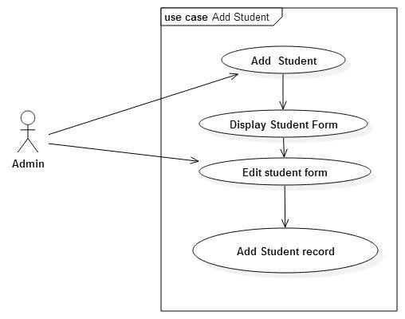

**Fig 3.1 Add Student Use Case**

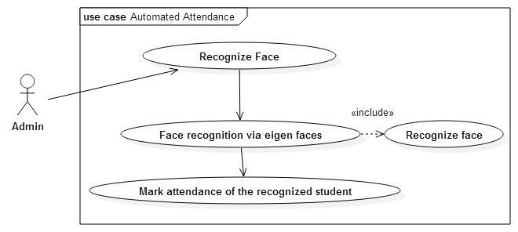

**Fig 3.2 Automated Attendance Use Case**

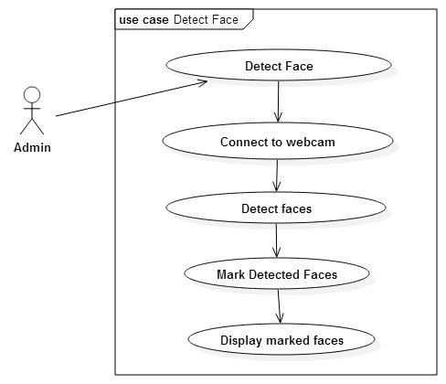

**Fig 3.3 Detect Face Use Case**

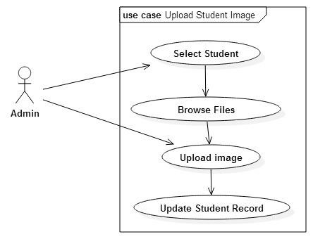

**Fig 3.3 Upload Student Image Use Case**

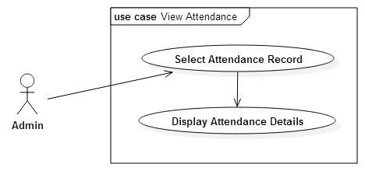

**Fig 3.4 View Attendance Use Case**

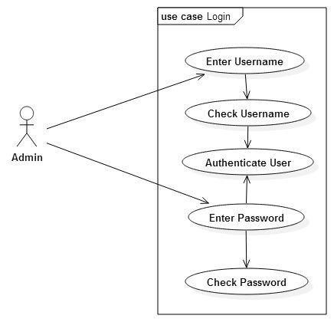

**Fig 3.5 Login Use Case**

|  |  |
| --- | --- |
| **Symbol** | **Description** |
|  | Actor |
|  | Use case |

**Table 3.1 Key for use case diagram**

# **3.6.2 NON-FUNCTIONAL REQUIREMENTS**

* The user interface has to be user friendly
* The system will be extensible for changes and to the latest technologies.
* Data will be available when it is needed and showed to users
* Data to be deleted will be confirmed first
* The system will not allow multiple logins at a time

# **3.7 CONCLUSION**

After evaluating all the possible alternatives, it has been considered appropriate to implement the development of the as a result all the functional and non-functional requirements have been identified. The functional and non-functional requirements discussed will be used to come up with a design of the system.

# **CHAPTER 4: DESIGN PHASE**

# **4.1 INTRODUCTION**

At this phase, the system is designed to satisfy the requirements identified in the previous phase. The requirements identified in the Requirements Analysis Phase are transformed into a System Design Document that accurately describes the design of the system and that can be used as an input to system development in the next phase.

# **4.2 SYSTEM DESIGN**

This is the process of defining the architecture, components, modules, interfaces and data for the system to satisfy specified requirements. One could see it as the application of systems theory to product development.

The following are components on which the design is going to evolve around:

**Efficiency**: It should also enable the user to send his or query and also get a feedback in time

**Security**: only authorized users should be allowed to use the system

**Reliability**: Most computer systems are susceptible to failure. In an environment where there are constant power outages and load shedding, the system should be able to maintain a certain level of reliability.

**User friendliness**: System should have uniform interfaces and shouldn’t be difficult to navigate.

**Maintainability**: it should be easy to maintain and update in line with technological changes in the environment or changes in the business need.

**Functions of the proposed system**

This section identifies the inputs, processes and outputs of the system to help clarify how the new system is going to work.

**Inputs**

* Video Footage

**Processes**

* Detect each frontal face in the video
* Compare each face with the ones in the training database
* Update attendance for every recognized student

**Outputs**

* Updated attendance sheet

**Context Diagram**

**Fig 4.1 DFD of the proposed System**

# 

# **4.3 ARCHITECTURAL DESIGN**

Software architecture has been identified as a main tool for high quality system development. Software architecture provides the basis for the reuse in a software product line. Unfortunately, the potential benefits of a well-designed software architecture can be lost if the software architecture is not followed in the design of the products. We suggest that a software architecture help desk could play an important role in enabling the dissemination of software architecture and in improving the communication between designers and architects.

Database of faces

Image Capture

Pre-processing

Image Capture

Pre-processing

Face Recognition

Image Capture

Feature

Extraction

Face Extraction

Classification

Attendance Marked

Fig 4.2 **Software Design Diagram**

# **4.4 PHYSICAL DESIGN**

physical design is the translation of business user requirements into a system model that depicts a technical implementation of the users’ business requirements. According to (Wixon2008) the physical design section outlines how the physical or hardware devices of the proposed system are going to be arranged or laid out and how they are going to be communicating. The most important aspect is that of the interaction between the hardware and the software under development. All the user machines will be connected to the client and database servers for storage of clients’ files.

**Fig 4.3 Physical Design**

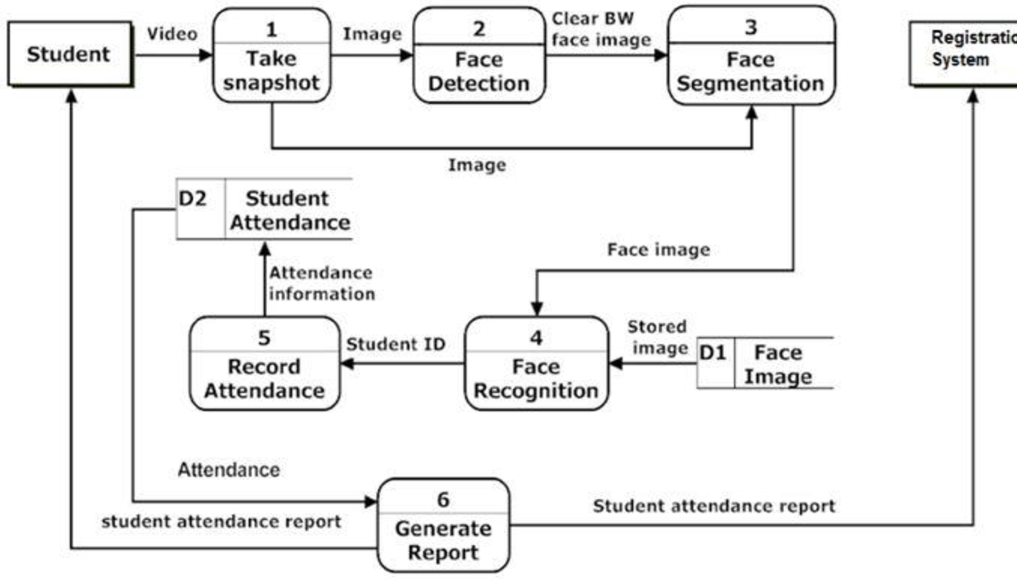

# **4.5 DATABASE DESIGN**

**Fig 4.2 Database Design**



**ERD DIAGRAM**

An entity-relationship diagram is a data modeling technique that creates a graphical representation of the entities, and the relationships between entities, within an information system.

**Fig 4.3 Student DBMS**

Attendance

Training Faces DBMS

Student

**Fig 4.4 Training Face DBMS**

Student DBMS

Images

Student

**Fig 4.5 RELATIONAL DIAGRAM**

*

Training Data

Student Name

Student Id No

Student Name

Image ID

1

Attendance

Student

* 1

Student Name

Status

Key

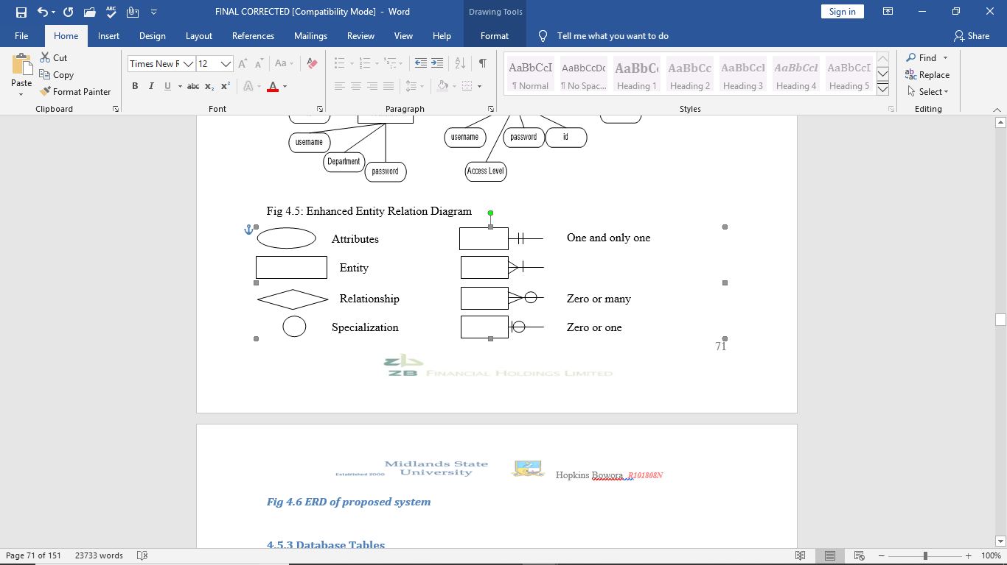

# **4.6 PROGRAM DESIGN**

Sequence diagrams show a detailed flow for a specific use case or even just part of a specific use case. They are almost self-explanatory; they show the calls between the different objects in their sequence and can show, at a detailed level, different calls to different objects. A sequence diagram has two dimensions: The vertical dimension shows the sequence of messages/calls in the time order that they occur; the horizontal dimension shows the object instances to which the messages are sent.

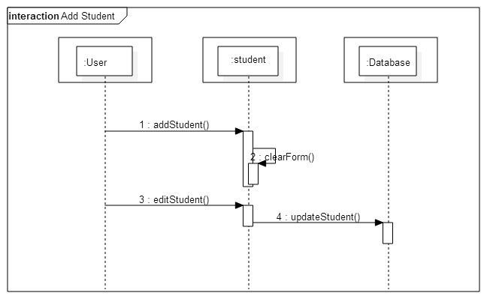

**Fig 4.6 Sequence Diagram for Add Student**

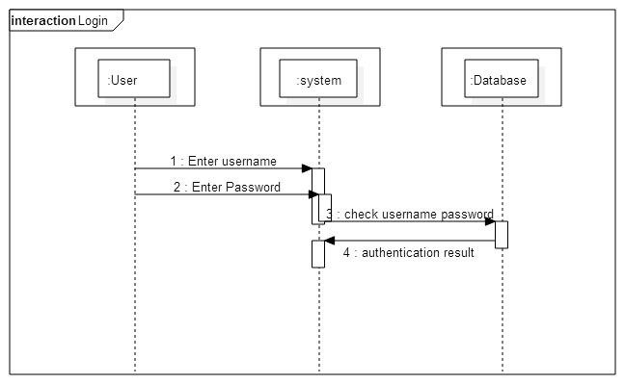

**Fig 4.7 Sequence Diagram for Login**

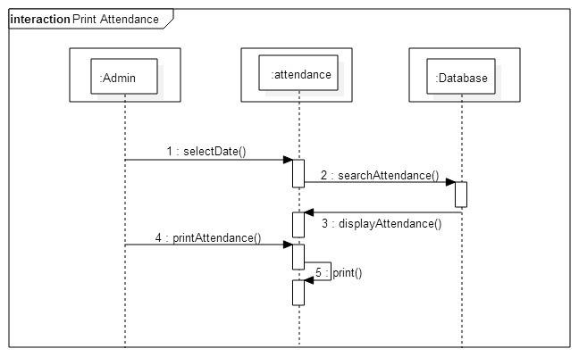

**Fig 4.8 Sequence Diagram to Display Attendance**

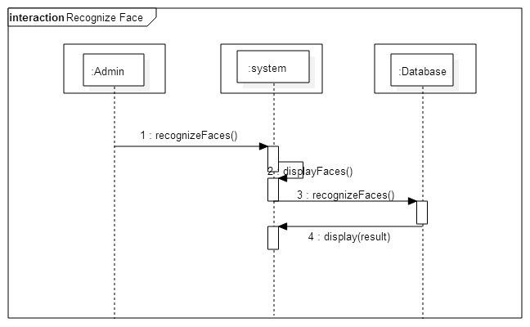

**Fig 4.9 Sequence Diagram for Recognize Face**

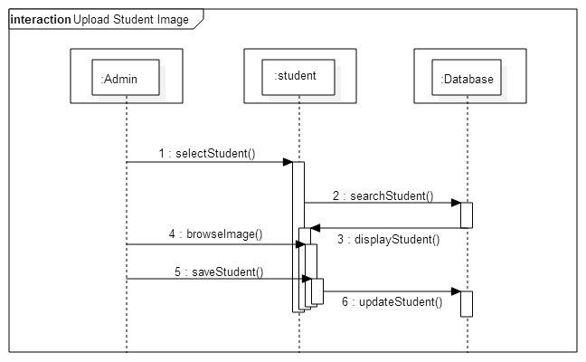

**Fig 4.10 Sequence Diagram for Upload Student Image**

**Fig 4.11 Activity Diagram for the Automated Attendance Process**

Update the Excel Sheet

Is face recognized

Click Mark Attendance

Detect Faces

Yes

**Fig 4.12 Activity Diagram for Add Student**

Update Student Record

Add Student

Click Menu

Output Student Form

**Fig 4.13 Activity Diagram for Uploading Student Image**

Upload Image

Click Browse Images

Select Student

Click Menu

# **4.7 INTERFACE DESIGN**

**4.7.1 Menu design**

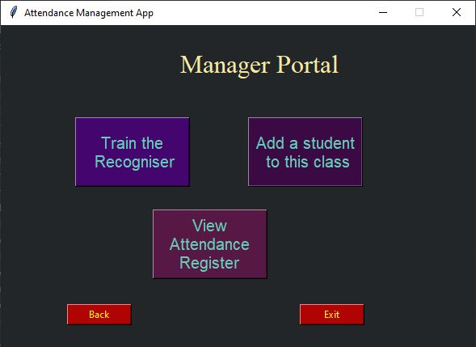

**Fig 4.13 The admin’s portal**

**4.7.2 Input design**

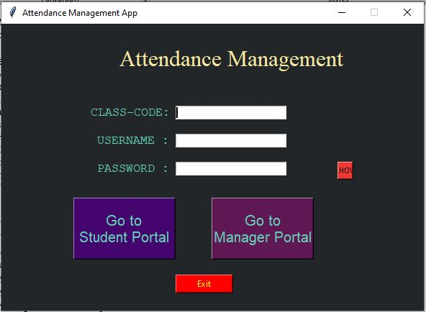

**Fig 4.14 Starting Page of the System**

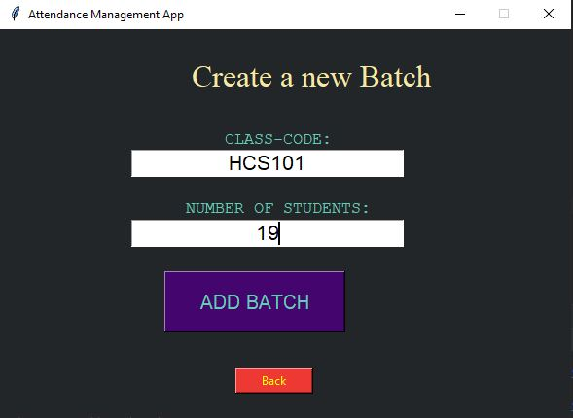

**Fig 4.15 Creating a class interface**

­­

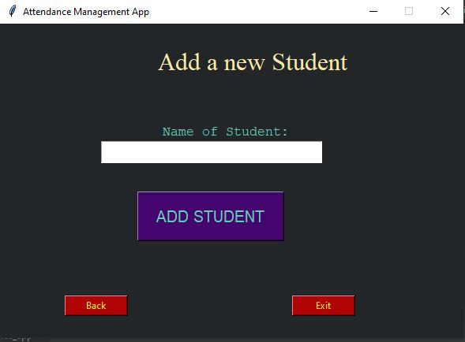

**Fig 4.16 Adding a student into a class**

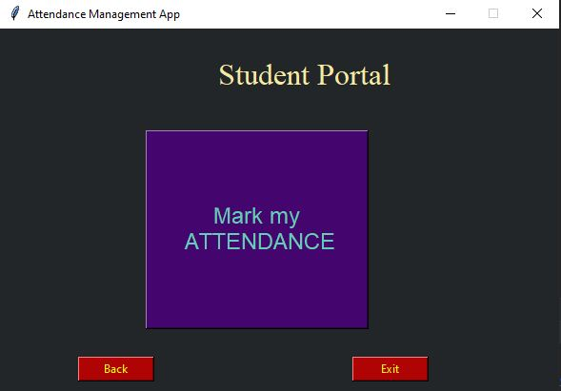

**Fig 4.17 Mark attendance interface**

When this mark my attendance button is clicked, the attendance process starts. The camera is activated and start taking a video looking for any frontal face in the video.

**4.7.3 Output design**

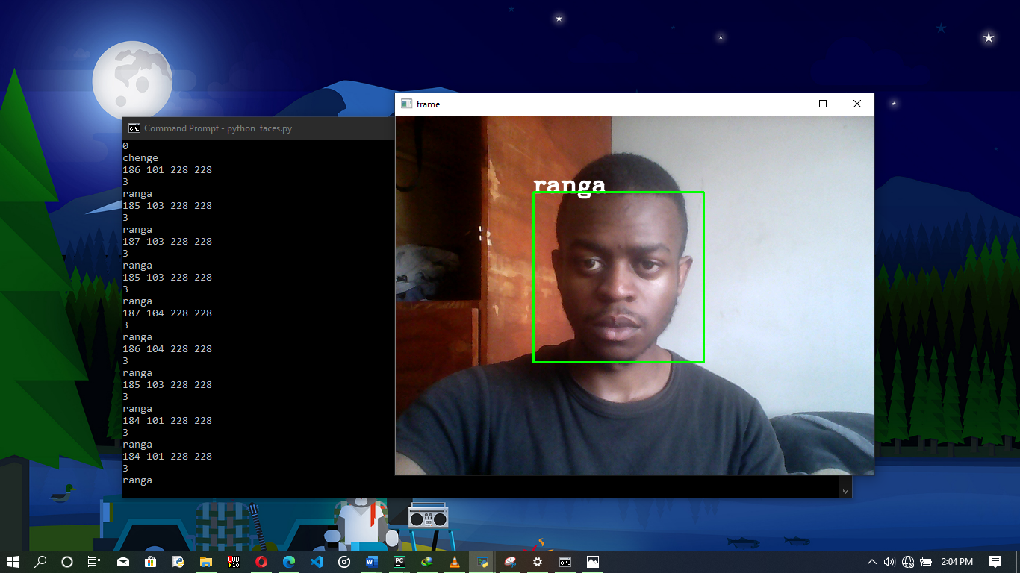

**Fig 4.18**

Here the student Ranga is detected and recognized. The system then goes to the spreadsheet and update the presence of the student for that particular day.

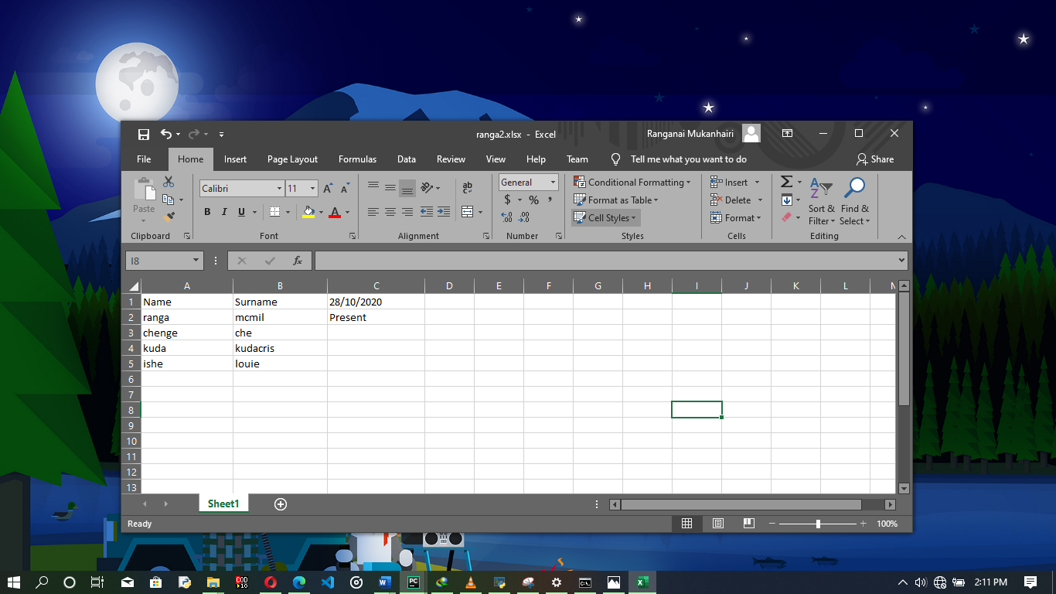

**Fig 4.19**

The updated spreadsheet after a student has been recognized

# **4.8 PSEUDO CODE**

**Login pseudo code**

Enter Username and password and class code.

If username and password is correct then redirect to the main menu

Else

Return error message

**Adding new face to the database**

Open Camera

Extract frontal face

Perfom HaarCascade method

Learn faces

Perform PCA algorithm

Store information in face data database

**Mark attendance pseudo code**

Open camera

Extract frontal face

Perform Haarcascade method

Compare face with ones in the database

If there’s a match then mark attendance for student

Else compare next face

**Pseudo code for Uploading Student Image**

Select student

Select browse images

Click images and upload

# **4.9 SECURITY DESIGN**

Security was achieved through assigning each lecture a class code and a lecturer a username and password so unauthorized users cannot use the system.

# **4.10 CONCLUSION**

The design phase enabled the developer to come up with an interface of the new system. All the design was carried in the design phase. Inputs, processes and outputs of the new system were designed. There was also design of the flow of activities in the proposed system, which will assist in the coding and construction. During the design phase there was also some information gathering that was done in terms of asking the prospective users of what they expect in the proposed system. The completion of the design phase paved the way for the implementation phase

# **CHAPTER 5: IMPLEMENTATION PHASE**

# **5.1 INTRODUCTION**

In software engineering, testing is used at key checkpoints of the program to check if the overall processes meet the objectives. This is where input and expected output are evaluated. This section focuses on the implementation and analysis of the results. This section also explains the implementations performed in terms of coding and experiments carried out. It also indicates the testing methodologies and evaluations made to the system’s components and should summarize the results.

# **5.2 IMPLEMENTATION & CODING**

1. Capture Video

The camera is on a fixed position to capture the frontal face of students in a class

1. Separate as frames from the video

The video is trimmed into frame per second to make the detection process faster and possible

1. Face Detection

This is where by the frontal face is looked for in the input video. If it’s found, it is cleaned up for easier recognition

1. Face Recognition

After detection and processing of the face is done, the face is compared to other faces in the training database

1. Post Processing

This is whereby the names of the identified faces are updated in the excel spreadsheet.

# 

# **CODE SNIPPETS**

**Fig 5.1 Code Snippet for capturing video**

while True:  
 # Capture video frames  
 ret, frame = cap.read()  
 # Convert to gray  
 gray = cv2.cvtColor(frame, cv2.COLOR_BGR2GRAY)  
 faces = face_cascade.detectMultiScale(gray, scaleFactor=1.5, minNeighbors=5)  
  
 for (x, y, w, h) in faces:  
 print(x, y, w, h)  
 roi_gray = gray[y:y+h, x:x+w]  
 roi_color = frame[y:y + h, x:x + w]  
  
 # recognize  
 id_, conf = recognizer.predict(roi_gray)  
 if 45 <= conf <= 85:  
 print(id_)  
 print(labels[id_])  
 if labels[id_] in names:  
 pass  
 else:  
 names.append(labels[id_])  
  
 font = cv2.FONT_HERSHEY_COMPLEX  
 person = labels[id_]  
 color = (255, 255, 255)  
 stroke = 2  
 cv2.putText(frame, person, (x, y), font, 1, color, stroke, cv2.LINE_AA)  
  
 img_item = 'my-image.png'  
 cv2.imwrite(img_item, roi_gray)  
  
 # drawing a rectangle  
 color = (0, 255, 0)  
 stroke = 2  
 end_cordX = x + w  
 end_cordY = y + h  
 cv2.rectangle(frame, (x, y), (end_cordX, end_cordY), color, stroke)  
  
 # Display video  
 cv2.imshow('frame', frame)  
 if cv2.waitKey(20) & 0xFF == ord('q'):  
 break

**Fig 5.2 Code snippet for loading HaarCascade:**

face_cascade = cv2.CascadeClassifier('cascades/data/haarcascade_frontalface_alt2.xml')

**Fig 5.3 Code Snippet for training faces module:**

import os  
import cv2  
from PIL import Image  
import numpy as np  
import pickle  
  
BASE_DIR = os.path.dirname(os.path.abspath(__file__))  
image_dir = os.path.join(BASE_DIR, 'images')  
face_cascade = cv2.CascadeClassifier('cascades/data/haarcascade_frontalface_alt2.xml')  
recognizer = cv2.face.LBPHFaceRecognizer_create()  
  
current_id = 0  
label_ids = {}  
y_labels = []  
x_train = []  
  
for root, dirs, files in os.walk(image_dir):  
 for file in files:  
 if file.endswith('jpg'):  
 path = os.path.join(root, file)  
 label = os.path.basename(root).replace(' ', '-').lower()  
 # print(label, path)  
 if not label in label_ids:  
 label_ids[label] = current_id  
 current_id += 1  
  
 id_ = label_ids[label]  
 # print(label_ids)  
 # y_labels.append(label)  
 # x_train.append(path)  
 pil_image = Image.open(path).convert('L') # converts into gray  
 image_array = np.array(pil_image, 'uint8')  
 # print(image_array)  
  
 faces = face_cascade.detectMultiScale(image_array, scaleFactor=1.5)  
  
 for (x, y, w, h) in faces:  
 roi = image_array[y:y + h, x:x + w]  
 x_train.append(roi)  
 y_labels.append(id_)  
  
# print(y_labels)  
# print(x_train)  
  
with open('labels.pickle', 'wb') as f:  
 pickle.dump(label_ids, f)  
  
recognizer.train(x_train, np.array(y_labels))  
recognizer.save('trainer.yml')

**Fig 5.4 Code snippet for the module to update the spreadsheet:**

import os  
import cv2  
from PIL import Image  
import numpy as np  
import pickle  
  
BASE_DIR = os.path.dirname(os.path.abspath(__file__))  
image_dir = os.path.join(BASE_DIR, 'images')  
face_cascade = cv2.CascadeClassifier('cascades/data/haarcascade_frontalface_alt2.xml')  
recognizer = cv2.face.LBPHFaceRecognizer_create()  
  
current_id = 0  
label_ids = {}  
y_labels = []  
x_train = []  
  
for root, dirs, files in os.walk(image_dir):  
 for file in files:  
 if file.endswith('jpg'):  
 path = os.path.join(root, file)  
 label = os.path.basename(root).replace(' ', '-').lower()  
 # print(label, path)  
 if not label in label_ids:  
 label_ids[label] = current_id  
 current_id += 1  
  
 id_ = label_ids[label]  
 # print(label_ids)  
 # y_labels.append(label)  
 # x_train.append(path)  
 pil_image = Image.open(path).convert('L') # converts into gray  
 image_array = np.array(pil_image, 'uint8')  
 # print(image_array)  
  
 faces = face_cascade.detectMultiScale(image_array, scaleFactor=1.5)  
  
 for (x, y, w, h) in faces:  
 roi = image_array[y:y + h, x:x + w]  
 x_train.append(roi)  
 y_labels.append(id_)  
  
# print(y_labels)  
# print(x_train)  
  
with open('labels.pickle', 'wb') as f:  
 pickle.dump(label_ids, f)  
  
recognizer.train(x_train, np.array(y_labels))  
recognizer.save('trainer.yml')

# 

# **5.3 TESTING**

**TABLE 5.1 OPENCV FUNCTIONS USED IN THE PROPOSED SYSTEM AND ITS EXECUTION RESULTS**

|  |  |  |  |
| --- | --- | --- | --- |
| Test Data | Expected Results | Observed Result | Pass/Fail |
| OpenCAM_CB() | Starts recording after it connects with the installed camera | Camera Started | P |
| LoadHaar Classifier() | Loads the HaarCascade Classifier for frontal face | Loads the Classifier | P |
| ExtractFace() | Initiates the LPBH extracting framework | Face extracted | P |
| Learn() | PCA Algorithm is executed | Updates the training data.xml | P |
| Recognize() | Compares the input face with the saved face | Compared | P |

**TABLE 5.2: TEST CASES FOR RECOGNITION PHASE**

|  |  |  |  |  |
| --- | --- | --- | --- | --- |
| Description | Test Data | Expected Result | Actual Result | Pass/Fail |
| Recognize a face that has been trained and saved in training database | Video as input | Recognize the face in the video and return respective name | Face successfully extracted and recognized | P |
| Identify a face that is not saved | Video as input | Fail to recognize | Fail to recognize | P |

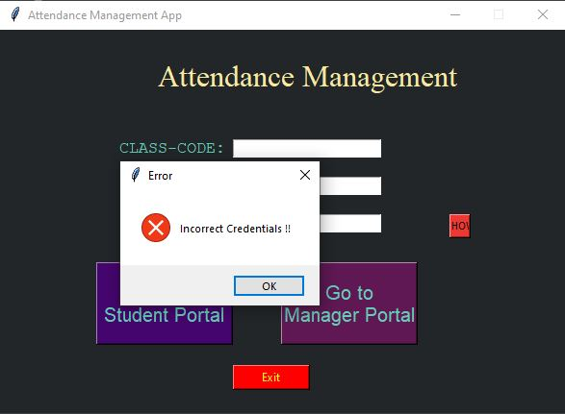

**Fig 5.5 Login with incorrect details**

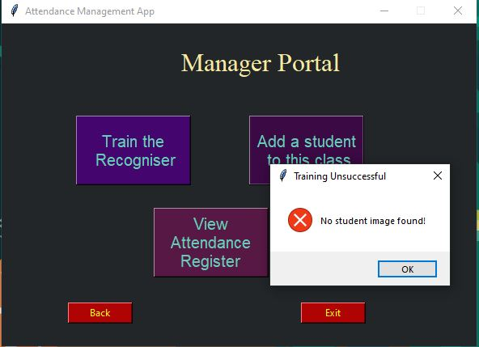

**Fig 5.6 Trying to train the program for new faces without selecting any**

# **5.5 MAINTENANCE**

Maintenance is an important aspect that will guarantee the durability and long-term functioning of any system. There was need to ensure that management had an appreciation of the importance of system maintenance so that they could dedicate adequate financial resources to support.

**Types of Maintenance**

* Corrective
* Adaptive
* Perfective

Below there is a diagrammatic representation of the maintenance processes.

Change Request

Impact Analysis

System Release Planning

Change Implementation

System Release

Perfective Maintenance

Adaptive Maintenance

Corrective Maintenance

***Fig 5.6 Maintenance Process***

**a) Corrective maintenance**

Corrective maintenance involves changing a software application to remove errors. The coding errors.

Design errors occur when, for example, changes made to the software are incorrect, incomplete, wrongly communicated or the change request is misunderstood

**b) Adaptive maintenance**

This is any effort that is the result of changes in a software application’s operating environment. The need for adaptive maintenance can only be recognized by monitoring the environment. The term environment in this context refers to the totality of all conditions and influences which act from outside upon the system. For example, there might be a need to upgrade the size of the database, as more branches will be opened in due course.

.

**5.6 Recommendations for future/further development**

* Poor lighting conditions in a room may affect image quality which degrades system performance, this can be improved by using a more advanced camera or some advanced algorithms
* Performance Improvement - Image processing algorithms and deep learning techniques can be used to increase the accuracy and makes attendance monitoring more efficient
* This type of system can be used in online exam verification

# **5.7 CONCLUSION**

The system development process was successful in that all the objectives of this phase were met. All the sections were according to the plan stated in the planning phase. The system was also tested to see if it met the requirements of the users. Automated Attendance System has been envisioned for the purpose of reducing the errors that occur in the traditional (manual) attendance taking system. The aim is to automate and make a system that is useful to the organization such as an institute. The efficient and accurate method of attendance in the office environment that can replace the old manual methods. This method is secure enough, reliable and available for use. No need for specialized hardware for installing the system in the office. It can be constructed using a camera and computer

# REFERENCE

[1]. W. Zhao, R. Chellappa, P. J. Phillips, and A. Rosenfeld,“Face recognition: A literature survey,” ACM Computing Surveys, 2003, vol. 35, no. 4, pp. 399-458.

[2]. Herbert Bay, Andreas Ess, Tinne Tuytelaars, and Luc Van Gool. Surf: Speeded up robust features. Computer Vision and Image Understanding (CVIU), 110(3):346–359.

[3]. H.K.Ekenel and R.Stiefelhagen,Analysis of local appearance based face recognition: Effe cts of feature selection and feature normalization. In CVPR Biometrics Workshop, New York, USA, 2006

[4]. IJCSI International Journal of Computer Science Issues, Vol. 9, Issue 4, No 1, July 2012 ISSN (Online): 1694-0814

[5]. Javier Ruiz Del Solar, Rodrigo Verschae, and Mauricio Correa. Face recognition in unconstrained environments: A comparative study. In ECCV Workshop on Faces in RealLife Images: Detection, Alignment, and Recognition, Marseille, France, October 2008.