Steps to run the application.

1. Deployed the application as per the ReadMe from the test.
2. To run the test files it is assumed that application is up and database is created and swagger can be seen at <http://localhost:5000/v1/ui>
3. Install the Eclipse and check out or download the source code and import it to the Eclipse
4. Once the code is imported, create the Maven build as below using the run configuration

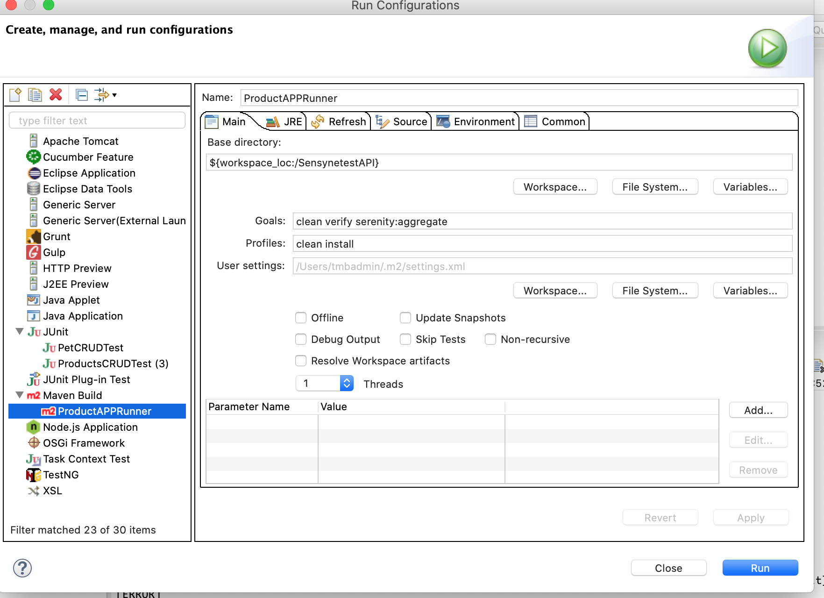

1. Once the code has deployed, it will end up saying build failure but not to worry because tests are failing and there are defects in the application ☺

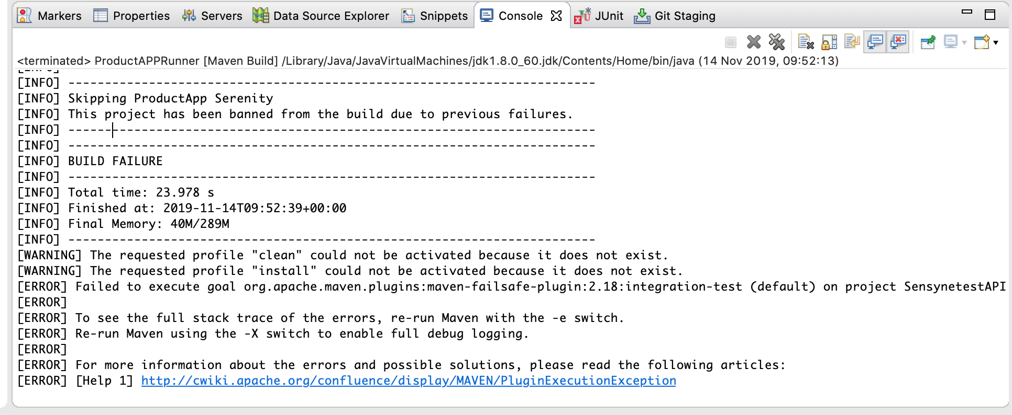

1. Once the code is built, reports are generated, navigate to the following location and open the index.html file

<Project path>/git/ProductAppTest/SensynetestAPI/target/site/serenity/index.html

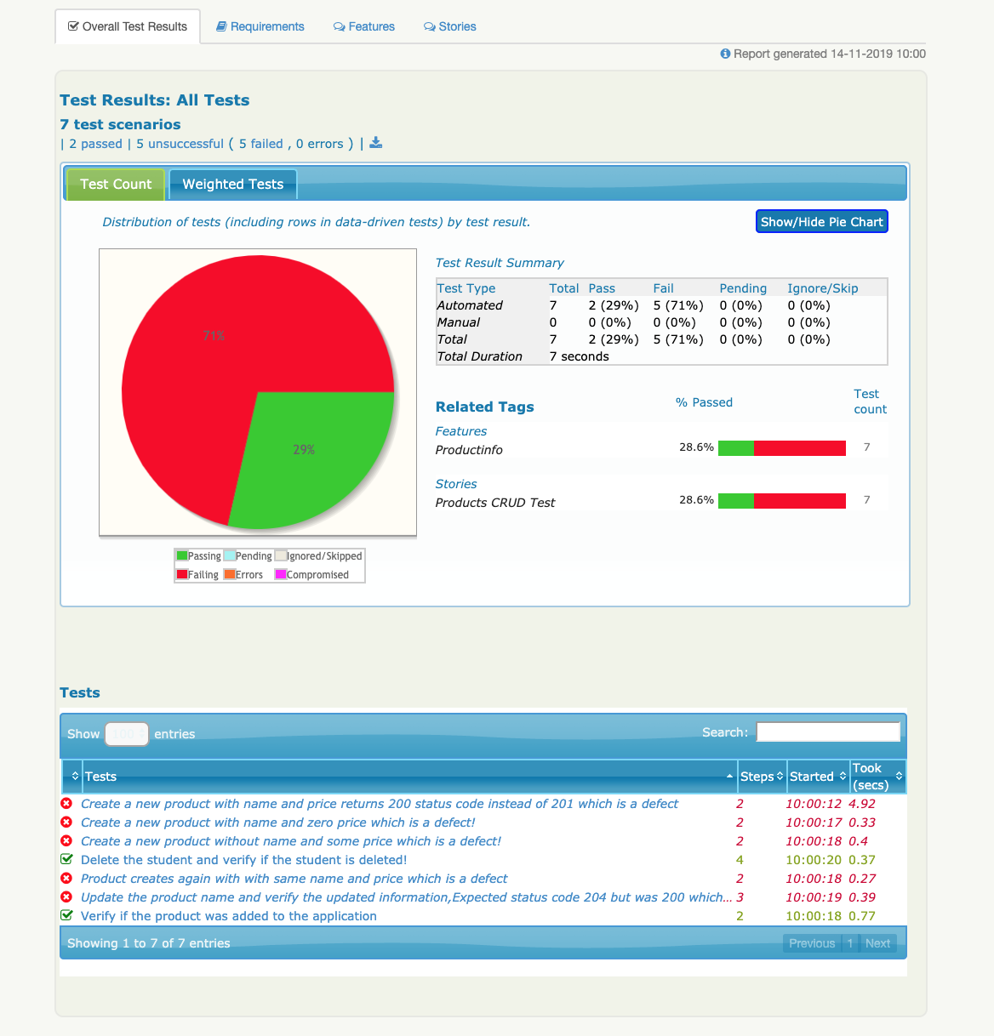

1. As we are using the serenity framework over rest assured, decent reports are generated.
2. I have created a feature named **productinfo**  and user story named **Products CURD Test** and it looks like below

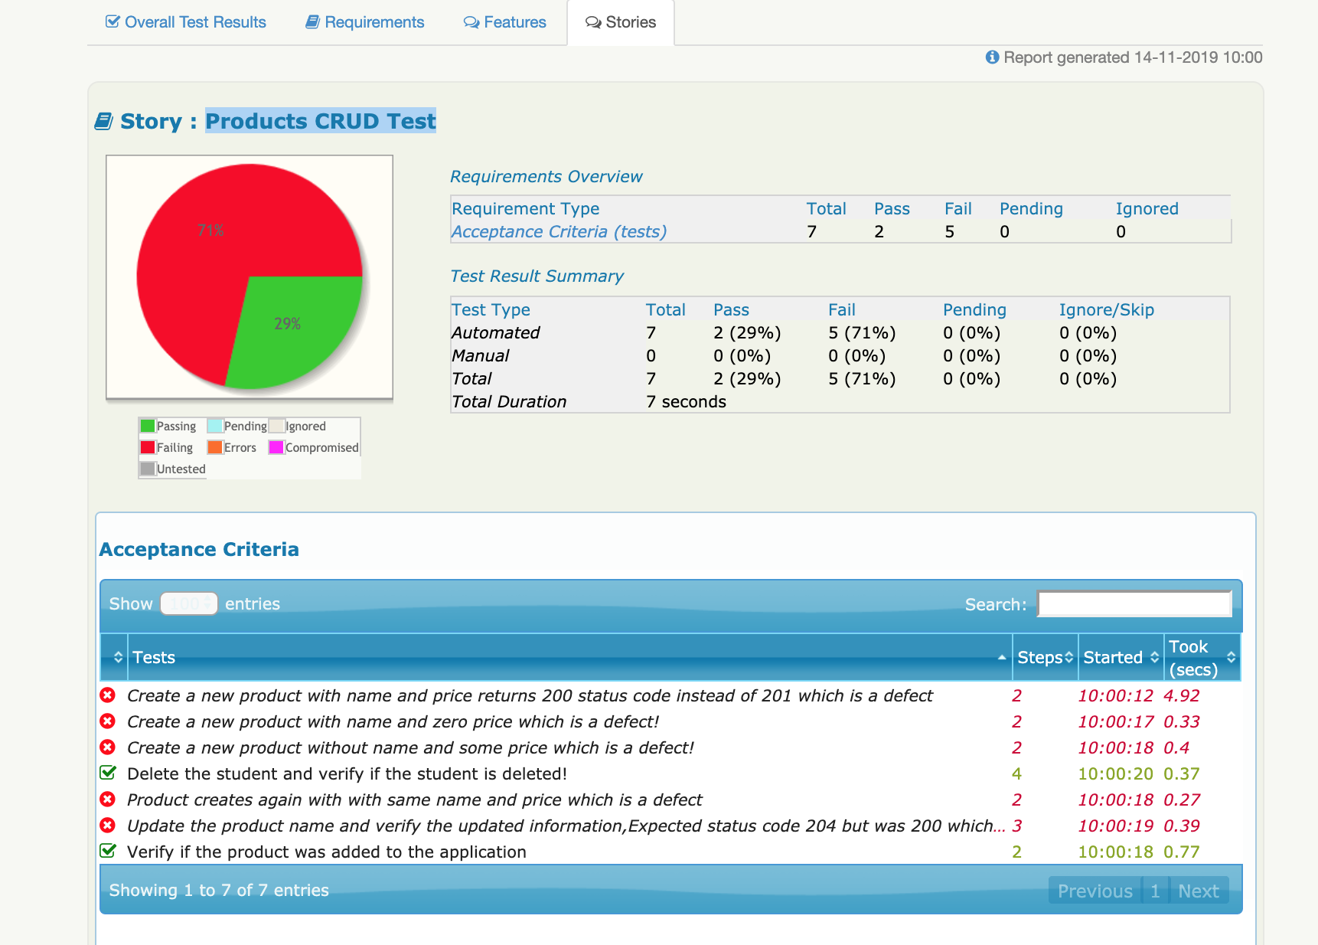

1. Click on the “ [*Create a new product with name and price returns 200 status code instead of 201 which is a defect*](0421aa17362af1b0791755bcbaeaeb1651d71a5c8e45ad9f91401312c1d6eb15.html)” Acceptance criteria it will navigate to the steps

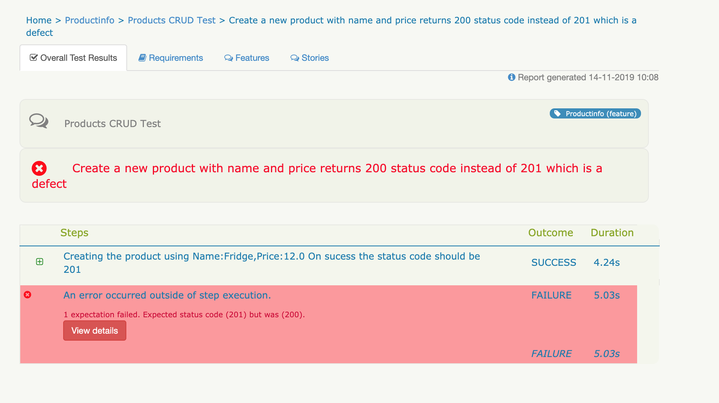

1. Click on the step which will expand and opens up the Rest Query and click on that

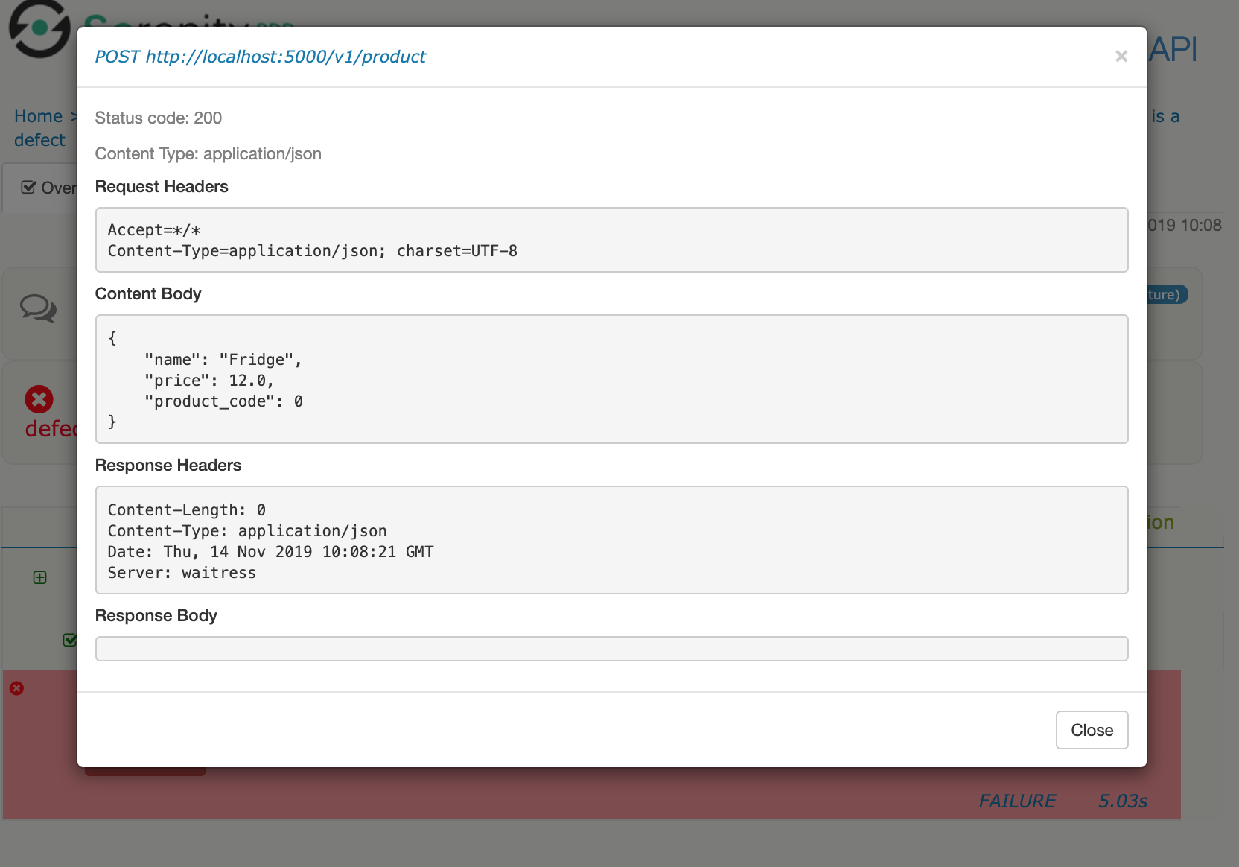

1. Test has performed the post operation first and added the above details however it has returned the **200** code instead of **201** which is a defect.

Likewise navigate to all the failed tests which are defects.

**Technologies used:**

1. Serenity BDD over Rest Assured and language used is Java