Steps to run the application.

**Software Required:**

* Eclipse or any Java IDE
* Maven
* Java 1.8

**Technologies used:**

* Serenity BDD over Rest Assured

1. Check out or download the source code from [GitHub](https://github.com/ranga2k/TradelX) and import it to the workspace.
2. Create Maven goals as “clean verify serenity:aggregate” to run the framework.

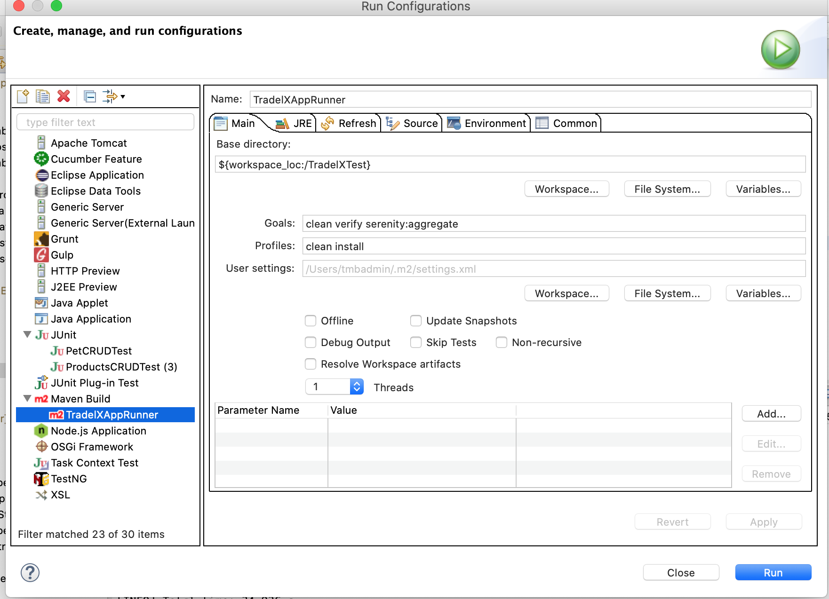

1. Once the code has run, the tests will be executed successfully, and the following tests are performed

* Create a pet
* Verify the pet has been created
* Update the pet
* Delete the Pet

1. Reports are generated, navigate to the following location and open the index.html fil

<Project path>/git/ TradelX/TradelXTest/target/site/serenity/index.html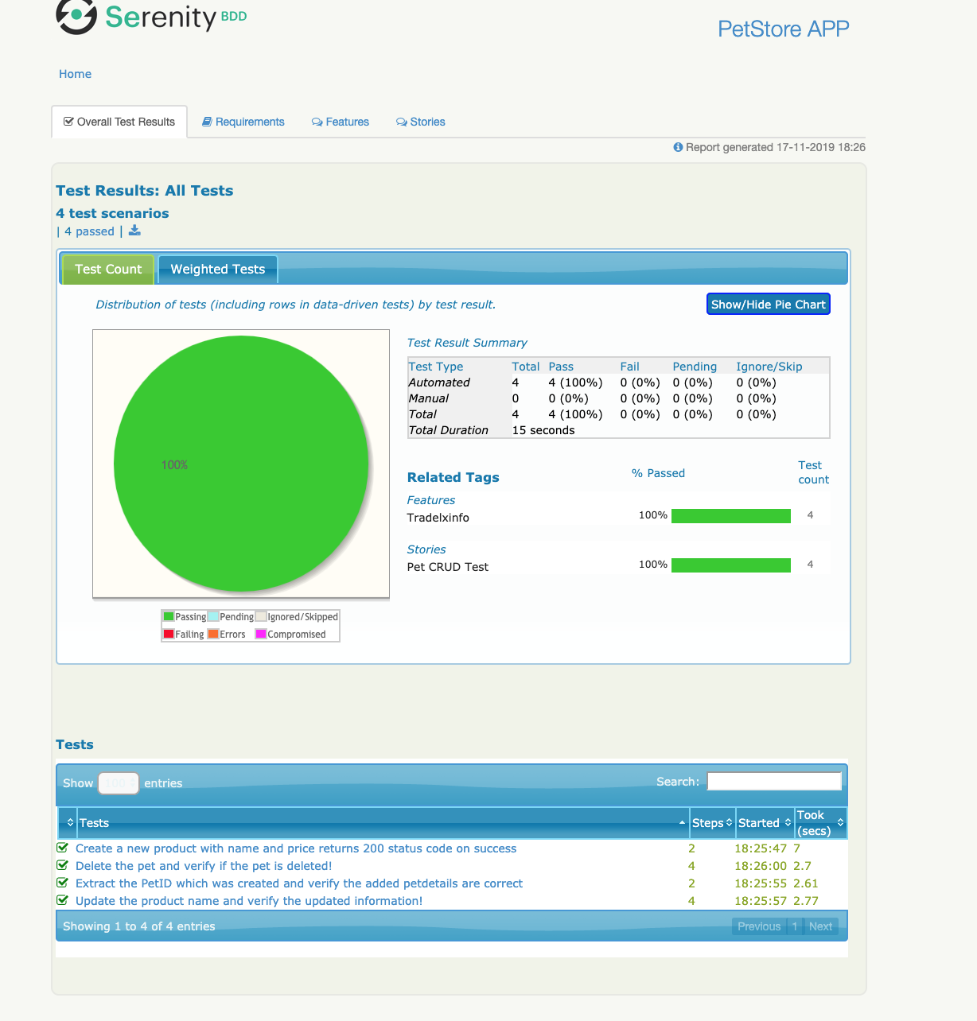

1. As we are using the serenity framework over rest assured, decent reports are generated.
2. I have created a feature named **Tradexinfo**  and user story named **Pet CURD Test**
3. Click on the “Create a new product with name and price returns 200 status code on success” and it will navigate to steps as

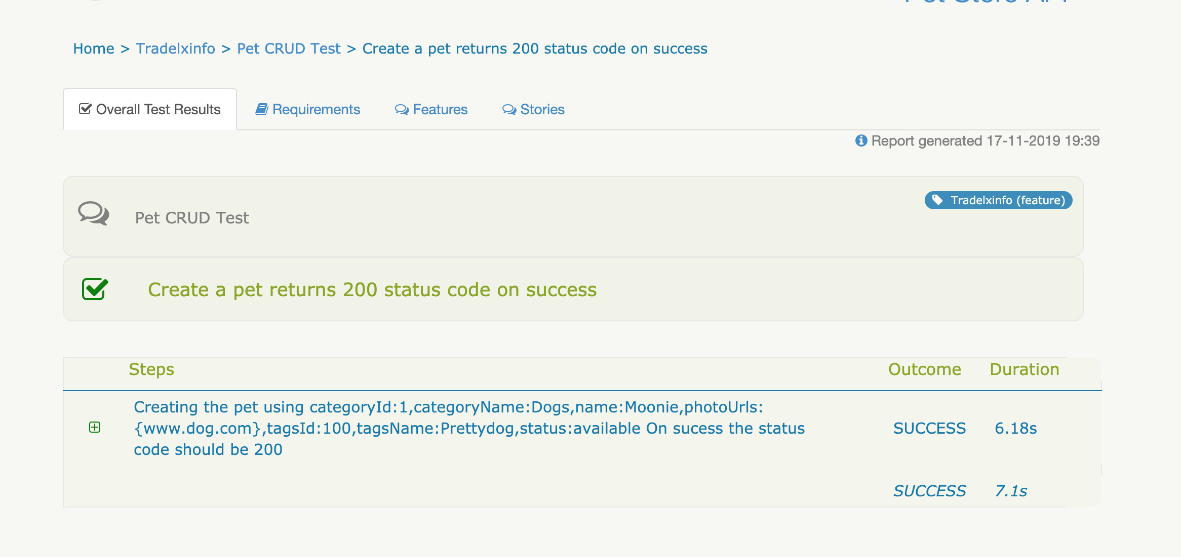

**Note:** The test data used is displayed in the steps.

8. Click on the Rest Query which gives the endpoint request & responses. Likewise navigate to all the test cases.

