TesterAlly.ai - Workflow Documentation

# Overview

TesterAlly.ai is an AI-powered automation testing tool designed to streamline the testing process for development teams. This document provides a detailed workflow from the perspective of both organization administrators and team members, outlining how they interact with the platform to create agents, connect repositories, and collaborate on projects.

# Organization (Admin) Workflow

1. Register on TesterAlly.ai Cloud  
2. Connect GitHub repository to link codebase with TesterAlly  
3. Create an Agent from the cloud dashboard  
4. Download the Agent as an `.exe` file  
5. Log in using the Agent Key provided in the cloud  
6. Clone the GitHub repository to the local machine using the Agent (not from cloud)  
7. Create a Project within the Agent interface  
8. Invite team members to collaborate on the project

# Member Workflow

1. Receive an invitation link via email  
2. Click the link and navigate to the TesterAlly.ai Cloud Member Page  
3. Register as a member on the platform  
4. Automatically get connected to the organization’s linked GitHub repository  
5. Create and download the Agent (.exe) from the cloud  
6. Log in using the Agent Key  
7. Access and contribute to the assigned project from the local instance

# Workflow Diagram

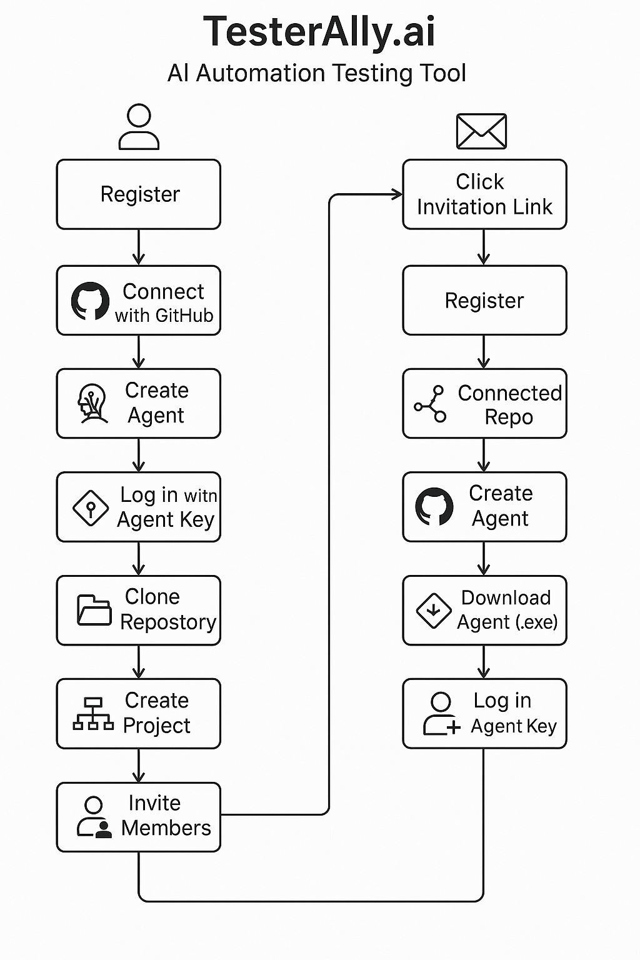

Figure: Visual Workflow for TesterAlly.ai Onboarding and Project Setup