Amzon auto scalling helps to maintains application availability and allow you to add and remove the ec2 instance based on the usage

In auto scaling 1st we create the launch configuration

Give the name to the lauch configuration

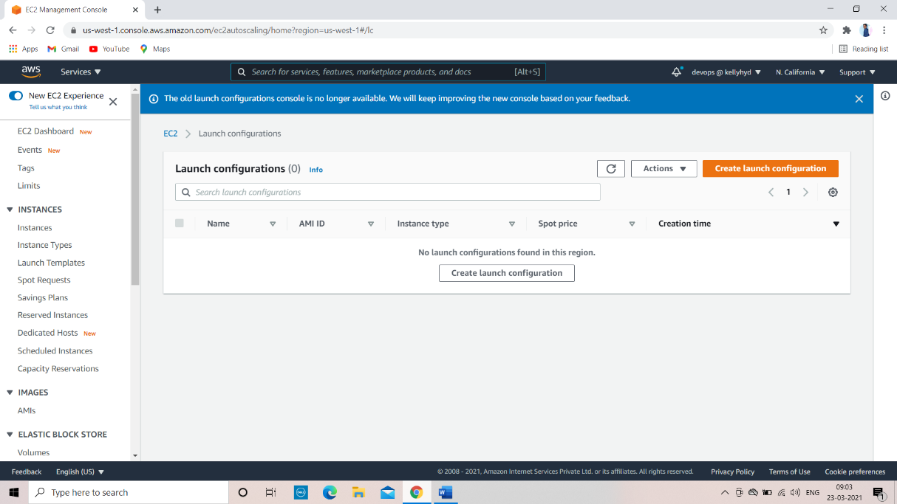

And selecst the ami (amazon machine image)

Then select the instance type which instance you want

Then give or select the keypair

Give the tag to the launch configuration

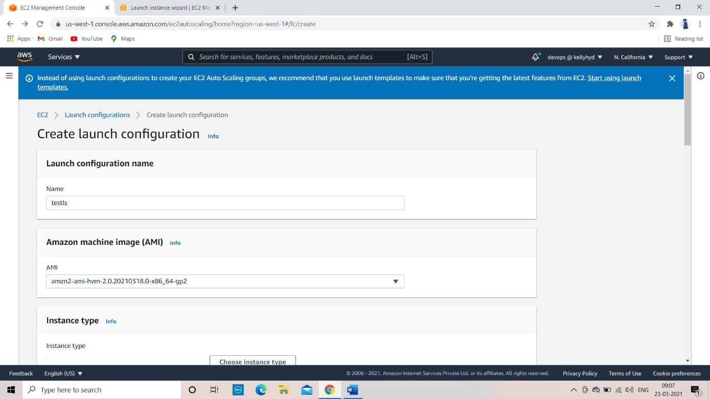

Finaly we created the launch configuration

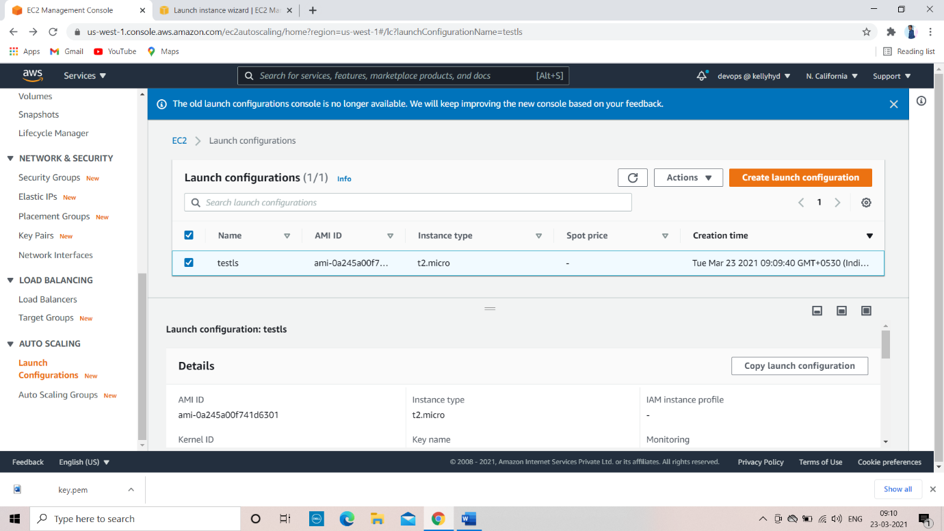

Step 2

Selecst auto scaling group

And give the name to the autoscaling group

And give the name of the lauch configuration name in the autoscaling group

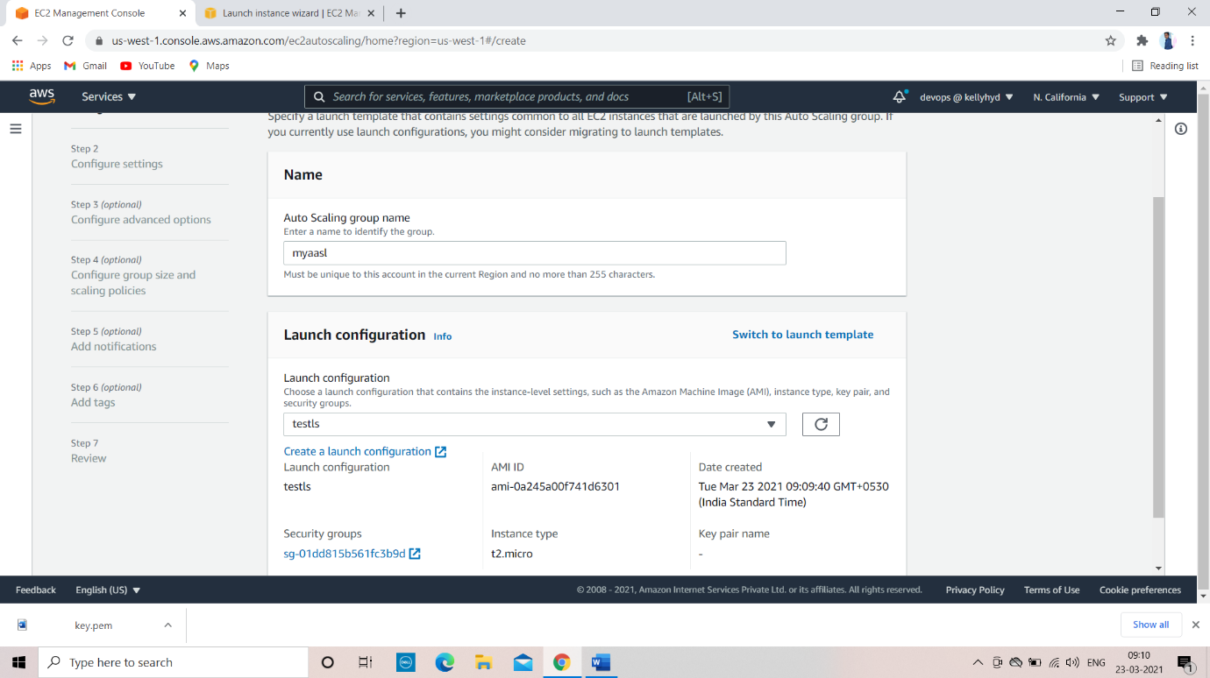

In auto scaling group we have to provide the load balancing

Also we skip without taking the load balancer

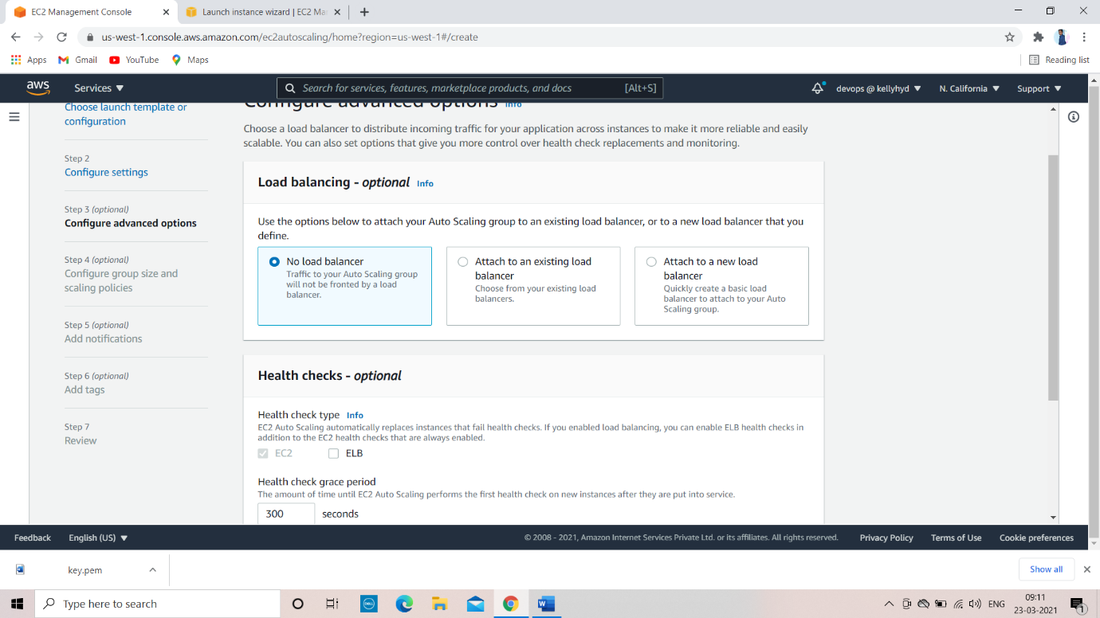

In configure group size and scaling policies

In this we have to provide how many instances we need

In desired capacity, minimum capacity and maximum capacity

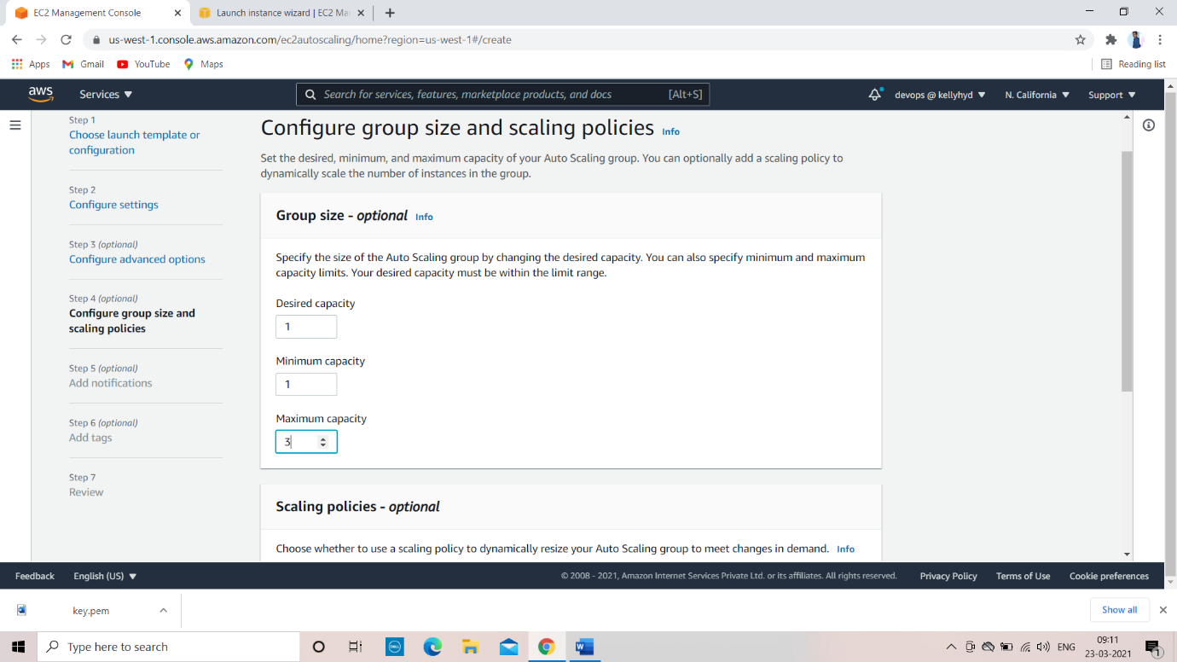

And autoscaling we have to choose policy

Target tracking scaling policy

Metric type => average CPU utilization

Provide if CPU utilization greater than 50% create new instance automatically

And if CPU utilization is less than 50% it automatically removes the instance

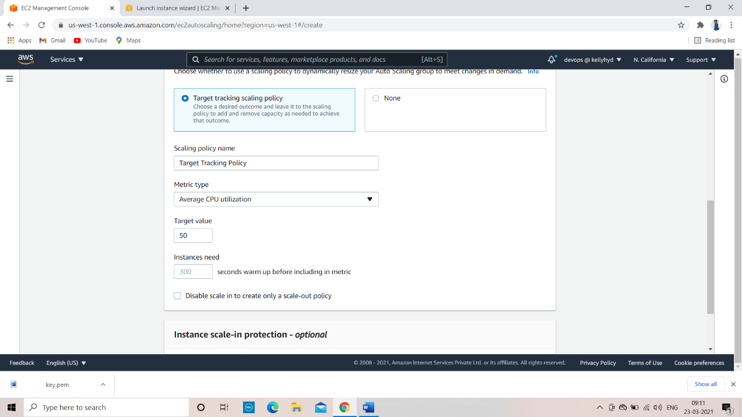

We succefully created the auto scalling group

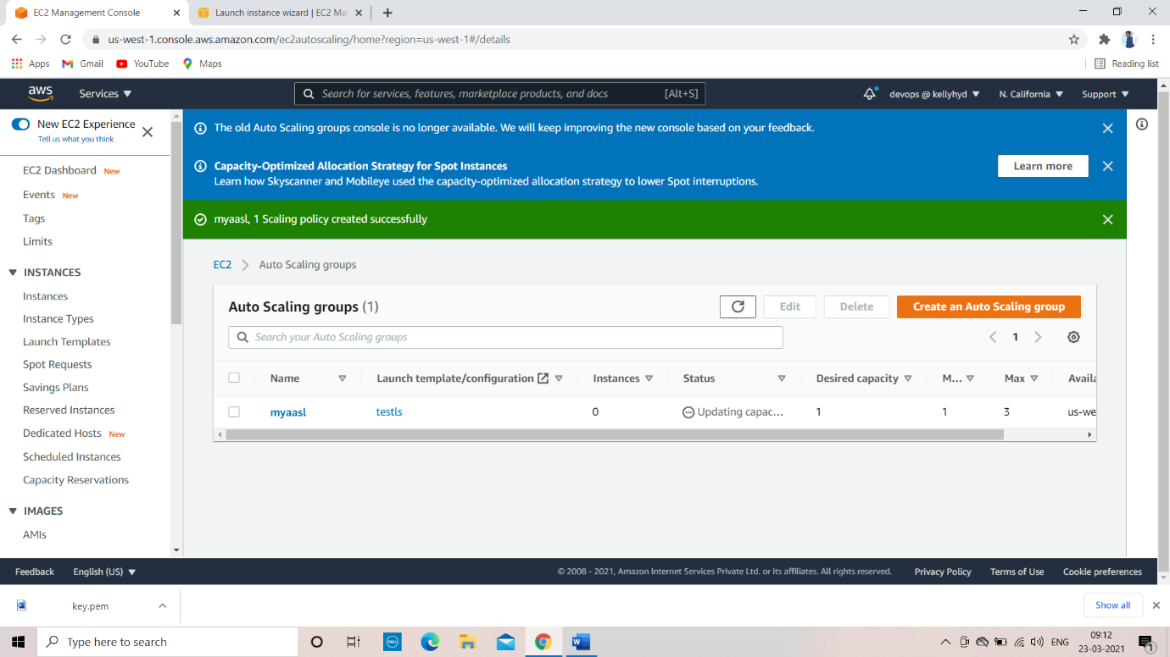

One instance wast created if CPU utilization is more than 50% automatically new instance was created

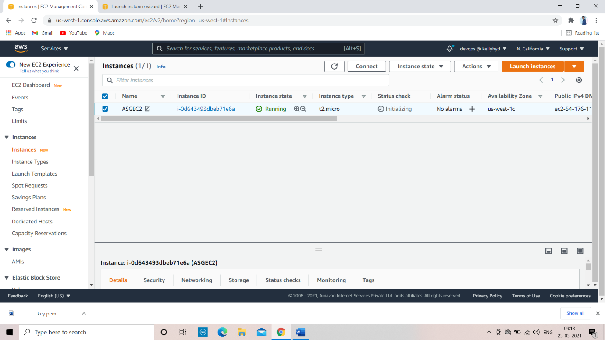

In below you can see the CPU utilization

And we will increase the CPU utilization by stress command

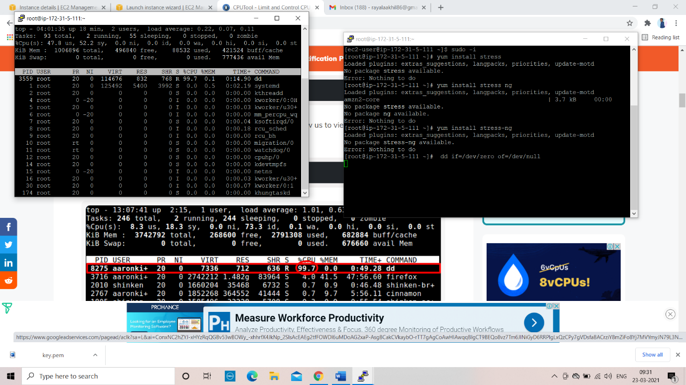

After creating stress on CPU

Autoscaling created a new instance

When CPU utilization is decreased the instance will be removed automatically

