Virtual private cloud

* It is a custom network created because to get more grip on server

There are two types of networks

* Mac
* Ip \* ip4 – internet protocolv4 32 bits

\*ip6 – internet protocol v6 128 bits

Class A => 0-127 =>N.H.H.H =>255.0.0.0 =>public Ip

Class B => 128-191=>N.N.H.H=>255.255.0.0=> public IP

Class C => 192-223=>N.N.N.H=>255.255.255.0=>private IP

Class D => 224-239=> Routers

Class E => 240-255=> super computers

In class A 10 series are private network

In class B 172 series are private network

* CIDR

Class inter domain route

INTERNET GATEWAY => allows outside traffic

ROUTE => to connect multiple network

VPC PEEN => to connect one VPC to multiple

NACT => network access control list

NATGATEWAY => To communicate public and private subnets

VPC creation

* For every region AWS as default VPC
* In every region we able to create 5 VPC

Step 1

Create a VPC

Open AWS services

Select VPC and create a VPC

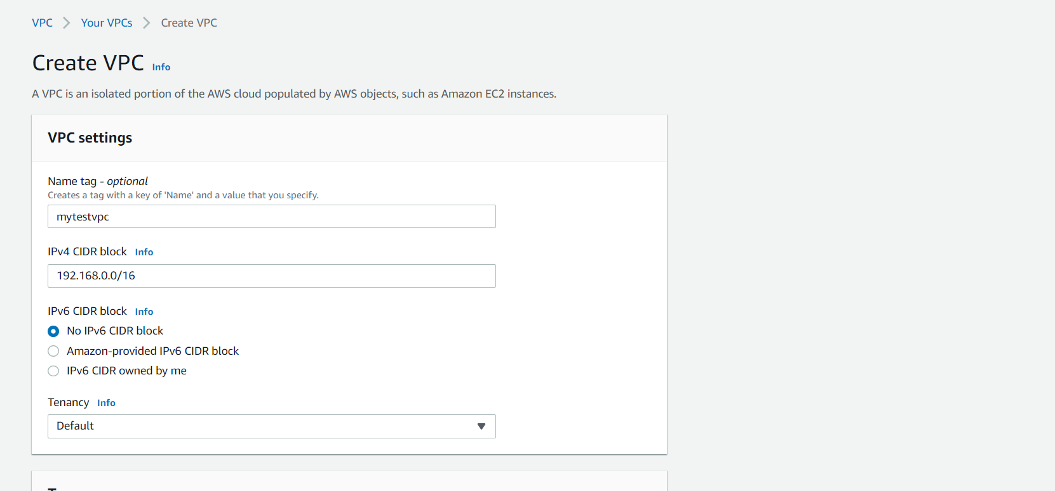

Step 2

After creating the VPC

Create a subnet

Add those subnets to VPC

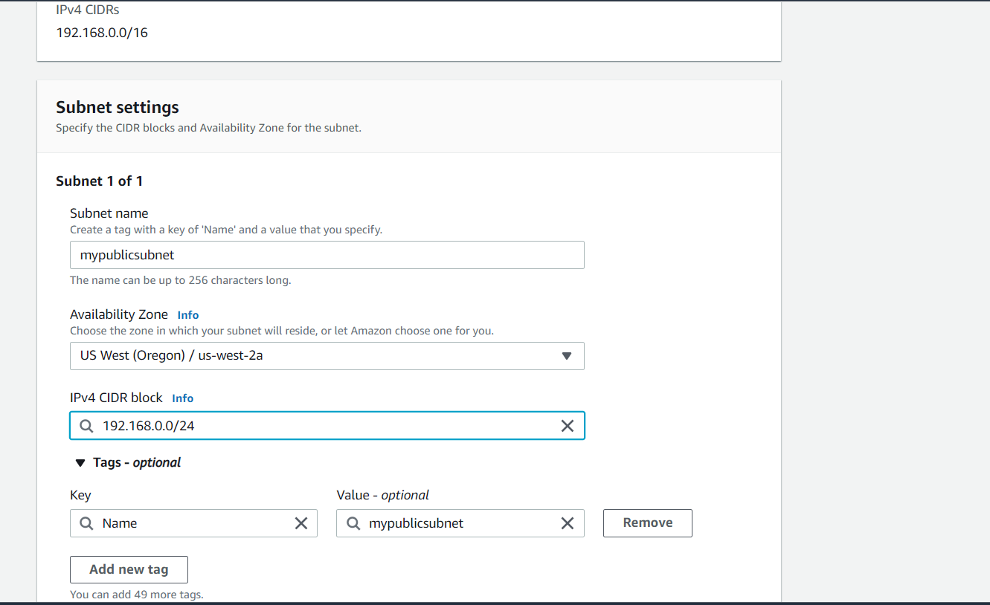

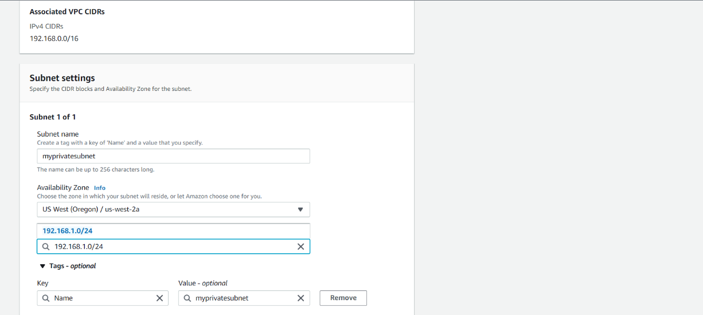

Step 3

After creating the subnet create the internet gateway

Allows outside traffic

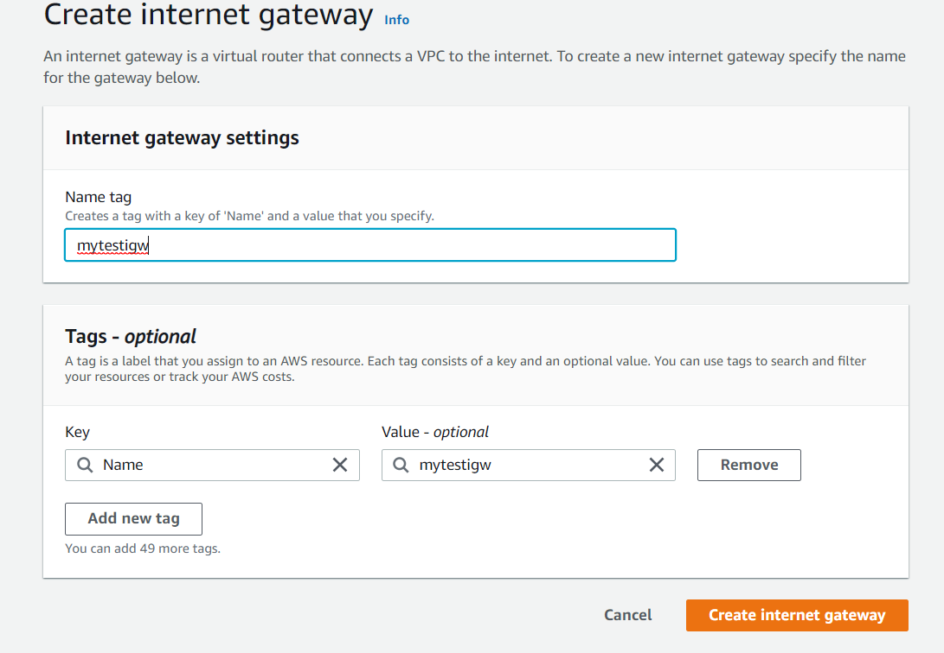

To communicate public and private subnets

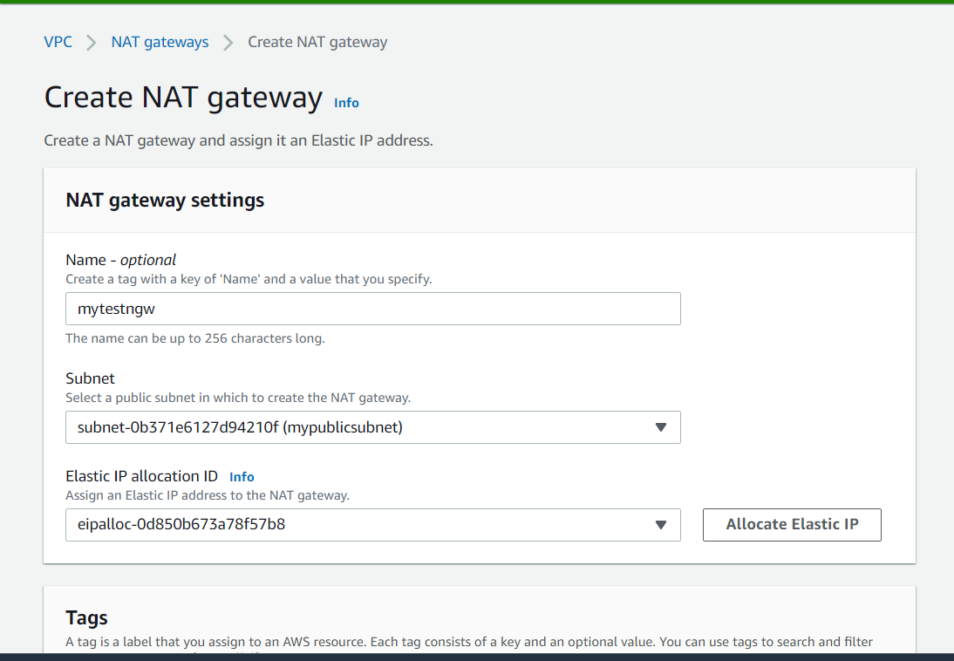

Launch a instance

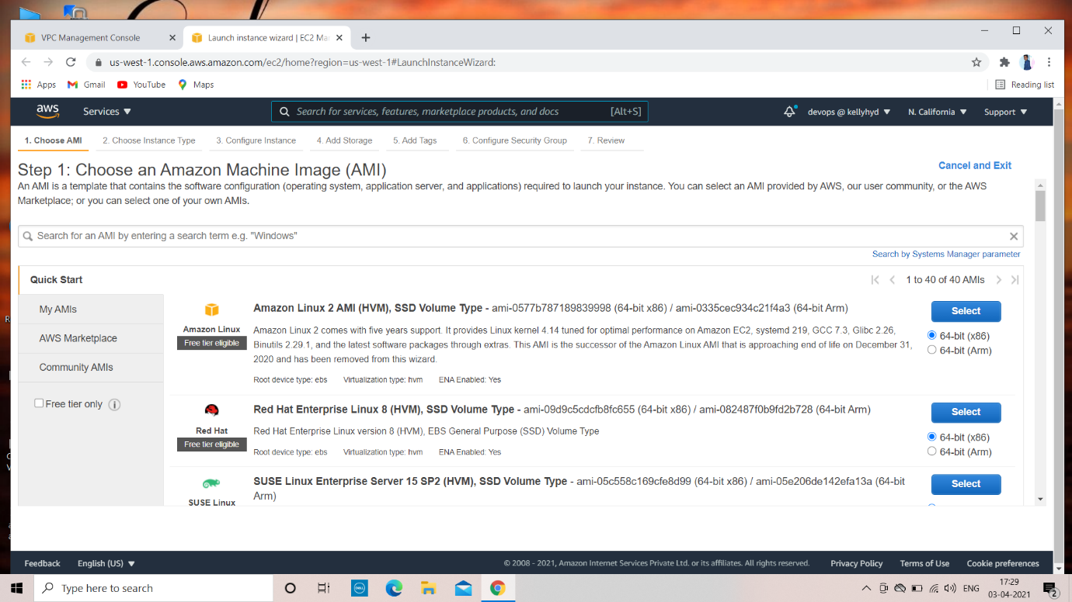

Launch instance using your own VPC and your public subnets

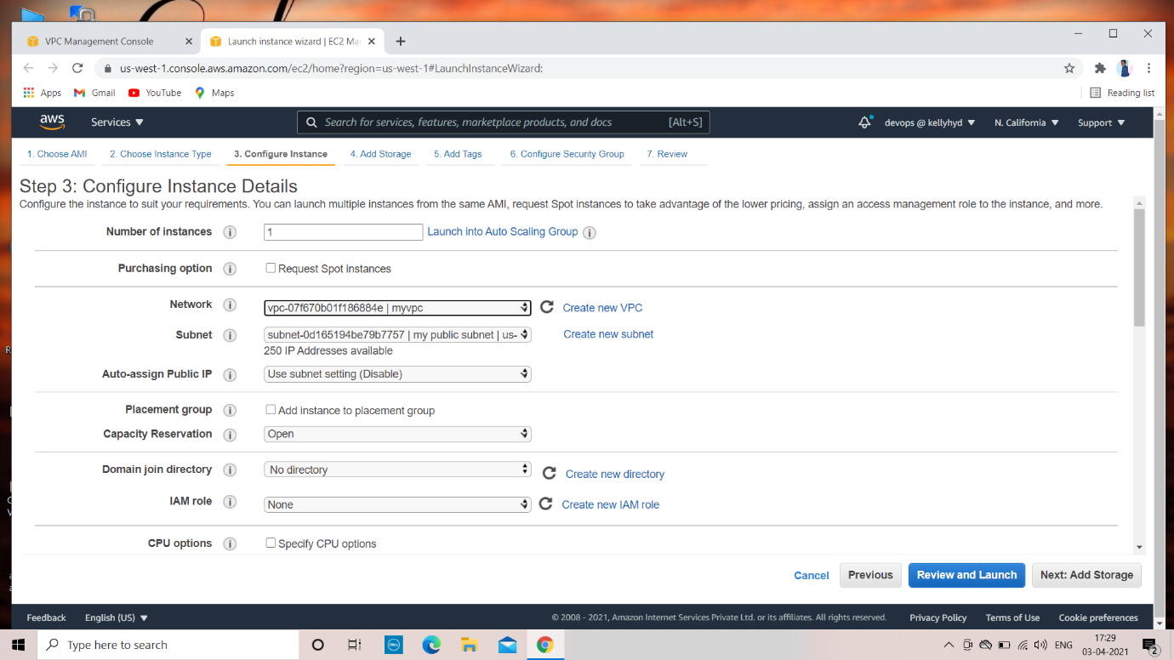

Review and launch instance

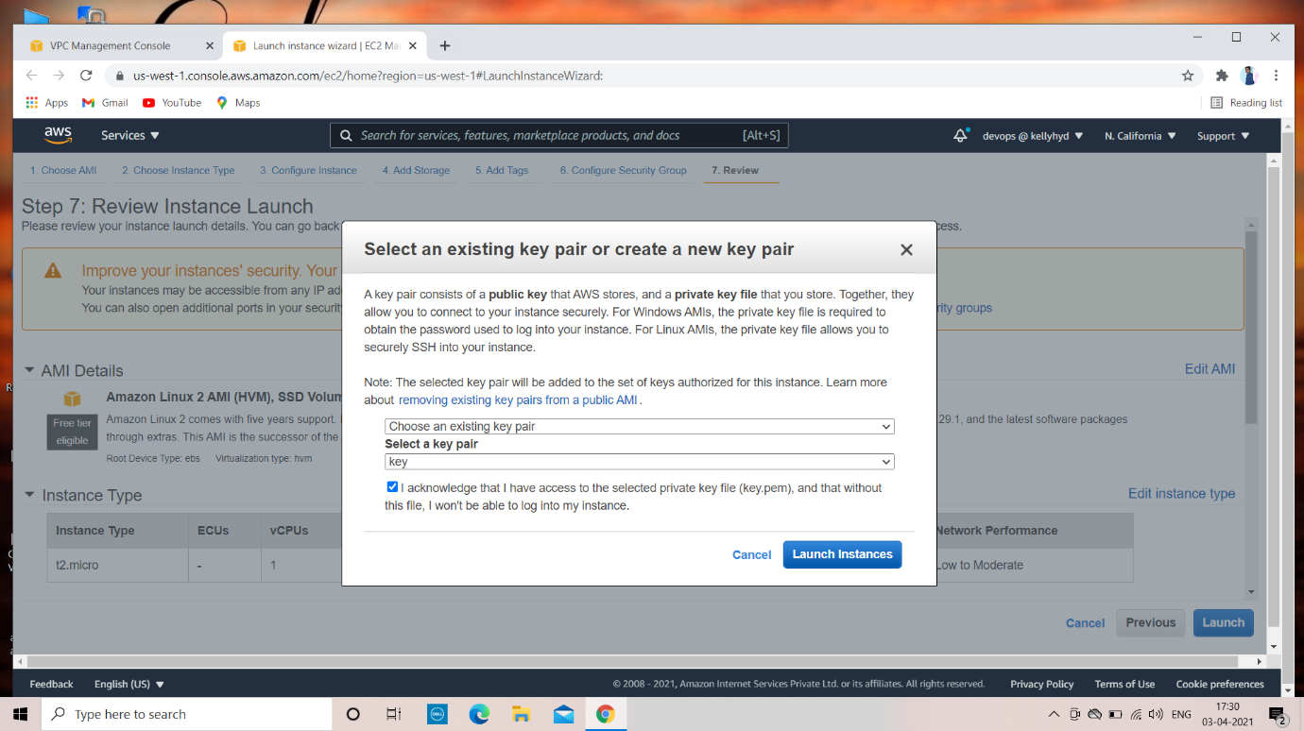

Launch second instance using your own VPC and your private subnet

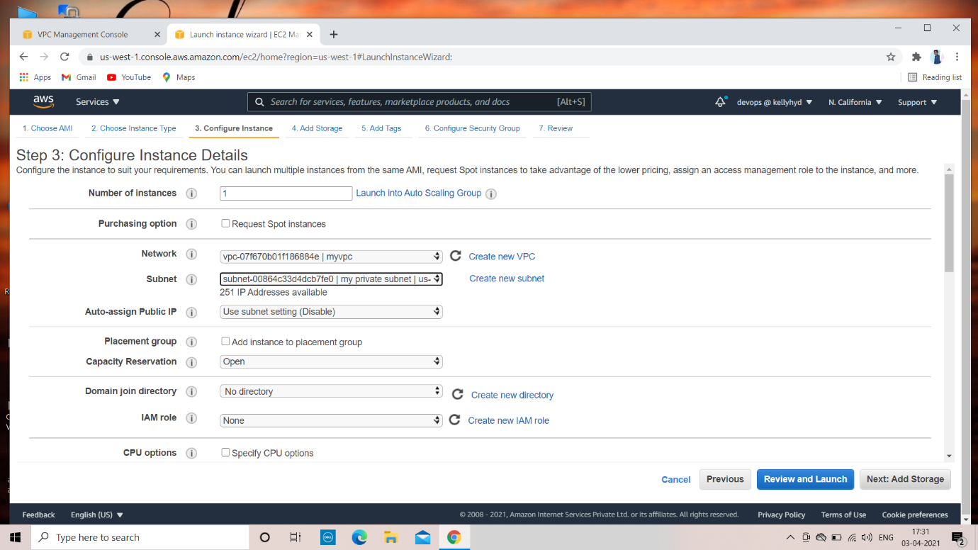

Review and laund the 2nd instance [private subnet]

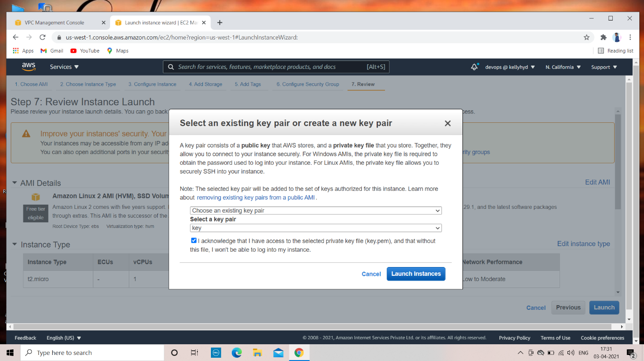

Take the ip address of your public subnet and connect it to the putty

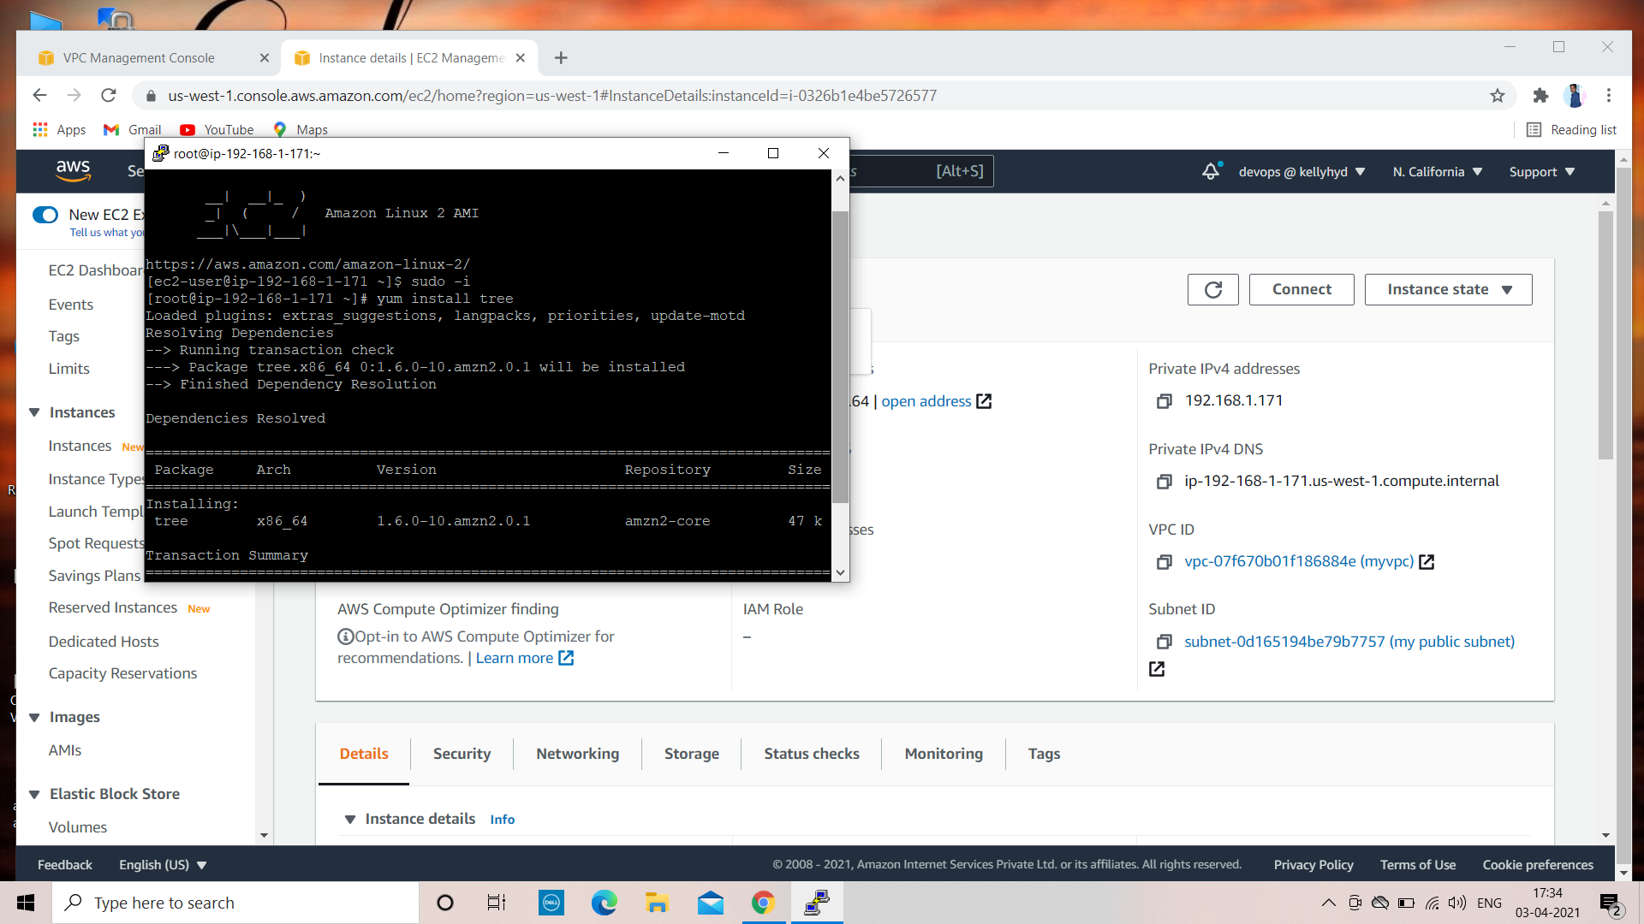

Private ip cannot connect to outside to the world

So in public instance

Copy your pem key and paste it on public key

Vi key.pem[name of the key]

And give the permission

Chmod 600 vi key.pem

Connect you private ip in public ip [private subnet in public subnet]

Using

ssh -i [name of the key] ec2-user@ip

