Squares in a Matrix
Show Topic Tags
Junglee Games

Given a MxN matrix, count the number of squares in the matrix.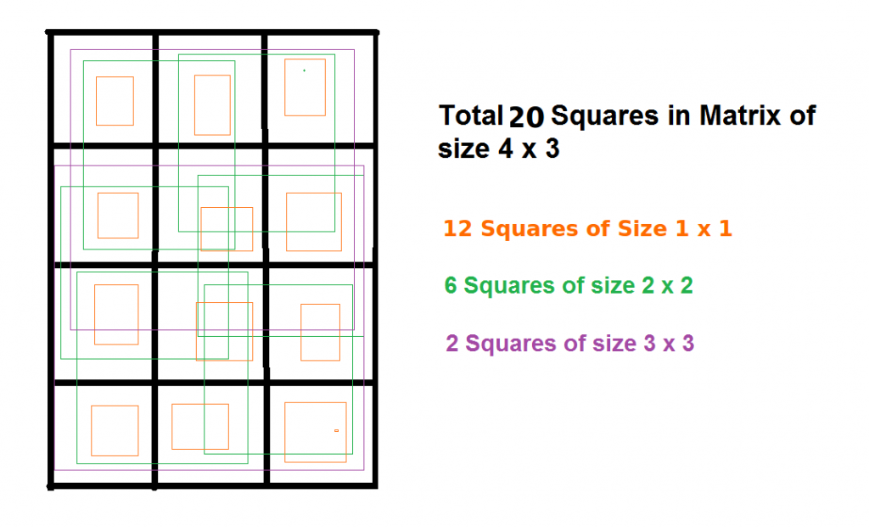
Input:
The first line of input contains an integer T denoting the no of test cases. Then T test cases follow. Each test case contains two space seperated integers M and N, denoting the size of the Matrix.
Output:
For each test output a single integer denoting the total number of squares.
Constraints:
1<=T<=102
1<=M,N<=10^4
Example:
Input:
2
2 2
4 3
Output:
5
20

