Sum of dependencies in a graph
Show Topic Tags
Flipkart

Given a directed graph with n nodes. If there is an edge from u to v then u depends on v. Our task is to find out the sum of dependencies for every node.
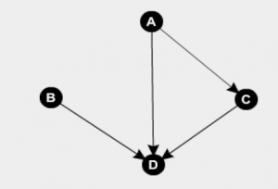
Example:
For the graph in diagram, A depends on C and D i.e. 2, B depends on D i.e. 1, C depends on D i.e. 1
and D depends on none.
Hence answer -> 0 + 1 + 1 + 2 = 4
Input:
The first line of input contains an integer T denoting the no of test cases. Then T test cases follow. The first line of each test case contains two integers N and E denoting the no of vertices and edges of the graph. Then in the next line are E pairs u and v denoting an edge from u to v.
Output:
For each test case in a new line print the required output.
Constraints:
1<=T<=100
1<=N,E<=150
Example:
Input:
2
4 4
0 2 0 3 1 3 2 3
4 3
0 2 0 1 0 3
Output:
4
3

