**Angular** is a platform and framework for building single-page client applications using HTML and TypeScript. Angular is written in TypeScript.

**Spring Boot**is a very popular Java framework for building Restful Webservices and Microservices.

**Angular Spring boot Full-Stack Architecture**

The application will be constructed using the following architecture:

**[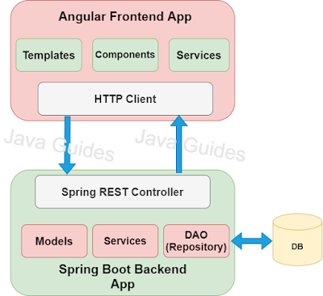](https://blogger.googleusercontent.com/img/b/R29vZ2xl/AVvXsEib8bQN3FISWODEwmdNd2eVnPP1sTW28DoNNMo4M6zz71IFfLcQzcpb8FJxlma9GjMJMQCkJ6quXfRqg6XdQRmTjsJ6I0Rm-GmR9VzffNx3dqCyVPHrDz6FG9pT2l2AN8J0VuLPhLXUfY0/s591/angular-springboot-database.png)**

**What we will build?**

Basically, we will create two projects:

1. **springboot-backend**: This project is used to develop CRUD RESTFul APIs for a simple **Employee Management System** using Spring Boot, JPA, and MySQL as a database.
2. **angular-frontend**: This project is used to develop single page application using Angular 12 as front-end technology. This Angular application consumes CRUD Restful APIs developed and exposed by a **springboot-backend** project.

Below are the screenshots shows the UI of our **Employee Management System App:**

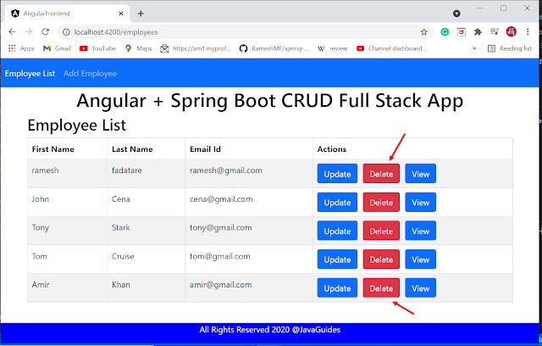

**Prerequisites**

* Basic familiarity with HTML & CSS
* Basic knowledge of JavaScript and programming
* Spring Boot Basics
* Angular basics
* Node.js and npm installed globally

**Tools and technologies used**

**Server-side technologies**

* Spring Boot
* JDK - 1.8 or later
* Spring Framework
* Spring Data JPA (Hibernate)

**Front end technologies**

* Angular (Latest version as of now)
* Bootstrap 4
* Node and NPM
* JQuery

**Tools**

* Maven - 3.2+
* IDE - Eclipse or Spring Tool Suite (STS) // Spring boot API development
* Visual Studio 2017 // Angular App development
* Angular CLI

Let's first develop the Spring boot backend and build CRUD REST APIs.

**1. Develop Spring Boot Backend Application**

Following are five REST APIs (Controller handler methods), we will develop for Employee resource.

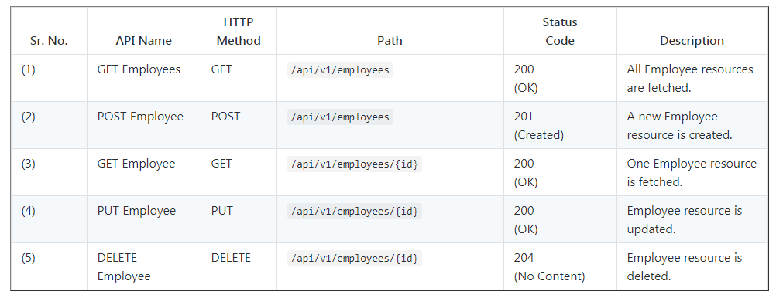

**Step1: Create a Spring Boot Application**

There are many ways to create a Spring Boot application. You can refer to the below articles to create a Spring Boot application.

>> **Create Spring Boot Project With Spring Initializer**  
>> **Create Spring Boot Project in Spring Tool Suite [STS]**

**Step 2: Maven dependencies**

<dependency>

<groupId>org.springframework.boot</groupId>

<artifactId>spring-boot-starter-data-jpa</artifactId>

</dependency>

<dependency>

<groupId>org.springframework.boot</groupId>

<artifactId>spring-boot-starter-web</artifactId>

</dependency>

<dependency>

<groupId>org.springframework.boot</groupId>

<artifactId>spring-boot-devtools</artifactId>

<scope>runtime</scope>

<optional>true</optional>

</dependency>

<dependency>

<groupId>com.h2database</groupId>

<artifactId>h2</artifactId>

<scope>runtime</scope>

</dependency>

**3. Configuring Database (H2 or MySQL)**

**H2 Database Configuration**

In this project, we will use the H2 database to quickly set up and run a spring boot project without installing databases.

Note that we have added the below dependency in the pom.xml file:

<dependency>

<groupId>com.h2database</groupId>

<artifactId>h2</artifactId>

<scope>runtime</scope>

</dependency>

If you use the H2 database then we no need to configure the database-related properties in the application.properties file.

If you use H2 in-memory database then you no need to create a database and tables, spring boot automatically do it for you.

**MySQL Database Configuration**

You can also use the MySQL database but make sure that you follow the below steps to configure the MySQL database in this spring boot project.  
  
**Step 1:**  Replace the H2 database dependency with MySQL dependency:

<dependency>

<groupId>com.mysql</groupId>

<artifactId>mysql-connector-j</artifactId>

<scope>runtime</scope>

</dependency>

**Step 2:** Configure application.properties to connect to your MySQL database. Add the following content to the application.properties file:

spring.datasource.url = jdbc:mysql://localhost:3306/EMS?useSSL=false

spring.datasource.username = root

spring.datasource.password = root

## Hibernate Properties

# The SQL dialect makes Hibernate generate better SQL for the chosen database

spring.jpa.properties.hibernate.dialect = org.hibernate.dialect.MySQL5InnoDBDialect

# Hibernate ddl auto (create, create-drop, validate, update)

spring.jpa.hibernate.ddl-auto = update

server.servlet.context-path=/

Make sure that you will change the above database configuration such as JDBC URL, username, and password as per your environment.

**Step 3:** You need to create a database in MySQL server with the following command:

create database EMS

Hibernate will automatically create database tables so you only need to manually create the database and configure an application.properties file.

**4. Create JPA Entity - Employee.java**

Let's create a new package called *model* inside net.javaguides.springboot package and then create the *Employee* class inside the *model* package with the following contents -

package com.example.crud.model;

import jakarta.persistence.*;

@Entity

@Table(name = "employees")

public class Employee {

@Id

@GeneratedValue(strategy = GenerationType.IDENTITY)

private long id;

@Column(name = "first_name")

private String firstName;

@Column(name = "last_name")

private String lastName;

@Column(name = "email_id")

private String emailId;

public Employee() {

}

public Employee(String firstName, String lastName, String emailId) {

super();

this.firstName = firstName;

this.lastName = lastName;

this.emailId = emailId;

}

public long getId() {

return id;

}

public void setId(long id) {

this.id = id;

}

public String getFirstName() {

return firstName;

}

public void setFirstName(String firstName) {

this.firstName = firstName;

}

public String getLastName() {

return lastName;

}

public void setLastName(String lastName) {

this.lastName = lastName;

}

public String getEmailId() {

return emailId;

}

public void setEmailId(String emailId) {

this.emailId = emailId;

}

}

**5. Create a Spring Data Repository - EmployeeRepository.java**

Create a new package called *repository* inside net.javaguides.springboot package and then create the following interface inside the *repository* package -

package com.example.crud.repository;

import org.springframework.data.jpa.repository.JpaRepository;

import org.springframework.stereotype.Repository;

import com.example.crud.model.Employee;

@Repository

public interface EmployeeRepository extends JpaRepository<Employee, Long>{

}

**6. Create Custom Exception**

Let's create an *exception* package and within this, create an ResourceNotFoundException class and add the following code to it:

package com.example.crud.exception;

import org.springframework.http.HttpStatus;

import org.springframework.web.bind.annotation.ResponseStatus;

@ResponseStatus(value = HttpStatus.NOT_FOUND)

public class ResourceNotFoundException extends RuntimeException{

private static final long serialVersionUID = 1L;

public ResourceNotFoundException(String message) {

super(message);

}

}

**7. Create Spring Rest Controller - EmployeeController.java**

Let's create a *controller* package and within this, create an EmployeeController class and add the following code to it:

package com.example.crud.controller;

import java.util.HashMap;

import java.util.List;

import java.util.Map;

import org.springframework.beans.factory.annotation.Autowired;

import org.springframework.http.ResponseEntity;

import org.springframework.web.bind.annotation.CrossOrigin;

import org.springframework.web.bind.annotation.DeleteMapping;

import org.springframework.web.bind.annotation.GetMapping;

import org.springframework.web.bind.annotation.PathVariable;

import org.springframework.web.bind.annotation.PostMapping;

import org.springframework.web.bind.annotation.PutMapping;

import org.springframework.web.bind.annotation.RequestBody;

import org.springframework.web.bind.annotation.RequestMapping;

import org.springframework.web.bind.annotation.RestController;

import com.example.crud.exception.ResourceNotFoundException;

import com.example.crud.model.Employee;

import com.example.crud.repository.EmployeeRepository;

@CrossOrigin(origins = "http://localhost:4200")

@RestController

@RequestMapping("/api/v1/")

public class EmployeeController {

@Autowired

private EmployeeRepository employeeRepository;

// get all employees

@GetMapping("/employees")

public List<Employee> getAllEmployees(){

return employeeRepository.findAll();

}

// create employee rest api

@PostMapping("/employees")

public Employee createEmployee(@RequestBody Employee employee) {

return employeeRepository.save(employee);

}

// get employee by id rest api

@GetMapping("/employees/{id}")

public ResponseEntity<Employee> getEmployeeById(@PathVariable Long id) {

Employee employee = employeeRepository.findById(id)

.orElseThrow(() -> new ResourceNotFoundException("Employee not exist with id :" + id));

return ResponseEntity.ok(employee);

}

// update employee rest api

@PutMapping("/employees/{id}")

public ResponseEntity<Employee> updateEmployee(@PathVariable Long id, @RequestBody Employee employeeDetails){

Employee employee = employeeRepository.findById(id)

.orElseThrow(() -> new ResourceNotFoundException("Employee not exist with id :" + id));

employee.setFirstName(employeeDetails.getFirstName());

employee.setLastName(employeeDetails.getLastName());

employee.setEmailId(employeeDetails.getEmailId());

Employee updatedEmployee = employeeRepository.save(employee);

return ResponseEntity.ok(updatedEmployee);

}

// delete employee rest api

@DeleteMapping("/employees/{id}")

public ResponseEntity<Map<String, Boolean>> deleteEmployee(@PathVariable Long id){

Employee employee = employeeRepository.findById(id)

.orElseThrow(() -> new ResourceNotFoundException("Employee not exist with id :" + id));

employeeRepository.delete(employee);

Map<String, Boolean> response = new HashMap<>();

response.put("deleted", Boolean.TRUE);

return ResponseEntity.ok(response);

}

}

**Enable CORS on the Server**

To enable CORS on the server, add a *@CrossOrigin* annotation to the *EmployeeController*:

@CrossOrigin(origins = "http://localhost:4200")

@RestController

@RequestMapping("/api/v1/")

public class EmployeeController {

// ..

}

**8. Running Application**

This spring boot application has an entry point Java class called SpringbootBackendApplication.java with the public static void main(String[] args) method, which you can run to start the application.

package com.example.crud;

import org.springframework.boot.SpringApplication;

import org.springframework.boot.autoconfigure.SpringBootApplication;

@SpringBootApplication

public class SpringbootBackendApplication {

public static void main(String[] args) {

SpringApplication.run(SpringbootBackendApplication.class, args);

}

}

Or you can start the spring boot application via the command line using **mvn spring-boot:run** command.

**9. Testing REST APIs**

Use below Rest endpoints to test CRUD Rest APIs and in Angular application.

**Get All Employees:**

HTTP Method: GET

http://localhost:8080/api/v1/employees

**Get Employee By Id:**

HTTP Method GET

http://localhost:8080/api/v1/employees/{employeeId}

**Create Employee:**

HTTP Method - POST

http://localhost:8080/api/v1/employees

**Update Employee**

HTTP Method - POST

http://localhost:8080/api/v1/employees/{employeeId}

**Delete Employee By Id:**

HTTP Method - DELETE

http://localhost:8080/api/v1/employees/{employeeId}

This completes the development of Spring boot CRUD Rest APIs.

**2. Develop Angular Frontend Application**

Let's develop a step-by-step CRUD (Create, Read, Update, Delete) web application using Angular 12 which consumes CRUD rest APIs.

I assume that you have installed **Node.js**. Now, we need to check the **Node.js** and NPM versions. Open the terminal or Node command line then type these commands.

G:\angular\Angular 12>node -v

v12.18.2

G:\angular\Angular 12>npm -v

6.14.5

**1. Install the latest version of Angular CLI**

To install or update Angular CLI, type this command in the Terminal or Node Command-Line.

npm install -g @angular/cli

Now, let's check the latest version of Angular CLI:

G:\angular\Angular 12>ng --version

_ _ ____ _ ___

/ \ _ __ __ _ _ _| | __ _ _ __ / ___| | |_ _|

/ △ \ | '_ \ / _` | | | | |/ _` | '__| | | | | | |

/ ___ \| | | | (_| | |_| | | (_| | | | |___| |___ | |

/_/ \_\_| |_|\__, |\__,_|_|\__,_|_| \____|_____|___|

|___/

Angular CLI: 12.1.3

Node: 12.18.2

Package Manager: npm 6.14.5

OS: win32 x64

Angular:

...

Package Version

------------------------------------------------------

@angular-devkit/architect 0.1201.3 (cli-only)

@angular-devkit/core 12.1.3 (cli-only)

@angular-devkit/schematics 12.1.3 (cli-only)

@schematics/angular 12.1.3 (cli-only)

**2. Create Angular App using Angular CLI**

The **Angular CLI** is a command-line interface tool that you use to initialize, develop, scaffold, and maintain Angular applications.

If you are new to Angular CLI then check out official documentation at [**https://cli.angular.io**](https://cli.angular.io/).

Let's use the below command to generate an Angular Client application. We name this project as "**angular-frontend**".

ng new angular-frontend

**3. Identify Components, Services, and Modules**

Let's list out what are **components**, **services**, and **modules** we are going to create in this application. We will use Angular CLI to generate components, services because Angular CLI follows best practices and saves much time.

**Components**

* create-employee
* update-employee
* employee-list
* employee-details

**Services**

* employee.service.ts - Service for HTTP Client methods

**Modules**

We use below in-built modules provided by Angular:

* FormsModule
* HttpClientModule
* AppRoutingModule

**Employee Class (Typescript class)**

* employee.ts: class Employee (id, firstName, lastName, emailId)

In the next step, we will generate these components, classes, and services using **Angular CLI.**

**4. Create Angular Components and Service Classes using Angular CLI**

Let's auto-generate the service and components using **Angular CLI**. Change your project directory to **angular-frontend\src\app** and run the following commands:

– ng g c create-employee

– ng g c update-employee

– ng g c employee-details

– ng g c employee-list

- ng g s employee

**5. Integrate JQuery and Bootstrap with Angular**

Use NPM to download **Bootstrap** & **JQuery**. **Bootstrap** and **jQuery** will be installed into the **node_modules** folder.

npm install bootstrap jquery --save

Configure installed **Bootstrap** & **JQuery** in an angular.json file:

...

"styles": [

"src/styles.css",

"node_modules/bootstrap/dist/css/bootstrap.min.css"

],

"scripts": [

"node_modules/jquery/dist/jquery.min.js",

"node_modules/bootstrap/dist/js/bootstrap.min.js"

]

...

**If bootstrap won't work then try to import bootstrap CSS in style.css like:**

/* You can add global styles to this file, and also import other style files */

@import '~bootstrap/dist/css/bootstrap.min.css';

.footer {

position: absolute;

bottom: 0;

width:100%;

height: 70px;

background-color: blue;

text-align: center;

color: white;

}

**6. Create an Employee Model (TypeScript)**

**Path - src/app/employee.ts**

Before defining the **EmployeeListComponent**, let’s define an **Employee** class for working with employees. create a new file employee.ts inside src/app folder and add the following code to it -

export class Employee {

id: number;

firstName: string;

lastName: string;

emailId: string;

}

**7. Create Employee Service - REST Client**

**Path - src/app/employee.service.ts**

The **EmployeeService** will be used to get the data from the backend by calling spring boot APIs. Update the employee.service.ts file inside src/app directory with the following code to it -

import { Injectable } from '@angular/core';

import { HttpClient } from '@angular/common/http'

import { Observable } from 'rxjs';

import { Employee } from './employee';

@Injectable({

providedIn: 'root'

})

export class EmployeeService {

private baseURL = "http://localhost:8080/api/v1/employees";

constructor(private httpClient: HttpClient) { }

getEmployeesList(): Observable<Employee[]>{

return this.httpClient.get<Employee[]>(`${this.baseURL}`);

}

createEmployee(employee: Employee): Observable<Object>{

return this.httpClient.post(`${this.baseURL}`, employee);

}

getEmployeeById(id: number): Observable<Employee>{

return this.httpClient.get<Employee>(`${this.baseURL}/${id}`);

}

updateEmployee(id: number, employee: Employee): Observable<Object>{

return this.httpClient.put(`${this.baseURL}/${id}`, employee);

}

deleteEmployee(id: number): Observable<Object>{

return this.httpClient.delete(`${this.baseURL}/${id}`);

}

}

In the next step, we will start creating Angular components.

**8. Creating Employee List Component and Template**

**Path - src/app/employee-list/employee-list.component.ts**

Let's create the **EmployeeListComponent** component which will be used to display a list of employees, create a new employee, and delete an employee.

Update/remove the content of employee-list.component.ts inside src/app directory and add the following code to it -

import { Component, OnInit } from '@angular/core';

import { Employee } from '../employee'

import { EmployeeService } from '../employee.service'

import { Router } from '@angular/router';

@Component({

selector: 'app-employee-list',

templateUrl: './employee-list.component.html',

styleUrls: ['./employee-list.component.css']

})

export class EmployeeListComponent implements OnInit {

employees: Employee[];

constructor(private employeeService: EmployeeService,

private router: Router) { }

ngOnInit(): void {

this.getEmployees();

}

private getEmployees(){

this.employeeService.getEmployeesList().subscribe(data => {

this.employees = data;

});

}

employeeDetails(id: number){

this.router.navigate(['employee-details', id]);

}

updateEmployee(id: number){

this.router.navigate(['update-employee', id]);

}

deleteEmployee(id: number){

this.employeeService.deleteEmployee(id).subscribe( data => {

console.log(data);

this.getEmployees();

})

}

}

**Path - src/app/employee-list/employee-list.component.html**

Add employee-list.component.html file with the following code to it -

<div class = "row">

<h2> Employee List</h2>

</div>

<table class = "table table-striped table-bordered">

<thead>

<tr>

<th> First Name</th>

<th> Last Name </th>

<th> Email Id</th>

<th> Actions </th>

</tr>

</thead>

<tbody>

<tr *ngFor = "let employee of employees" >

<td> {{ employee.firstName }} </td>

<td> {{ employee.lastName }} </td>

<td> {{ employee.emailId }} </td>

<td>

<button (click) = "updateEmployee(employee.id)" class = "btn btn-primary"> Update</button>

<button (click) = "deleteEmployee(employee.id)" class = "btn btn-danger" style="margin-left: 10px"> Delete</button>

<button (click) = "employeeDetails(employee.id)" class = "btn btn-primary" style="margin-left: 10px"> View</button>

</td>

</tr>

</tbody>

</table>

**9. Create Add Employee Component and Template**

**Path - src/app/create-employee/create-employee.component.ts**

**CreateEmployeeComponent** is used to create and handle a new employee form data. Add the following code to it -

import { Component, OnInit } from '@angular/core';

import { Employee } from '../employee';

import { EmployeeService } from '../employee.service';

import { Router } from '@angular/router';

@Component({

selector: 'app-create-employee',

templateUrl: './create-employee.component.html',

styleUrls: ['./create-employee.component.css']

})

export class CreateEmployeeComponent implements OnInit {

employee: Employee = new Employee();

constructor(private employeeService: EmployeeService,

private router: Router) { }

ngOnInit(): void {

}

saveEmployee(){

this.employeeService.createEmployee(this.employee).subscribe( data =>{

console.log(data);

this.goToEmployeeList();

},

error => console.log(error));

}

goToEmployeeList(){

this.router.navigate(['/employees']);

}

onSubmit(){

console.log(this.employee);

this.saveEmployee();

}

}

**Path - src/app/create-employee/create-employee.component.html**

The create-employee.component.html shows the add employee HTML form. Add the following code to it -

<div class="row">

<div class="card col-md-6 offset-md-3 offset-md-3">

<div class="row">

<h3 class="text-center"> Create Employee </h3>

<hr />

<div class="card-body">

<form (ngSubmit)="onSubmit()">

<div class="form-group">

<label> First Name</label>

<input type="text" class="form-control" id="firstName" [(ngModel)]="employee.firstName"

name="firstName">

</div>

<div class="form-group">

<label> Last Name</label>

<input type="text" class="form-control" id="lastName" [(ngModel)]="employee.lastName"

name="lastName">

</div>

<div class="form-group">

<label> Email Id</label>

<input type="text" class="form-control" id="emailId" [(ngModel)]="employee.emailId"

name="emailId">

</div>

<br />

<button class="btn btn-success" type="submit">Submit</button>

</form>

</div>

</div>

</div>

</div>

**10. Create Update Employee Component and Template**

**Path - src/app/update-employee/update-employee.component.ts**

In this UpdateEmployeeComponent, we first get the employee object using REST API and populate it in HTML form via data binding. Users can edit the employee form data and submit the form.

Let's add the following code to UpdateEmployeeComponent -

import { Component, OnInit } from '@angular/core';

import { EmployeeService } from '../employee.service';

import { Employee } from '../employee';

import { ActivatedRoute, Router } from '@angular/router';

@Component({

selector: 'app-update-employee',

templateUrl: './update-employee.component.html',

styleUrls: ['./update-employee.component.css']

})

export class UpdateEmployeeComponent implements OnInit {

id: number;

employee: Employee = new Employee();

constructor(private employeeService: EmployeeService,

private route: ActivatedRoute,

private router: Router) { }

ngOnInit(): void {

this.id = this.route.snapshot.params['id'];

this.employeeService.getEmployeeById(this.id).subscribe(data => {

this.employee = data;

}, error => console.log(error));

}

onSubmit(){

this.employeeService.updateEmployee(this.id, this.employee).subscribe( data =>{

this.goToEmployeeList();

}

, error => console.log(error));

}

goToEmployeeList(){

this.router.navigate(['/employees']);

}

}

**Path - src/app/update-employee/update-employee.component.html**

The *update-employee.component.html* shows the updated employee HTML form. Add the following code to this file -

<div class="row">

<div class="card col-md-6 offset-md-3 offset-md-3">

<div class="row">

<h3 class="text-center"> Update Employee </h3>

<hr />

<div class="card-body">

<form (ngSubmit)="onSubmit()">

<div class="form-group">

<label> First Name</label>

<input type="text" class="form-control" id="firstName" [(ngModel)]="employee.firstName"

name="firstName">

</div>

<div class="form-group">

<label> Last Name</label>

<input type="text" class="form-control" id="lastName" [(ngModel)]="employee.lastName"

name="lastName">

</div>

<div class="form-group">

<label> Email Id</label>

<input type="text" class="form-control" id="emailId" [(ngModel)]="employee.emailId"

name="emailId">

</div>

<br />

<button class="btn btn-success" type="submit">Submit</button>

</form>

</div>

</div>

</div>

</div>

**11. Create View Employee Details Component and Template**

**Path - src/app/employee-details/employee-details.component.ts**

The *EmployeeDetailsComponent* component is used to display a particular employee detail. Add the following code to it -

import { Component, OnInit } from '@angular/core';

import { Employee } from '../employee';

import { ActivatedRoute } from '@angular/router';

import { EmployeeService } from '../employee.service';

@Component({

selector: 'app-employee-details',

templateUrl: './employee-details.component.html',

styleUrls: ['./employee-details.component.css']

})

export class EmployeeDetailsComponent implements OnInit {

id: number

employee: Employee

constructor(private route: ActivatedRoute, private employeService: EmployeeService) { }

ngOnInit(): void {

this.id = this.route.snapshot.params['id'];

this.employee = new Employee();

this.employeService.getEmployeeById(this.id).subscribe( data => {

this.employee = data;

});

}

}

**Path - src/app/employee-details/employee-details.component.html**

The employee-details.component.html displays a particular employee detail. Add the following code to it -

<h3> View Employee Details</h3>

<div>

<div>

<label> <b> First Name: </b></label> {{employee.firstName}}

</div>

<div>

<label> <b> Last Name: </b></label> {{employee.lastName}}

</div>

<div>

<label> <b> Email Id: </b></label> {{employee.emailId}}

</div>

</div>

**12. package.json - Configure Dependencies**

**Path: /package.json**

The package.json file contains project configuration information including package dependencies that get installed when you run npm install. Full documentation is available on the **[npm docs website](https://docs.npmjs.com/files/package.json)**.

**Note that angular version 12.1.0 is in the dependencies section in the below file.**

{

"name": "angular-frontend",

"version": "0.0.0",

"scripts": {

"ng": "ng",

"start": "ng serve",

"build": "ng build",

"watch": "ng build --watch --configuration development",

"test": "ng test"

},

"private": true,

"dependencies": {

"@angular/animations": "~12.1.0-",

"@angular/common": "~12.1.0-",

"@angular/compiler": "~12.1.0-",

"@angular/core": "~12.1.0-",

"@angular/forms": "~12.1.0-",

"@angular/platform-browser": "~12.1.0-",

"@angular/platform-browser-dynamic": "~12.1.0-",

"@angular/router": "~12.1.0-",

"bootstrap": "^5.0.2",

"jquery": "^3.6.0",

"rxjs": "~6.6.0",

"tslib": "^2.2.0",

"zone.js": "~0.11.4"

},

"devDependencies": {

"@angular-devkit/build-angular": "~12.1.3",

"@angular/cli": "~12.1.3",

"@angular/compiler-cli": "~12.1.0-",

"@types/jasmine": "~3.8.0",

"@types/node": "^12.11.1",

"jasmine-core": "~3.8.0",

"karma": "~6.3.0",

"karma-chrome-launcher": "~3.1.0",

"karma-coverage": "~2.0.3",

"karma-jasmine": "~4.0.0",

"karma-jasmine-html-reporter": "~1.7.0",

"typescript": "~4.3.2"

}

}

**13. App Routing Module**

**Path: /src/app/app.routing.module.ts**

Routing for the Angular app is configured as an array of **Routes**, each component is mapped to a path so the Angular Router knows which component to display based on the URL in the browser address bar.

import { NgModule } from '@angular/core';

import { Routes, RouterModule } from '@angular/router';

import { EmployeeListComponent } from './employee-list/employee-list.component';

import { CreateEmployeeComponent } from './create-employee/create-employee.component';

import { UpdateEmployeeComponent } from './update-employee/update-employee.component';

import { EmployeeDetailsComponent } from './employee-details/employee-details.component';

const routes: Routes = [

{path: 'employees', component: EmployeeListComponent},

{path: 'create-employee', component: CreateEmployeeComponent},

{path: '', redirectTo: 'employees', pathMatch: 'full'},

{path: 'update-employee/:id', component: UpdateEmployeeComponent},

{path: 'employee-details/:id', component: EmployeeDetailsComponent}

];

@NgModule({

imports: [RouterModule.forRoot(routes)],

exports: [RouterModule]

})

export class AppRoutingModule { }

**14. App Component**

**Path: /src/app/app.component.ts**

The app component is the root component of the application, it defines the root tag of the app as with the selector property of the **@Component** decorator.

import { Component } from '@angular/core';

@Component({

selector: 'app-root',

templateUrl: './app.component.html',

styleUrls: ['./app.component.css']

})

export class AppComponent {

title = 'Angular + Spring Boot CRUD Full Stack App';

}

**15. App Component Template**

**Path: /src/app/app.component.html**

Defines the HTML template associated with the root AppComponent.

<nav class="navbar navbar-expand-sm bg-primary navbar-dark">

<ul class = "navbar-nav">

<li class = "nav-item">

<a routerLink="employees" routerLinkActive="active" class="nav-link" >Employee List</a>

</li>

<li class = "nav-item">

<a routerLink="create-employee" routerLinkActive="active" class="nav-link" >Add Employee</a>

</li>

</ul>

</nav>

<h1 class="text-center"> {{title}} </h1>

<div class = "container">

<router-outlet></router-outlet>

</div>

<footer class = "footer">

<div class = "container">

<span>All Rights Reserved 2020 @JavaGuides</span>

</div>

</footer>

**16. App Module**

**Path: /src/app/app.module.ts**

Defines the root module, named AppModule, that tells Angular how to assemble the application. Initially declares only the AppComponent. As you add more components to the app, they must be declared here.

import { BrowserModule } from '@angular/platform-browser';

import { NgModule } from '@angular/core';

import { HttpClientModule } from '@angular/common/http'

import { AppRoutingModule } from './app-routing.module';

import { AppComponent } from './app.component';

import { EmployeeListComponent } from './employee-list/employee-list.component';

import { CreateEmployeeComponent } from './create-employee/create-employee.component';

import { FormsModule} from '@angular/forms';

import { UpdateEmployeeComponent } from './update-employee/update-employee.component';

import { EmployeeDetailsComponent } from './employee-details/employee-details.component'

@NgModule({

declarations: [

AppComponent,

EmployeeListComponent,

CreateEmployeeComponent,

UpdateEmployeeComponent,

EmployeeDetailsComponent

],

imports: [

BrowserModule,

AppRoutingModule,

HttpClientModule,

FormsModule

],

providers: [],

bootstrap: [AppComponent]

})

export class AppModule { }

**17. Running Angular Client Application**

Let's run the above developed Angular App with a command:

ng serve

By default, the Angular app runs on **4200** port but you can change the default port with the following command:

ng serve --port 4201

**3. Demo of Complete Full-stack Application**

Make sure that both (Spring boot and Angular) applications are up and running.

Hit [**http://localhost:4200**](http://localhost:4200/) link in a browser that will host this Angular CRUD app.

Below are the screenshots shows the UI of our **Employee Management System** App.

**Employee List Page**



**Add Employee Page**

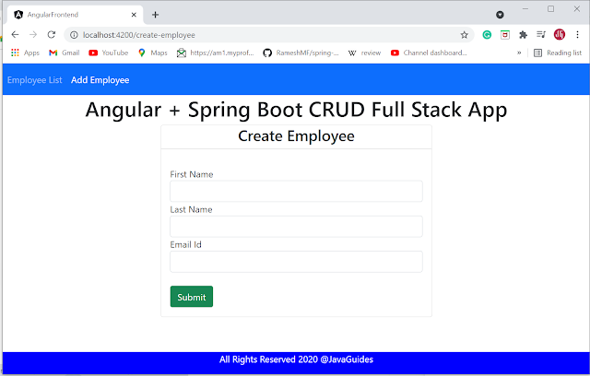

**Update Employee Page**

