“HeartBeats”  **Rangnathan.KR**

**ABSTARCT:**

* HeartBeats is a website where we can get the information of the collective blood donors on the specific area of mentioned.
* Here a recipient can request there need to the specific Donor personally.
* Here a recipient can request and report the donor without any registration.
* HeartBeats is a website used for getting blood donor volunteer's number where blood was in short of Blood Bank

**TABLE:**

There are 3 tables in our project

1. Donor Table
2. Request Table
3. Report Table

The following table elements are been explained clearly below.

**Donor Table:**

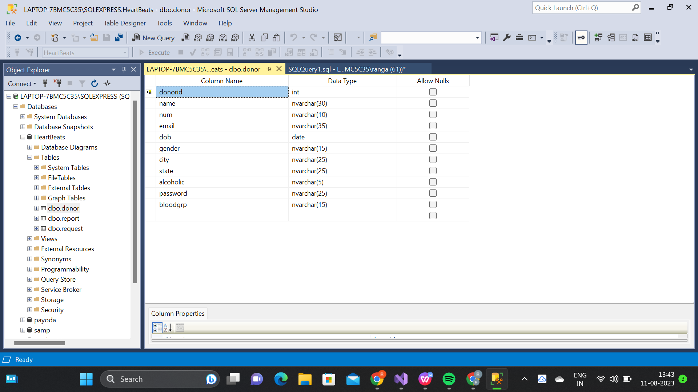

**Request Table:**

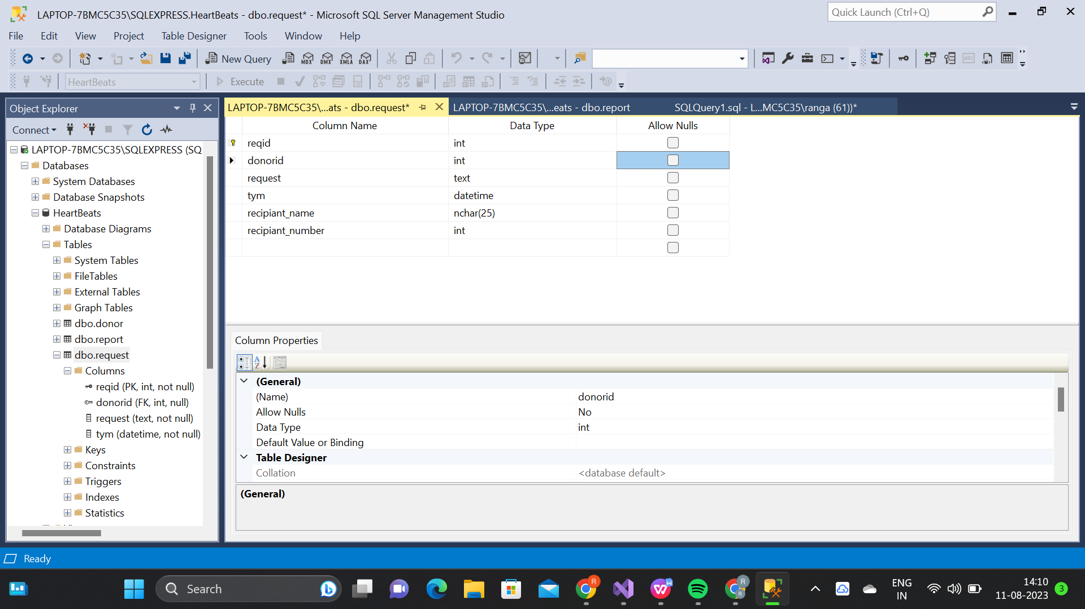

**Report Table:**

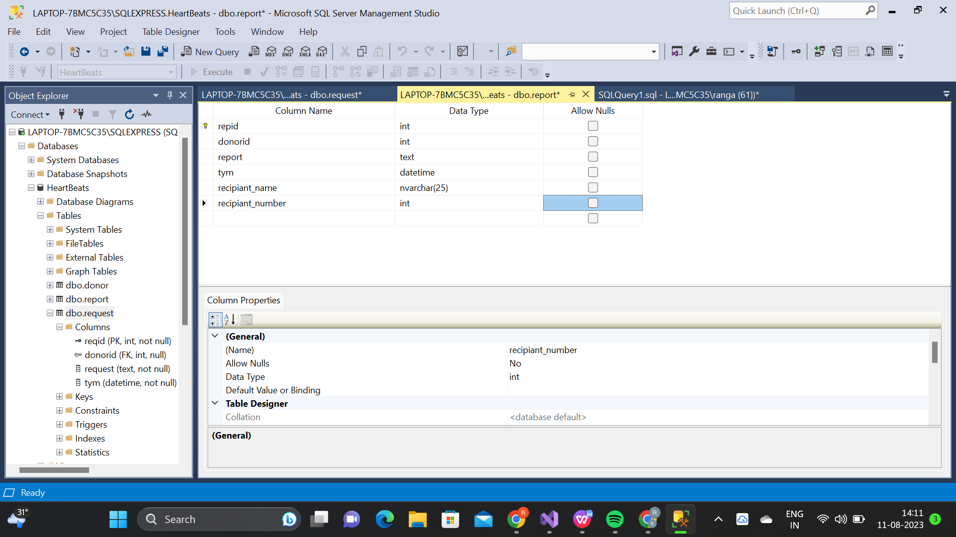

**EndPoints(CRUD) :**

**Create:**

* Donor create his own account
* Recipiant create a request and report

**Read:**

* Donor request view
* Donor profile view

**Update:**

* Donor profile update

**Delete:**

* Donor delete his account