EDUGENIE
Google Gemini Powered Learning Assistant
PROJECT DOCUMENTATION — BASED ON THE UPLOADED SOURCE CODE

FastAPI • Python • Google Gemini • REST APIs • Render Deployment

1. Project Description
EduGenie is a FastAPI-based learning assistant that uses Google Gemini to provide educational question answering, concept explanations, text summaries, multiple-choice quizzes, and personalized learning paths. The uploaded README describes the application as a FastAPI learning assistant with Gemini-powered Q&A, explanations, summaries, quizzes, and learning paths.
The source code confirms that the FastAPI application is the central entry point. It exposes the learning features as HTTP endpoints and also serves the web frontend from the root route.

2. Objectives
- Answer user questions through the Gemini API.
- Explain topics using simple educational language.
- Summarize supplied text while preserving important points.
- Generate five multiple-choice questions in structured JSON.
- Generate beginner-to-advanced learning recommendations with activities and resources.
- Provide a health endpoint for checking application/API-key configuration.
- Support local execution and Render deployment.

3. Source-Code Based Architecture
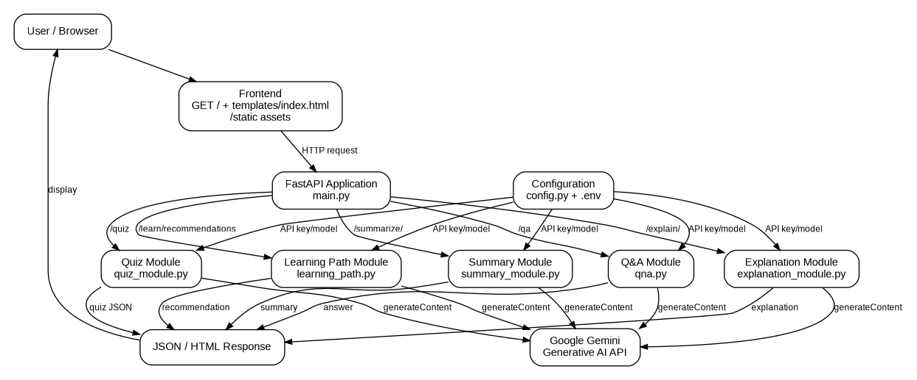
Fig. 1. EduGenie architecture derived from the uploaded Python source code.
The architecture is centered on main.py. The FastAPI application imports qna.py, explanation_module.py, summary_module.py, quiz_module.py, and learning_path.py. These modules use configuration values from config.py and send requests to Google's Gemini generateContent API.

4. Technology Stack
Technology | Role | Evidence in source
Python | Application and AI integration | All backend modules are Python files.
FastAPI | Web/API framework | main.py creates FastAPI app and routes.
Uvicorn | ASGI server | main.py starts uvicorn; render.yaml uses uvicorn.
Jinja2 | HTML templating | main.py creates Jinja2Templates and serves index.html.
Requests | HTTP calls to Gemini | AI modules use requests.post().
python-dotenv | Environment configuration | config.py calls load_dotenv().
Google Gemini | Generative AI backend | All five AI modules call Gemini generateContent.

5. Project Folder / File Structure
The uploaded source set contains the following application files and deployment configuration:
EduGenie/
├── main.py
├── config.py
├── qna.py
├── explanation_module.py
├── summary_module.py
├── quiz_module.py
├── learning_path.py
├── requirements.txt
├── README.md
├── render.yaml
├── .env
└── .gitignore
main.py also expects a templates directory containing index.html and a static directory for static assets. Those directories were not included in the uploaded source files, so their internal contents are not described here.

6. Main Application — main.py
main.py creates the FastAPI application with the title 'EduGenie', description 'Google Gemini Powered Learning Assistant', and version 1.0.0. It mounts /static and configures Jinja2 templates. The root route renders index.html.

6.1 API Endpoints
Method | Endpoint | Input | Purpose
GET | / | Browser request | Serves the HTML frontend.
GET | /health | None | Returns status and whether Gemini is configured.
GET | /qa | question query parameter | Returns an AI answer.
POST | /explain/ | JSON: topic | Returns a simple explanation.
POST | /summarize/ | JSON: text | Returns a concise summary.
POST | /quiz | JSON: text | Returns generated quiz items.
GET | /learn/recommendations | topic query parameter | Returns a learning recommendation.

7. Overall Application Flow
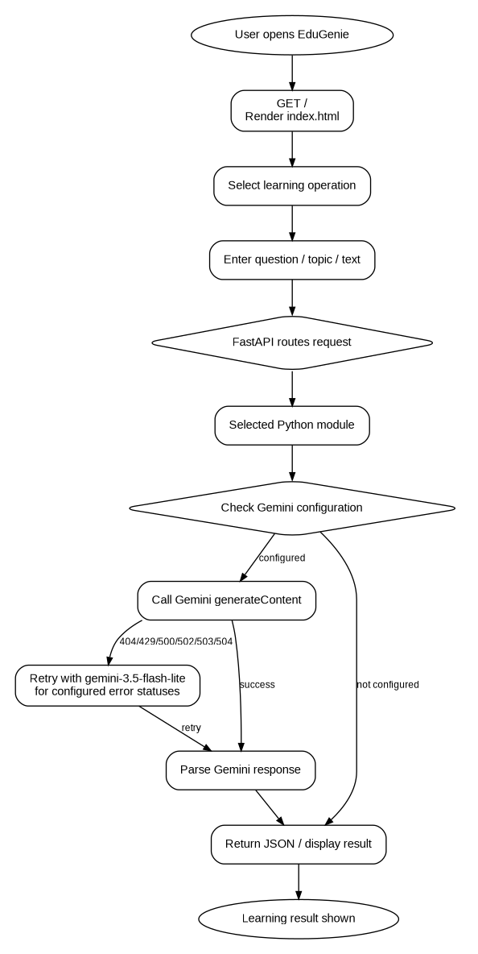
Fig. 2. Overall request and response flow.
A request begins at the browser/frontend and is routed by FastAPI to the selected module. The module checks whether a Gemini API key is configured, sends a request to Gemini, optionally retries with the fallback model for selected HTTP errors, extracts the generated text, and returns the result to the API caller.

8. Q&A Module
The Q&A endpoint is GET /qa and requires the question query parameter. main.py passes the question to answer_question_with_gemini() in qna.py. The function sends the question directly as the Gemini content prompt and uses temperature 0.2 with a maximum of 500 output tokens.
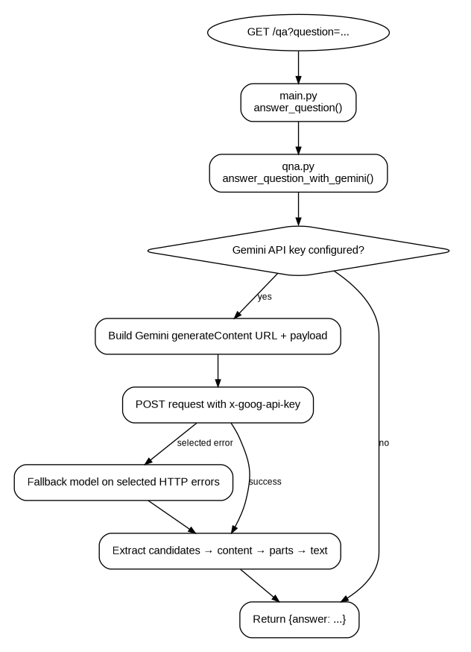
Fig. 3. Q&A module flow derived from qna.py.

9. Explanation Module
The explanation endpoint is POST /explain/. The request body must contain a topic. The module builds a prompt asking Gemini to explain the topic in simple educational language using three sections: what it is, why it matters, and a short example. The response is returned together with the topic.
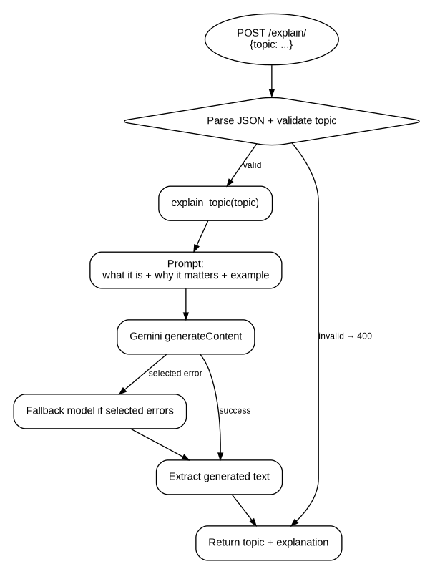
Fig. 4. Explanation module flow derived from main.py and explanation_module.py.

10. Summary Module
The summary endpoint is POST /summarize/. The request body must contain text. The summary module asks Gemini to summarize the text concisely and readably while keeping the most important points.
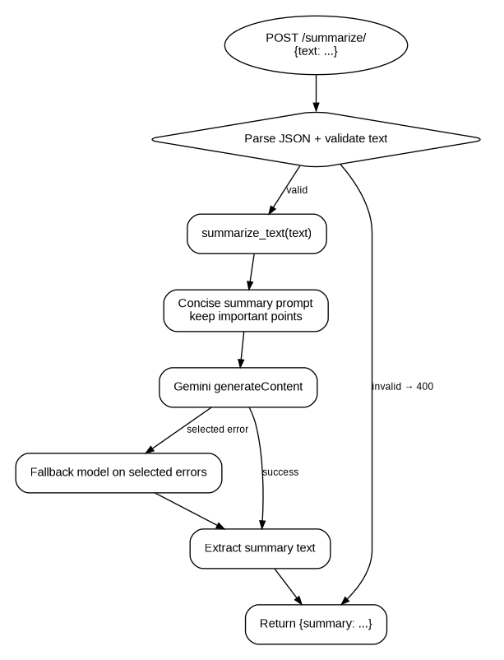
Fig. 5. Summary module flow derived from main.py and summary_module.py.

11. Quiz Module
The quiz endpoint is POST /quiz. The module instructs Gemini to create five multiple-choice questions. Each item is requested in JSON format with a question, four options, and an answer. The returned text is cleaned of Markdown code fences when present and then parsed using json.loads().
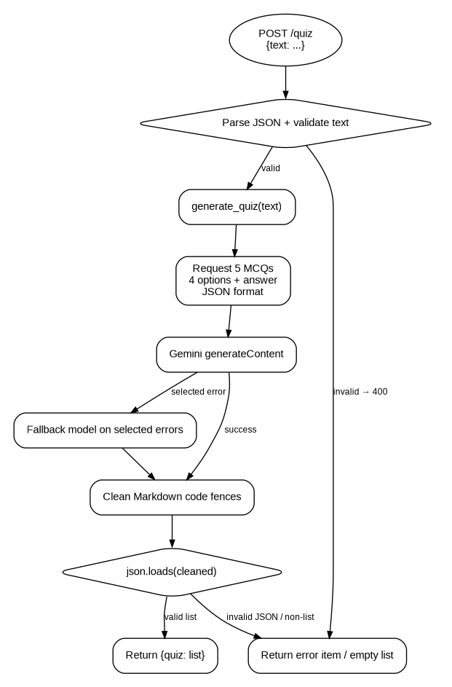
Fig. 6. Quiz generation and JSON parsing flow derived from quiz_module.py.

12. Learning Path Module
The learning recommendations endpoint is GET /learn/recommendations and requires a topic query parameter. The module asks Gemini for a learning path containing beginner, intermediate, and advanced steps together with practical study activities and resources.
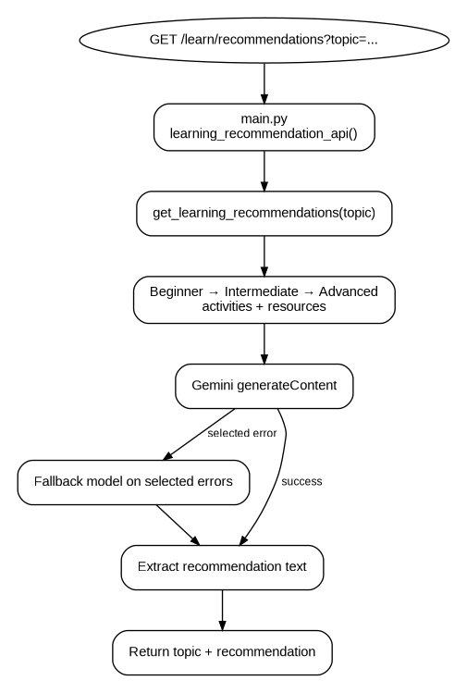
Fig. 7. Learning path flow derived from learning_path.py.

13. Configuration Management
config.py loads environment variables with python-dotenv. GEMINI_API_KEY is read from the environment, GEMINI_MODEL defaults to gemini-3.8-flash when not specified, and is_configured() returns whether the API key is present.
- GEMINI_API_KEY — Gemini authentication key.
- GEMINI_MODEL — Gemini model name used by the modules.
- USE_LOCAL_EXPLAIN_MODEL — configuration flag present in the project.
In the uploaded implementation, USE_LOCAL_EXPLAIN_MODEL is read by config.py, but the current explanation_module.py does not branch on that flag; it calls Gemini directly.

14. Gemini API Integration
Each AI module builds a Google Generative Language API URL using the configured model and calls the generateContent endpoint with requests.post(). The API key is sent through the x-goog-api-key header. Responses are parsed from candidates → content → parts → text.
For Q&A, explanation, summary, quiz, and learning-path modules, selected HTTP statuses (404, 429, 500, 502, 503, 504) trigger a retry using gemini-3.5-flash-lite when the configured model is different from that fallback.

15. Error Handling
- Missing Gemini configuration returns a clear configuration message.
- Invalid JSON bodies return HTTP 400 responses from the POST endpoints.
- Missing required topic/text fields return HTTP 400 responses.
- Gemini request failures are logged and converted into readable error strings.
- Quiz JSON parsing failures return an error item rather than crashing the application.
- The /health endpoint reports application status and Gemini configuration state.

16. Deployment
The project includes render.yaml for Render deployment. It defines a Python web service named edugenie-ai, installs dependencies from requirements.txt, starts Uvicorn on 0.0.0.0:$PORT, and uses /health as the health-check path.
Deployment configuration from render.yaml:
services:
- type: web
name: edugenie-ai
runtime: python
plan: free
buildCommand: pip install -r requirements.txt
startCommand: uvicorn main:app --host 0.0.0.0 --port $PORT
healthCheckPath: /health

17. Dependencies
The uploaded requirements.txt contains:
fastapi
uvicorn[standard]
jinja2
requests
python-dotenv

18. Testing Plan
Test | Input | Expected Result | Source
Health check | GET /health | JSON containing status and gemini_configured | main.py
Q&A | GET /qa?question=... | JSON answer | main.py + qna.py
Explanation | POST /explain/ with topic | Topic and explanation | main.py + explanation_module.py
Summary | POST /summarize/ with text | Summary text | main.py + summary_module.py
Quiz | POST /quiz with text | Quiz list in JSON | main.py + quiz_module.py
Learning path | GET /learn/recommendations?topic=... | Topic and recommendation | main.py + learning_path.py

19. Security and API-Key Handling
The uploaded .env file contains a Gemini API key. That secret value is intentionally not reproduced in this documentation. Because an API key has been shared in an uploaded file, it should be treated as exposed and rotated/replaced before continued use.
The README and deployment configuration indicate that the API key should be supplied through environment settings and should not be committed to the repository. The .gitignore is intended to exclude .env and Python virtual environments.

20. Local Execution
- Open the project folder in VS Code.
- Create/activate a Python virtual environment if desired.
- Install dependencies using: pip install -r requirements.txt
- Set GEMINI_API_KEY in the local environment/.env file.
- Run the application with: python main.py
- Open the host/port printed by Uvicorn. The current .env specifies HOST=127.0.0.1 and PORT=8011.

21. Current Project Deployment URL
The project owner supplied the following public/demo URL:
https://stewart-unto-coated-conferences.trycloudflare.com/
This URL is included as supplied by the project owner. The documentation is based on the uploaded source code; the live URL itself was not used to infer features that are absent from the source files.

22. Advantages
- Simple modular structure with one Python module per major learning function.
- FastAPI provides clear REST endpoints.
- Gemini is used consistently across the AI features.
- Quiz output is structured as JSON for programmatic use.
- Fallback handling is included for several Gemini HTTP errors.
- Health-check support is available for deployment monitoring.
- Render deployment configuration is included in the repository.

23. Limitations Identified from the Uploaded Code
- The uploaded source set does not include the actual templates/index.html or static assets, although main.py expects them.
- There is no persistent database or learner account system in the uploaded backend code.
- The application does not show authentication or authorization routes.
- AI outputs are generated dynamically and are not independently fact-checked by the backend.
- The USE_LOCAL_EXPLAIN_MODEL configuration value is present but is not used to select a local model in the current explanation implementation.

24. Future Enhancements
- Add persistent user profiles and learning history.
- Add authentication and role-based access.
- Add database-backed progress tracking.
- Add frontend validation and richer quiz interaction.
- Add multilingual and voice features.
- Add file/PDF/image input for educational content.
- Add analytics and adaptive learning recommendations.
- Add automated API tests and deployment monitoring.
- Implement the local explanation model branch if the USE_LOCAL_EXPLAIN_MODEL option is intended to be supported.

25. Conclusion
The uploaded source code implements EduGenie as a modular FastAPI learning assistant powered by Google Gemini. The application separates Q&A, explanation, summarization, quiz generation, and learning-path logic into individual Python modules while using main.py as the API and frontend entry point. This separation makes the system straightforward to understand, test, and extend.
The included Render configuration provides a deployment path, while the health endpoint supports a basic service check. The flowcharts in this document are derived directly from the uploaded source code and show how requests move from the frontend/API through the individual AI modules and back to the user.

26. References / Source Files
- main.py
- config.py
- qna.py
- explanation_module.py
- summary_module.py
- quiz_module.py
- learning_path.py
- requirements.txt
- README.md
- render.yaml
- Sample EduGenie documentation supplied by the project owner

APPENDIX A
COMPLETE SOURCE CODE
The following appendix contains the source code supplied for the EduGenie project. The code is included as documentation reference so that the project report contains both the explanation/flowcharts and the implementation used to build the backend and deployment.

main.py
Source code from uploaded project file.
"""
main.py
-------
EduGenie: Google Gemini Powered Learning Assistant
FastAPI backend entry point.

Endpoints (as documented):
GET /qa - Q&A
POST /explain/ - Concept explanation
POST /summarize/ - Summarization
POST /quiz - Quiz generation
GET /learn/recommendations - Personalized learning path

Also serves the HTML+CSS frontend at "/".
"""

from fastapi import FastAPI, Request, Query
from fastapi.responses import JSONResponse, HTMLResponse
from fastapi.staticfiles import StaticFiles
from fastapi.templating import Jinja2Templates

from qna import answer_question_with_gemini
from explanation_module import explain_topic
from summary_module import summarize_text
from quiz_module import generate_quiz
from learning_path import get_learning_recommendations
from config import is_configured, logger

app = FastAPI(
title="EduGenie",
description="Google Gemini Powered Learning Assistant",
version="1.0.0",
)

app.mount("/static", StaticFiles(directory="static"), name="static")
templates = Jinja2Templates(directory="templates")

# --------------------------------------------------------------------------
# Frontend
# --------------------------------------------------------------------------
@app.get("/", response_class=HTMLResponse)
async def home(request: Request):
return templates.TemplateResponse(request=request, name="index.html", context={"request": request})

# --------------------------------------------------------------------------
# Health check (handy for verifying the API key / server status quickly)
# --------------------------------------------------------------------------
@app.get("/health")
async def health():
return {
"status": "ok",
"gemini_configured": is_configured(),
}

# --------------------------------------------------------------------------
# Q&A - GET API using Gemini
# --------------------------------------------------------------------------
@app.get("/qa")
async def answer_question(question: str = Query(...)):
answer = answer_question_with_gemini(question)
return {"answer": answer}

# --------------------------------------------------------------------------
# Explanation - POST API
# --------------------------------------------------------------------------
@app.post("/explain/")
async def explain_api(request: Request):
try:
data = await request.json()
except Exception:
return JSONResponse(content={"error": "Invalid JSON body. Please send {\"topic\": \"...\"}."}, status_code=400)

topic = data.get("topic") if isinstance(data, dict) else None
if not topic:
return JSONResponse(content={"error": "Please provide a topic."}, status_code=400)
explanation = explain_topic(topic)
return {"topic": topic, "explanation": explanation}

# --------------------------------------------------------------------------
# Summarization - POST API
# --------------------------------------------------------------------------
@app.post("/summarize/")
async def summarize_api(request: Request):
try:
data = await request.json()
except Exception:
return JSONResponse(content={"error": "Invalid JSON body. Please send {\"text\": \"...\"}."}, status_code=400)

text = data.get("text") if isinstance(data, dict) else None
if not text:
return JSONResponse(content={"error": "Please provide text to summarize."}, status_code=400)
summary = summarize_text(text)
return {"summary": summary}

# --------------------------------------------------------------------------
# Quiz Generation - POST API
# --------------------------------------------------------------------------
@app.post("/quiz")
async def quiz_api(request: Request):
try:
data = await request.json()
except Exception:
return JSONResponse(content={"error": "Invalid JSON body. Please send {\"text\": \"...\"}."}, status_code=400)

text = data.get("text") if isinstance(data, dict) else None
if not text:
return JSONResponse(content={"error": "Please provide text for quiz."}, status_code=400)
quiz = generate_quiz(text)
logger.info("Generated quiz with %d item(s)", len(quiz) if isinstance(quiz, list) else 0)
return JSONResponse(content={"quiz": quiz})

# --------------------------------------------------------------------------
# Learning Recommendations - GET API
# --------------------------------------------------------------------------
@app.get("/learn/recommendations")
async def learning_recommendation_api(topic: str = Query(...)):
recommendation = get_learning_recommendations(topic)
return {"topic": topic, "recommendation": recommendation}

if __name__ == "__main__":
import os
import socket

import uvicorn

def get_available_port(start_port: int, max_tries: int = 20) -> int:
for port in range(start_port, start_port + max_tries):
with socket.socket(socket.AF_INET, socket.SOCK_STREAM) as sock:
sock.setsockopt(socket.SOL_SOCKET, socket.SO_REUSEADDR, 1)
try:
sock.bind(("127.0.0.1", port))
return port
except OSError:
continue
raise RuntimeError(f"No available port found starting from {start_port}")

host = os.getenv("HOST", "127.0.0.1")
requested_port = int(os.getenv("PORT", "8010"))
port = get_available_port(requested_port)
uvicorn.run("main:app", host=host, port=port, reload=True)

config.py
Source code from uploaded project file.
import logging
import os

from dotenv import load_dotenv

load_dotenv(override=True)

GEMINI_API_KEY = os.getenv("GEMINI_API_KEY", "")
GEMINI_MODEL = (os.getenv("GEMINI_MODEL", "gemini-3.8-flash") or "gemini-3.8-flash").strip()

USE_LOCAL_EXPLAIN_MODEL = os.getenv("USE_LOCAL_EXPLAIN_MODEL", "false").lower() == "true"

logger = logging.getLogger("EduGenie")
if not logger.handlers:
logging.basicConfig(level=logging.INFO, format="%(asctime)s - %(levelname)s - %(message)s")

def is_configured() -> bool:
return bool(GEMINI_API_KEY)

qna.py
Source code from uploaded project file.
import requests

from config import GEMINI_API_KEY, GEMINI_MODEL, is_configured, logger

def answer_question_with_gemini(question: str) -> str:
if not is_configured():
return "Gemini API key is not configured. Add your GEMINI_API_KEY in the .env file."

url = f"https://generativelanguage.googleapis.com/v1beta/models/{GEMINI_MODEL}:generateContent"
payload = {
"contents": [{"parts": [{"text": question}]}],
"generationConfig": {"temperature": 0.2, "maxOutputTokens": 500},
}

try:
response = requests.post(url, headers={"x-goog-api-key": GEMINI_API_KEY}, json=payload, timeout=60)
if response.status_code in {404, 429, 500, 502, 503, 504} and GEMINI_MODEL != "gemini-3.5-flash-lite":
fallback_url = "https://generativelanguage.googleapis.com/v1beta/models/gemini-3.5-flash-lite:generateContent"
logger.warning(
"Gemini model %s returned HTTP %d; retrying Q&A with gemini-3.5-flash-lite",
GEMINI_MODEL,
response.status_code,
)
response = requests.post(
fallback_url,
headers={"x-goog-api-key": GEMINI_API_KEY},
json=payload,
timeout=60,
)
response.raise_for_status()
data = response.json()
text = data.get("candidates", [{}])[0].get("content", {}).get("parts", [{}])[0].get("text")
if text:
return text.strip()
return "I couldn't generate an answer from Gemini right now."
except Exception as exc:
logger.exception("Gemini Q&A request failed")
return f"Error generating answer: {exc}"

explanation_module.py
Source code from uploaded project file.
from config import GEMINI_API_KEY, GEMINI_MODEL, is_configured, logger
import requests

def explain_topic(topic: str) -> str:
if not is_configured():
return "Gemini API key is not configured. Add your GEMINI_API_KEY in the .env file."

prompt = (
f"Explain the topic '{topic}' in simple, educational language. "
"Break it into clear sections: what it is, why it matters, and a short example."
)
url = f"https://generativelanguage.googleapis.com/v1beta/models/{GEMINI_MODEL}:generateContent"
payload = {
"contents": [{"parts": [{"text": prompt}]}],
"generationConfig": {"temperature": 0.3, "maxOutputTokens": 700},
}

try:
response = requests.post(url, headers={"x-goog-api-key": GEMINI_API_KEY}, json=payload, timeout=60)
if response.status_code in {404, 429, 500, 502, 503, 504} and GEMINI_MODEL != "gemini-3.5-flash-lite":
fallback_url = "https://generativelanguage.googleapis.com/v1beta/models/gemini-3.5-flash-lite:generateContent"
logger.warning(
"Gemini model %s returned HTTP %d; retrying explanation with gemini-3.5-flash-lite",
GEMINI_MODEL,
response.status_code,
)
response = requests.post(
fallback_url,
headers={"x-goog-api-key": GEMINI_API_KEY},
json=payload,
timeout=60,
)
response.raise_for_status()
data = response.json()
text = data.get("candidates", [{}])[0].get("content", {}).get("parts", [{}])[0].get("text")
return text.strip() if text else "Unable to explain this topic right now."
except Exception as exc:
logger.exception("Gemini explanation failed")
return f"Error explaining topic: {exc}"

summary_module.py
Source code from uploaded project file.
from config import GEMINI_API_KEY, GEMINI_MODEL, is_configured, logger
import requests

def summarize_text(text: str) -> str:
if not is_configured():
return "Gemini API key is not configured. Add your GEMINI_API_KEY in the .env file."

prompt = (
"Summarize the following text in a concise and readable way while keeping the most important points.\n\n"
f"{text}"
)
url = f"https://generativelanguage.googleapis.com/v1beta/models/{GEMINI_MODEL}:generateContent"
payload = {
"contents": [{"parts": [{"text": prompt}]}],
"generationConfig": {"temperature": 0.2, "maxOutputTokens": 500},
}

try:
response = requests.post(url, headers={"x-goog-api-key": GEMINI_API_KEY}, json=payload, timeout=60)
if response.status_code in {404, 429, 500, 502, 503, 504} and GEMINI_MODEL != "gemini-3.5-flash-lite":
fallback_url = "https://generativelanguage.googleapis.com/v1beta/models/gemini-3.5-flash-lite:generateContent"
logger.warning(
"Gemini model %s returned HTTP %d; retrying summarization with gemini-3.5-flash-lite",
GEMINI_MODEL,
response.status_code,
)
response = requests.post(
fallback_url,
headers={"x-goog-api-key": GEMINI_API_KEY},
json=payload,
timeout=60,
)
response.raise_for_status()
data = response.json()
summary = data.get("candidates", [{}])[0].get("content", {}).get("parts", [{}])[0].get("text")
return summary.strip() if summary else "Unable to summarize the text right now."
except Exception as exc:
logger.exception("Gemini summarization failed")
return f"Error summarizing text: {exc}"

quiz_module.py
Source code from uploaded project file.
import json
import re

from config import GEMINI_API_KEY, GEMINI_MODEL, is_configured, logger
import requests

def generate_quiz(text: str):
if not is_configured():
return [{"question": "Gemini API key is not configured.", "options": ["Please add your GEMINI_API_KEY in .env"], "answer": "Please add your GEMINI_API_KEY in .env"}]

prompt = (
"Generate a quiz from the following text. Return valid JSON in this exact format: "
"[{\"question\": \"...\", \"options\": [\"A\", \"B\", \"C\", \"D\"], \"answer\": \"...\"}, ...]. "
"Create 5 multiple-choice questions.\n\n"
f"{text}"
)
url = f"https://generativelanguage.googleapis.com/v1beta/models/{GEMINI_MODEL}:generateContent"
payload = {
"contents": [{"parts": [{"text": prompt}]}],
"generationConfig": {"temperature": 0.3, "maxOutputTokens": 1200},
}

try:
response = requests.post(url, headers={"x-goog-api-key": GEMINI_API_KEY}, json=payload, timeout=60)
if response.status_code in {404, 429, 500, 502, 503, 504} and GEMINI_MODEL != "gemini-3.5-flash-lite":
fallback_url = "https://generativelanguage.googleapis.com/v1beta/models/gemini-3.5-flash-lite:generateContent"
logger.warning(
"Gemini model %s returned HTTP %d; retrying quiz with gemini-3.5-flash-lite",
GEMINI_MODEL,
response.status_code,
)
response = requests.post(
fallback_url,
headers={"x-goog-api-key": GEMINI_API_KEY},
json=payload,
timeout=60,
)
response.raise_for_status()
data = response.json()
result = data.get("candidates", [{}])[0].get("content", {}).get("parts", [{}])[0].get("text")
if not result:
return []

cleaned = result.strip()
if cleaned.startswith("```"):
cleaned = re.sub(r"^```(?:json)?\s*", "", cleaned)
cleaned = re.sub(r"\s*```$", "", cleaned)

quiz = json.loads(cleaned)
if isinstance(quiz, list):
return quiz
return []
except Exception as exc:
logger.exception("Gemini quiz generation failed")
return [{"question": f"Error generating quiz: {exc}", "options": ["Try again later"], "answer": "Try again later"}]

learning_path.py
Source code from uploaded project file.
from config import GEMINI_API_KEY, GEMINI_MODEL, is_configured, logger
import requests

def get_learning_recommendations(topic: str) -> str:
if not is_configured():
return "Gemini API key is not configured. Add your GEMINI_API_KEY in the .env file."

prompt = (
f"Recommend a clear learning path for '{topic}'. Include beginner, intermediate, and advanced steps, "
"plus practical study activities and resources."
)
url = f"https://generativelanguage.googleapis.com/v1beta/models/{GEMINI_MODEL}:generateContent"
payload = {
"contents": [{"parts": [{"text": prompt}]}],
"generationConfig": {"temperature": 0.3, "maxOutputTokens": 700},
}

try:
response = requests.post(url, headers={"x-goog-api-key": GEMINI_API_KEY}, json=payload, timeout=60)
if response.status_code in {404, 429, 500, 502, 503, 504} and GEMINI_MODEL != "gemini-3.5-flash-lite":
fallback_url = "https://generativelanguage.googleapis.com/v1beta/models/gemini-3.5-flash-lite:generateContent"
logger.warning(
"Gemini model %s returned HTTP %d; retrying learning recommendations with gemini-3.5-flash-lite",
GEMINI_MODEL,
response.status_code,
)
response = requests.post(
fallback_url,
headers={"x-goog-api-key": GEMINI_API_KEY},
json=payload,
timeout=60,
)
response.raise_for_status()
data = response.json()
text = data.get("candidates", [{}])[0].get("content", {}).get("parts", [{}])[0].get("text")
return text.strip() if text else "Unable to generate recommendations right now."
except Exception as exc:
logger.exception("Gemini learning recommendation failed")
return f"Error generating recommendations: {exc}"

requirements.txt
Source code from uploaded project file.
fastapi
uvicorn[standard]
jinja2
requests
python-dotenv

render.yaml
Source code from uploaded project file.
services:
- type: web
name: edugenie-ai
runtime: python
plan: free
buildCommand: pip install -r requirements.txt
startCommand: uvicorn main:app --host 0.0.0.0 --port $PORT
healthCheckPath: /health
envVars:
- key: GEMINI_API_KEY
sync: false
- key: GEMINI_MODEL
value: gemini-3.8-flash
- key: USE_LOCAL_EXPLAIN_MODEL
value: "false"

README.md
Source code from uploaded project file.
# EduGenie AI

FastAPI learning assistant with Gemini-powered Q&A, explanations, summaries, quizzes, and learning paths.

## Deploy to Render

1. Push this project to a GitHub repository. The `.gitignore` excludes `.env` and Python virtual environments; do not commit API keys.
2. In Render, choose **New** > **Blueprint** and connect the GitHub repository containing `render.yaml`.
3. Enter your Gemini API key when Render prompts for `GEMINI_API_KEY`, then deploy.
4. Use the stable `onrender.com` URL assigned to the service. Free services may sleep when idle; choose a paid plan if you need it to remain continuously available.

The API key belongs in Render's environment settings, not in `render.yaml` or the repository. The local `.env` file continues to be used for development.

.gitignore
Source code from uploaded project file.
.env
.env.*
!.env.example
venv/
.venv/
__pycache__/
*.py[cod]
.pytest_cache/

.env Configuration (Secret Redacted)
The uploaded .env file contains a live Gemini API key. For security, the key is not reproduced in this report. The configuration structure is documented below:
GEMINI_API_KEY=<REPLACE_WITH_YOUR_GEMINI_API_KEY>
GEMINI_MODEL=gemini-3.8-flash
USE_LOCAL_EXPLAIN_MODEL=false
HOST=127.0.0.1
PORT=8011
Security note: because the original .env contained an API key that was uploaded during this conversation, that key should be rotated/revoked and replaced with a new key before use.

Appendix B — Source-Code File Summary
File | Purpose | Included
main.py | FastAPI application, frontend route, health check, and API endpoints. | Yes
config.py | Environment variables, Gemini configuration, logging, and configuration check. | Yes
qna.py | Gemini-powered question answering. | Yes
explanation_module.py | Simple educational topic explanations. | Yes
summary_module.py | Concise text summarization. | Yes
quiz_module.py | Five-question MCQ generation and JSON parsing. | Yes
learning_path.py | Beginner-to-advanced learning recommendations. | Yes
requirements.txt | Python dependencies. | Yes
render.yaml | Render web-service deployment configuration. | Yes
README.md | Project and Render deployment instructions. | Yes
.gitignore | Excludes secrets, virtual environments, caches, and compiled Python files. | Yes
.env | Runtime configuration and Gemini API key. | Key redacted

