DWS Data Engineering Case Study
Cloud-native ETL pipeline for daily trade data ingestion, validation, and reporting using Snowflake, DBT, Airflow, and Terraform.

Data Architecture

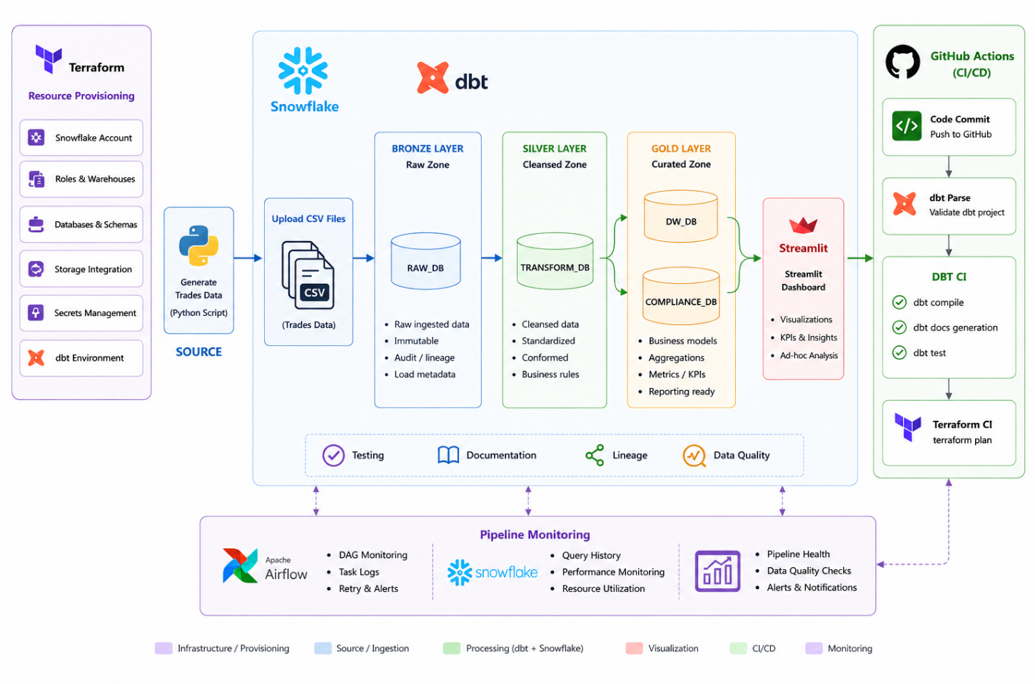
Tech Stack Choices
- Terraform: Infrastructure as code for provisioning Snowflake account, databases, schemas, roles, users, stages, and grants.
- Snowflake: cloud-native data warehouse with native support for stages, file formats, COPY INTO, and Streamlit app eliminates infrastructure management
- RSA key-pair authentication is used for secure snowflake connection
- DBT: SQL-based transformation framework that simplifies database/tables dependency management with incremental materializations and built in lineage.
DBT handles underlying DDL/DML executions.
- Apache Airflow: Orchestrates the end-to-end pipeline (file sensing → Snowflake upload → dbt run → dbt test) with retry logic, timeouts, and email alerting on failure.
- Streamlit in Snowflake: For data visualization.
- Docker: Containerizes Airflow, DBT and all dependencies for consistent local development and deployment; avoids environment conflicts
- GitHub Actions: CI/CD pipelines validate dbt models (parse, compile, test) and Terraform code (fmt, validate, plan) on every push/PR to master.

Validation Logic
Valid Trades
- Trade must have a non-null MATURITY_DATE
- MATURITY_DATE must be ≥ EXECUTION_DATE
- Incoming VERSION must be ≥ the version already stored for that TRADE_ID (no downgrades)
- If multiple records arrive for the same TRADE_ID in one batch, only the highest version is kept
- Status is set to ACTIVE if MATURITY_DATE >= CURRENT_DATE, otherwise EXPIRED
- On every run, all existing rows are re-evaluated and trades transition from ACTIVE to EXPIRED once their maturity date passes
Rejected Trades
- MATURITY_DATE is NULL or unparseable → rejection reason: INVALID_MATURITY_DATE
- MATURITY_DATE is earlier than EXECUTION_DATE → rejection reason: MATURITY_BEFORE_EXECUTION
- Incoming VERSION is lower than the version already stored in valid trades → rejection reason: STALE_VERSION

