Table of Contents

Overview 1

Developer Notes 2

Requirement# III) 2

ViewSalesUser.aspx: 2

ViewApplicantUser.aspx 3

Requirement# II) 4

Requirement# I) 4

MISC 6

# Overview

This document describes the changes made for the **TaskID**#: REC001-XIII, link -

<http://web.jmgrovebuildingsupply.com/Sr_App/TaskGenerator.aspx?TaskId=2&hstid=549+>

Following two souce code files are modified and committed GitHub repository :

|  |  |
| --- | --- |
| **Fine Name** | **Path** |
| 1. ViewSalesUser.aspx | https://github.com/jmgrove2016/JGProspectLive/blob/nandc/JG_Prospect.web/Sr_App/ViewSalesUser.aspx |
| 1. ViewSalesUser.aspx.cs | https://github.com/jmgrove2016/JGProspectLive/blob/nandc/JG_Prospect.web/Sr_App/ViewSalesUser.aspx.cs |
| 1. ViewApplicantUser.aspx | https://github.com/jmgrove2016/JGProspectLive/blob/**nandc**/JG_Prospect.web/ViewApplicantUser.aspx |
| 1. ViewApplicantUser.aspx.cs | https://github.com/jmgrove2016/JGProspectLive/blob/nandc/JG_Prospect.web/ViewApplicantUser.aspx.cs |
| 1. nandkumarchavan_04222017_db.sql | https://github.com/jmgrove2016/JGProspectLive/blob/nandc/JG_Prospect.web/Database Scripts/nandc/nandkumarchavan_04222017_db.sql |
| nandkumarchavan_0422017.docx | https://github.com/jmgrove2016/JGProspectLive/blob/nandc/nandkumarchavan_04222017.docx |

# Developer Notes

This section lists the assumptions, feedback, questions, issues, changes, testing done etc. for completing this task.

## Requirement# III)

### ViewSalesUser.aspx:

|  |  |
| --- | --- |
|  | * The ID# field shows value as per the logic in the code. Please let me know if any change required:      * The Phone# is **shows-up** correctly |
|  | * **The Zip shows-up correctly:**      * **Note – the same Zip is shown here and above the touch log grid. The one above the touch point log grid is updatable.** |
|  | * **Following two fields shows-up correctly:** |
|  | * **Country flag now shots the flag of selected country:** |

### ViewApplicantUser.aspx

|  |  |
| --- | --- |
|  | The ID#, Phone#, Employee Type, Source shows-up correctly. The “touch point log” grid shows “**Message to Recruiter”:** |
|  | The stored procedure - Sp_GetTouchPointLogDataByUserID, modified to “**Message to Recruiter” in the grid** |

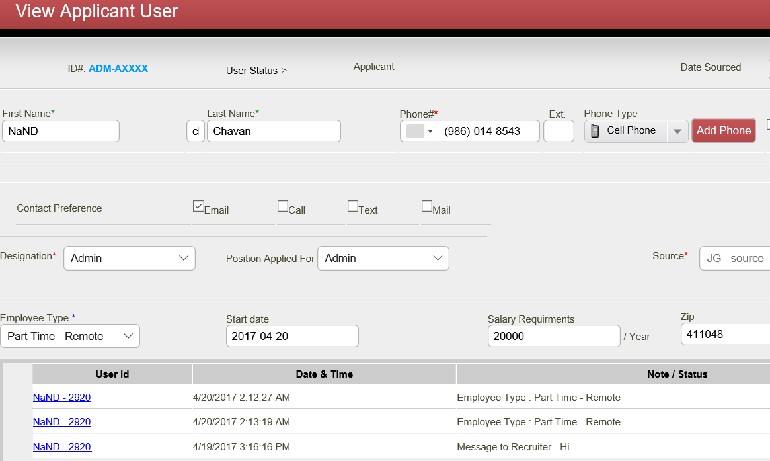

|  |  |
| --- | --- |
|  | Radio buttons, Zip, Country flag, works correctly. The Notes field is removed. |

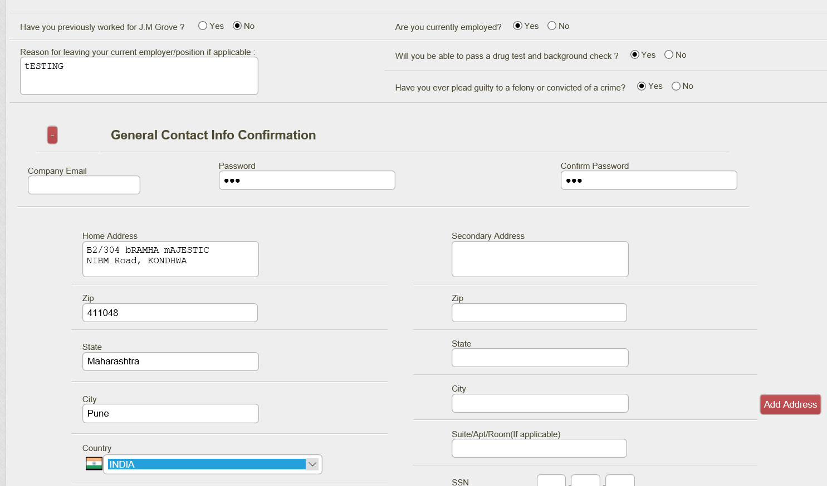

|  |  |
| --- | --- |
|  | * Note – the same Zip is shown here and above the touch log grid. The one above the touch point log grid is updatable. |

## Requirement# II)

|  |  |
| --- | --- |
|  | * Verified that the login with Phone# works correctly |

## Requirement# I)

|  |  |
| --- | --- |
|  | * As per Webdevelopers4u the pop-up works correctly in production. Attached below is the screen-shot provided by him:      * I have verified that the pop-up logic in stafflogin.aspx.cs code file works as: * The message is poped-up when **sendemployee.php** page redirects user to stafflogin.aspx. * The user is automatically logs-in when request comes from **employment.php.** * Currently on the **DEMO** site the PHP transfers to production site. To perform the Integration testing in development, the PHP demo site needs to be modified to transfer to development env. * I have informed @Bismi and @Yogesh about this. |

# MISC

Please let me know if you need anything else and I would be happy to work.

**Thank you!**

Nand Chavan