Table of Contents

Overview 2

The Second commit 2

Scripts REC001-XIII v 1.0.sql 3

Developer Notes 4

Requirement# III) 4

ViewSalesUser.aspx: 4

ViewApplicantUser.aspx 6

CreateSalesUser.aspx 7

InstallCreateUser.aspx 7

Requirement# II) 8

Requirement# I) 8

MISC 9

# Overview

This document describes the changes made for the **TaskID**#: REC001-XIII, link -

<http://web.jmgrovebuildingsupply.com/Sr_App/TaskGenerator.aspx?TaskId=2&hstid=549+>

Following souce code files are modified and committed GitHub repository :

|  |  |
| --- | --- |
| **Fine Name** | **Path** |
| 1. ViewSalesUser.aspx | https://github.com/jmgrove2016/JGProspectLive/blob/nandc/JG_Prospect.web/Sr_App/ViewSalesUser.aspx |
| 1. ViewSalesUser.aspx.cs | https://github.com/jmgrove2016/JGProspectLive/blob/nandc/JG_Prospect.web/Sr_App/ViewSalesUser.aspx.cs |
| 1. user.cs | https://github.com/jmgrove2016/JGProspectLive/blob/nandc/JG_Prospect.Common/modal/user.cs |
| 1. InstallUserDAL.CS | https://github.com/jmgrove2016/JGProspectLive/blob/nandc/JG_Prospect.DAL/InstallUserDAL.cs |
| 1. ViewApplicantUser.aspx | https://github.com/jmgrove2016/JGProspectLive/blob/**nandc**/JG_Prospect.web/ViewApplicantUser.aspx |
| 1. ViewApplicantUser.aspx.cs | https://github.com/jmgrove2016/JGProspectLive/blob/nandc/JG_Prospect.web/ViewApplicantUser.aspx.cs |
| 1. CreateSalesUser.aspx | https://github.com/jmgrove2016/JGProspectLive/blob/nandc/JG_Prospect.web/Sr_App/CreateSalesUser.aspx |
| 1. CreateSalesUser.aspx.cs | https://github.com/jmgrove2016/JGProspectLive/blob/nandc/JG_Prospect.web/Sr_App/CreateSalesUser.aspx.cs |
| 1. InstallCreateUser.aspx.cs | https://github.com/jmgrove2016/JGProspectLive/blob/nandc/JG_Prospect.web/Sr_App/InstallCreateUser.aspx |
| 1. Scripts REC001-XIII v 1.0.sql | https://github.com/jmgrove2016/JGProspectLive/blob/nandc/JG_Prospect.web/Database Scripts/nandc/Scripts REC001-XIII v 1.0.sql |
| nandkumarchavan_0426017.docx | https://github.com/jmgrove2016/JGProspectLive/blob/nandc/nandkumarchavan_04262017.docx |

## The Second commit

This is **second commit** to GitHub repository, and includes following additional:

|  |  |
| --- | --- |
|  | The Source field now points to SourceID column in tblInstallUsers table, instead of Source column. This change needed update to all app layers – UI, BAL, DAL and SQL sprocs.  Without this update the Source field value won’t displayed or would be lost on screen update. This can be verified on demo site with following steps?   * Create application with employee.php * Login to demo site with that use Id * Verify Source value * Update the Source value |
|  | The issue with Phone# login is fixed. |
|  | CreateSalesUser.aspx and InstallCreateUser.aspx updated, more details provided below. |

## Scripts REC001-XIII v 1.0.sql

The Scripts REC001-XIII v 1.0.sql file contains alter scripts for following sprocs:

|  |  |
| --- | --- |
|  | UDP_GetInstallerUserDetailsByLoginId |
|  | UDP_IsValidInstallerUser |
|  | UDP_AddInstallUser |
|  | UDP_UpdateInstallUsers |
|  | UDP_GETInstallUserDetails |
|  | Sp_GetTouchPointLogDataByUserID |

# Developer Notes

This section lists the assumptions, feedback, questions, issues, changes, testing done etc. for completing this task.

|  |  |
| --- | --- |
|  | The source code downloaded from GitHub and also the Test site has issue with GoogleCalender.aspx. It terminates the app.   * So UserID won’t work: [jgrove@jmgroveconstruction.com](mailto:jgrove@jmgroveconstruction.com) , because it transfers to GoogleCalender * So for testing I created an employee from PHP site and loged-in with that user Id ([NandKChavan@Gmail.com](mailto:NandKChavan@Gmail.com) / 321) * This issue initially took lot of time. |

## Requirement# III)

### ViewSalesUser.aspx:

|  |  |
| --- | --- |
|  | * The ID# field shows value as per the logic in the code. Please let me know if any change required:      * The Phone# is **shows-up** correctly |
|  | * **The Zip shows-up correctly:**      * **Note – the same Zip is shown here and above the touch log grid. The one above the touch point log grid is not updatable.** |
|  | * **Following two fields shows-up correctly:** |
|  | * **Country flag now shots the flag of selected country:** |

### ViewApplicantUser.aspx

|  |  |
| --- | --- |
|  | The ID#, Phone#, Employee Type, Source shows-up correctly. The “touch point log” grid shows “**Message to Recruiter”:** |
|  | The stored procedure - Sp_GetTouchPointLogDataByUserID, modified to “**Message to Recruiter” in the grid** |

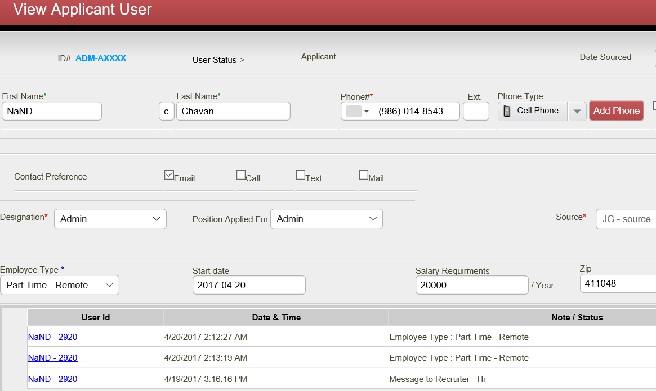

|  |  |
| --- | --- |
|  | Radio buttons, Zip, Country flag, works correctly. The Notes field is removed. |

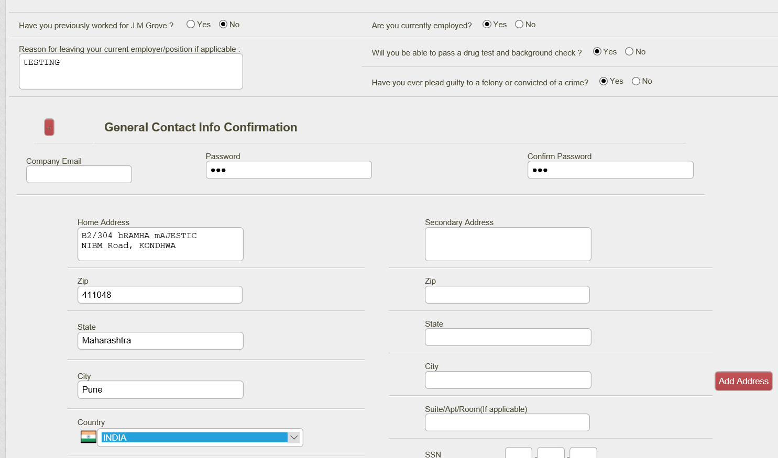

|  |  |
| --- | --- |
|  | * Note – the same Zip is shown here and above the touch log grid. The one above the touch point log grid is not updatable. |

### CreateSalesUser.aspx

|  |  |
| --- | --- |
|  | * All above modifications done |

### InstallCreateUser.aspx

|  |  |
| --- | --- |
|  | * Only following relevant modifications for Source field is done: |
|  | * The Source now points to SourceID column |
|  | * As per the existing logic the Source field is disabled while viewing existing record. No change is done here. |

## Requirement# II)

|  |  |
| --- | --- |
|  | Fixed the issue with the login with Phone# :   * The phone column in tblInstallUsers table – has data values in both formatted and unformatted text (ex 9860148543 & (986)-014-8543. * To fix this issue follwing sproc modified - UDP_GetInstallerUserDetailsByLoginId & UDP_IsValidInstallerUser |

## Requirement# I)

|  |  |
| --- | --- |
|  | * As per Webdevelopers4u the pop-up works correctly in production. Attached below is the screen-shot provided by him:      * I have verified that the pop-up logic in stafflogin.aspx.cs code file works as: * The message is poped-up when **sendemployee.php** page redirects user to stafflogin.aspx. * The user is automatically logs-in when request comes from **employment.php.** * Currently on the **DEMO** site the PHP transfers to production site. To perform the Integration testing in development, the PHP demo site needs to be modified to transfer to development env. * I have informed @Bismi and @Yogesh about this. |

# MISC

Please let me know if you need anything else and I would be happy to work.

**Thank you!**

Nand Chavan