ACTIVITY 1

**MENDEL’S LAWS OF INHERITANCE**

Directions: Perform the following instructions. Write your answers on a sheet of paper and submit it to your teacher.

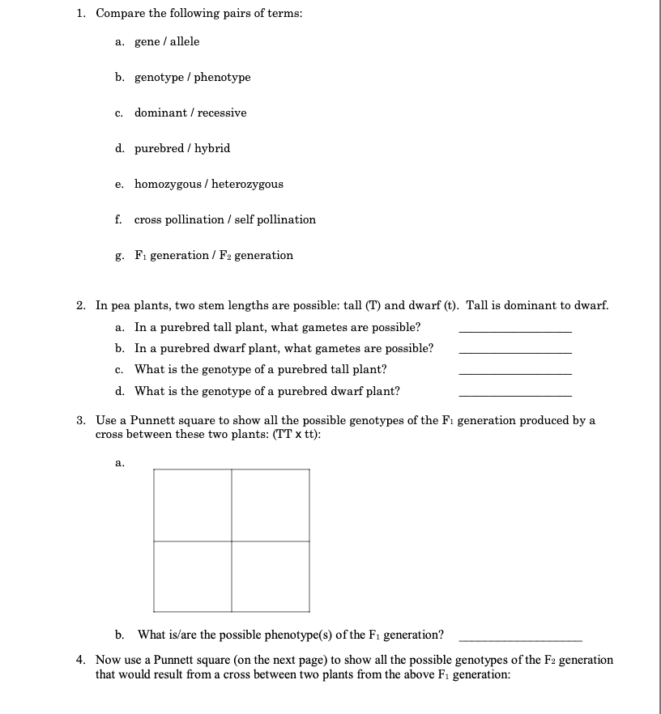

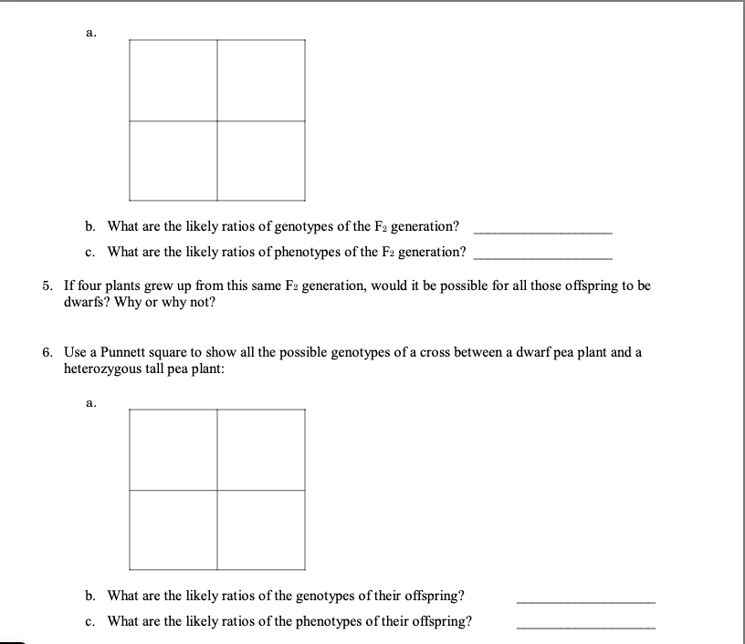

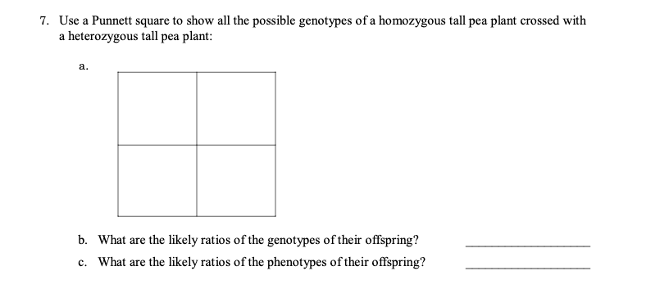

TRUE OR FALSE

Write true if the statement is true or false if the statement is false.

_____ 1. The rules of probability apply to genetics.

_____ 2. If an individual has a Gg genotype, half of his gametes should have the G allele, and the other half should have the g allele.

_____ 3. A Punnett square is a chart that allows you to easily determine the expected genotypes in the offspring of two parents.

_____ 4. In a cross between two homozygous dominant individuals, 25% of the offspring may have the recessive phenotype.

_____ 5. A parent cell makes gametes through the process of mitosis.

_____ 6. It is entirely likely for a gene to have more than two alleles.

_____ 7. Incomplete dominance occurs when the recessive allele is not completely dominant. _____ 8. Your height and skin color are not just due to your genes.

_____ 9. In a cross between an individual homozygous dominant for two characteristics and an individual homozygous recessive for the same characteristics, all of the F1 offspring will have the dominant phenotypes.

_____ 10. All genetics is fairly straightforward and follows the patterns Mendel observed in pea plants.

_____ 11. Codominance occurs when, essentially, there is no recessive allele.

_____ 12. If one parent is MM and the other parent is mm, the only possible phenotype of their offspring is Mm.

_____ 13. The probability of inheriting either an A, B, or O allele for blood type from your parent is 33.33%.

_____ 14. In any cross between two heterozygous parents, half the offspring should have the dominant phenotype and half the offspring should have the recessive phenotype.

_____ 15. When you toss a coin in the air, it should turn up tails 50% of the time.

SOURCE:

<https://www.pdffiller.com/jsfiller-desk17/?projectId=618bffd4222056541004cfdb&lp=true#e0261e0b38a0462887535b4de77452a8>

<https://www.cusd80.com/cms/lib/AZ01001175/Centricity/Domain/4939/Chapter%206%20%20CK-12%20Biology%20Chapter%206%20Worksheets.pdf>