ACTIVITY 2

**SEX LINKAGE AND RECOMBINATION**

Directions: Using your understanding in the Lesson, illustrate the chromosomes on each circle of the diagram below (cell is 2n = 4 ) ; one long green, one long red, one short black, one short white.

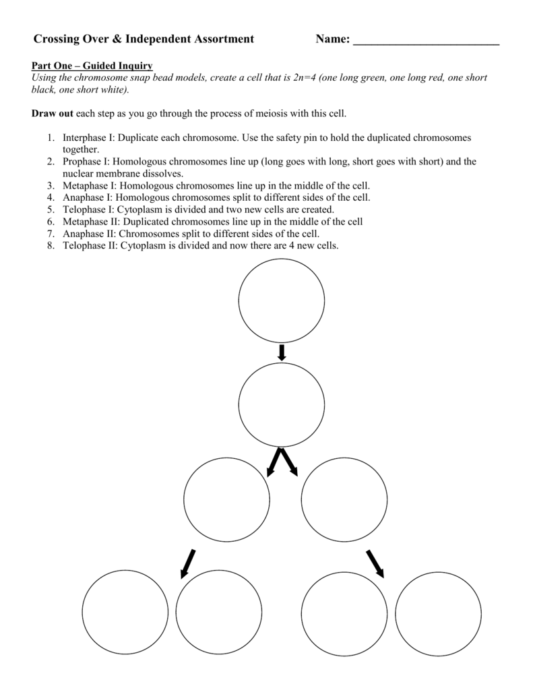

Source: https://studylib.net/doc/8600599/crossing-over-and-independent-assortment-investigation