ACTIVITY 3

**CENTRAL DOGMA OF MOLECULAR BIOLOGY**

Directions: Read and analyze the instructions below to answer the essential questions.

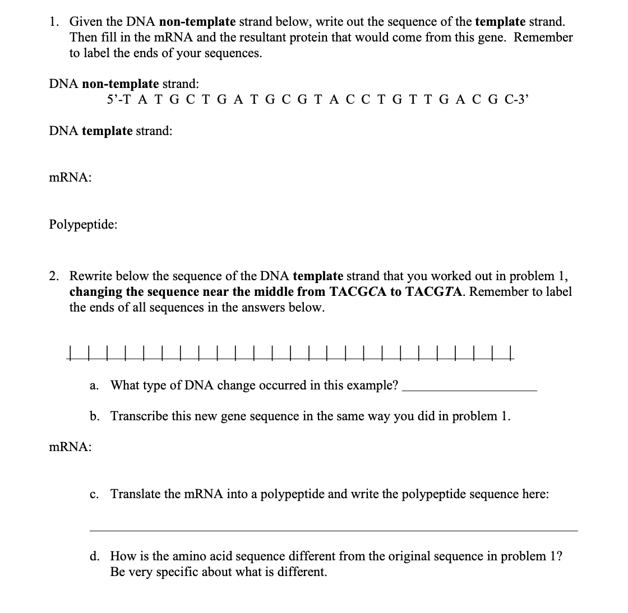

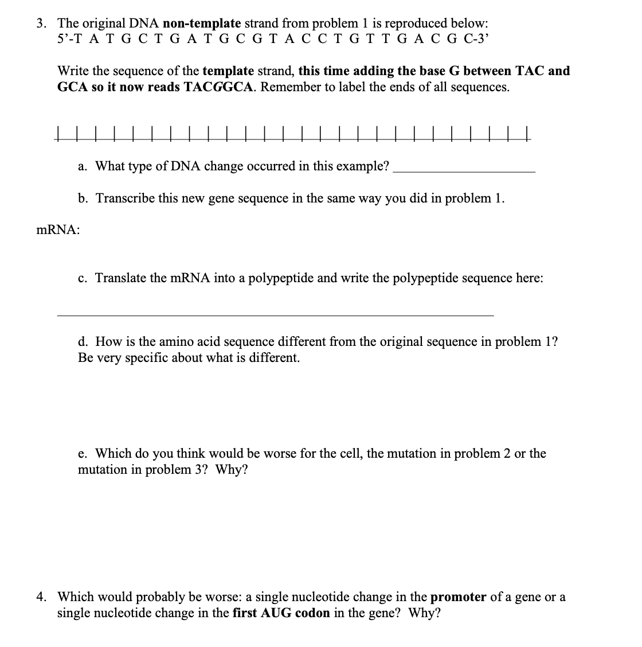

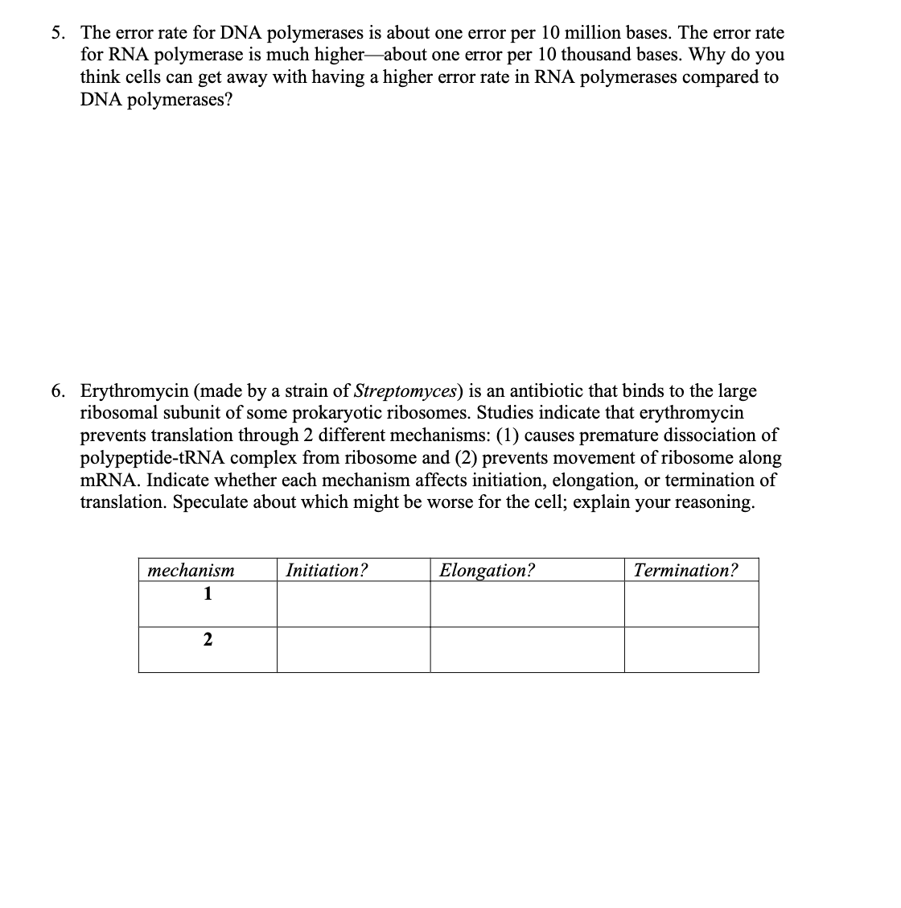

Source: https://studylib.net/doc/25243058/central-dogma-worksheet