ACTIVITY 4

**RECOMBINANT DNA**

Part I. Directions: Read and analyze the words or group of words on Across and Down Column below. Fill the Crossword Puzzle with correct answer that describes each statement in each column.

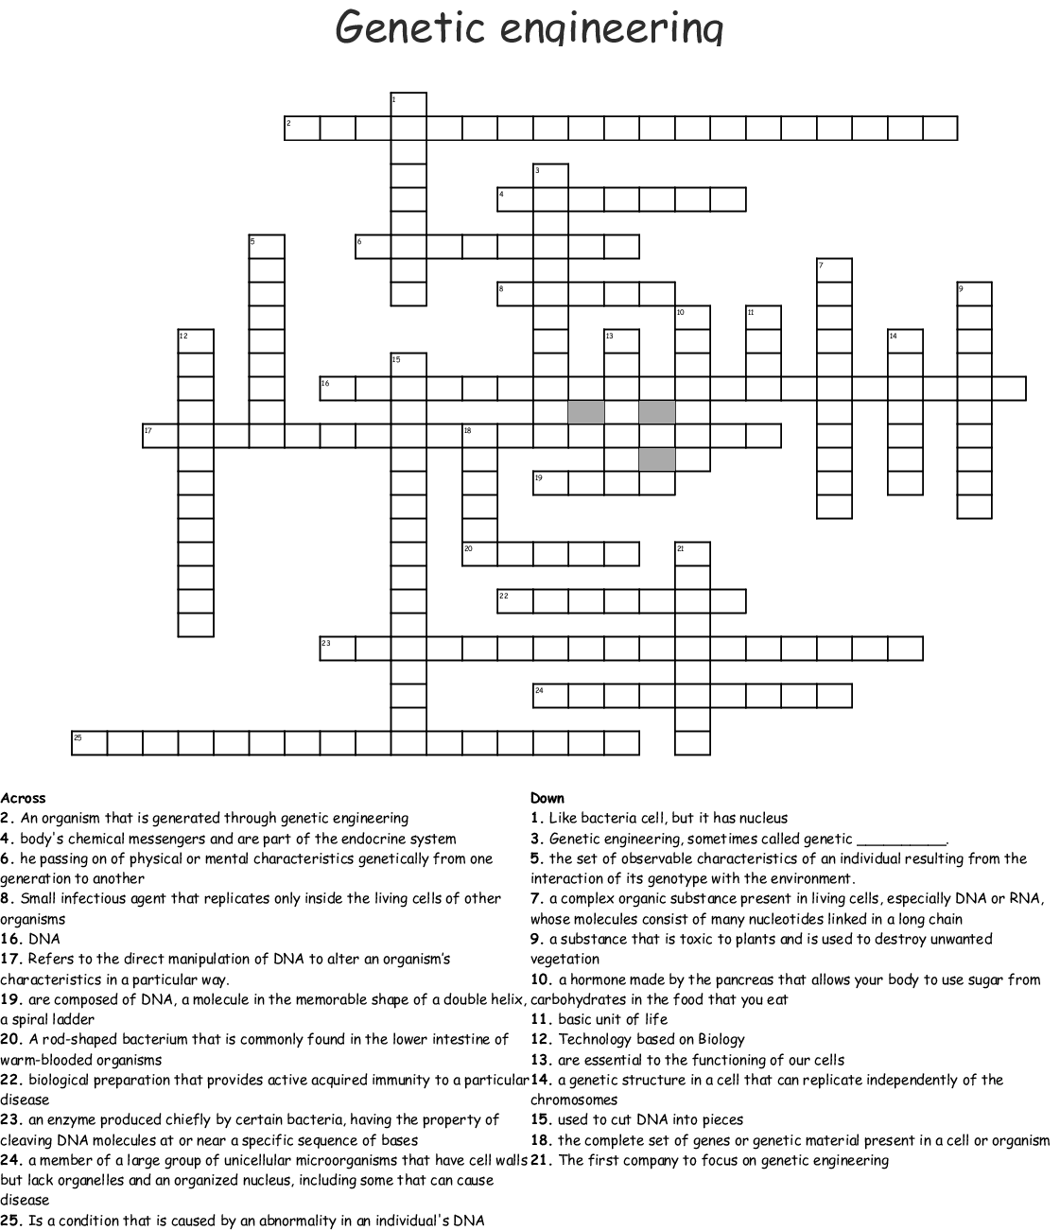

Part II.

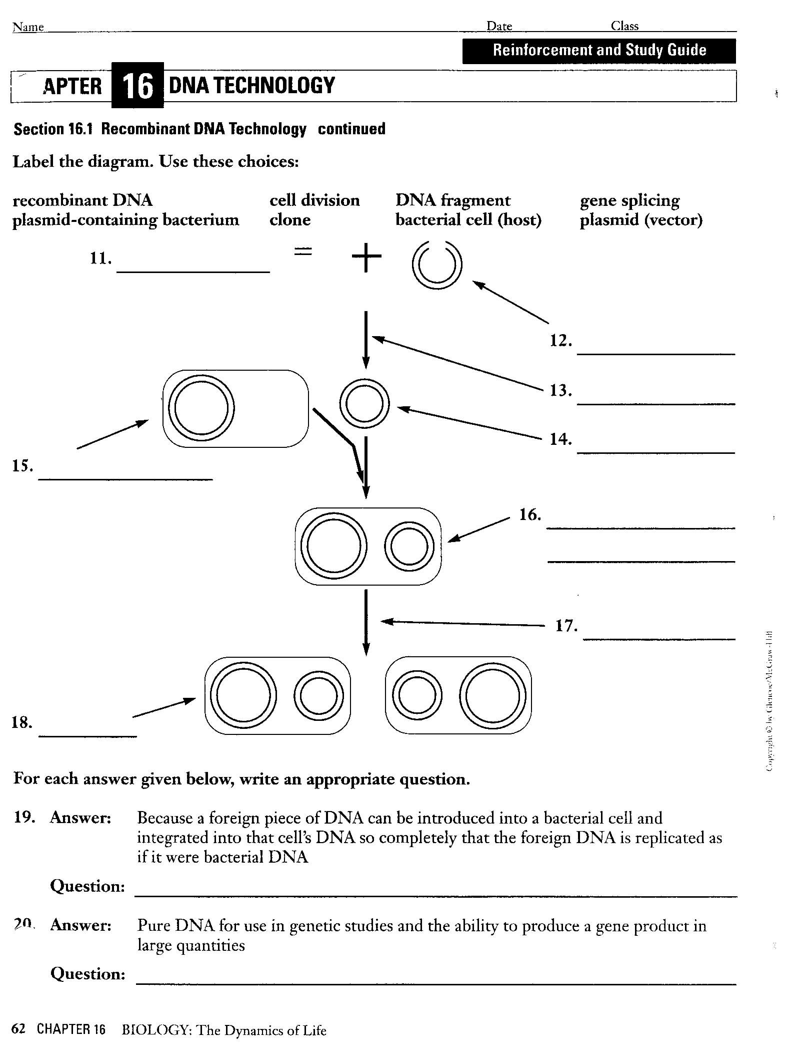

Source:

<https://www.saubhaya.com/dna-makeup-crossword-clue/>

https://promotiontablecovers.blogspot.com/2017/03/restriction-enzymes-worksheet-answers.html