Qn 1

public void qn1(int num)

{

if (num > 0)

{

for (int i = 0; i <= num; i++)

{

Console.WriteLine(i);

}

}

}

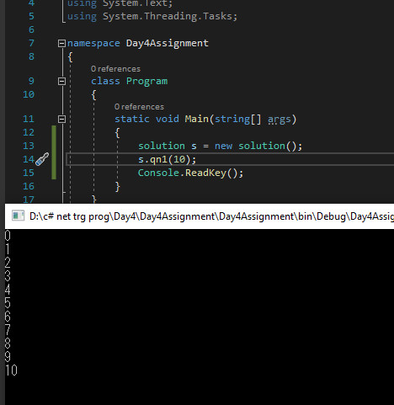

Qn 2

public void qn2(int num)

{

if(num % 2 == 1)

{

Console.WriteLine("Odd number");

}

else

Console.WriteLine("Even Number");

}

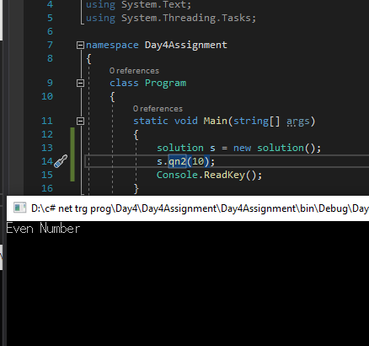

Qn 3

public void qn3(int num1,int num2)

{

if (num1 > num2)

{

Console.WriteLine(num1 + "is the greater number");

}

else if (num1 < num2)

{

Console.WriteLine(num2 + "is the greater number");

}

else

Console.WriteLine("The numbers are equal");

}

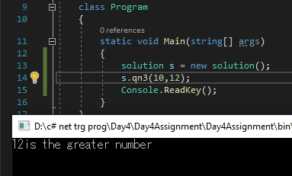

Qn 4

public void qn4(int num1, int num2,int num3)

{

int theGreaternum = num1;

theGreaternum = compareGreater(theGreaternum, num2);

theGreaternum = compareGreater(theGreaternum, num3);

Console.WriteLine(theGreaternum + " is the greater number.");

}

public int compareGreater(int num1,int num2)

{

if (num1 > num2)

{

return num1;

}

else

return num2;

}

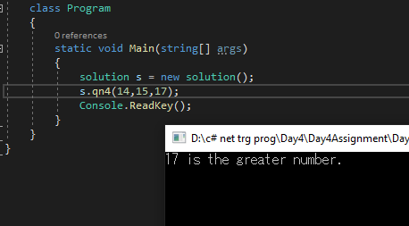

Qn 5

public void qn5(int num1,int num2)

{

if (num1 > num2)

{

printBetweenNum(num2, num1);

}

else

printBetweenNum(num1, num2);

}

public void printBetweenNum(int num1,int num2)

{

for (int i = num1; i < num2; i++)

{

Console.WriteLine(i);

}

}

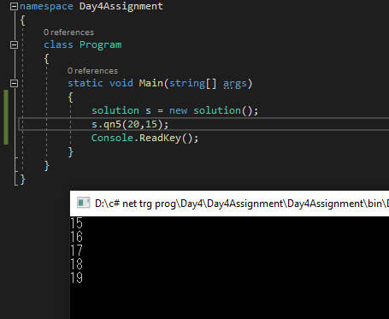

Qn6

public void qn6(int num1)

{

bool prime = true;

if (num1 > 1)

{

for (int i = 2; i < num1; i++)

{

if (num1 % i == 0)

{

prime = false;

}

}

}

else

prime = false;

if (prime)

{

Console.WriteLine(num1 + " is prime number.");

}

else

Console.WriteLine(num1 + " is not prime number.");

}

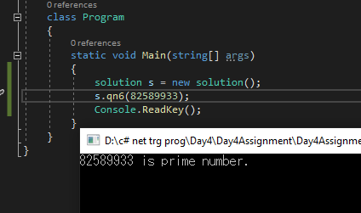

Qn7

public void qn7(int num1, int num2)

{

if (num1 > num2)

{

printBetweenNumQ7(num2, num1);

}

else

printBetweenNumQ7(num1, num2);

}

public void printBetweenNumQ7(int num1, int num2)

{

for (int i = num1; i < num2; i++)

{

qn6(i);

//Console.WriteLine(i);

}

}

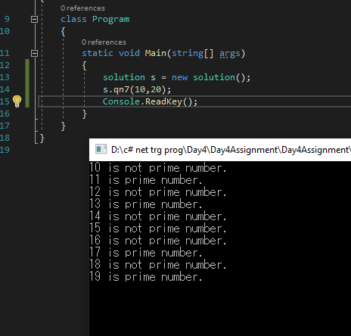

Qn8

public void qn8()

{

int sum = 0;

int num1 = Int32.Parse(Console.ReadLine());

while (num1 > 0)

{

if(num1%7 == 0)

{

sum += num1;

}

num1 = Int32.Parse(Console.ReadLine());

}

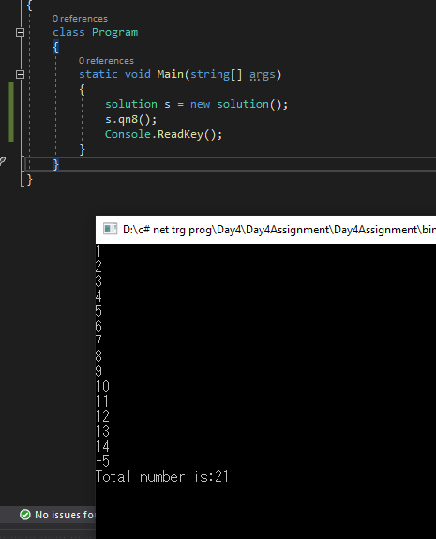

Qn9

public void qn9(int num1)

{

int num1st = 0;

int num2nd = 0;

int num3rd = 0;

int num4th = 0;

if (num1 > 999 && num1 < 10000)

{

num4th = num1 % 10;

num3rd = ((num1 - num4th) % 100) / 10;

num2nd = ((num1 - num4th - num3rd \* 10) % 1000) / 100;

num1st = ((num1 - num4th - num3rd \* 10 - num2nd \* 100) % 10000) / 1000;

int sum = num1st + num2nd + num3rd + num4th;

Console.WriteLine("Result is: " +sum);

}

else

Console.WriteLine("Enter a number between 1000-9999");

}

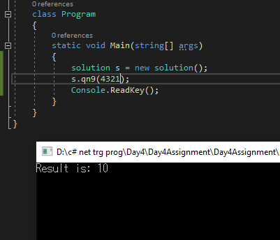

Qn 10

public void qn10(int num1)

{

int num1st = 0;

int num2nd = 0;

int num3rd = 0;

int num4th = 0;

if (num1 > 999 && num1 < 10000)

{

num4th = num1 % 10;

num3rd = ((num1 - num4th) % 100) / 10;

num2nd = ((num1 - num4th - num3rd \* 10) % 1000) / 100;

num1st = ((num1 - num4th - num3rd \* 10 - num2nd \* 100) % 10000) / 1000;

if (num1st == num4th && num2nd == num3rd)

{

Console.WriteLine(num1 + " is plaindrome.");

}

else

Console.WriteLine(num1 + " is not Plaindrome.");

}

}

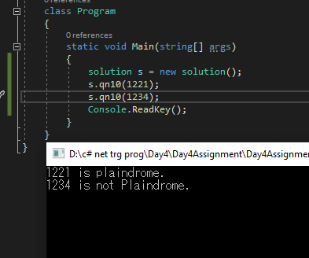

Qn 11

public void qn11(int num1,int num2)

{

int total = num1;

for (int i = 1; i < num2; i++)

{

total = total \* num1;

}

Console.WriteLine(num1 + " to the power of "+num2+" is:"+total);

}

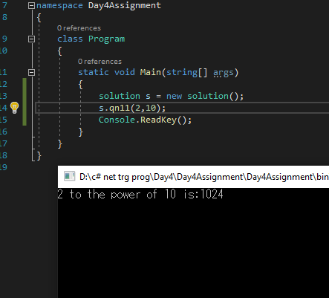

Qn 12

public void qn12(int num1)

{

int curNum = num1;

while (curNum > 9)

{

curNum = checkHappy(curNum);

}

if (curNum == 1 || curNum == 7)

{

Console.WriteLine(num1 +" is a happy number.");

}

else

Console.WriteLine(num1 + " is not a happy number.");

}

private int checkHappy(int num1)

{

int rem = 0, sum = 0;

while (num1 > 0)

{

rem = num1 % 10;

sum = sum + (rem \* rem);

num1 = num1 / 10;

}

return sum;

}

