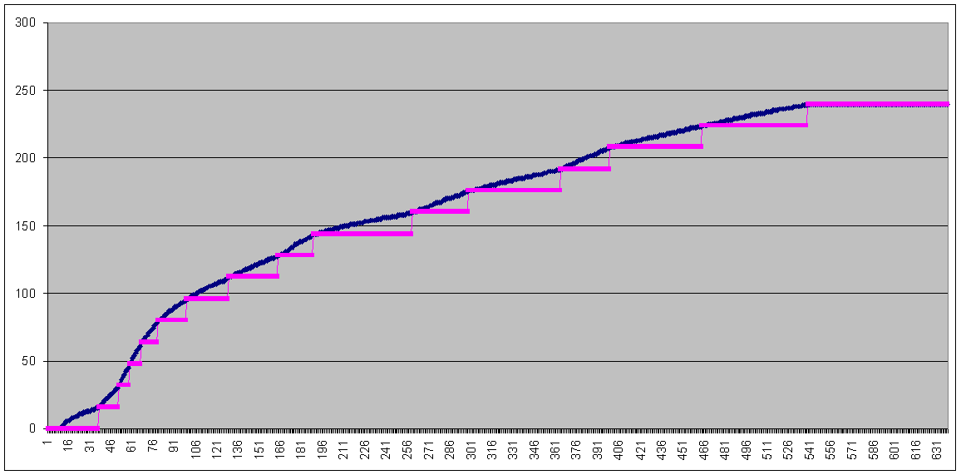
Standard Land Rover RPM Table (5502 limit)

RPM Scan: 120 to 6500 (10 RPM increments)

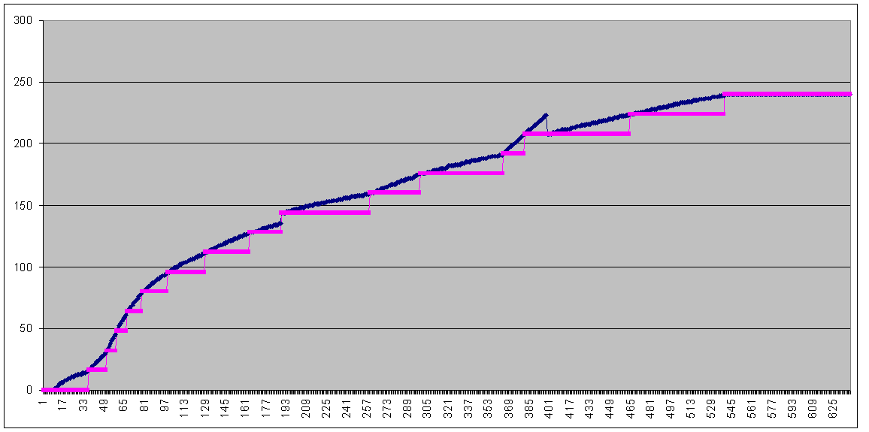
Modified Land Rover RPM Table (5502 limit)
RPM Scan: 120 to 6500 (10 RPM increments)

Gain on step 8 reduced (0x7A to 0x3D)
Gain on step 12 increased (0x18 to 0x30)

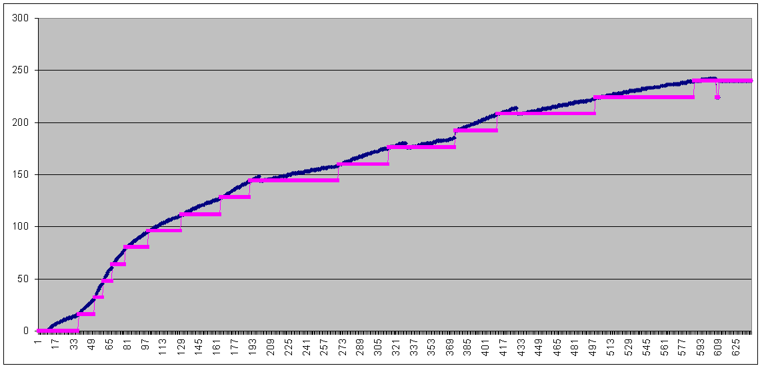
LR RPM Table with RPM extended to 6200
RPM Scan: 120 to 6500 (10 RPM increments)
RPM increase distributed over 7 brackets.

(This shows need to modify gain column in RPM table.)
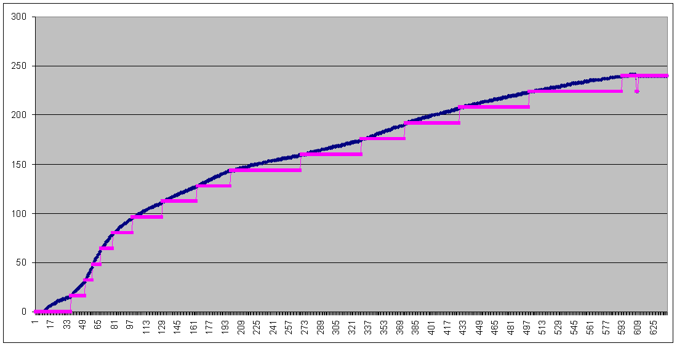
6200 RPM Table with Gain Values Modified
RPM Scan: 120 to 6500 (10 RPM increments)

(Curve is now again smooth although glitch in last bracket still exists.)

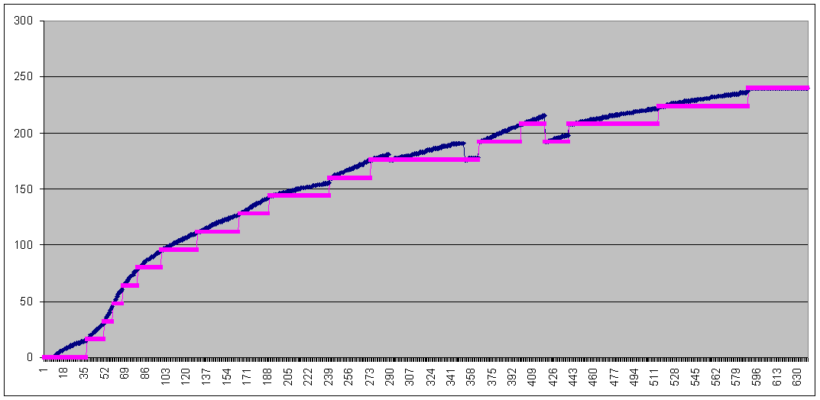
6000 RPM Table from Aftermarket Chip
RPM Scan: 120 to 6500 (10 RPM increments)

(This shows errors both in gain and in 3rd column data. In other words, remainder range does not match interpolation method.)

