GestureBridge
Hand Gesture Recognition System for Touchless Computer Control
Midterm Progress Report
Project III (CACS452)
Bachelor of Computer Applications, 8th Semester
Tribhuvan University, Nepal
Submitted By: Arun Shrestha
TU Registration Number: 6-2-1228-04-2021
College: V.S. International College
Supervisor: Mr. Diwakar Upadhyaya
Submission Date: 30th June 2026
[VERIFY: Tribhuvan University faculty / exam section details required by your campus]

Certificate Page
This is to certify that the midterm progress report entitled GestureBridge: Hand Gesture Recognition System for Touchless Computer Control has been prepared and submitted by Arun Shrestha, TU Registration Number 6-2-1228-04-2021, a student of BCA 8th Semester at V.S. International College, for Project III (CACS452) under Tribhuvan University. The work presented in this report is based on the student's ongoing solo project development and review of the current GestureBridge codebase.
This report is recommended for midterm evaluation as a record of the analysis, design, implementation progress, and planned completion work completed up to this stage. The remaining implementation testing, final evaluation, and conclusion chapters are to be completed for final submission.
Supervisor Recommendation
Supervisor Name: Mr. Diwakar Upadhyaya
Signature: _______________________________ Date: __________________
Internal / External Examiner Approval
Internal Examiner: [VERIFY: Internal examiner name, if known]
Signature: _______________________________ Date: __________________
External Examiner: [VERIFY: External examiner name, if known]
Signature: _______________________________ Date: __________________

Acknowledgement
I would like to express sincere gratitude to Mr. Diwakar Upadhyaya for guidance during the planning, analysis, and development of GestureBridge. I am also thankful to V.S. International College and the BCA department for providing the academic structure for this Project III work.
GestureBridge is a solo project, and the present midterm report reflects the current codebase, design decisions, and implementation progress. The motivation stated in this report should be reviewed and personalized before submission: [VERIFY: Confirm the personal motivation/problem framing you want in the acknowledgement and introduction].

Abstract
GestureBridge is a real-time hand gesture recognition system designed to support touchless computer interaction. The project uses a webcam feed and MediaPipe Hands to detect hand landmarks, converts each detected hand into a normalized 63-value feature vector, classifies the gesture using a TensorFlow.js multilayer perceptron, and maps recognized gestures to mouse actions in an Electron desktop shell. The active implementation uses a Next.js custom server with Socket.IO telemetry, MongoDB storage for gestures, samples, and logs, and Electron IPC with robotjs for native operating-system cursor control.
At the midterm stage, the core architecture, default gesture classes, server-side model training, browser inference, admin-gated dataset collection/import flows, and Electron mouse-control bridge are implemented in TypeScript. Current default labels are Pointing, Fist, Peace, Open Palm, Rock, and Thumb. The current control scheme includes pointing-based cursor movement, pinch left click, Peace right click, Rock scroll up, Fist scroll down, Open Palm mode toggling, and two-hand modifier actions for drag, middle click, cursor freeze, and zoom. The report focuses on analysis and design rather than final performance claims because final accuracy evaluation, user testing, and full implementation-testing evidence are still pending.
The system remains bounded to local desktop use with a webcam and configured MongoDB connection. Before final submission, the project should verify the handedness role assignment, replace screenshot placeholders with live captures, complete final tests, and record measured model accuracy and usability results.

Table of Contents
Certificate Page i
Acknowledgement ii
Abstract iii
List of Abbreviations v
List of Figures v
List of Tables vi
Chapter 1: Introduction 1
1.1 Introduction 1
1.2 Problem Statement 1
1.3 Objectives 2
1.4 Scope and Limitation 2
1.5 Development Methodology 3
1.6 Report Organization 3
Chapter 2: Background Study and Literature Review 3
2.1 Background Study 3
2.2 Literature Review 4
Chapter 3: System Analysis and Design 6
3.1 System Analysis 6
3.2 System Design 11
3.3 Algorithm Details 12
Chapter 4: Implementation and Testing (Midterm Status Stub) 15
References 16
Bibliography 16
Appendices 17

List of Abbreviations
Table F.1: List of Abbreviations
Abbreviation | Meaning
API | Application Programming Interface
BCA | Bachelor of Computer Applications
CDN | Content Delivery Network
HCI | Human-Computer Interaction
IPC | Inter-Process Communication
JWT | JSON Web Token
ML | Machine Learning
MLP | Multilayer Perceptron
OS | Operating System
RGB | Red Green Blue image input
TF.js | TensorFlow.js
UI | User Interface
WASM | WebAssembly

List of Figures
Figure 3.1: Use Case Diagram of GestureBridge
Figure 3.2: Object and Module Model Derived from the Current Codebase
Figure 3.3: Gesture Recognition State Model
Figure 3.4: Sequence Diagram for Gesture-to-OS Action Flow
Figure 3.5: Activity Diagram for Recognition and Control
Figure 3.6: Component Diagram of the Current Implementation
Figure 3.7: Deployment Diagram for Browser and Electron Modes
Figure A.1: Recognition View Screenshot Placeholder
Figure A.2: Admin Training Panel Screenshot Placeholder
Figure A.3: Dataset Import Page Screenshot Placeholder
Figure A.4: Gesture History Page Screenshot Placeholder

List of Tables
Table 2.1: Literature and Reference Summary
Table 3.1: Functional Requirements
Table 3.2: Non-Functional Requirements
Table 3.3: Feasibility Analysis
Table 3.4: Implemented Gesture-to-Action Mapping
Table 4.1: Midterm Verification Snapshot

Chapter 1: Introduction

1.1 Introduction
GestureBridge is a touchless desktop-control system that uses real-time hand tracking to let a user move the cursor, click, scroll, freeze movement, drag, and zoom without holding a physical mouse. The project sits in the human-computer interaction area where the main technical problem is not only detecting a hand, but turning unstable camera-space landmarks into deliberate, debounced operating-system actions.
The active codebase is organized as two separate TypeScript projects. The web project is a Next.js application with a custom server, MediaPipe Hands loaded from a CDN, TensorFlow.js inference in the browser, TensorFlow.js Node training on the server, MongoDB-backed API routes, and Socket.IO telemetry. The desktop project is an Electron shell that loads the local web app and exposes a small, validated IPC bridge to robotjs for native OS control.
The project is developed as a solo BCA 8th semester Project III submission. The personal motivation and campus-specific framing should be finalized by the student before submission: [VERIFY: Confirm the personal motivation/problem framing you want in the acknowledgement and introduction].

1.2 Problem Statement
Most desktop workflows assume that the user can continuously operate a physical pointing device. That assumption creates friction in hands-free scenarios, accessibility-sensitive contexts, demonstrations, hygiene-sensitive environments, and situations where the user wants brief computer control while away from the mouse. A camera-based gesture-control system can reduce that dependency, but only if it is responsive, stable, resistant to accidental triggers, and able to reach the operating system safely.
GestureBridge addresses this gap by combining webcam-based hand landmarks, a trained gesture classifier, confidence thresholds, gesture-specific cooldowns, a mode-toggle state machine, and a desktop IPC boundary. The goal is not to replace every traditional input device, but to provide a working local prototype for common cursor actions through a small set of recognizable hand gestures.

1.3 Objectives
- Capture live webcam frames and detect up to two hands using MediaPipe Hands.
- Convert 21 three-dimensional hand landmarks into normalized 63-value feature vectors.
- Train and serve a TensorFlow.js MLP gesture classifier with index-aligned gesture labels.
- Map high-confidence dominant-hand gestures to cursor movement, click, and scroll actions in Electron.
- Support two-hand modifier behavior for drag, middle click, cursor freeze, and zoom.
- Provide admin-gated tools for collecting samples, importing datasets, seeding starter samples, retraining the model, and viewing logs.
- Keep OS-level control inside the Electron main process through a constrained IPC bridge.

1.4 Scope and Limitation
The current scope is a local desktop gesture-control prototype. It supports a browser recognition interface and an Electron desktop shell. The browser can show recognition and training workflows, while native mouse and keyboard-like control is only expected in Electron because robotjs runs in the desktop main process.
Table 1.1: Scope and Current Limitations
In Scope | Current Limitation
Webcam hand detection, skeleton overlay, and browser inference. | Requires a working camera and MediaPipe CDN scripts.
Six default gesture labels: Pointing, Fist, Peace, Open Palm, Rock, Thumb. | [VERIFY: Current code has six default gesture labels; confirm this should replace the prompt's earlier five-gesture wording].
Electron IPC for move, click, scroll, drag, zoom, screen size, and compact mode. | Production packaging and launch mode still need final documentation.
Admin-gated ML data collection, import, seeding, train, and logs. | Requires configured ADMIN_EMAIL, ADMIN_PASSWORD_HASH, JWT_SECRET, and MongoDB.
Server-side training and client-side hot model reload. | No measured final accuracy, latency, or user-study results are reported yet.
Two-hand role-based controls. | [VERIFY: Confirm or fix the handedness role assignment; useMediaPipe mirror-corrects handedness and assignHandRoles is still called with MIRRORED_FEED=true].

1.5 Development Methodology
The project follows an incremental and iterative methodology. The repository evidence shows phased work: scaffolding a Next.js TypeScript web app, moving server-side database and ML logic into the web project, adding route handlers and model training, integrating MediaPipe and TF.js inference, then tightening the Electron IPC boundary and admin protection. This approach fits a solo project because each increment can be verified independently: first landmark capture, then classifier training, then mouse-control mapping, then data-management and security hardening.
The midterm deliverable therefore emphasizes the implemented architecture and remaining risks rather than pretending the system is final. Verification completed during this report generation includes TypeScript checks for both projects and a production web build with network access for Google Fonts. Linting remains a tooling gap because the current web script calls next lint, which fails under Next.js 16.

1.6 Report Organization
Chapter 1 introduces the problem, objectives, scope, and methodology. Chapter 2 explains the background concepts and reviews the most relevant technical literature and implementation references. Chapter 3 presents the system analysis, diagrams, component design, deployment view, and GestureBridge-specific algorithms. Chapter 4 is intentionally left as a midterm status stub; detailed implementation testing, measured results, and conclusion will be completed for the final report.

Chapter 2: Background Study and Literature Review

2.1 Background Study
GestureBridge depends on hand-landmark detection rather than raw image classification. MediaPipe Hands and the current Google AI Edge hand landmarker documentation describe a task that accepts images or live video and outputs hand landmarks, handedness, and coordinate information [1], [2]. In GestureBridge, those landmarks are consumed directly by React hooks instead of being stored as raw images. This keeps the feature vector small and avoids training a heavy image model from scratch.
The model layer uses TensorFlow.js because the project needs one ML stack that can train in Node.js and run inference in the browser. TensorFlow.js was designed for machine learning algorithms in JavaScript and supports both browser and Node.js environments [3]. GestureBridge uses @tensorflow/tfjs-node on the server for training and @tensorflow/tfjs in the browser for inference from the static model files saved under public/ml/model.
Socket.IO is used as a real-time event channel, but the current source uses it for telemetry and gesture broadcasts rather than local OS control. This matches Socket.IO's role as a low-latency, bidirectional, event-based communication library [4]. Native cursor actions are handled inside Electron because Electron can isolate the renderer and expose a narrow preload API. The Electron security documentation recommends context isolation, avoiding Node.js integration in remote content, limiting navigation, and validating IPC messages [5]. GestureBridge follows much of that pattern with contextBridge, local-origin restrictions, runtime payload guards, and robotjs calls in the main process.
RobotJS provides desktop automation for mouse, keyboard, and screen operations and supports major desktop operating systems [6]. GestureBridge wraps those native functions behind validated IPC messages instead of exposing robotjs directly to the renderer. This boundary is important because gesture recognition is driven by a web page loaded inside Electron.

2.2 Literature Review
Table 2.1: Literature and Reference Summary
Source | Key Idea | Relevance to GestureBridge
Zhang et al., MediaPipe Hands [1] | Real-time on-device hand tracking using a palm detector and hand landmark model. | Justifies using landmark extraction as the first stage instead of building a hand detector from scratch.
Google AI Edge Hand Landmarker guide [2] | Hand landmark task supports image/video/live stream input and returns landmarks plus handedness. | Matches GestureBridge's live webcam pipeline and two-hand role logic.
Smilkov et al., TensorFlow.js [3] | JavaScript ML models can run in browser and Node.js environments. | Supports the split between server training and browser inference.
Socket.IO documentation [4] | Low-latency bidirectional event transport. | Explains the telemetry channel used alongside the custom Next.js server.
Electron security documentation [5] | Renderer isolation, permission handling, and IPC validation are central security practices. | Shapes the design choice to keep OS control in Electron main process.
RobotJS project documentation [6] | Desktop automation API for mouse, keyboard, and screen. | Provides the OS cursor-control mechanism used after IPC validation.

The literature and implementation references point toward a layered system: use an established hand tracker for real-time landmarks, keep the classifier lightweight, separate browser inference from native OS control, and protect the bridge between the renderer and the desktop automation layer. GestureBridge follows this pattern by using MediaPipe for landmarks, an MLP for gesture classification, Electron IPC for native actions, and admin-gated routes for mutating training data.
[VERIFY: Confirm the IEEE references are acceptable to the supervisor before final submission]. Additional academic comparisons can be added if the supervisor expects more traditional HCI literature beyond implementation-oriented references.

Chapter 3: System Analysis and Design

3.1 System Analysis

3.1.1 Requirement Analysis
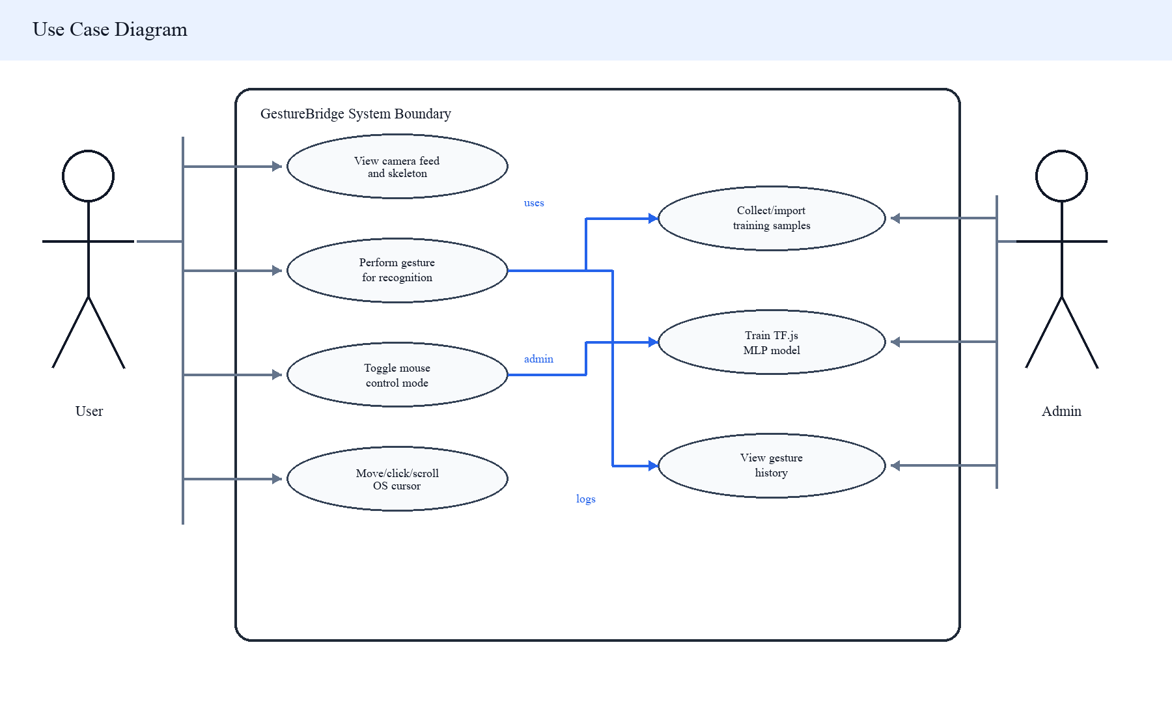
Figure 3.1: Use Case Diagram of GestureBridge
Table 3.1: Functional Requirements
ID | Requirement | Current Evidence
FR1 | Detect one or two hands from webcam input. | useMediaPipe sets maxNumHands to 2 and streams video frames.
FR2 | Classify each detected hand into an index-aligned gesture label. | useGestureModel loads /ml/model/model.json and maps softmax index to gestureLabels.
FR3 | Move cursor using dominant-hand pointing. | useMouseControl maps index fingertip to screen coordinates.
FR4 | Trigger click and scroll gestures. | Pinch, Peace, Rock, and Fist are mapped to left click, right click, scroll up, and scroll down.
FR5 | Support two-hand modifier controls. | useTwoHandControl and useTwoHandZoom implement drag, middle click, freeze, and zoom.
FR6 | Admin can collect/import/train data. | Protected admin routes handle collect, import, seed, train, and gestures.
FR7 | Admin can view recent gesture history. | /history calls /api/logs and displays counts and activity.

Table 3.2: Non-Functional Requirements
Requirement | Design Response
Responsiveness | MediaPipe runs continuously, frame updates are deduplicated, pointer movement is throttled to about 60 fps, and scroll/zoom are interval-limited.
Safety | Mouse mode requires an Open Palm hold sequence or explicit UI toggle in Electron; click actions are leading-edge gated with cooldowns.
Security | Admin mutations require an HTTP-only JWT-backed admin session, same-origin checks, request body limits, and rate limits.
Maintainability | Gesture logic is divided into hooks and server utilities: MediaPipe, classifier, mouse control, two-hand control, validation, and admin auth.
Cross-platform desktop goal | Electron and robotjs target desktop platforms, but native module rebuild and OS accessibility permissions still require final setup documentation.

3.1.2 Feasibility Analysis
Table 3.3: Feasibility Analysis
Feasibility Area | Assessment
Technical | The chosen libraries exist in the current package files and TypeScript checks pass for both web and desktop. MediaPipe, TF.js, Socket.IO, MongoDB, Electron, and robotjs cover the main technical needs.
Operational | The system can be demonstrated on a laptop with a webcam, a configured MongoDB connection, browser permissions, and Electron accessibility permissions. MongoDB DNS could not be resolved in this report environment, so live screenshots were not captured.
Economic | The project uses open-source libraries and existing student hardware, so cost is mainly development time and any optional database hosting.
Schedule | The iterative migration and hardening work is suitable for a solo midterm project, but final evaluation, packaging, and documentation remain scheduled for the final stage.

3.1.3 Object Modelling Using Class and Object Diagrams
The current implementation is hook- and module-oriented rather than class-heavy. The object model therefore maps actual runtime responsibilities: hand landmark objects, prediction results, Mongoose models, admin session objects, and the Electron IPC bridge. The diagram below represents concrete files and data structures from the current source rather than invented domain classes.
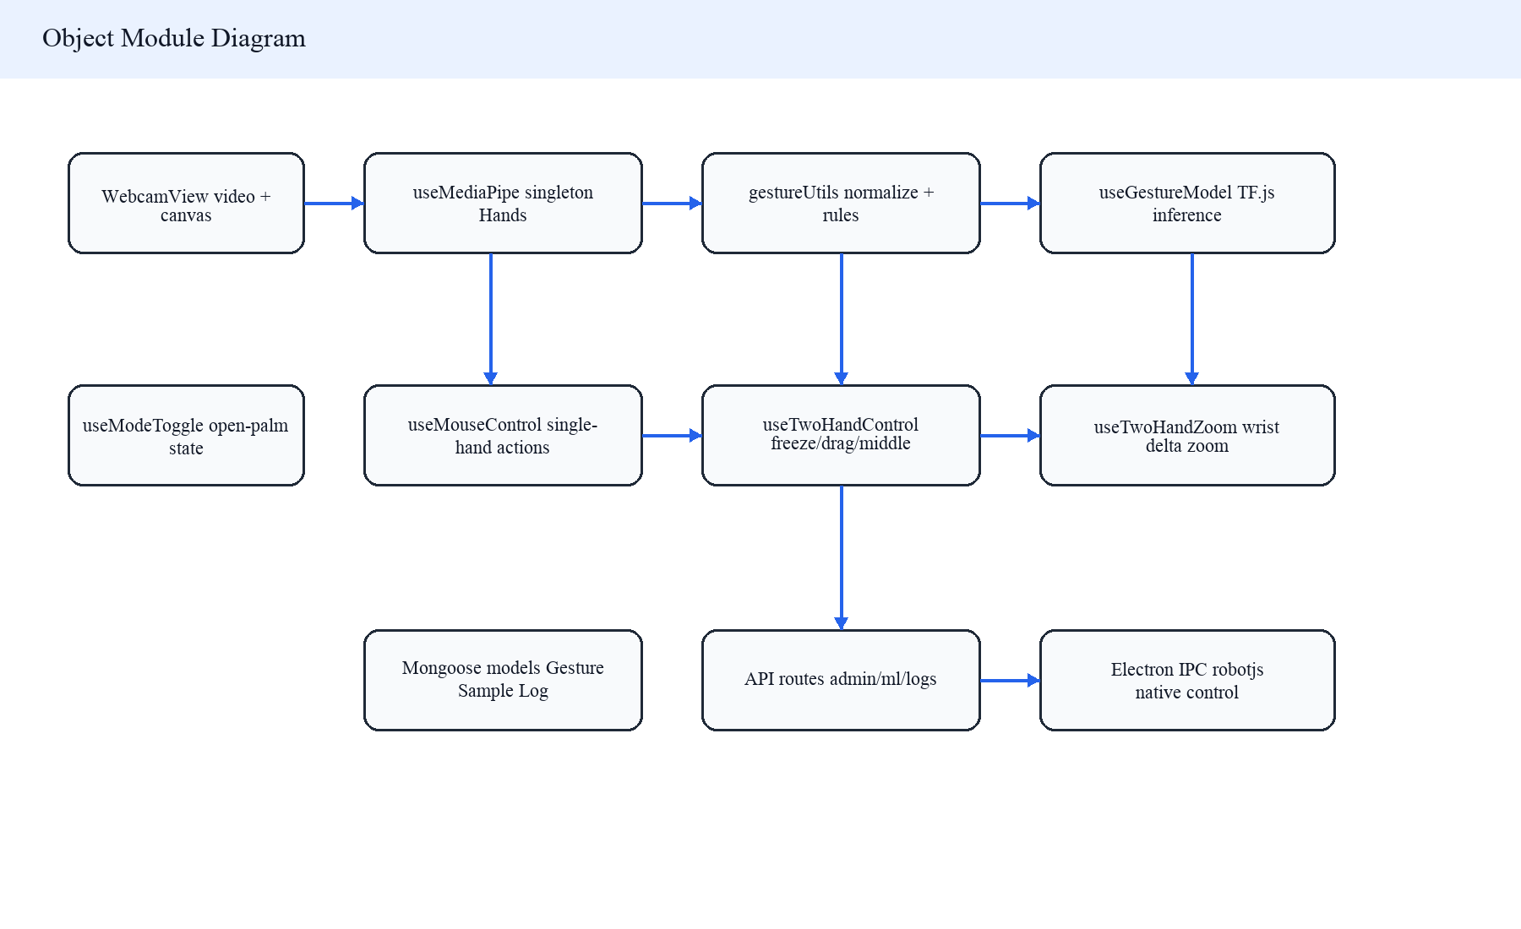
Figure 3.2: Object and Module Model Derived from the Current Codebase

3.1.4 Dynamic Modelling Using State and Sequence Diagrams
GestureBridge has two important dynamic behaviors. The first is the recognition state flow from idle camera frames to classified predictions and possible actions. The second is the event sequence that crosses browser, model, Electron preload, Electron main, and robotjs. These models explain how a visual gesture becomes a controlled OS operation.
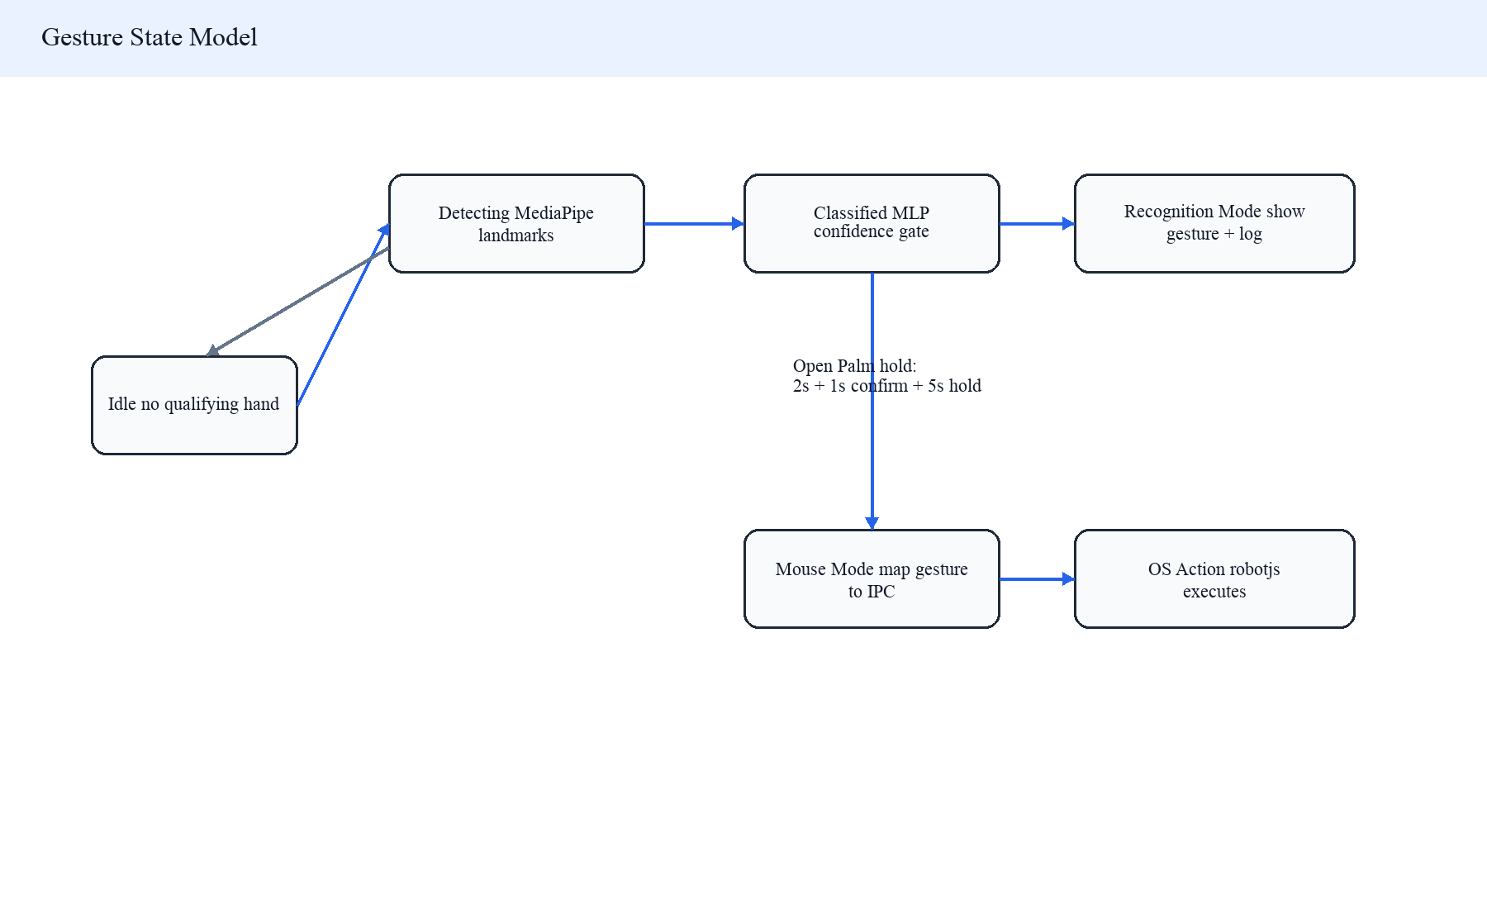
Figure 3.3: Gesture Recognition State Model
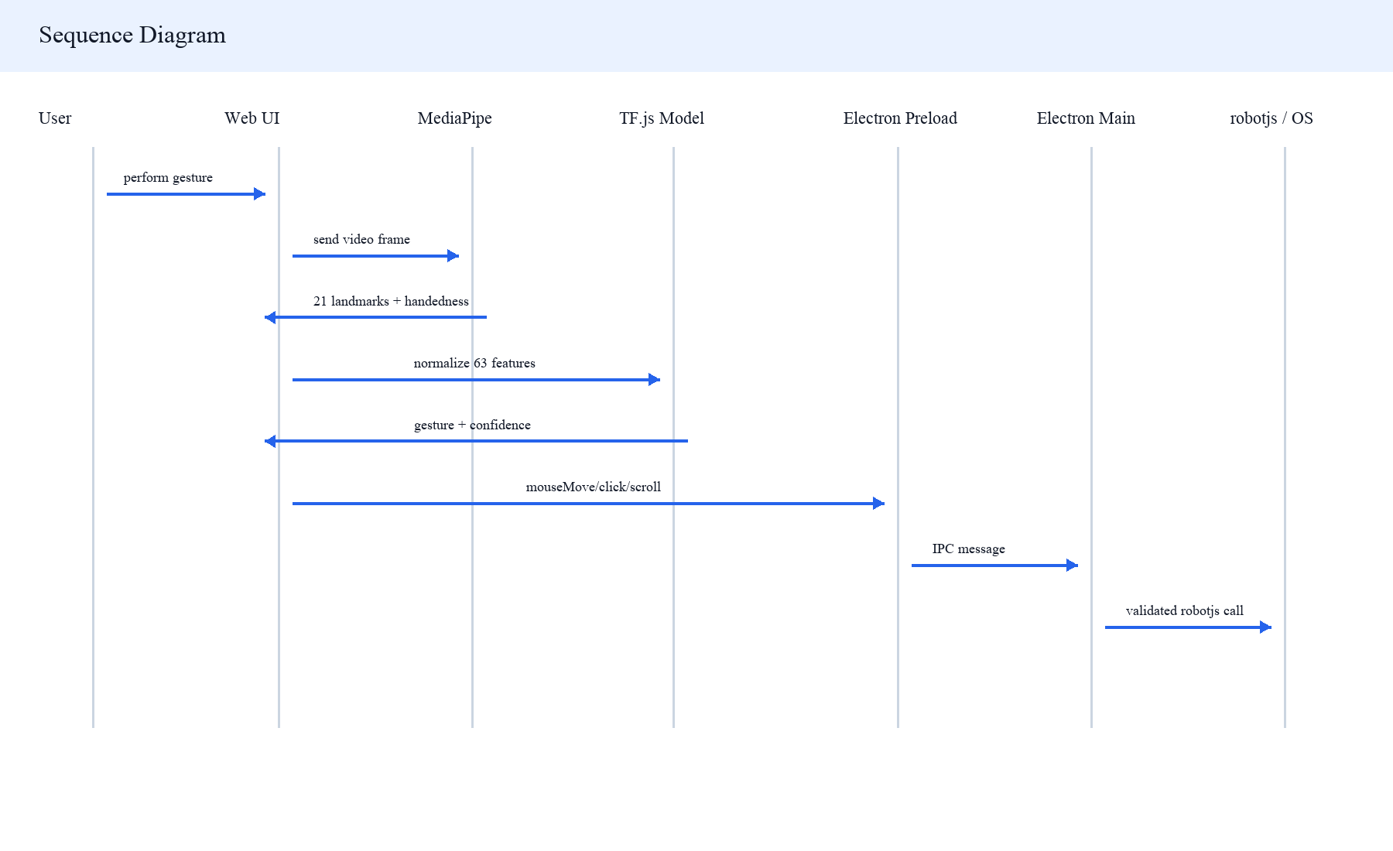
Figure 3.4: Sequence Diagram for Gesture-to-OS Action Flow

3.1.5 Process Modelling Using Activity Diagrams
The recognition process is frame-based. Each frame is processed only when it produces a significant landmark change or a hand appears/disappears. The classifier result then either remains a recognition display event or becomes an Electron IPC action when mouse mode is active and the confidence gates pass.
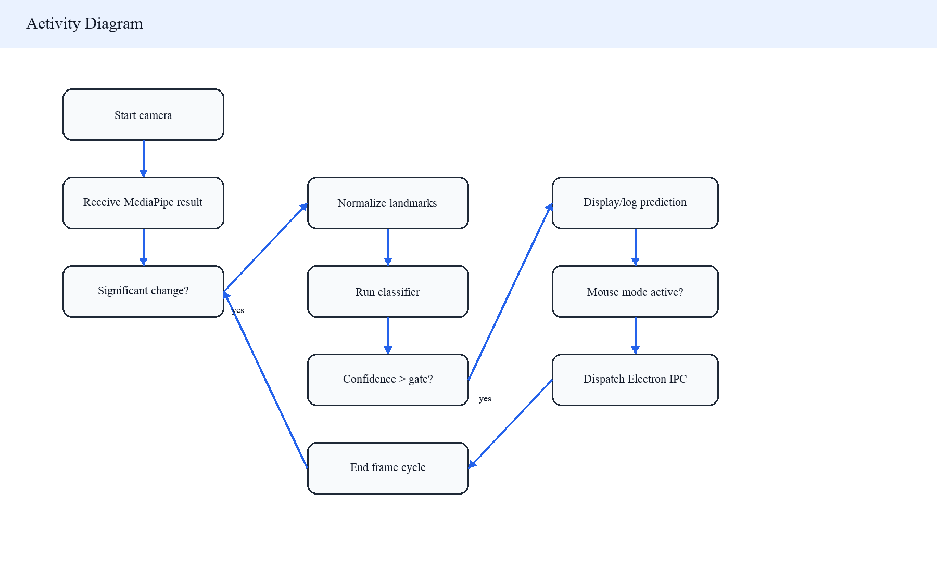
Figure 3.5: Activity Diagram for Recognition and Control

3.2 System Design

3.2.1 Refinement of Diagrams for Actual Implementation
The current design uses / as the active recognition page; /recognition redirects to /. GestureBridge is not a pure REST application because the custom server attaches Socket.IO to the same HTTP server as Next.js. However, local OS control is not handled by Socket.IO in the current source. It is handled by Electron IPC, which is a safer ownership boundary for native input control.
The design also separates public recognition from admin-only mutation. Public users can view recognition, while dataset collection, import, training, seeding, and logs require an admin session. This is implemented through configured admin credentials, bcrypt password-hash verification, JWT session cookies, same-origin checks, and route-specific rate limits.

3.2.2 Component Diagrams
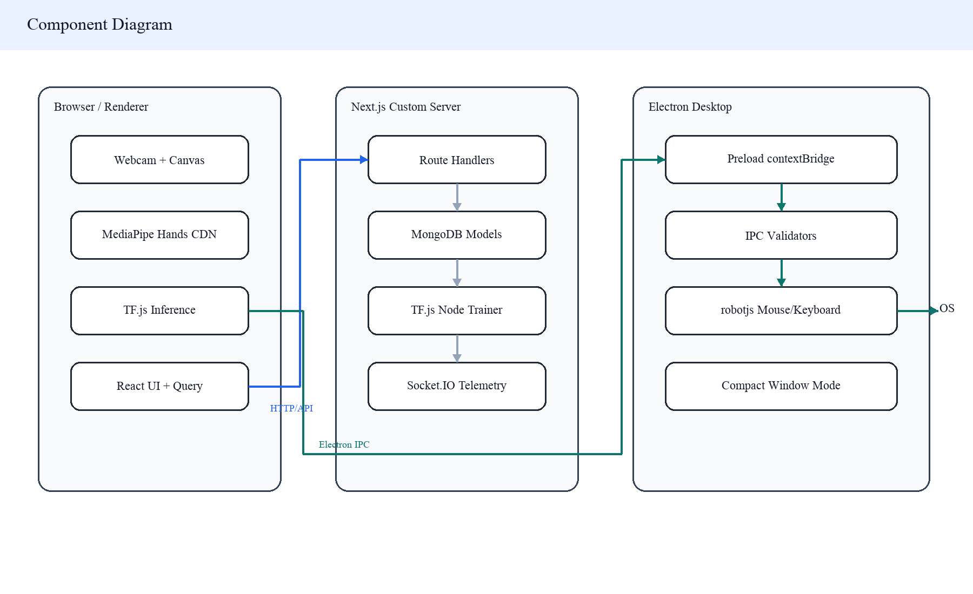
Figure 3.6: Component Diagram of the Current Implementation

3.2.3 Deployment Diagrams
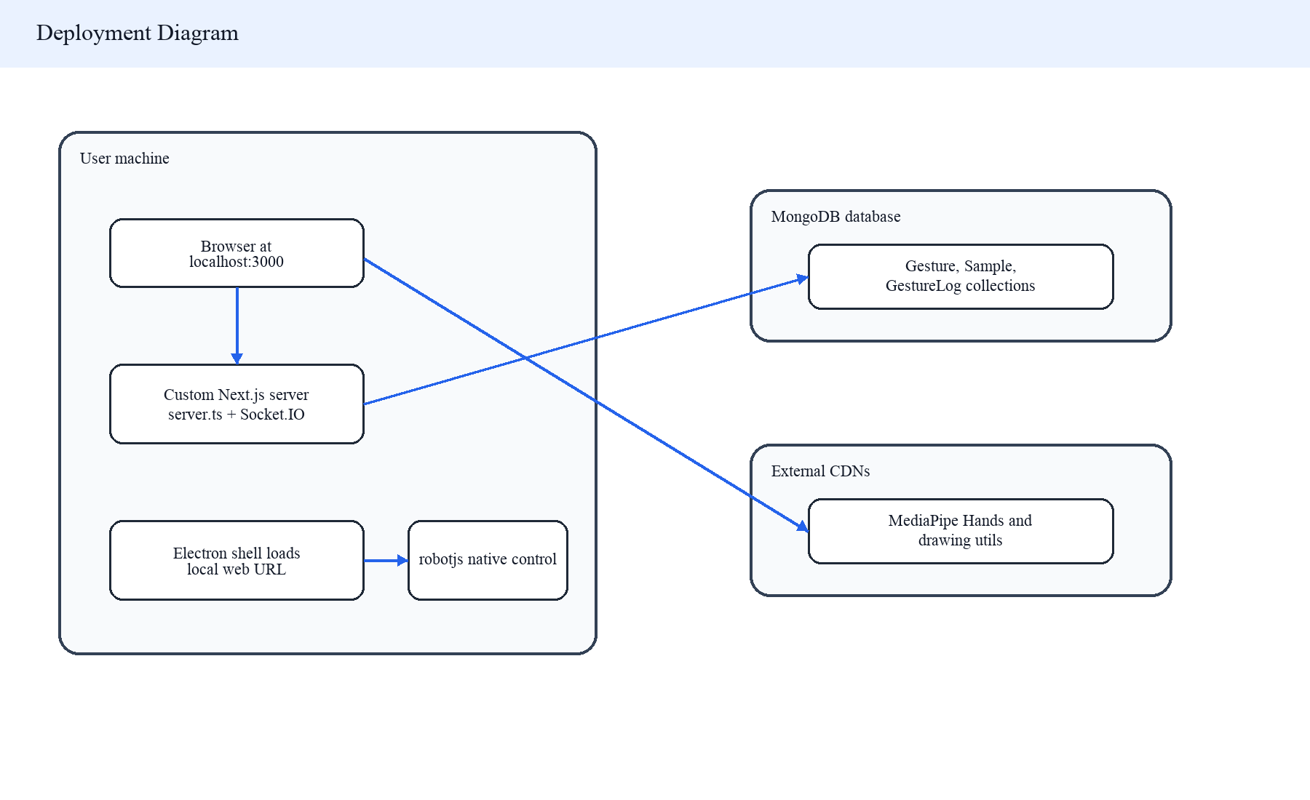
Figure 3.7: Deployment Diagram for Browser and Electron Modes
[VERIFY: Confirm production Electron mode: companion localhost server, managed child server, or trusted hosted URL]. The current desktop source loads WEB_URL when it is a local URL and falls back to http://localhost:3000.

3.3 Algorithm Details
The key algorithmic work in GestureBridge is the conversion from camera-space hand landmarks into stable desktop actions. The system avoids a direct image-to-action shortcut. Instead, it runs a sequence of landmark detection, significant-change filtering, feature normalization, MLP classification, confidence gating, gesture-specific debouncing, and coordinate mapping.

3.3.1 Landmark Acquisition and Deduplication
useMediaPipe creates a module-level singleton for the MediaPipe Hands instance. It requests a 1280 by 720 camera stream at 30 fps, sets maxNumHands to 2, uses detection confidence 0.7 and tracking confidence 0.5, and mirrors the drawing canvas so the skeleton matches the CSS-mirrored video. It sends frames through requestAnimationFrame and delegates results through one active callback so route transitions do not recreate the MediaPipe instance.
To reduce unnecessary React updates, the hook compares key landmarks only: wrist, thumb tip, index tip, middle tip, and pinky tip. If the squared distance change of these points stays below the 0.002 threshold, the callback is skipped unless a hand appears or disappears.

3.3.2 Landmark Normalization
GestureBridge uses 21 landmarks with x, y, and z values. The normalizeLandmarks function subtracts the wrist landmark from every point, flattens the relative coordinates into 63 numbers, finds the maximum absolute coordinate value, and divides every feature by that value plus a small epsilon. This makes the classifier less sensitive to hand position and scale in the camera frame.
Representative source snippet: normalizeLandmarks
const wrist = landmarks[0];
const relative = landmarks.map((lm) => ({
x: lm.x - wrist.x,
y: lm.y - wrist.y,
z: lm.z - wrist.z,
}));
const flat = relative.flatMap((lm) => [lm.x, lm.y, lm.z]);
const maxVal = Math.max(...flat.map(Math.abs));
return flat.map((v) => v / (maxVal + 1e-7));

3.3.3 MLP Classification
The training pipeline loads all Sample records from MongoDB, builds xTrain as a tensor2d of 63-feature vectors, and one-hot encodes labels. The number of classes is calculated from the largest registered gesture label and the largest label present in samples, with a minimum of six default classes. The model architecture is Dense(64, ReLU), Dropout(0.3), Dense(32, ReLU), Dropout(0.2), and Dense(numClasses, Softmax), trained for 50 epochs with Adam at learning rate 0.001 and categorical cross-entropy loss.
Client-side inference loads /ml/model/model.json with a cache-busting timestamp and uses tf.tidy around each prediction. The highest softmax probability chooses the gesture label. A prediction confidence above 0.6 is required for local action decisions, while confidence above 0.7 is required for Socket.IO gesture emission and admin-only history logging.

3.3.4 Gesture-to-Action Mapping
Table 3.4: Implemented Gesture-to-Action Mapping
Hand / Condition | Gesture or Geometry | Action
Dominant hand | Pointing, label 0 | Move mouse using index fingertip x/y mapping.
Dominant hand | Thumb-index pinch distance below 0.06 | Left click on leading edge, 500 ms cooldown.
Dominant hand | Peace, label 2 | Right click on leading edge, 400 ms cooldown.
Dominant hand | Rock, label 4 | Scroll up, interval-limited to 120 ms.
Dominant hand | Fist, label 1 | Scroll down, interval-limited to 120 ms.
Dominant hand | Open Palm, label 3 | Mode toggle state machine: 2 s hold, 1 s confirm, 5 s hold.
Modifier hand | Fist, label 1 | Hold left mouse button for drag; release when gesture changes or hand disappears.
Modifier hand | Peace, label 2 | Middle click on leading edge.
Modifier hand | Open Palm, label 3 | Freeze cursor movement while mouse mode is active.
Both hands | Wrist distance delta above 0.05 | Zoom in/out through Ctrl plus scroll at 100 ms interval.

Cursor mapping uses the index fingertip. The x-coordinate is flipped to match the mirrored camera view: x = (1 - landmark[8].x) * screenWidth, while y = landmark[8].y * screenHeight. The Electron main process then clamps the point to the nearest display bounds before calling robotjs.moveMouse.

3.3.5 Validation, Rate Limiting, and Admin Boundary
Training samples are validated before insertion. A sample must be an object with exactly 63 finite numeric feature values and an integer label that exists in the registered gesture label set. Collect requests accept up to 1000 samples and import requests accept up to 5000 samples, with request-body size limits. Admin-only mutation routes also use same-origin checks and rate limits. These controls reduce accidental dataset poisoning and runaway training requests, although final production hardening should still add a training lock or queue.
Gesture registration normalizes names and escapes regular-expression input before checking for duplicates. However, label allocation still uses the current maximum labelIndex plus one rather than a transaction or atomic counter, so concurrent gesture creation can remain a final-stage risk.

Chapter 4: Implementation and Testing (Midterm Status Stub)
This chapter is intentionally not written as a final implementation and testing chapter. At midterm stage, the project has working source structure and core pipeline implementation, but measured accuracy, latency, live webcam verification, Electron OS-control verification, packaging, and user testing should be completed before final submission. [VERIFY: Do not add final accuracy or user-test metrics until they are measured].
Table 4.1: Midterm Verification Snapshot
Check | Result During Report Generation | Notes
web npm run type-check | Passed | TypeScript completed with no errors.
desktop npx tsc --noEmit | Passed | Desktop TypeScript completed with no errors.
web npm run build | Passed with network access | Initial sandbox run failed because Google Fonts could not be fetched; network-approved run succeeded.
web npm run lint | Failed | The script still calls next lint, which fails under the current Next.js setup.
Live app screenshot capture | Not completed | Custom server startup failed because the configured MongoDB SRV host could not be resolved from this environment.
Live camera / OS mouse test | Not completed | Requires running app, camera permission, MongoDB connectivity, and desktop accessibility permissions.

References
[1] F. Zhang, V. Bazarevsky, A. Vakunov, A. Tkachenka, G. Sung, C.-L. Chang, and M. Grundmann, "MediaPipe Hands: On-device Real-time Hand Tracking," arXiv:2006.10214, 2020. doi: 10.48550/arXiv.2006.10214.
[2] Google, "Hand landmarks detection guide," Google AI Edge, accessed Jun. 28, 2026. [Online]. Available: https://developers.google.com/edge/mediapipe/solutions/vision/hand_landmarker
[3] D. Smilkov et al., "TensorFlow.js: Machine Learning for the Web and Beyond," arXiv:1901.05350, 2019. doi: 10.48550/arXiv.1901.05350.
[4] Socket.IO, "Introduction | Socket.IO," accessed Jun. 28, 2026. [Online]. Available: https://socket.io/docs/v4/
[5] Electron, "Security," accessed Jun. 28, 2026. [Online]. Available: https://www.electronjs.org/docs/latest/tutorial/security
[6] RobotJS contributors, "RobotJS: Node.js Desktop Automation," GitHub, accessed Jun. 28, 2026. [Online]. Available: https://github.com/octalmage/robotjs

Bibliography
Internal project materials consulted but not formally cited as external references include AGENTS.md, TASK.md, docs/README.md, docs/01-web-review.md, docs/02-desktop-review.md, docs/03-tooling-and-verification.md, docs/04-remediation-backlog.md, and source files under web/ and desktop/src/.

Appendices

Appendix A: Screenshot Placeholders
The following placeholders identify the exact screenshots that should be captured from the running app before submission. [VERIFY: Replace appendix screenshot placeholders with live captures after MongoDB/network/camera access is available].
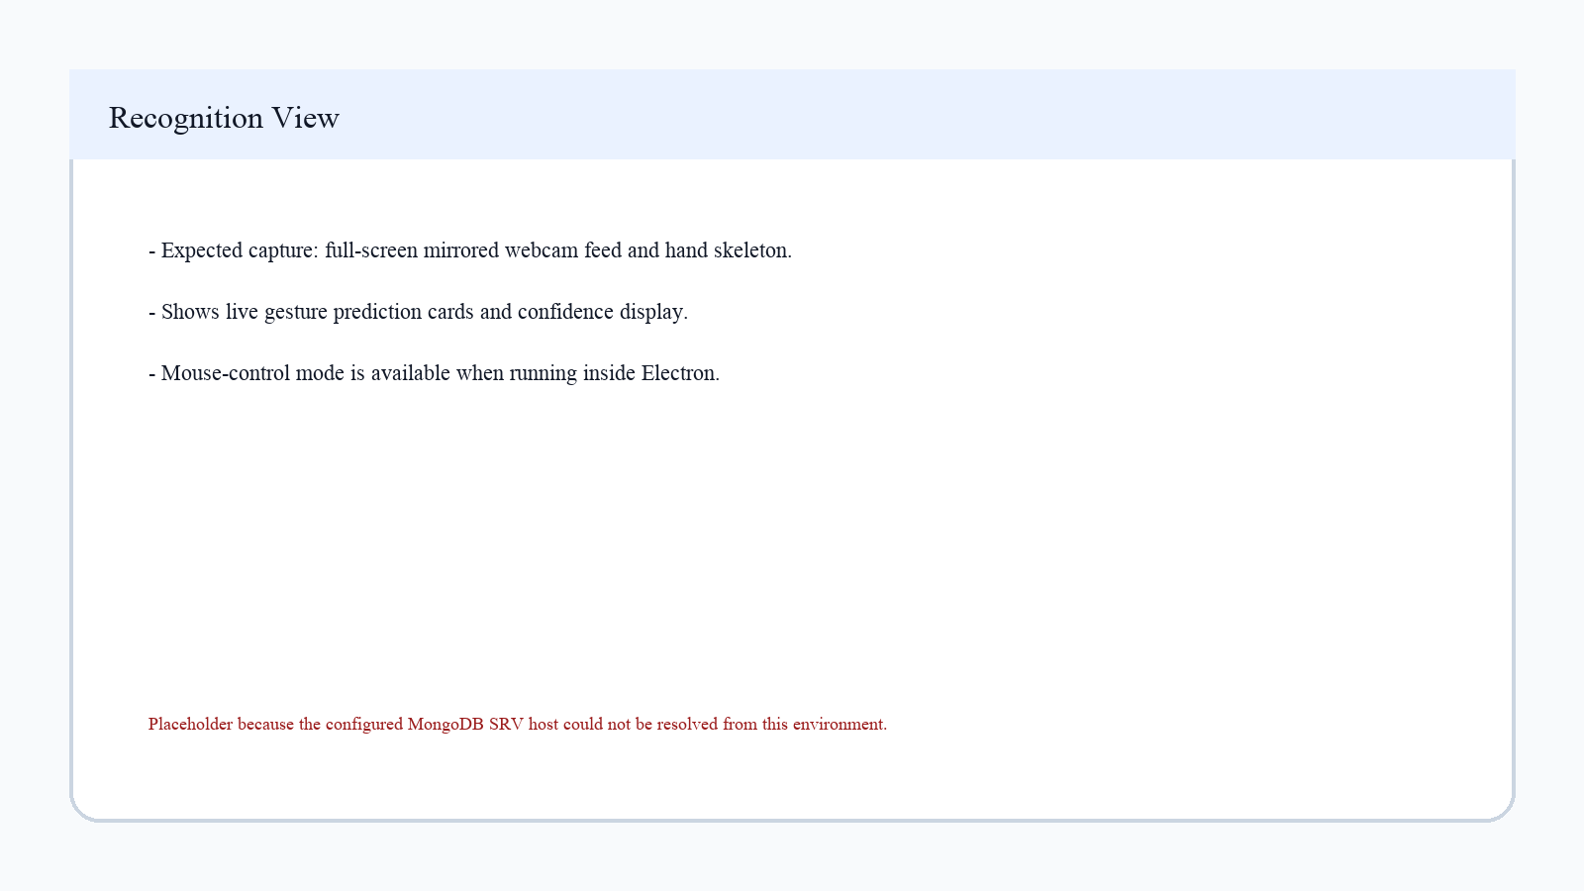
Figure A.1: Recognition View Screenshot Placeholder
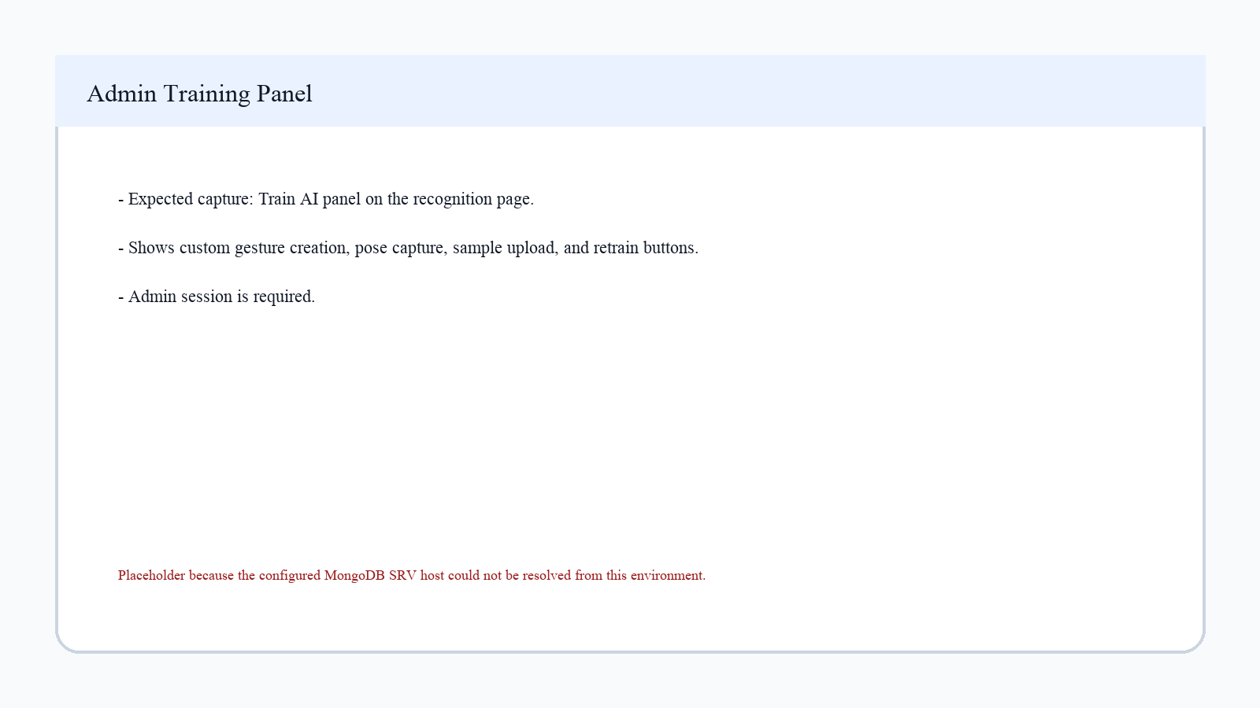
Figure A.2: Admin Training Panel Screenshot Placeholder
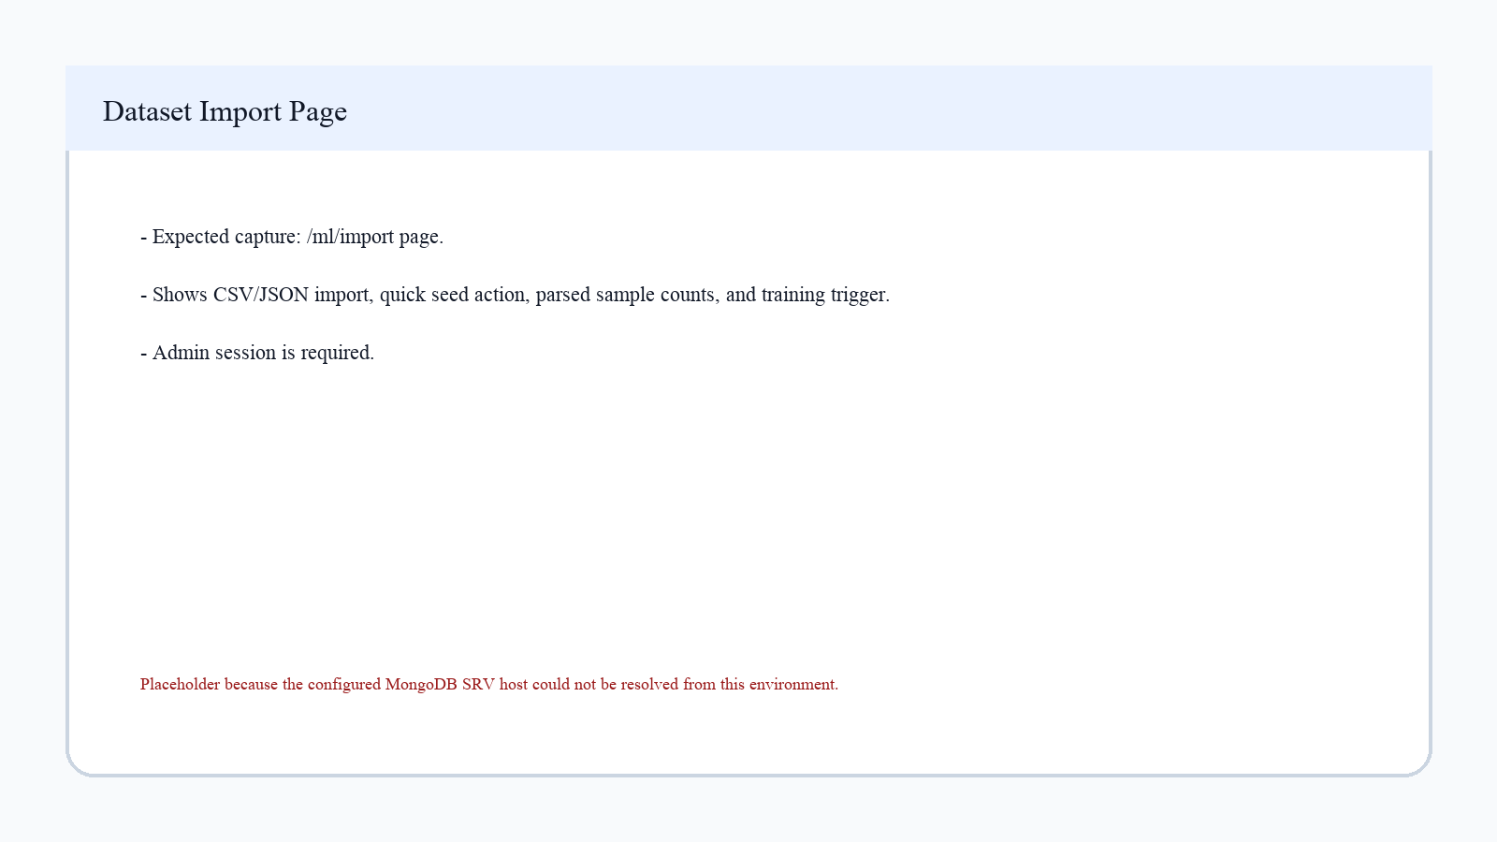
Figure A.3: Dataset Import Page Screenshot Placeholder
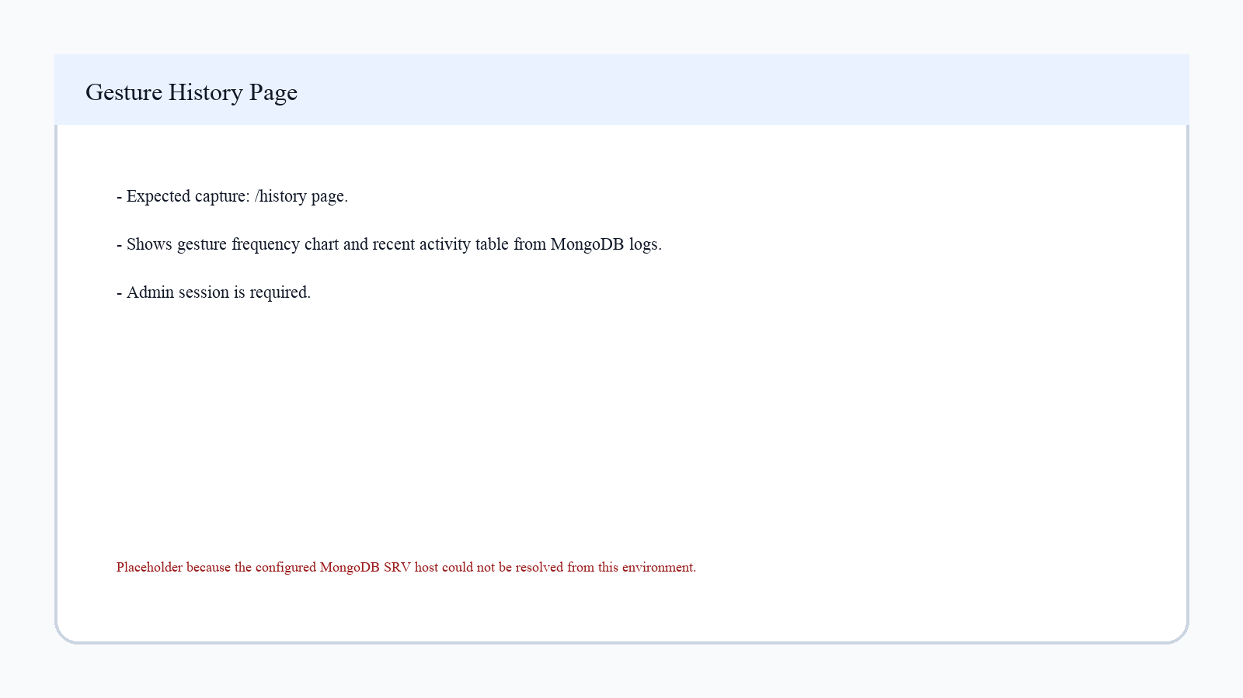
Figure A.4: Gesture History Page Screenshot Placeholder

Appendix B: Representative Source Code Snippets
Snippet B.1: Pinch detection threshold
const dx = thumbTip.x - indexTip.x;
const dy = thumbTip.y - indexTip.y;
const distance = Math.sqrt(dx * dx + dy * dy);
return distance < PINCH_THRESHOLD;
Snippet B.2: Dominant-hand cursor mapping
if (currLabel === 0 && !isFrozen) {
const x = (1 - landmarks[8].x) * screenSize.width;
const y = landmarks[8].y * screenSize.height;
window.electronAPI?.mouseMove(x, y);
}
Snippet B.3: Electron IPC bridge surface
contextBridge.exposeInMainWorld('electronAPI', {
mouseMove: (x, y) => ipcRenderer.send('mouse:move', { x, y }),
mouseClick: (button) => ipcRenderer.send('mouse:click', { button }),
mouseButton: (button, action) => ipcRenderer.send('mouse:button', { button, action }),
mouseScroll: (direction) => ipcRenderer.send('mouse:scroll', { direction }),
zoom: (direction) => ipcRenderer.send('zoom', { direction }),
});
Snippet B.4: Training sample validation
if (!Array.isArray(features) || features.length !== 63) reject();
if (!features.every((value) => typeof value === 'number' && Number.isFinite(value))) reject();
if (typeof label !== 'number' || !Number.isInteger(label)) reject();
if (!knownLabels.has(label)) reject();

Appendix C: Open Questions and VERIFY Flags
The repository cannot provide the following personal, administrative, and final-verification details. Resolve these before the report is submitted to the supervisor.
- [VERIFY: Tribhuvan University faculty / exam section details required by your campus]
- [VERIFY: Internal examiner name, if known]
- [VERIFY: External examiner name, if known]
- [VERIFY: Confirm the personal motivation/problem framing you want in the acknowledgement and introduction]
- [VERIFY: Current code has six default gesture labels; confirm this should replace the prompt's earlier five-gesture wording]
- [VERIFY: Confirm or fix the handedness role assignment; useMediaPipe mirror-corrects handedness and assignHandRoles is still called with MIRRORED_FEED=true]
- [VERIFY: Replace appendix screenshot placeholders with live captures after MongoDB/network/camera access is available]
- [VERIFY: Confirm MongoDB Atlas DNS and credentials work in the demonstration/submission environment]
- [VERIFY: Confirm production Electron mode: companion localhost server, managed child server, or trusted hosted URL]
- [VERIFY: Confirm the IEEE references are acceptable to the supervisor before final submission]
- [VERIFY: Do not add final accuracy or user-test metrics until they are measured]

