F
FlightGear PA28
Rendering Settings

i
This PA28 model is optimized to look best with certain rendering settings.
Please note that
- this is optional and you can use the aircraft without doing this
- adjusting these settings
  - may lead to a decrease in performance
  - will also stay active for other aircraft you use in FlightGear.
  - can be undone at any time by doing the opposite of the procedure described below

This document will guide you how to set the rendering settings in a way that let‘s you get the most out of this model, especially its lights.
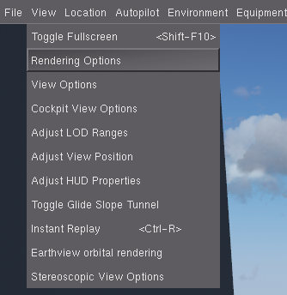
1. In the menu, go to View → Rendering Settings

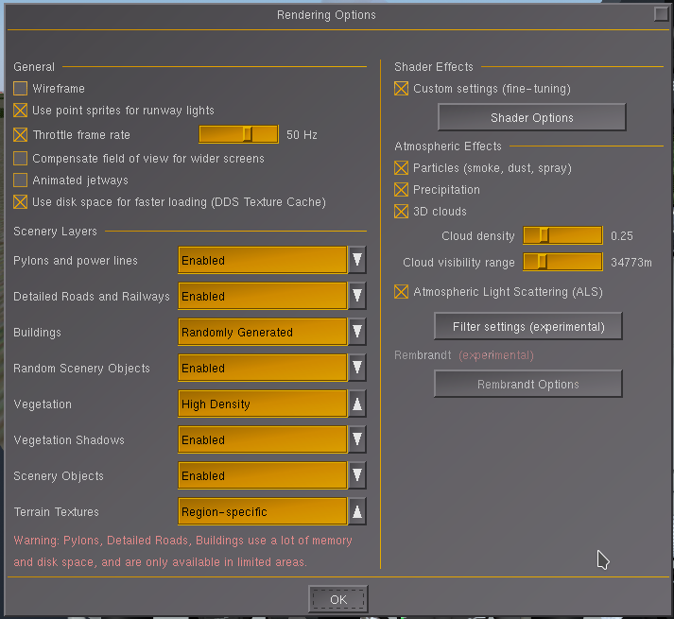
2. Enable Custom Settings and
Atmospheric Light Scattering (ALS)

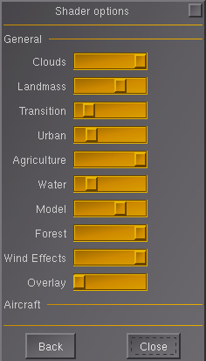
3. Click on Shader Options

4. Set Landmass to minimum 4
(fully left = 0; fully right = 6)
5. Set Model to minimum 2
(fully left = 0; fully right = 3)

6. That‘s it!

