F
FlightGear PA28
Mini Panel

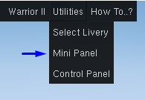
The Mini Panel is an easy way to access commonly used items without taking up much space on the screen.

The panel can be shown by selecting
Mini Panel
from the Utilities menu.

The mini panel will be open when FlightGear is restarted if it was open when FlightGear was closed.

The options on the Mini Panel are as follows:

X Close the Mini Panel

? Access this help document

A Show Aircraft Configuration

C Show Control Panel

= Show Checklist Dialog

<> Switch tanks between left and right wing

