**GOVERNMENT POLYTECHNIC KADUR**

**COMPUTER SCIENCE & ENGINEERING**



**Online Course Report**

**Unity Game – Role Playing Game(RPG)**

**SUBMITTED BY :**

**NAME :** Dhanush D V

**SEM :** 5TH Sem

**REG NO :** 197CS23013

**YEAR :** 3rdyear

**OBTAINED MARKS : _______/40**

**SIGNATURE :________________**

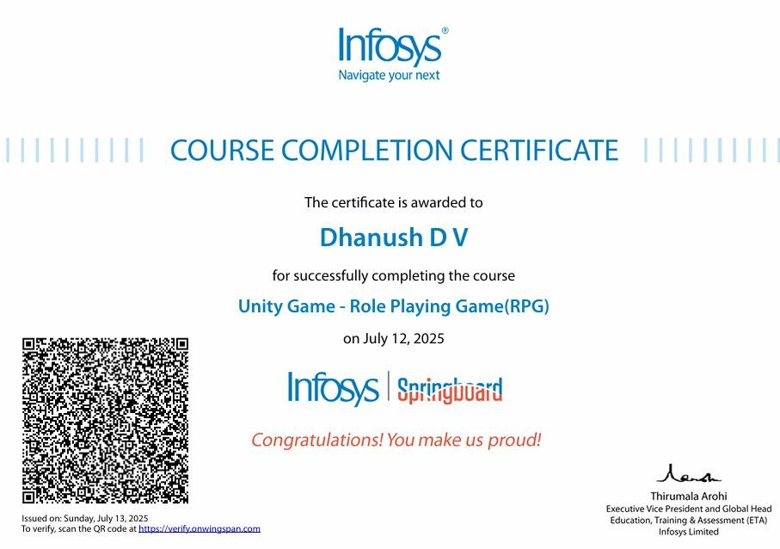

**Course Overview:**

|  |  |  |  |
| --- | --- | --- | --- |
| **Program** | **Computer Science & Engineering** | **Course Duration** | **10 hour**  **28-min** |
| **Course Name** | Unity Game – Role Playing Game(RPG) | Course Level | Beginner Level |
| **Course Provider** | Infosys Springboard | Author | Techademy |

**Infosys Springboard**

Is a digital learning platform developed by Infosys to empower individuals with in-demand digital and professional skills.

It offers a wide range of resources, including online courses, virtual internships, and curated content, to help learners of all backgrounds enhance their employability and career prospects.



# Key aspects of Infosys Springboard

**Accessibility :**

The platform is designed to be accessible on any device, anytime, and anywhere, making learning flexible and convenient.

**Curated Content :** It provides access to a vast library of courses and learning paths, covering various domains like technology, data science, business, and more.

# Table of the Content

|  |  |  |
| --- | --- | --- |
| **SLNo** | **Content Name** | **Duration** |
| **1** | **Introduction**   * Introduction to Developing a RolePlaying Game (RPG)... * Exploration and Quests | 47m 33s |
| **2** | **Setting up the Environment**   * Plot and Quests * Plot and Quests Continues | 2h 15m |
| **3** | **Designing the Characters**   * Writing the IK Script Continues * IK Handle | 2h 22m |
| **4** | **Game Mechanics**   * Implementing Scene Management * Restructuring Game Mechanics Co | 1h 9m |
| **5** | **Creating the Inventory**   * Coding the HUD Continues * HUD-Inventory System | 2h 53m |

**Unity Game Development for RPGs**

Unity is a popular game engine for creating immersive and engaging Role-Playing Games (RPGs). With Unity, you can build 2D or 3D RPGs for various platforms, including PC, consoles, and mobile devices.

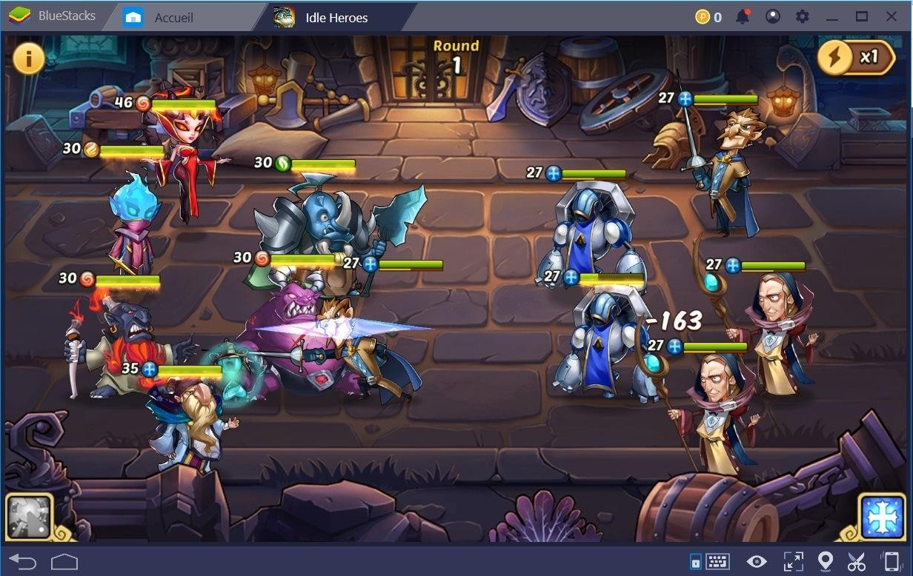

Unity game development, particularly Role Playing Games (RPGs), here are some great resources and examples to get you started. With Unity, you can build 2D or 3D RPGs for various platforms, including PC, consoles, and mobile devices.

Use Unity's built-in features, such as networking and input handling, to create seamless multiplayer experiences.

**Some key features of Unity for RPG development include:**

1. Scene management and level design
2. Character creation and customization
3. Animation and physics systems
4. Dialogue and storytelling tools
5. Inventory and quest management



**Climactic Decision/Puzzle:** For more narrative-driven or less combat-focused RPGs, the conclusion might involve a difficult choice, a complex puzzle, or a series of narrative interactions that determine the outcome.

**You can create various types of RPGs, such as**

1. Action RPGs (e.g., Dark Souls)
2. Open-world RPGs (e.g., Skyrim)
3. Tactical RPGs (e.g., Final Fantasy Tactics)
4. JRPGs (e.g., Dragon Quest)

**Learning Resources for Unity RPG Development:**

* **Unity Learn :** Official tutorials and courses, many specifically for RPG mechanics.
* **YouTube Tutorials :** Channels like Code Monkey, Brackeys, Blackthornprod, and Dapper Dino often have series on RPG development.
* **Online Courses (Udemy, Coursera, GameDev.tv):** Comprehensive courses that walk you through building an RPG from scratch.
* **Unity Asset Store RPG Kits:** There are pre-made RPG frameworks and templates available on the Asset Store (e.g., Invector, RPG Builder) that can give you a head start, though understanding the underlying mechanics is still crucial.
* **Books:** Various books are available on Unity game development, some focusing specifically on RPGs.
* **Explore Game Optimization**: Understanding how to optimize your game performance is crucial for RPGs, which often involve large worlds and complex systems.

**User Interface (UI):**

* **HUD (Heads-Up Display):** Health bars, mana bars, minimap, quest tracker.
* **Menus:** Main menu, pause menu, options menu.
* **Inventory UI:** Managing items.
* **Character Sheet UI:** Displaying character stats and equipment.
* **Quest Log UI:** Tracking quests.

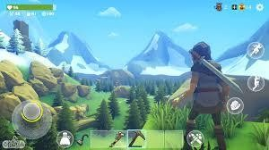

With Unity, you can build 2D or 3D RPGs for various platforms, including PC, consoles, and mobile devices. o effectively learn Unity for RPG development, focus on foundational Unity skills, C# programming, and then delve into specific RPG mechanics. [Unity Learn](https://learn.unity.com/) and [Udemy](https://www.udemy.com/topic/unity/) offer structured courses and pathways. Resources like Eincode's Unity course and GameDev.tv's RPG-focused courses can provide practical, in-depth guidance.

**Conclusion:**

Unity is a powerful tool for creating immersive RPGs. With its versatility and extensive features, you can bring your RPG vision to life. Whether you're a seasoned developer or just starting out, Unity's vast resources and community support make it an ideal choice for crafting engaging Role-Playing Games. Happy game development.

Concluding a Unity RPG is a critical phase of game development that brings the player's journey to a satisfying end.

It involves more than just a "Game Over" screen; it's about providing narrative closure, celebrating player accomplishments, and potentially setting the stage for future content or replays.