LAB SESSION 3 :

2 : Analyzing UDP datagrams using Wireshark:
A.
a. the source port number.
Source Port: 53

b. the destination port number.
Destination Port: 33403

c. the total length of the user datagram.
Length: 119

d. the length of the data.
Total Length: 139

e. whether the packet is directed from a client to a server or vice versa.
Directed from server to client.

f. the application-layer protocol.
0100 .... = Version: 4
Internet Protocol Version 4, Src: 172.16.19.202, Dst: 172.16.59.37

g. whether a checksum is calculated for this packet or not.
Header Checksum: 0x5a0e [validation disabled]
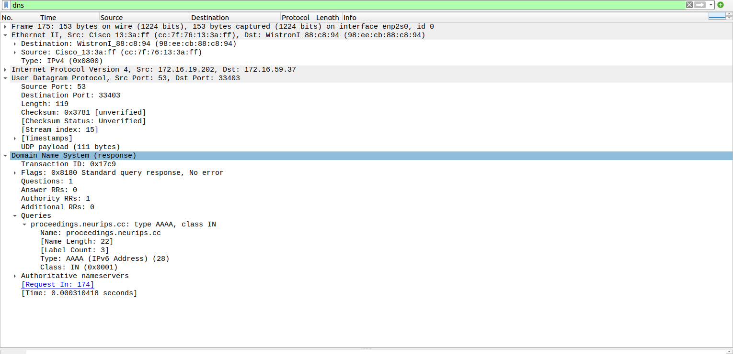

B. What are the source and destination IP addresses in the DNS query message? What are those
addresses in the response message? What is the relationship between the two?

Internet Protocol Version 4, Src: 172.16.19.202, Dst: 172.16.59.37

This DNS packet was a response to a packet sent from client to server before.

174 2.549942977 172.16.59.37 172.16.19.202 DNS 82 Standard query 0x17c9 AAAA proceedings.neurips.cc

When searching for a page the ip 172.16.19.202 is called by the current machine ie 172.16.59.37

C. What are the source and destination port numbers in the query message? What are those
addresses in the response message? What is the relationship between the two? Which port
number is a well-known port number?

Source : 53
destination : 33403
in the query message :
User Datagram Protocol, Src Port: 52603, Dst Port: 53

in response message:
User Datagram Protocol, Src Port: 53, Dst Port: 52603

well known port number for local hosts is port 8000

D. What is the length of the first packet? How many bytes of payload are carried by the first
packet?

Length : 80

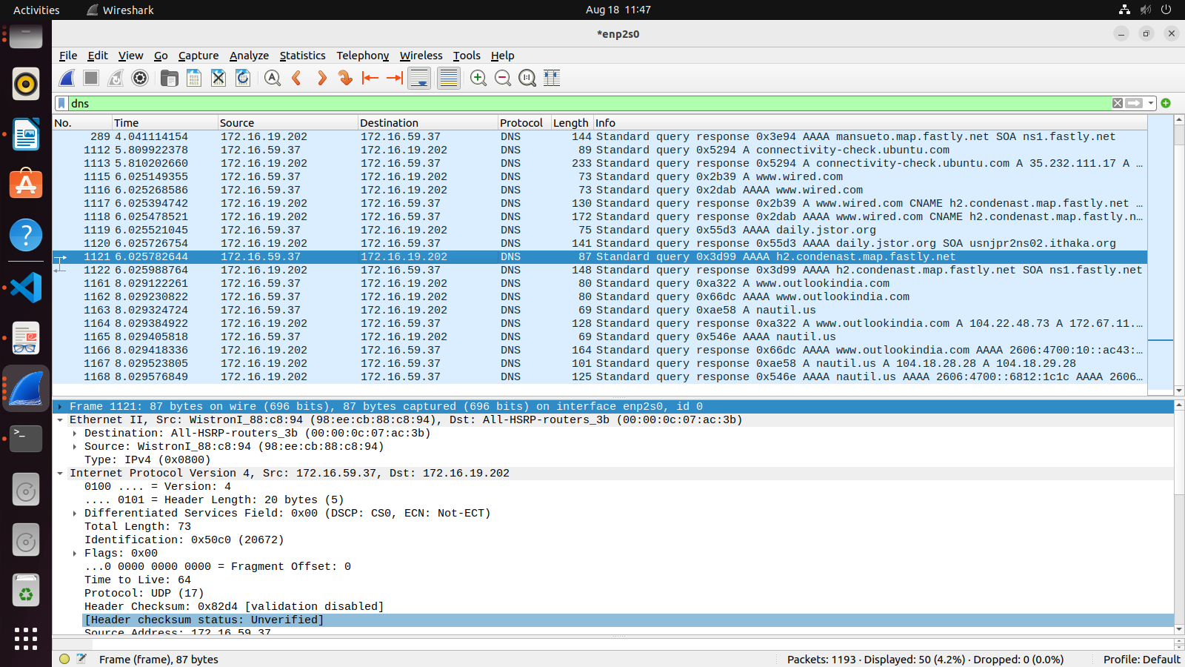
First packet payload : 38 bytes
2b. Analyzing TCP packets using Wireshark:
1. What are the socket addresses for each packet?
Source: 192.168.65.23
Destination: 152.195.38.76

2. What flags are set in each packet?
Flags: 0x4000, Don't fragment
0... .... .... .... = Reserved bit: Not set
.1.. .... .... .... = Don't fragment: Set
..0. .... .... .... = More fragments: Not set

3. What are the sequence number and acknowledgment number of each packet?
Sequence number: 1 (relative sequence number)
Sequence number (raw): 258284319
Acknowledgment number: 1 (relative ack number)
Acknowledgment number (raw): 2549708043

4. What are the window size of each packet?
Window size value: 501
[Calculated window size: 501]
[Window size scaling factor: -1 (unknown)]

Part II: Data-Transfer Phase

1. What TCP flags are set in the first data-transfer packet (HTTP GET message)?
Flags: 0x010 (ACK)
000. .... .... = Reserved: Not set
...0 .... .... = Nonce: Not set
.... 0... .... = Congestion Window Reduced (CWR): Not set
.... .0.. .... = ECN-Echo: Not set
.... ..0. .... = Urgent: Not set
.... ...1 .... = Acknowledgment: Set
.... .... 0... = Push: Not set
.... .... .0.. = Reset: Not set
.... .... ..0. = Syn: Not set
.... .... ...0 = Fin: Not set

2. How many bytes are transmitted in this packet?
Frame 877: 66 bytes on wire (528 bits), 66 bytes captured (528 bits) on interface wlp3s0, id 0

3. How often does the receiver generate an acknowledgment? To which acknowledgment rule
(defined in Page 200 in the textbook) does your answer correspond to?

NOT SURE

4. How many bytes are transmitted in each packet? How are the sequence and acknowledgment
numbers related to number of bytes transmitted?

In each TCP segment, the relationship between the sequence number and the acknowledgment number reflects the sender's perspective (sequence number) and the receiver's perspective (acknowledgment number) of the data being transmitted. The sequence number marks where the data starts in the sender's stream, while the acknowledgment number indicates the next expected byte in the receiver's stream.

As to for relation of sequence and acknowledgment
numbers related to number of bytes transmitted not sure

