电 子 科 技 大 学
作 业 报 告
学生姓名：郭航宇 学 号：202221080233 指导教师：段翰聪
学生E-mail：1756360431@qq.com
一、作业名称
多线程聚集写程序
二、作业要求
利用单生产者和多消费者模型，利用管道或内存队列实现一个多线程协作拷贝文件的程序。
具体功能如下：
- 一个线程读文件，另外n个线程写文件，完成1G的文件并行拷贝。
- 读文件需要读定长数据块，消费者线程根据数据块在文件的偏移量写入对应的文件位置。
- 校验拷贝后的数据的正确性，可通过比较原文件的md5值验证。
三、实验流程
- 代码编译
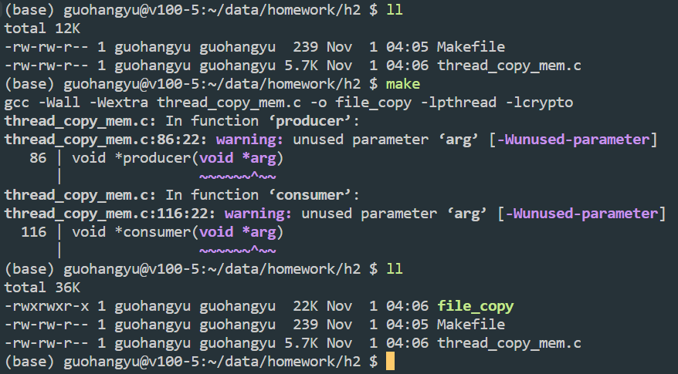
- 创建读文件
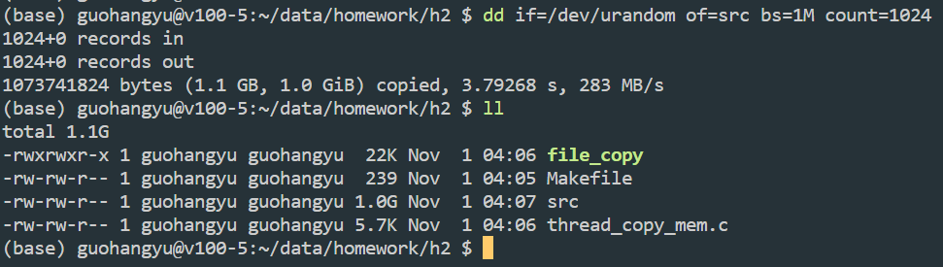
- 文件拷贝和md5验证
多线程文件拷贝命令格式：
./mem_file_copier <input_file> <output_file> <number_of_consumer_threads>
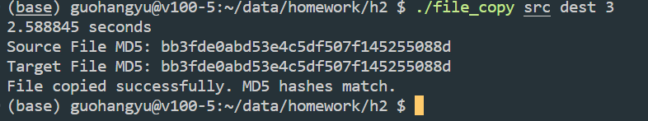
- 不同线程数下的CPU开销和时间开销，以及md5验证
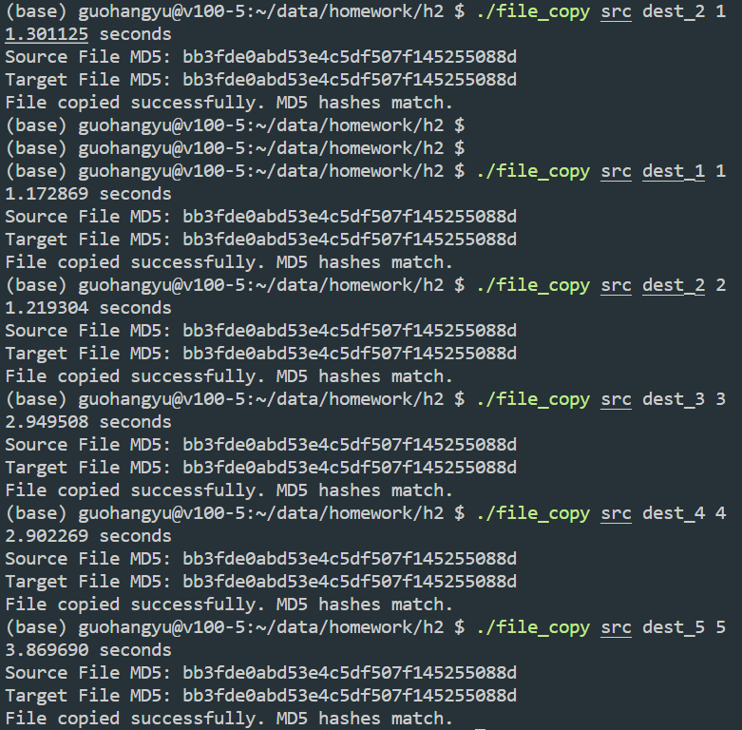
四、附录
- Makefile
CC = gcc
CFLAGS = -Wall -Wextra
LDFLAGS = -lpthread -lcrypto
TARGET = file_copy
SRC = thread_copy_mem.c

all: $(TARGET)

$(TARGET): $(SRC)
$(CC) $(CFLAGS) $(SRC) -o $(TARGET) $(LDFLAGS)

clean:
rm -f $(TARGET)
- thread_copy_mem.c
#include <stdio.h>
#include <stdlib.h>
#include <pthread.h>
#include <string.h>
#include <sys/mman.h>
#include <sys/types.h>
#include <sys/stat.h>
#include <fcntl.h>
#include <unistd.h>
#include <openssl/md5.h>
#include <time.h>

#define BLOCK_SIZE (1024 * 1024) // 1MB
#define QUEUE_SIZE 10

typedef struct
{
char data[BLOCK_SIZE];
off_t offset;
int size;
} DataBlock;

typedef struct
{
DataBlock queue[QUEUE_SIZE];
int front;
int rear;
int count;
int finish;
pthread_mutex_t mutex;
pthread_cond_t notEmpty;
pthread_cond_t notFull;
} CircularQueue;

CircularQueue buffer;
char *inputFileName;
char *outputFileName;
int nConsumers;

void initQueue(CircularQueue *q)
{
q->front = 0;
q->rear = 0;
q->count = 0;
q->finish = 0;
pthread_mutex_init(&q->mutex, NULL);
pthread_cond_init(&q->notEmpty, NULL);
pthread_cond_init(&q->notFull, NULL);
}

void enqueue(CircularQueue *q, DataBlock block)
{
pthread_mutex_lock(&q->mutex);
while (q->count == QUEUE_SIZE)
{
pthread_cond_wait(&q->notFull, &q->mutex);
}
memcpy(&q->queue[q->rear], &block, sizeof(DataBlock));
q->rear = (q->rear + 1) % QUEUE_SIZE;
q->count++;
pthread_cond_signal(&q->notEmpty);
pthread_mutex_unlock(&q->mutex);
}

int dequeue(CircularQueue *q, DataBlock *block)
{
pthread_mutex_lock(&q->mutex);
while (q->count == 0 && q->finish == 0)
{
pthread_cond_wait(&q->notEmpty, &q->mutex);
}
if (q->count == 0 && q->finish == 1)
{
pthread_cond_signal(&q->notEmpty);
pthread_mutex_unlock(&q->mutex);
return 0;
}
memcpy(block, &q->queue[q->front], sizeof(DataBlock));
q->front = (q->front + 1) % QUEUE_SIZE;
q->count--;
pthread_cond_signal(&q->notFull);
pthread_mutex_unlock(&q->mutex);
return 1;
}

void *producer(void *arg)
{
int fd = open(inputFileName, O_RDONLY);
if (fd == -1)
{
perror("Failed to open input file");
exit(EXIT_FAILURE);
}

off_t offset = 0;
DataBlock block;
while (1)
{
block.size = pread(fd, block.data, BLOCK_SIZE, offset);
if (block.size <= 0)
{
pthread_mutex_lock(&buffer.mutex);
buffer.finish = 1;
pthread_mutex_unlock(&buffer.mutex);
break; // End of file or error
}
block.offset = offset;
enqueue(&buffer, block);
offset += block.size;
}

close(fd);
return NULL;
}

void *consumer(void *arg)
{
int fd = open(outputFileName, O_WRONLY);
if (fd == -1)
{
perror("Failed to open output file");
exit(EXIT_FAILURE);
}

DataBlock block;
while (1)
{
if (dequeue(&buffer, &block) == 0)
break;
pwrite(fd, block.data, block.size, block.offset);
}

close(fd);
return NULL;
}

char *computeMD5(const char *filename)
{
int fd = open(filename, O_RDONLY);
if (fd == -1)
{
perror("Failed to open file for MD5 computation");
exit(EXIT_FAILURE);
}

unsigned char c[MD5_DIGEST_LENGTH];
char *hash = (char *)malloc(2 * MD5_DIGEST_LENGTH + 1);
if (!hash)
{
perror("Failed to allocate memory for MD5 hash");
exit(EXIT_FAILURE);
}

unsigned char *fileContents;
struct stat st;
fstat(fd, &st);
fileContents = mmap(0, st.st_size, PROT_READ, MAP_SHARED, fd, 0);
if (fileContents == MAP_FAILED)
{
perror("Failed to mmap file for MD5 computation");
close(fd);
exit(EXIT_FAILURE);
}

MD5(fileContents, st.st_size, c);
munmap(fileContents, st.st_size);
close(fd);

for (int i = 0; i < MD5_DIGEST_LENGTH; i++)
{
sprintf(&hash[i * 2], "%02x", c[i]);
}
return hash;
}

int main(int argc, char *argv[])
{
if (argc != 4)
{
printf("Usage: %s <input_file> <output_file> <number_of_consumer_threads>\n", argv[0]);
return EXIT_FAILURE;
}

clock_t start_time, finish_time;
double total_time;
start_time = clock();

inputFileName = argv[1];
outputFileName = argv[2];
nConsumers = atoi(argv[3]);

int src_fd = open(inputFileName, O_RDONLY);
struct stat st;
if (fstat(src_fd, &st) != 0)
{
perror("Failed to get size of source file");
exit(EXIT_FAILURE);
}
close(src_fd);

int dest_fd = open(outputFileName, O_RDWR | O_CREAT, 0666);
if (dest_fd == -1)
{
perror("Failed to open or create destination file");
exit(EXIT_FAILURE);
}

if (ftruncate(dest_fd, st.st_size) != 0)
{
perror("Failed to set size of destination file");
exit(EXIT_FAILURE);
}
close(dest_fd);

initQueue(&buffer);

pthread_t prodThread;
pthread_create(&prodThread, NULL, producer, NULL);

pthread_t *consThreads = (pthread_t *)malloc(nConsumers * sizeof(pthread_t));
for (int i = 0; i < nConsumers; i++)
{
pthread_create(&consThreads[i], NULL, consumer, NULL);
}

pthread_join(prodThread, NULL);
for (int i = 0; i < nConsumers; i++)
{
pthread_join(consThreads[i], NULL);
}

finish_time = clock();
total_time = ((double)(finish_time - start_time)) / CLOCKS_PER_SEC;
printf("%f seconds\n", total_time);

char *srcMD5 = computeMD5(inputFileName);
char *dstMD5 = computeMD5(outputFileName);

printf("Source File MD5: %s\n", srcMD5);
printf("Target File MD5: %s\n", dstMD5);

if (strcmp(srcMD5, dstMD5) == 0)
{
printf("File copied successfully. MD5 hashes match.\n");
}
else
{
printf("MD5 hashes do not match. File copy might be corrupted.\n");
}

free(srcMD5);
free(dstMD5);
free(consThreads);

return EXIT_SUCCESS;
}

