**Huawei Cloud**

**Huawei Cloud server operating system supports various virtualization technologies, including virtual machines, containers, and bare metal, which enable efficient resource utilization and flexibility through virtualization. Its main services and functions include:**

**• Virtualization technology: Allows multiple virtual machines to run on the same physical server, each of which can run a different operating system independently.**

**• Secure and reliable operating environment: The operating system kernel has undergone rigorous security testing and optimization, providing virtualization security, data encryption, and access control security features.**

**• Strong performance and scalability: Supports high-performance computing and large-scale data processing, meeting the needs of high-performance applications such as scientific computing and big data analysis, and supports fast scaling to flexibly adjust server scale based on business needs.**

**• Simple and easy-to-use management interface: Provides a Web management interface and API interface for easy server management and configuration, and supports automated deployment and management.**

**• Tencent Cloud**

**Tencent Cloud provides a rich set of cloud services and solutions, including the following services and functions related to the operating system level:**

**• Cloud Server (CVM): Provides elastic computing capabilities and can flexibly adjust configuration and scale based on business needs.**

**• Cloud Database (CDB): Provides high-availability and scalable database services, including relational databases (such as MySQL and SQL Server) and NoSQL databases (such as MongoDB and Redis).**

**• Cloud Storage (COS): Provides a secure and reliable object storage service suitable for storing and managing various types of data, such as pictures, audio and video files, and documents.**

**• Cloud Container (TKE): Provides a management and running environment for containerized applications and supports container orchestration tools such as Kubernetes.**

**Alibaba Cloud**

**Alibaba Cloud offers a wide range of services, covering various aspects of cloud computing, including the following categories:**

**One, Elastic Computing**

**• Elastic Compute Service (ECS): Provides secure, scalable computing services with support for various operating systems and application software to meet diverse cloud computing needs of enterprises.**

**• GPU Cloud Server: Provides elastic computing services with GPU computing power, suitable for deep learning, scientific computing, graphical visualization, and video processing in various application scenarios.**

**• Elastic Bare Metal Server: High-performance computing services with security-enhanced physical isolation, supporting minute-level delivery cycle and providing real-time business response capability.**

**• Lightweight Application Server: Provides simple and cost-effective server services for small and medium-sized enterprises and individual developers.**

**Two, Storage Services**

**• Object Storage Service (OSS): Provides massive, secure, low-cost, and highly reliable cloud storage services suitable for storing any type of files and supporting data access and management via RESTful API.**

**• File Storage Service (NAS): Provides standard file access interface suitable for multiple Windows, Linux, or UNIX clients accessing the same file system simultaneously.**

**• Block Storage Service (EBS): Provides high-performance, high-reliability block-level random storage suitable for database, file system, and other applications requiring high-performance storage.**

**Three, Network Services**

**• Private Network (VPC): Helps users easily build a logically isolated private network to achieve isolation and inter-access of cloud resources.**

**• Load Balancer (SLB): A load balancing service that distributes traffic among multiple cloud servers to improve application availability and stability.**

**• Content Delivery Network (CDN): Through globally distributed nodes, quickly and reliably distribute website content to users nearby to improve user access speed and experience.**

**Four, Database Services**

**• Relational Database Service (RDS): Provides stable, reliable, and elastically scalable online database services supporting various database engines, including MySQL, PostgreSQL, and SQL Server.**

**• NoSQL Database: Including high-performance, highly scalable NoSQL database services such as MongoDB and Redis。**

**Tencent Cloud uses：**

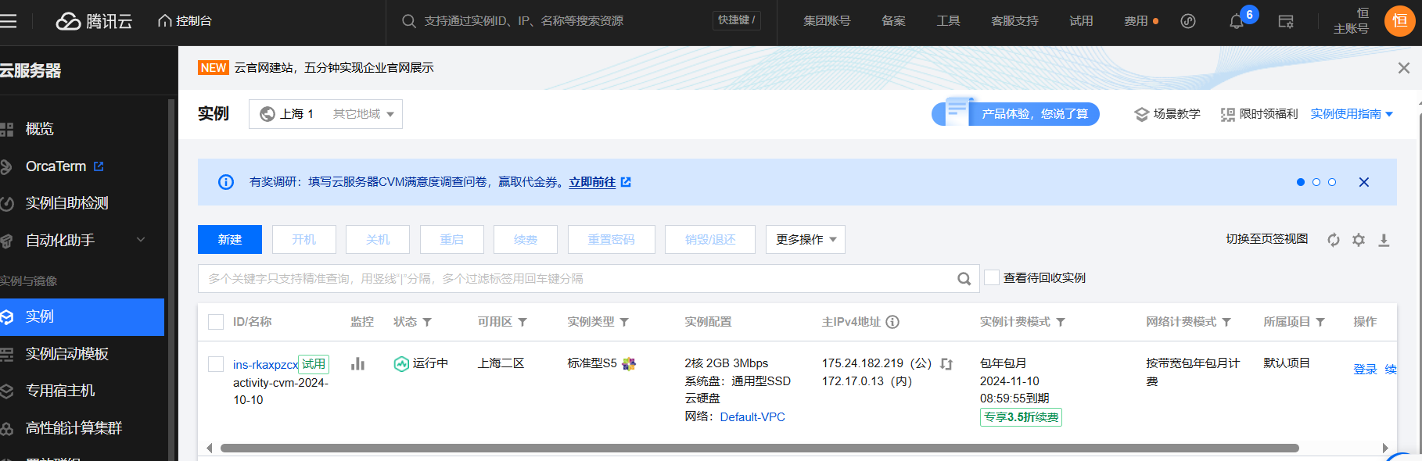

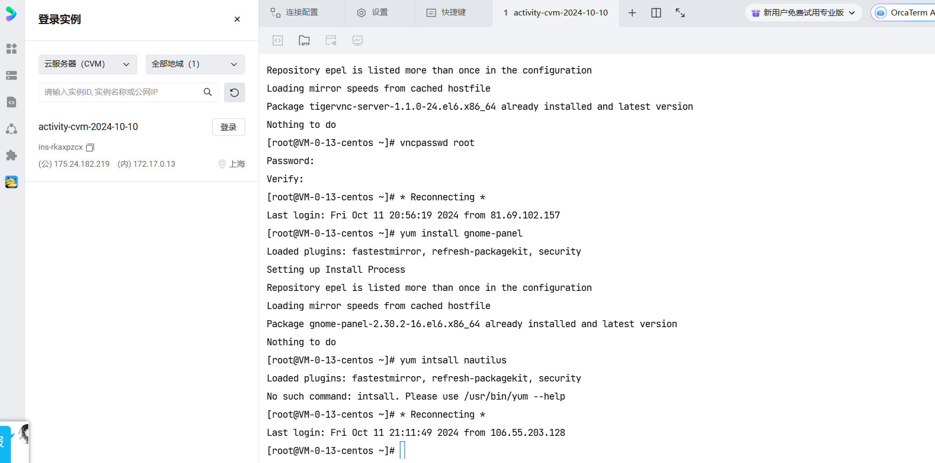

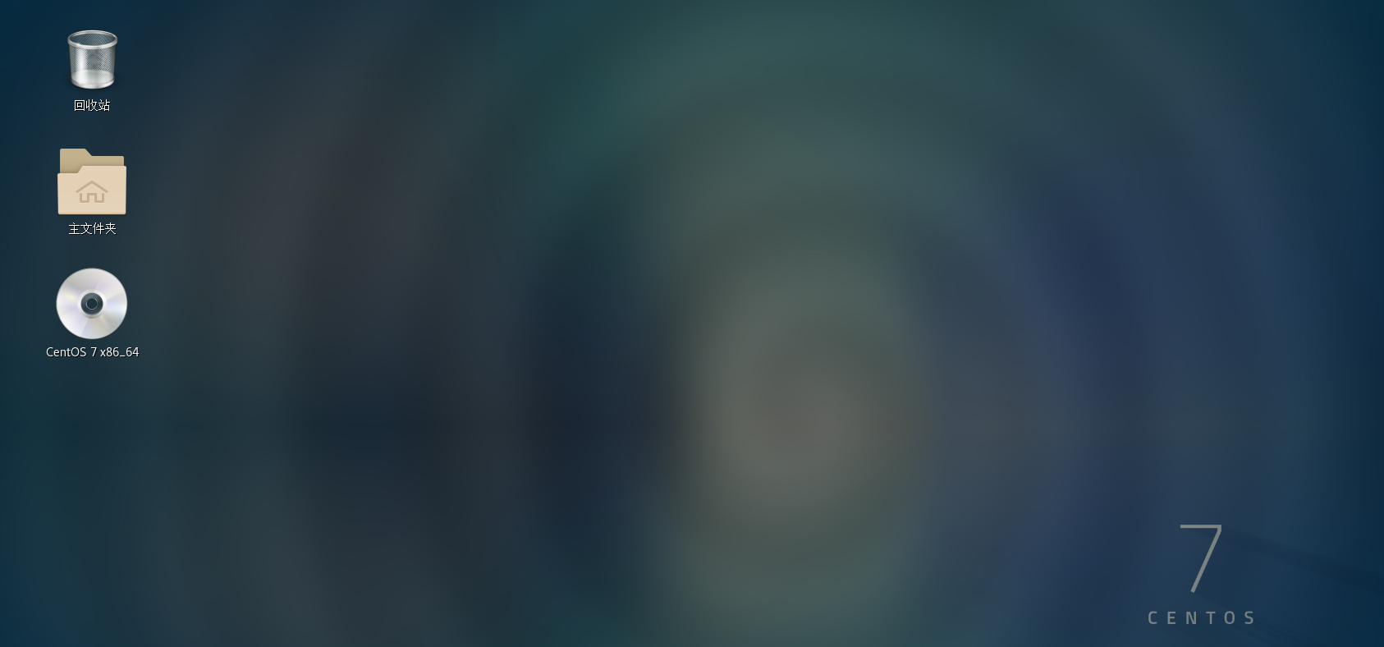

Price：

Alibaba cloud

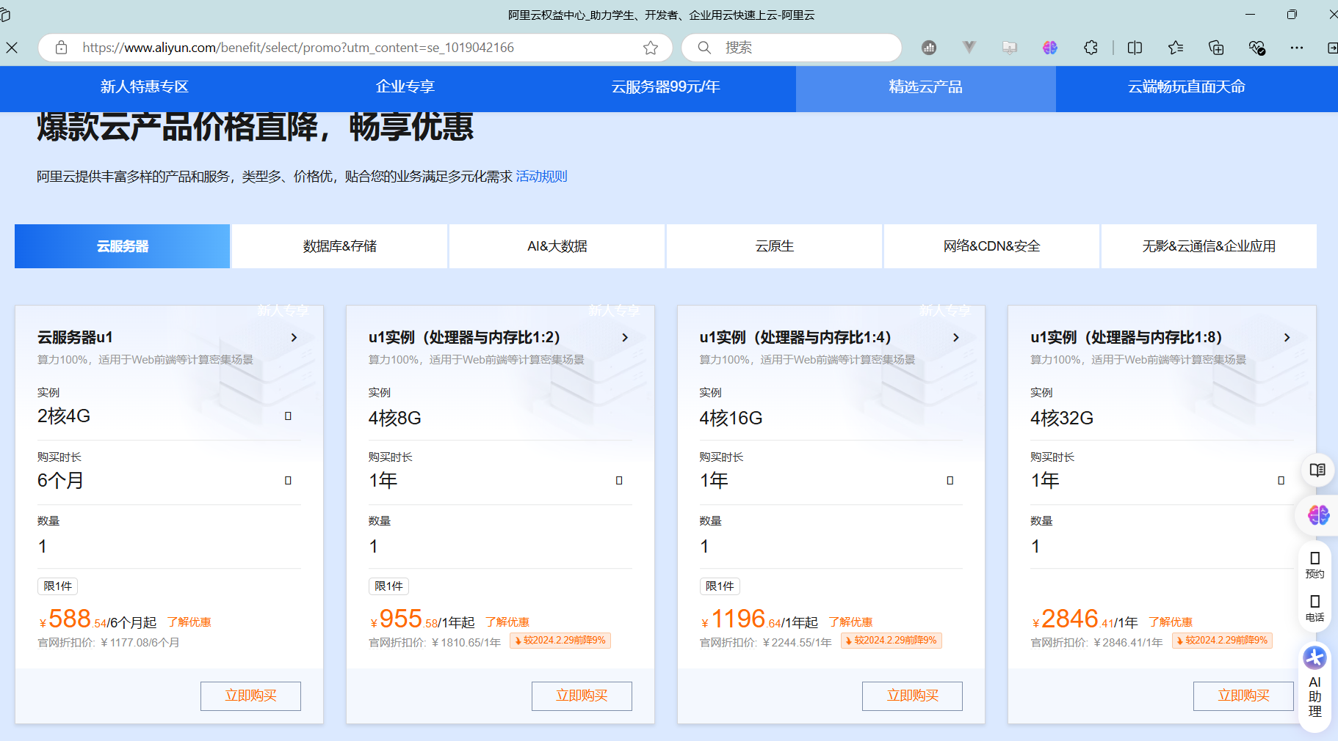

Tencent Cloud：

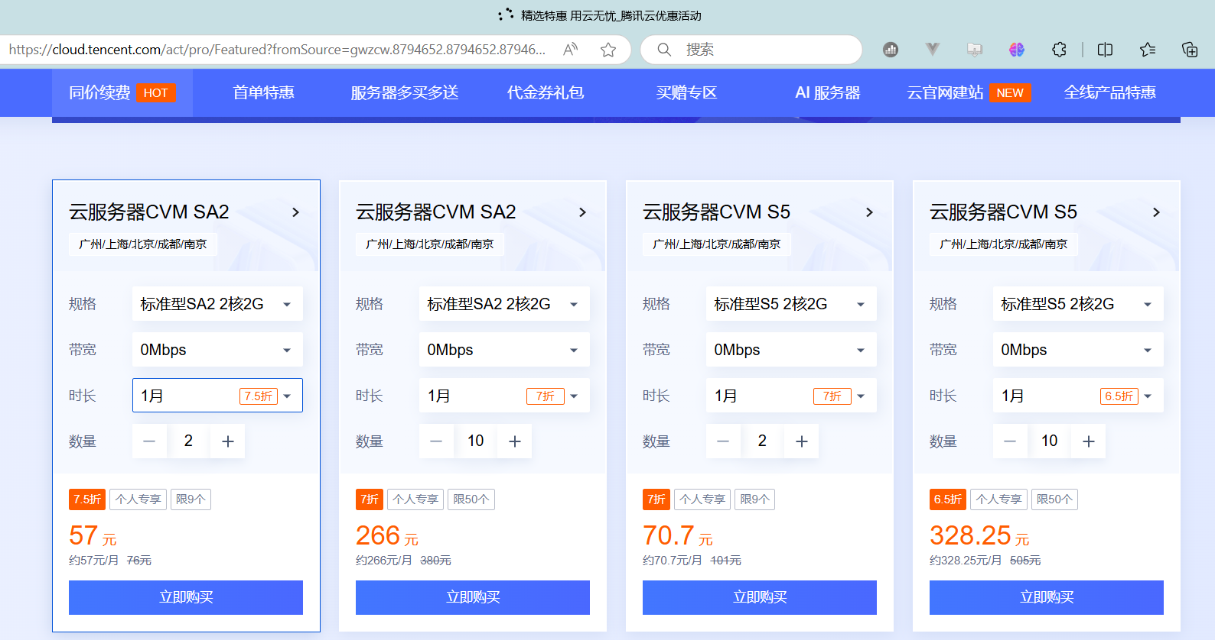

Huawei Cloud：

