

**CROP PREDICTION USING MACHINE LEARNING**

# **PROBLEM STATEMENT**

Agriculture plays a critical role in the economy of many countries. With the challenges posed by climate change, unpredictable weather conditions, and the increasing demand for food, it is essential for farmers to have tools that can help them make informed decisions about what crops to plant and when. Predicting crop yields can help optimize agricultural production and ensure food security.

The goal of this project is to develop a machine learning model that can predict which crops are most suitable for a given region based on various factors such as weather patterns, soil conditions, and historical crop data. By leveraging machine learning algorithms, we aim to provide farmers with accurate and actionable predictions for their farming activities.

# **PROJECT OVERVIEW**

The Crop Prediction Using Machine Learning project aims to create a system that helps farmers predict the most suitable crops for their geographical region based on environmental and historical data. By leveraging machine learning, the goal is to optimize agricultural practices, improve crop yields, reduce wastage, and mitigate risks posed by climate change and unpredictable weather patterns. This predictive model will analyze factors like climate, soil conditions, geographical features, and past crop yields to recommend the best crops for cultivation in a given area.

# **SOLUTION OFFERED**

The proposed solution for crop prediction using machine learning aims to help farmers make informed decisions regarding which crops to plant based on a variety of environmental, climatic, and historical data. The solution leverages advanced data analytics and machine learning algorithms to recommend the most suitable crops for specific geographical areas, helping farmers optimize yield, reduce resource waste, and adapt to changing environmental conditions. Below is a detailed breakdown of the solution offered.

**WHO ARE THE END USERS?**

Farmers

Agronomists and Agricultural Experts

Agricultural Corporations or Companies

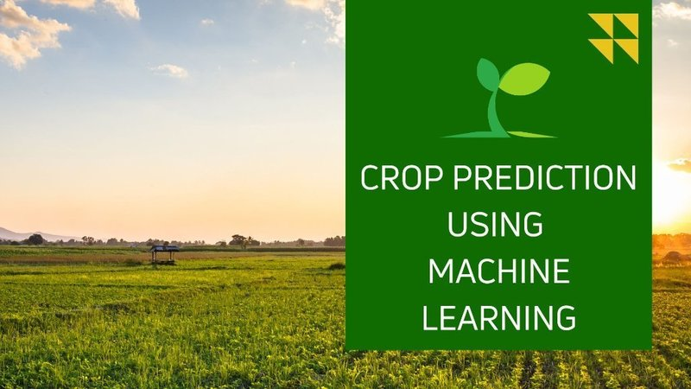

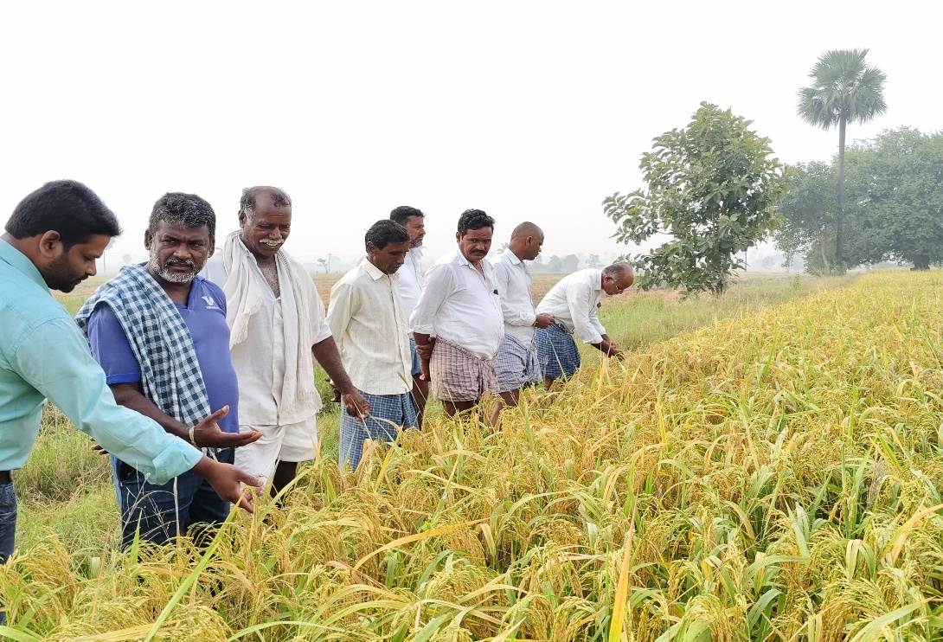



# **TECHNOLOGY USED TO SOLVE THE PROBLEM**

* Python
* Random forest
* Decision Trees
* Support Vector Machines [SVMs]
* K-Nearest Neighbours Selection [KNNs]

**Libraries**

* Jupyter
* Numpy
* Pandas
* Seaborn
* Tensor Flow
* Pytorch
* Scikit-Learn

