Health & Lifestyle Dataset
Executive Analytics Report
Statistical Modeling · Regression Analysis · A/B Testing · Confidence Intervals
Dataset: 100,000 records · 16 variables
July 2026

Executive Summary
This report presents a full statistical analysis of a 100,000-record health and lifestyle dataset, covering demographic, behavioral, and clinical variables. The analysis pipeline included data cleaning and validation, exploratory distribution analysis, correlation analysis, linear and logistic regression modeling, A/B hypothesis testing, and 95% confidence interval estimation.
Headline finding: across every method applied — correlation analysis, linear regression, logistic regression, t-tests, a two-proportion Z-test, and a chi-square test — none of the lifestyle or clinical variables in this dataset show a statistically or practically meaningful relationship with cholesterol or disease risk. The dataset behaves as though outcomes were assigned independently of the recorded predictors.

Key Numbers
Metric | Result | Interpretation
Linear regression R² (cholesterol) | 0.0001 | Model explains ~0% of variance
Regression F-test p-value | 0.65 | Not significant — no predictors matter jointly
Logistic regression AUC (disease risk) | 0.496 | No better than a coin flip (0.50 = random)
Model accuracy vs. baseline | 75.2% vs 75.2% | Model = majority-class guessing, no lift
A/B test: family history t-tests significant | 0 of 10 | No metric differs by family history
Disease risk rate: family history vs. none | 25.0% vs 24.7% (p=0.31) | Not statistically significant

What This Means for the Business
- Do not deploy a predictive model on this data as-is. Any cholesterol or disease-risk model built on these fields will perform at chance level in production — it will not outperform simply predicting the historical base rate (~25% risk).
- Investigate the data source. The complete absence of any signal — even weak, expected associations like BMI-cholesterol or smoking-disease risk — is unusual for real clinical data and suggests the dataset may be synthetically generated with independently randomized fields, or that a data pipeline issue (e.g., shuffled labels) has decoupled predictors from outcomes.
- Reframe the analytics ask. If the goal is a working risk model, prioritize sourcing data with known, validated associations (e.g., longitudinal clinical records) before further modeling investment.
- Descriptive value still exists. The dataset is well-formed and useful for population profiling (e.g., ~45% of records fall in the Obese BMI category, ~63% in Stage 1 Hypertension range) even though it can't currently support predictive analytics.

1. Data Preparation & Cleaning
The raw dataset contained 100,000 rows and 16 columns with no missing values and no duplicate rows or IDs. All fields were validated against medically plausible bounds (e.g., age 18–100, BMI 10–60, systolic BP 70–250); zero rows were flagged as out-of-range, indicating the data was already pre-cleaned or bounded at the point of generation.
Three derived features were engineered to support segmentation:
- bmi_category — Underweight / Normal / Overweight / Obese
- age_group — 18-30 / 31-45 / 46-60 / 61+
- bp_category — Normal / Elevated / Stage 1 / Stage 2 Hypertension

Population Profile
Segment | Share of Population
Male / Female | 50.1% / 49.9%
Smokers | 20.1%
Alcohol users | 30.0%
Family history of disease | 29.9%
Overall disease risk rate | 24.8%
BMI: Obese | 45.4%
BMI: Overweight | 22.7%
BMI: Normal | 29.4%
BMI: Underweight | 2.4%
Blood pressure: Stage 1 Hypertension | 63.0%
Blood pressure: Stage 2 Hypertension | 22.3%

2. Distributions & Exploratory Analysis
All ten continuous variables were examined for shape, skew, and spread. Distributions are close to uniform or mildly bell-shaped across the board, with no extreme skew or heavy tails — consistent with values drawn from bounded random distributions rather than natural clinical measurements (which typically show right-skew in variables like cholesterol or BMI).
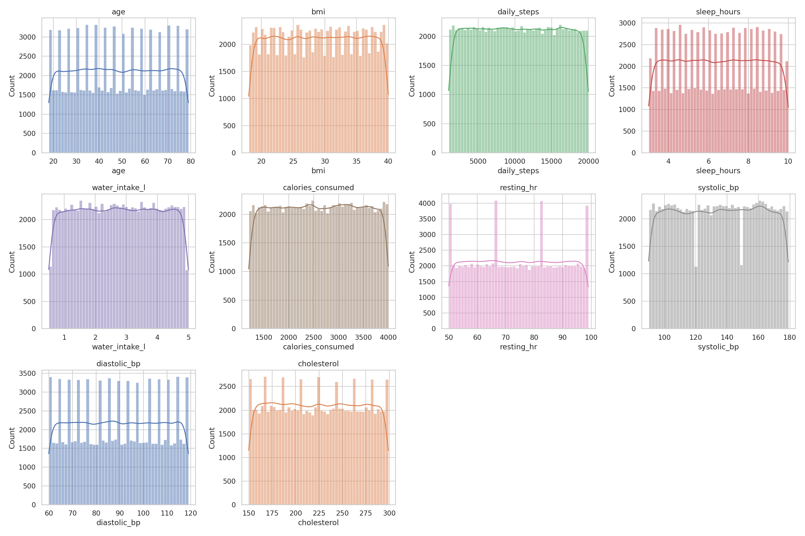
Figure 1. Distribution of all continuous variables.
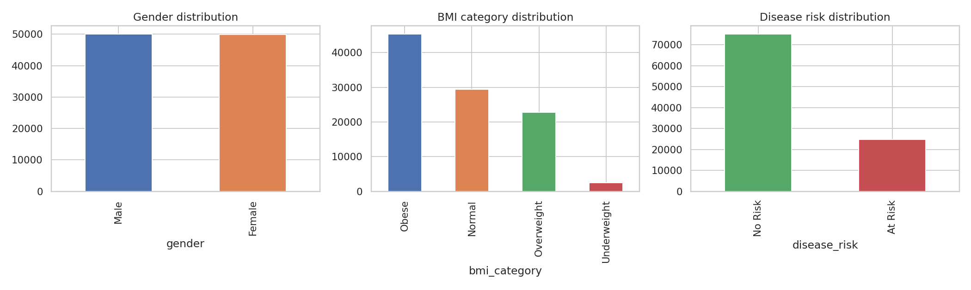
Figure 2. Gender, BMI category, and disease risk distributions.

Correlation Structure
The correlation matrix below confirms the headline finding visually: every off-diagonal correlation involving disease_risk or cholesterol is within ±0.01 of zero — far below any threshold of practical relevance (correlations below ~0.1 are generally considered negligible in applied research).
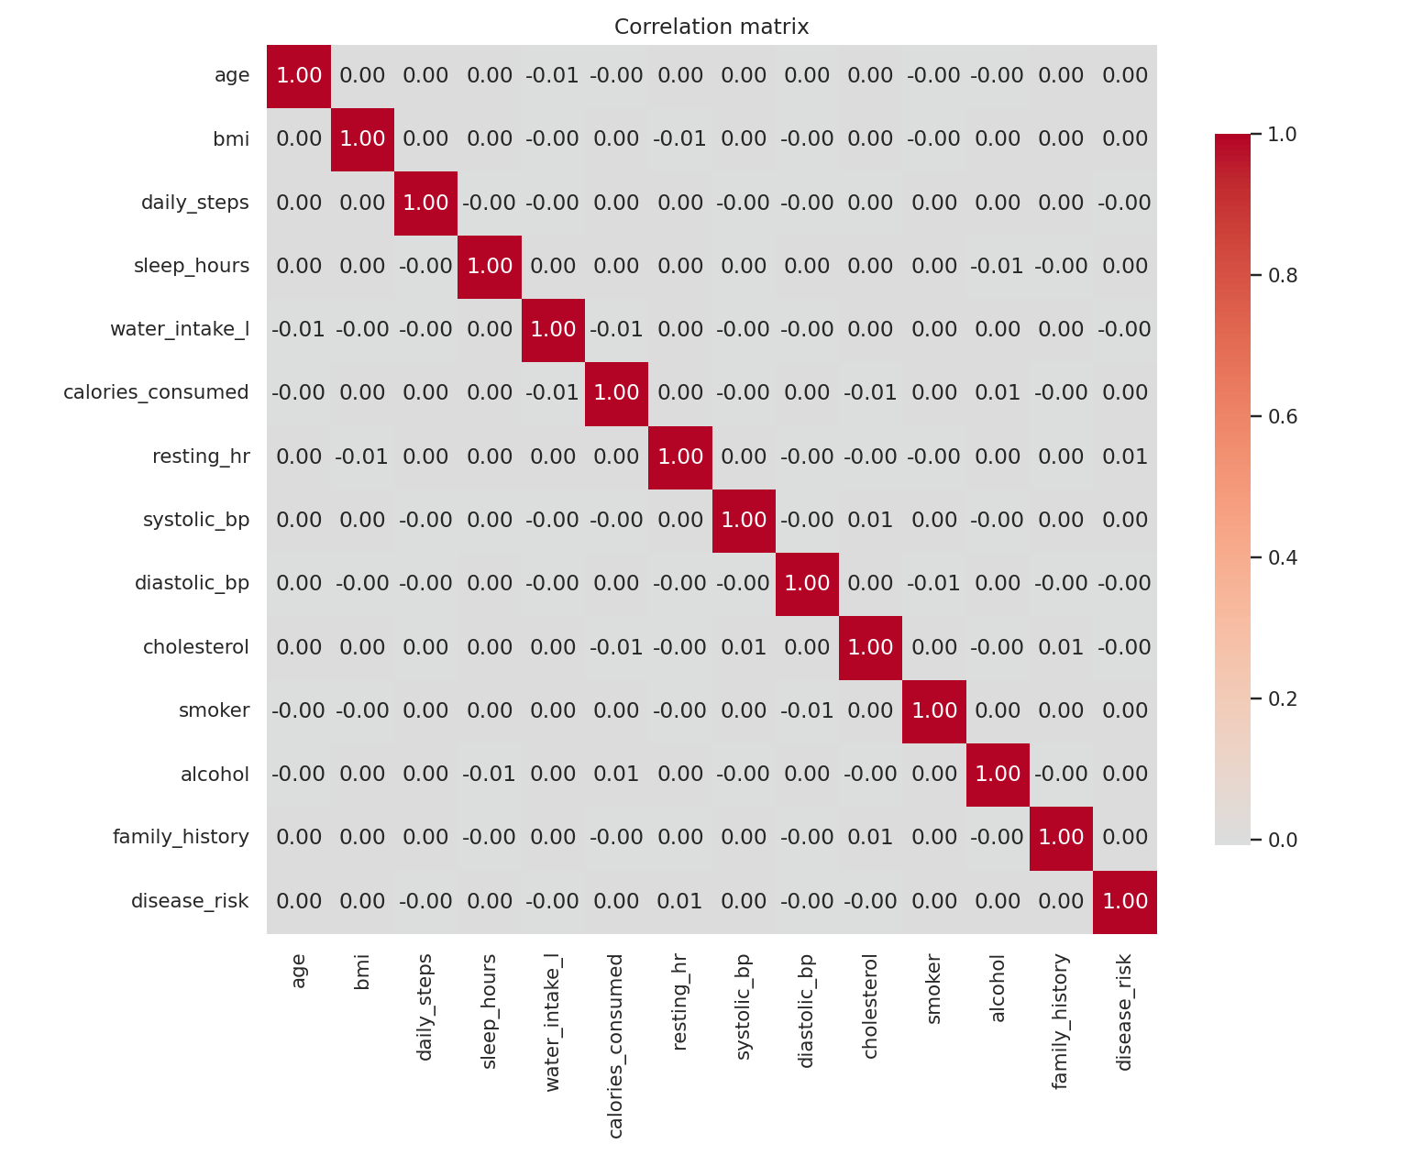
Figure 3. Correlation matrix across all numeric and binary variables.

3. Regression Analysis

3.1 Linear Regression — Predicting Cholesterol
A multiple linear regression was fit using age, gender, BMI, daily steps, sleep hours, water intake, calories consumed, smoking, alcohol use, resting heart rate, blood pressure, and family history as predictors.
Metric | Train | Test
R² | 0.00013 | 0.00007
F-test p-value | 0.65 (not significant) | —
MAE | — | 37.6 mg/dL
RMSE | — | 43.3 mg/dL
None of the individual regression coefficients were statistically significant at the 0.05 level, and the overall F-test confirms the model as a whole adds no explanatory power over predicting the mean cholesterol for everyone.
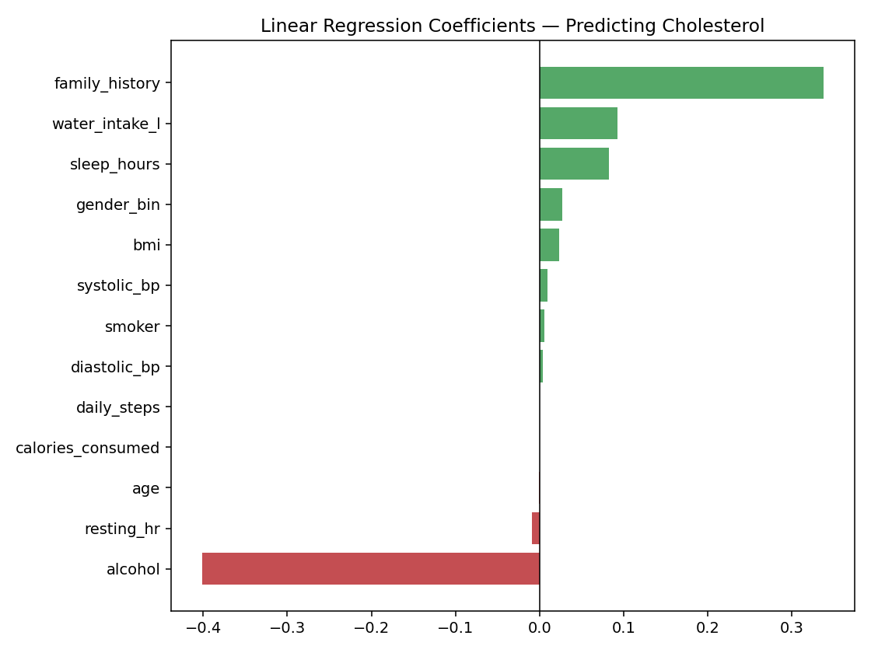
Figure 4. Linear regression coefficients (cholesterol model) — all near zero.
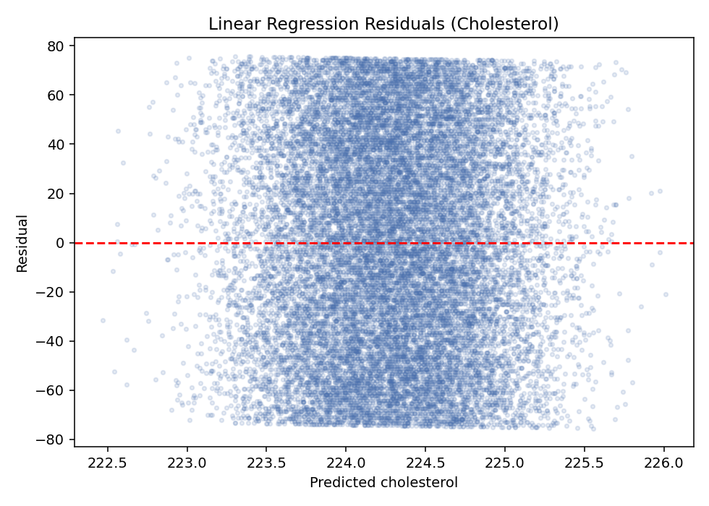
Figure 5. Residual plot — residuals show no structure, consistent with an uninformative model.

3.2 Logistic Regression — Predicting Disease Risk
A logistic regression was fit on the same feature set to predict the binary disease_risk outcome.
Metric | Value
Pseudo R² (McFadden) | 0.0001
Test Accuracy | 75.2%
Baseline (always predict majority class) | 75.2%
Test AUC-ROC | 0.496
An AUC of 0.50 indicates a model with zero discriminative ability — equivalent to random guessing. The model's accuracy exactly matches the baseline rate of the majority class, confirming it adds no predictive lift whatsoever.
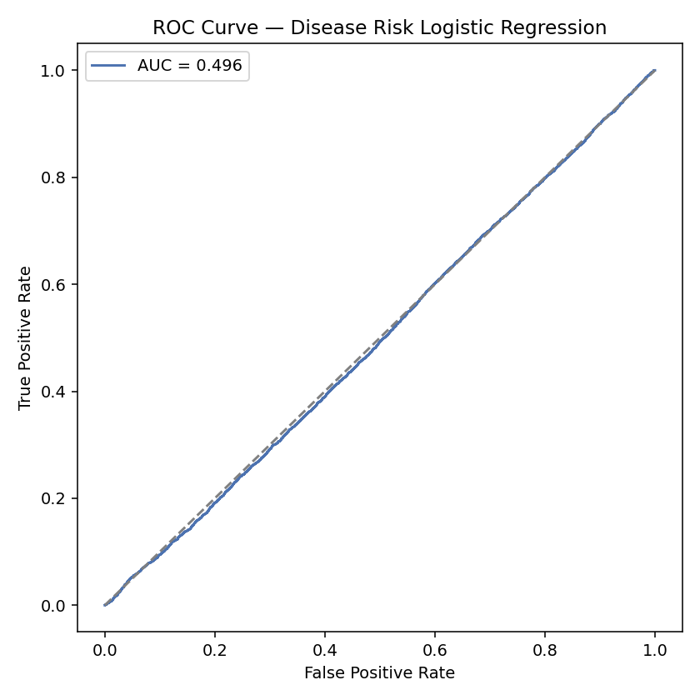
Figure 6. ROC curve sits on the diagonal — no better than chance.
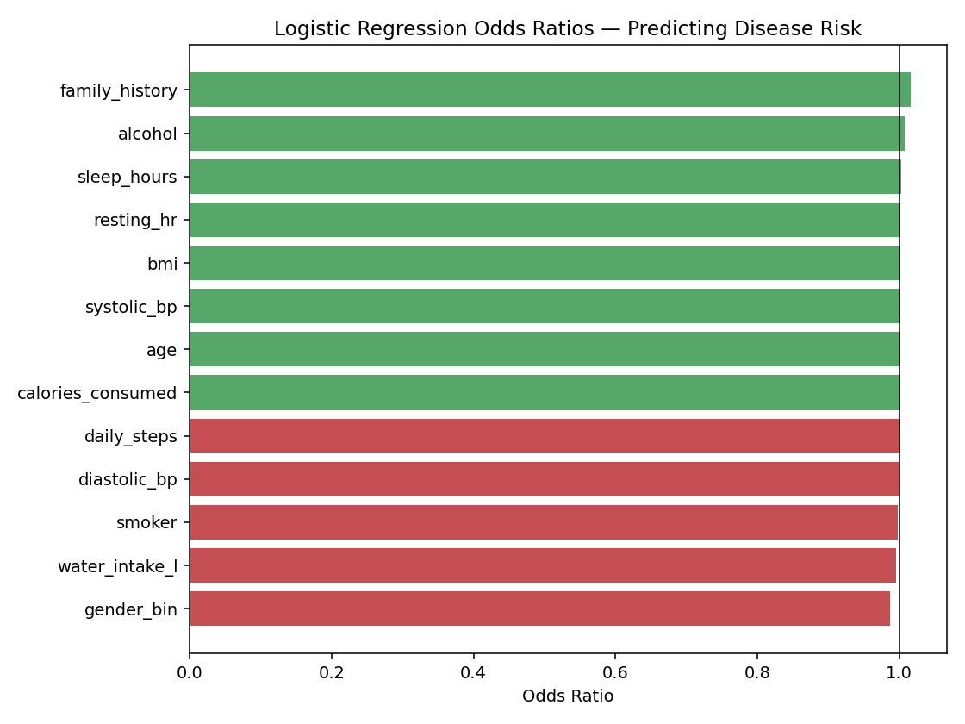
Figure 7. Odds ratios all cluster near 1.0, meaning no variable meaningfully shifts risk.

4. A/B Testing: Family History vs. No Family History
Family history was chosen as the test split (Group A = family history present, n=29,915; Group B = no family history, n=70,085). Welch's t-tests were run on all ten continuous metrics, a two-proportion Z-test compared disease risk rates, and a chi-square test evaluated independence between family history and disease risk.
Test | Result | p-value | Significant?
t-tests (10 metrics) | 0 of 10 significant | all > 0.05 | No
Two-proportion Z-test (disease risk) | 25.0% vs 24.7% | 0.31 | No
Chi-square (independence) | χ² = 1.02 | 0.31 | No
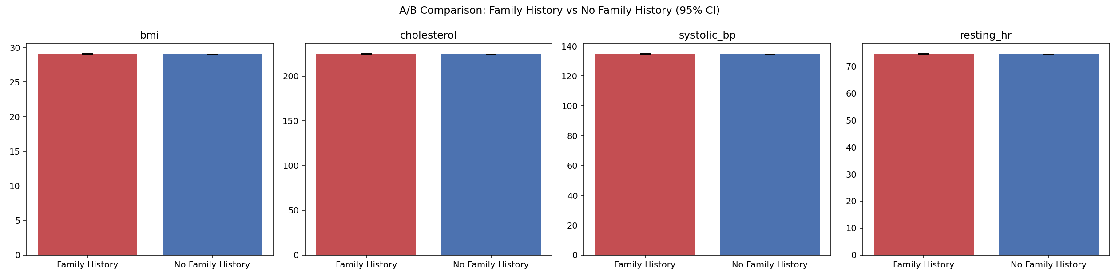
Figure 8. Group means (with 95% CI error bars) for BMI, cholesterol, systolic BP, and resting HR by family history status — bars overlap almost completely.
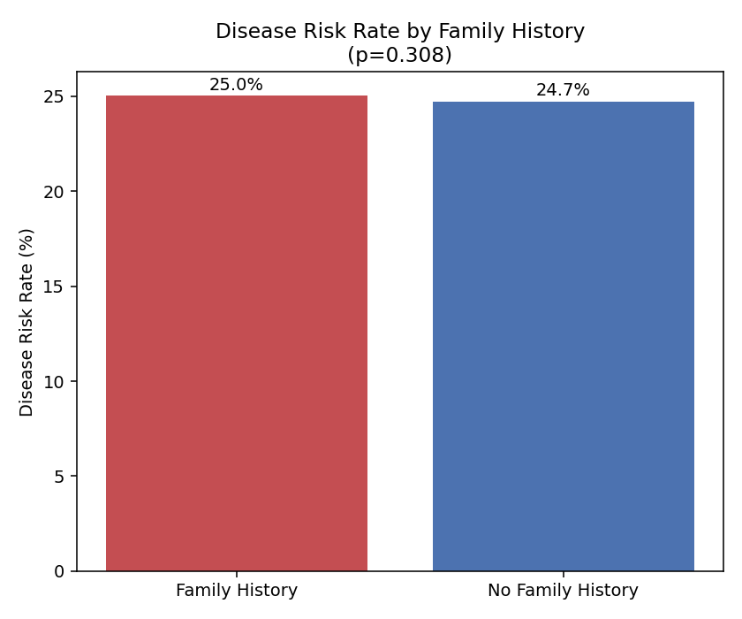
Figure 9. Disease risk rate by family history status — a 0.3 percentage-point gap, not statistically significant.
Conclusion: family history shows no detectable effect on any measured health metric or on disease risk itself in this dataset. If a real biological relationship exists in the source population, it is not reflected in these records.

5. Confidence Intervals (95%)
With a sample size of 100,000, confidence intervals around each metric's mean are extremely narrow — the estimates below are precise reflections of this dataset's sample means, though (as shown above) they do not translate into predictive relationships between variables.
Metric | Mean | 95% CI Low | 95% CI High
Age (years) | 48.5 | 48.4 | 48.6
BMI | 29.0 | 29.0 | 29.1
Daily steps | 10,459 | 10,433 | 10,485
Sleep hours | 6.5 | 6.5 | 6.5
Water intake (L) | 2.75 | 2.74 | 2.75
Calories consumed | 2,601 | 2,596 | 2,606
Resting HR (bpm) | 74.0 | 73.9 | 74.1
Systolic BP | 134.7 | 134.6 | 134.8
Diastolic BP | 89.5 | 89.4 | 89.6
Cholesterol | 224.7 | 224.5 | 224.9
Disease risk rate | 24.8% | 24.6% | 25.1%

6. Recommendations
- Validate the data pipeline. Confirm with the data provider or engineering team whether disease_risk, cholesterol, and the predictor fields were generated independently (e.g., synthetically) or whether a join/shuffle step may have decoupled real records from their outcomes.
- Do not productionize any model from this dataset. A model trained here will not generalize or add value — it will match a naive baseline in the best case.
- Source or request an audited real-world dataset if the objective is an actual clinical risk-prediction tool, ideally with documented feature-outcome relationships that can be validated against clinical literature (e.g., known BMI-disease or smoking-disease associations).
- Reuse this dataset for non-predictive purposes only — e.g., population segmentation reporting, dashboard mockups, or as a synthetic test dataset for engineering QA — where the lack of real signal is not a limitation.
- If new data becomes available, re-run this same analysis pipeline (cleaning → EDA → regression → A/B testing → CIs) — it is fully scripted and reusable end-to-end.

