Before we begin building sheets for the layout in Part
A: 1. Open Tableau Desktop. 2. Connect to matches.csv as your primary data source (or link matches.csv to deliveries.csvon id = match_id if using combined fields).
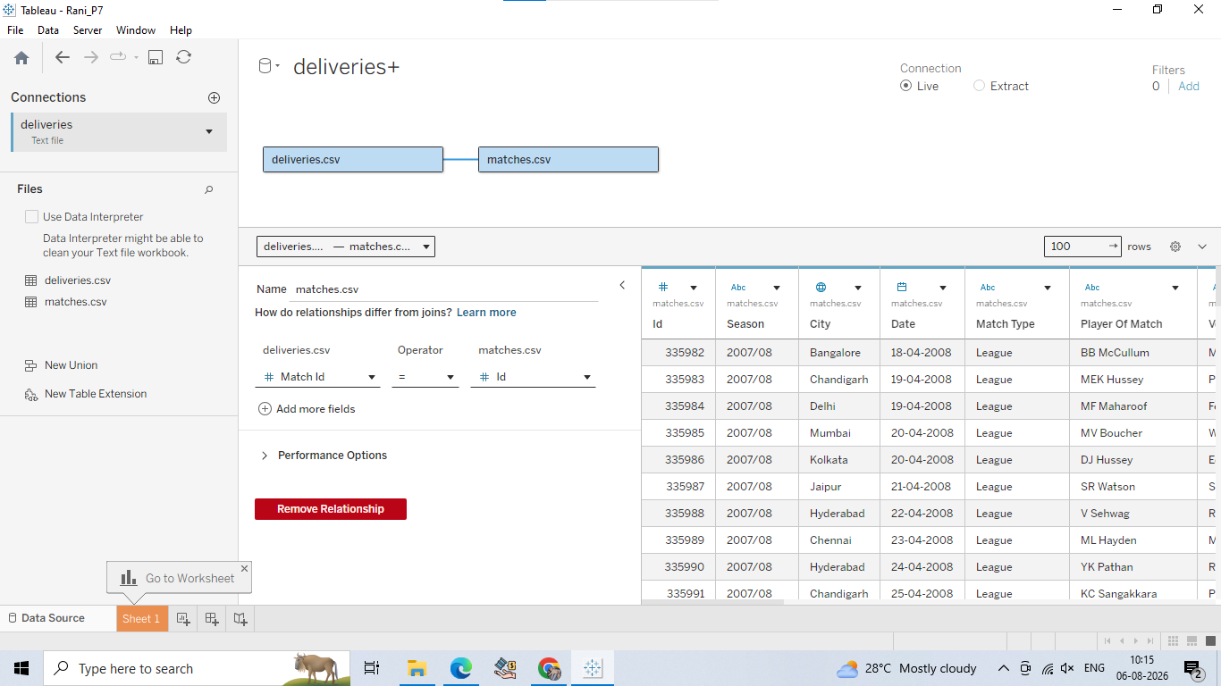
A: Design a basic dashboard layout using sheets
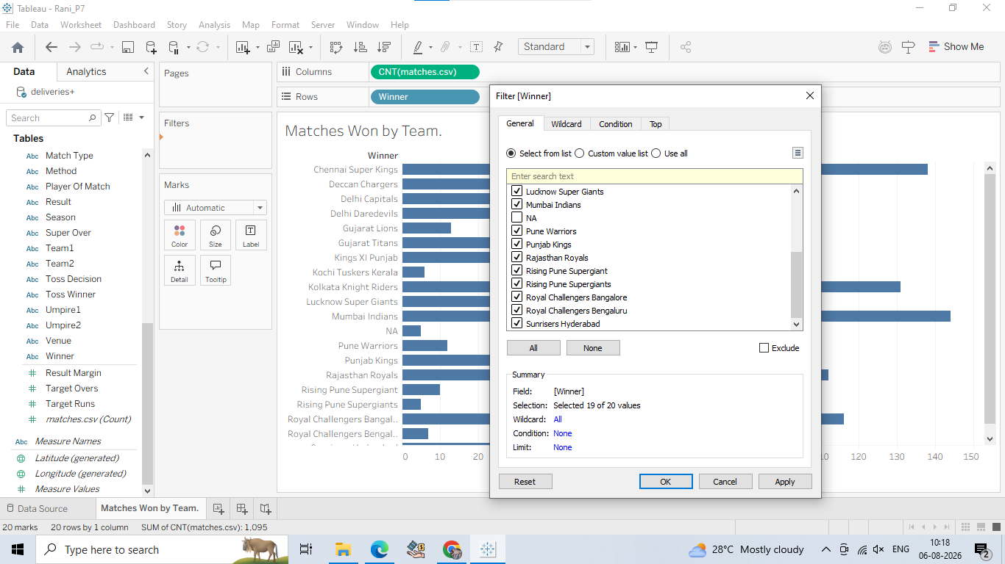

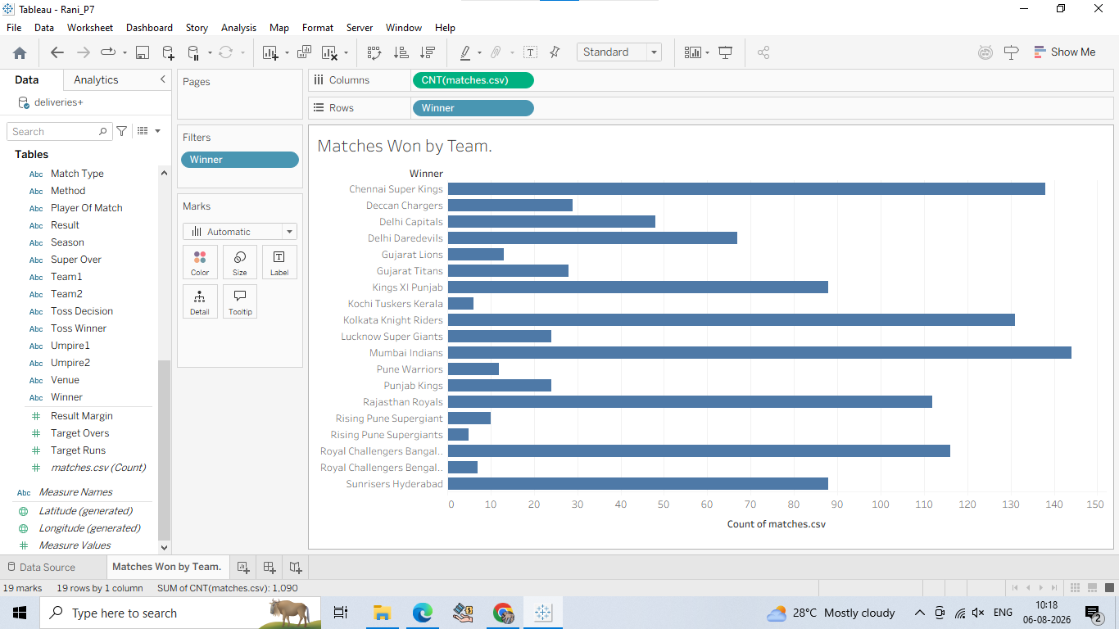

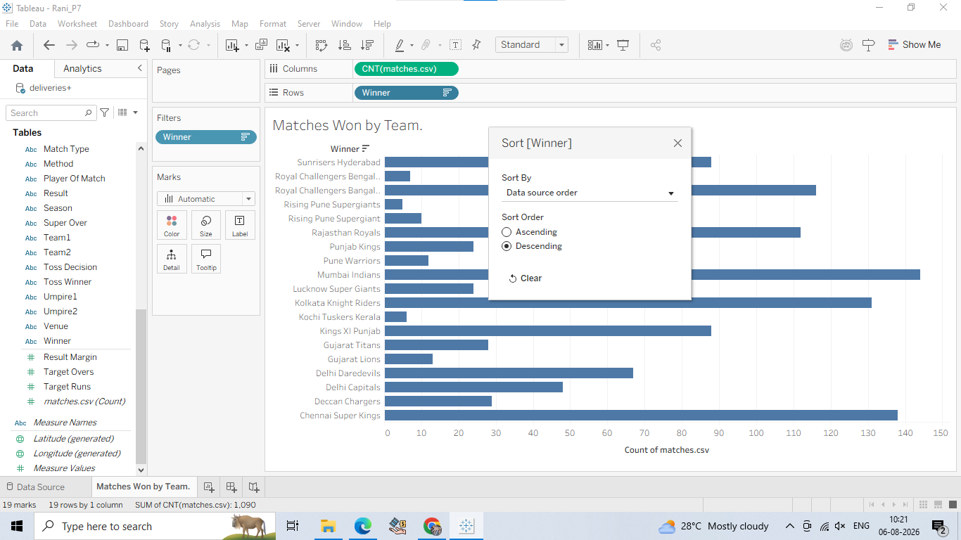

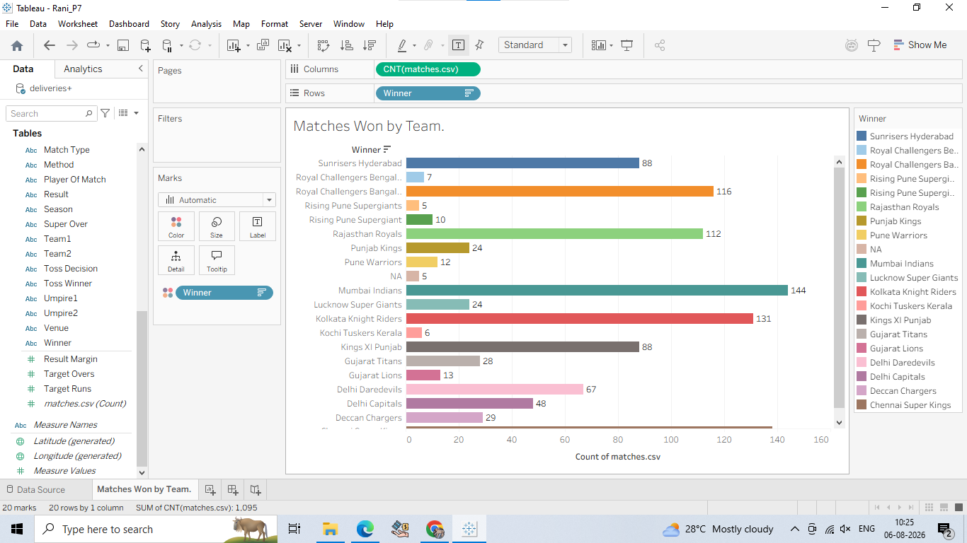

Step 2: Create Sheet 2 — "Top Match Venues" (Horizontal Bar Chart)
1. Open a new worksheet and rename it: Top Venues. 2. Drag Venue to the Rows shelf. 3. Drag Matches (Count) (or Id using CNTD) to the Columns shelf.
4. Sort in Descending order (Left Click on Venue on The Rows and Navigate to Sort).
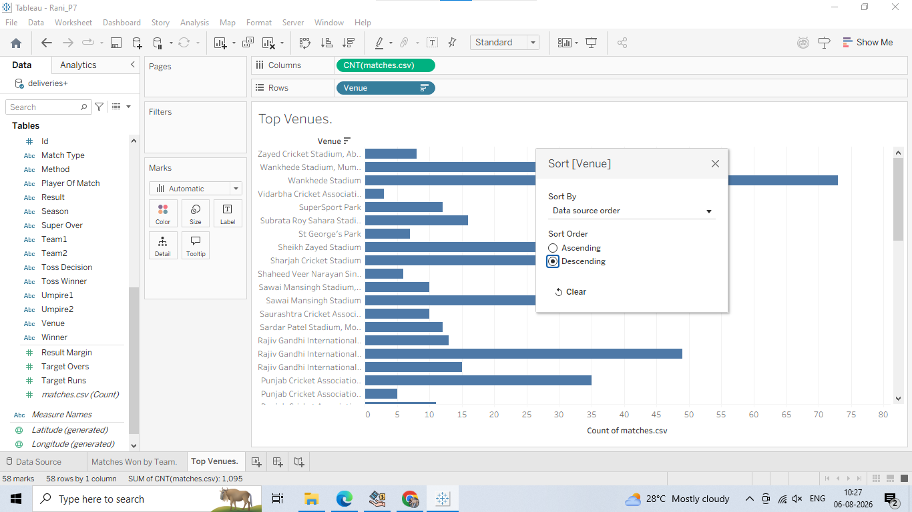

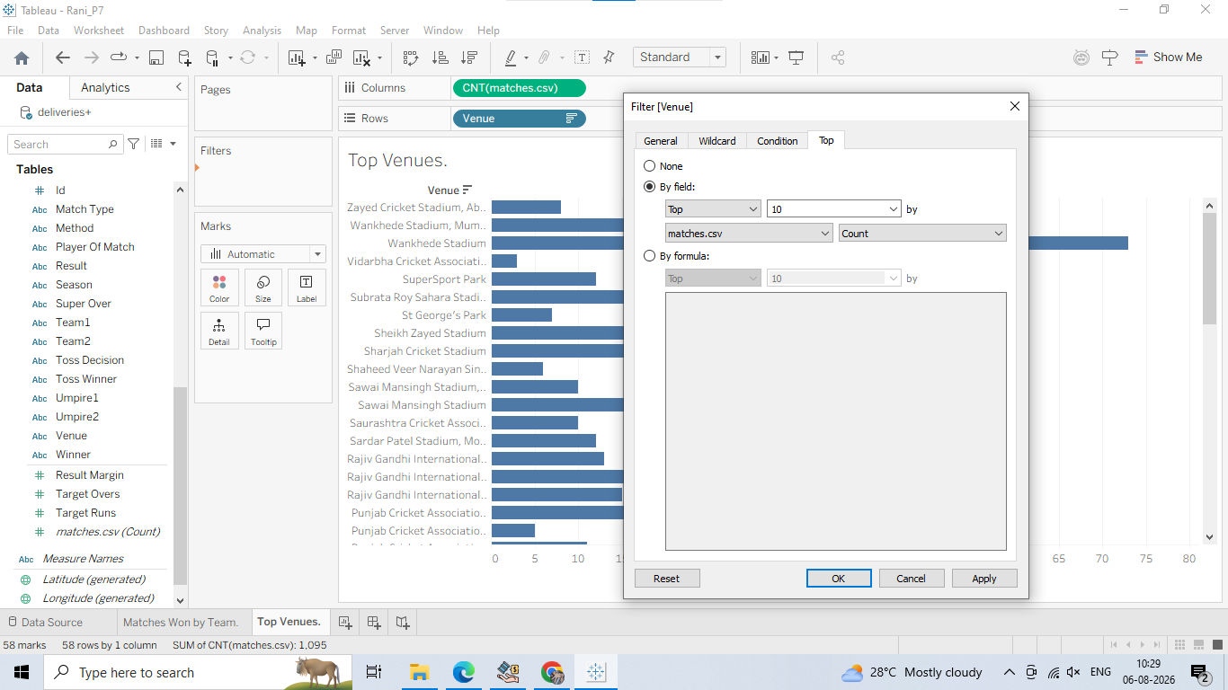
5. Drag Venue to the Filters shelf, go to the Top tab select By field Top 10 by Matches (Count).
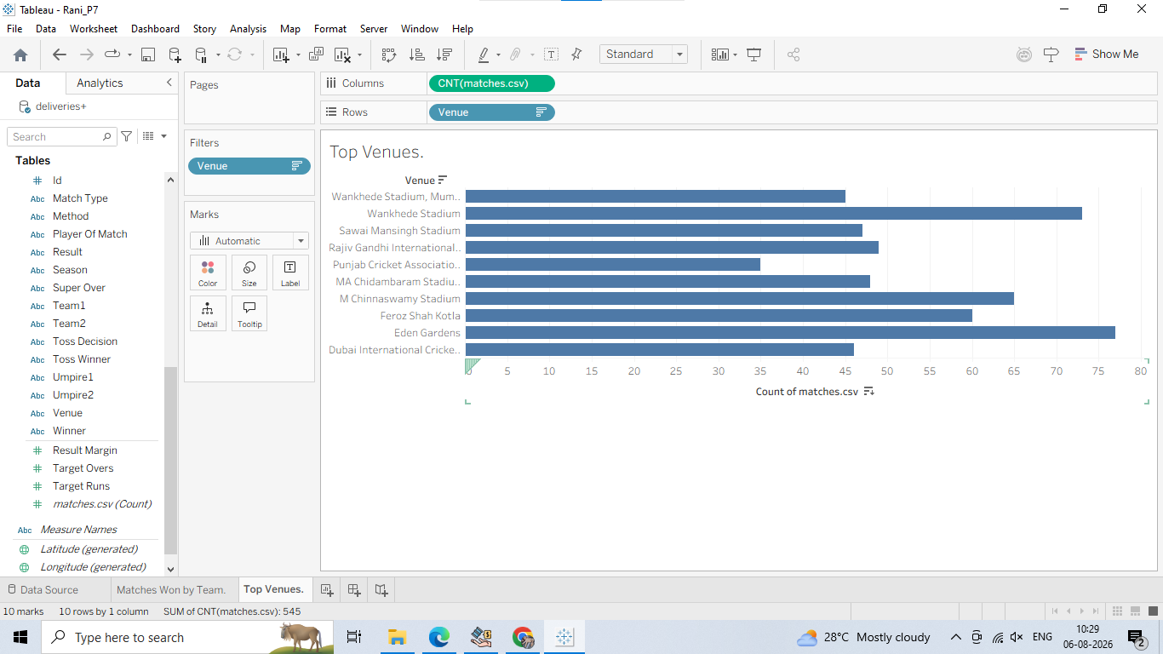

6. Change the mark type on the Marks card to Bar and color it a neutral shade (e.g., Navy Blue).
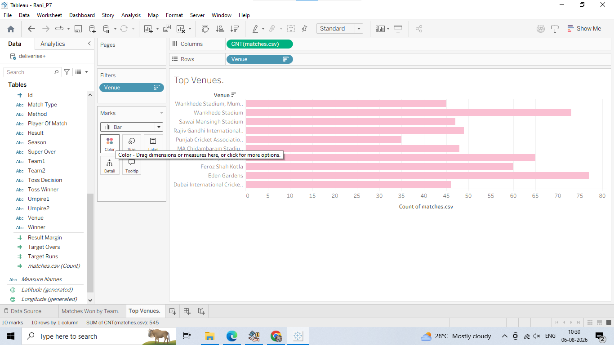
Step 3: Create Sheet 3 "Toss Decision Impact" (Pie Chart or Donut Chart)
1. Open a new worksheet and rename it: Toss Decision Impact.
2. Change the Marks card drop-down from Automatic to Pie.
3. Drag Toss Decision (bat/field) to Color on the Marks card.
4. Drag Matches (Count) to Angle on the Marks card.
5. Drag Toss Decision and Matches (Count) to Label on the Marks card.

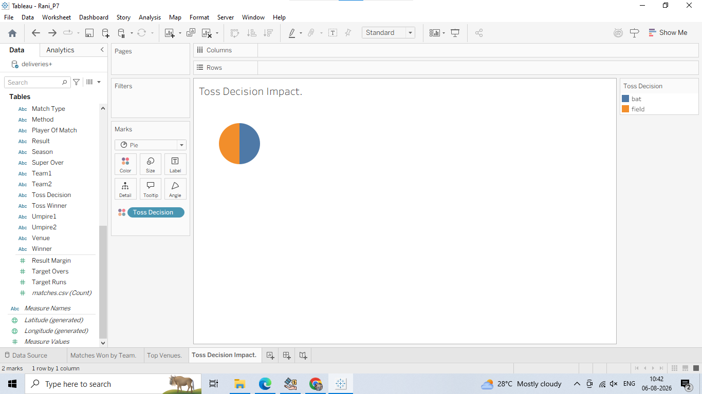
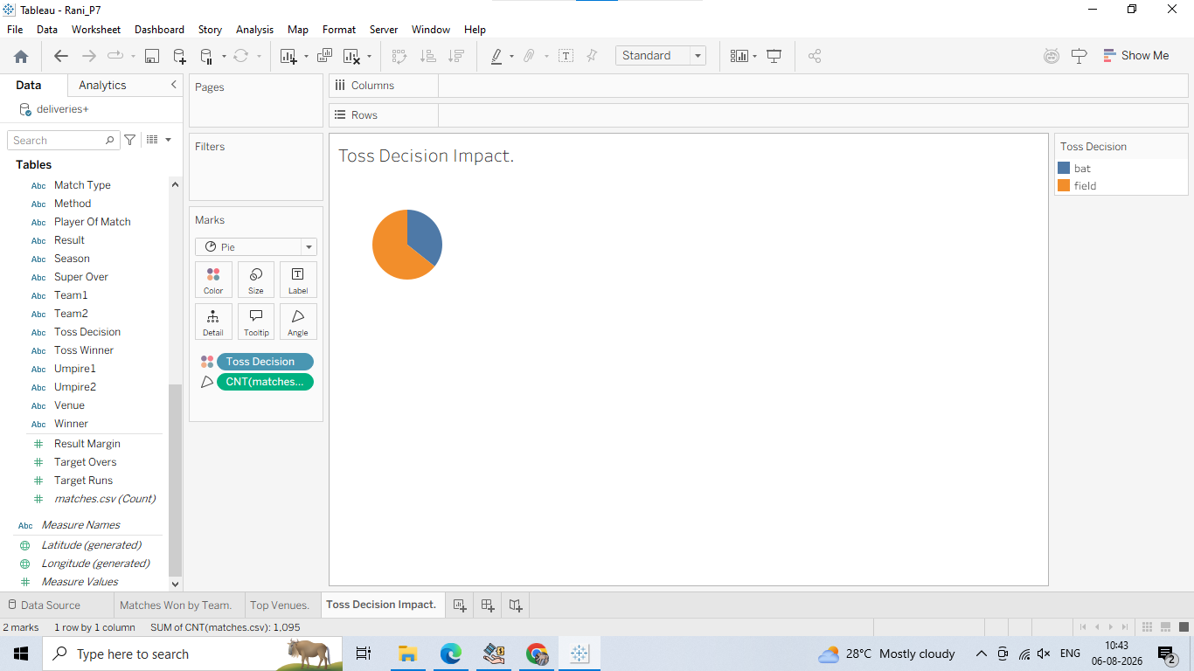

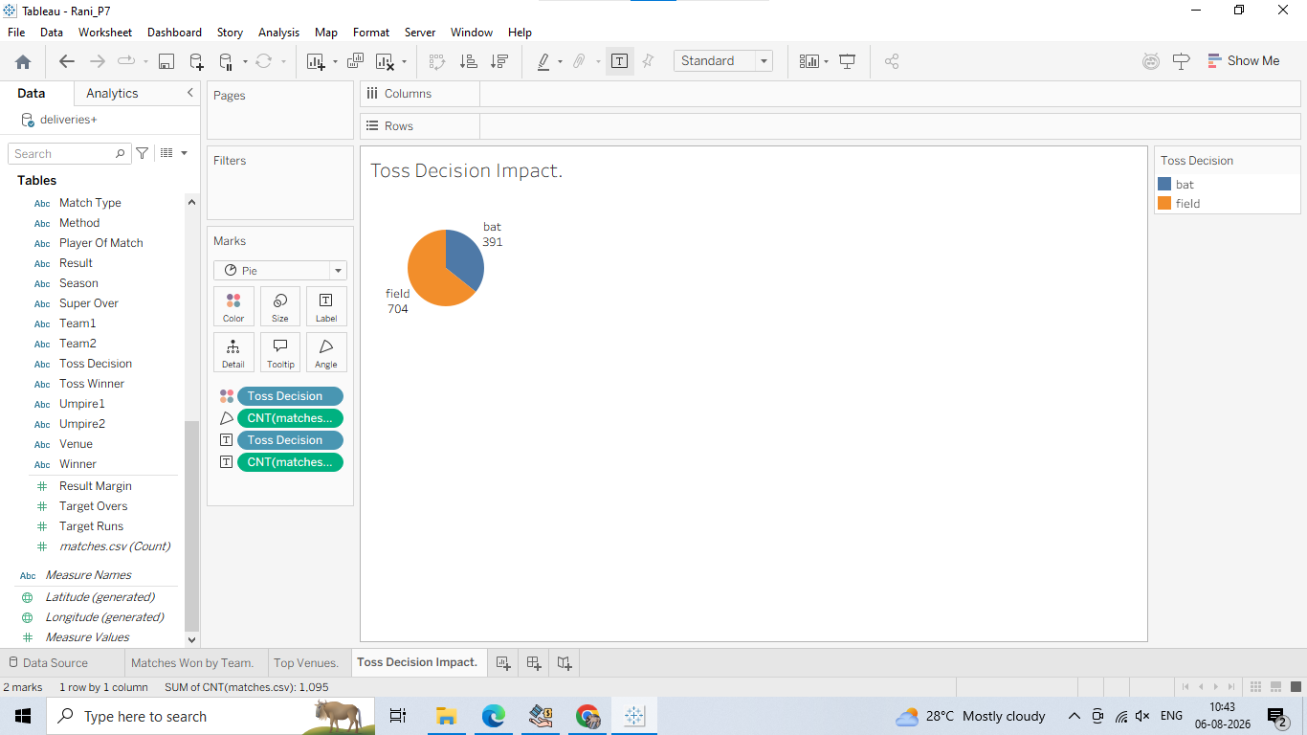
6. Look at the Marks card on the left side of your chart view.
7. Find the green pill named CNT(Matches) (or CNTD(Id)) that has a small T or Label icon next to it.
8. Right-click directly on that green pill (or click its small drop-down arrow).
9. In the pop-up menu, hover over Quick Table Calculation.
10. Select Percent of Total.

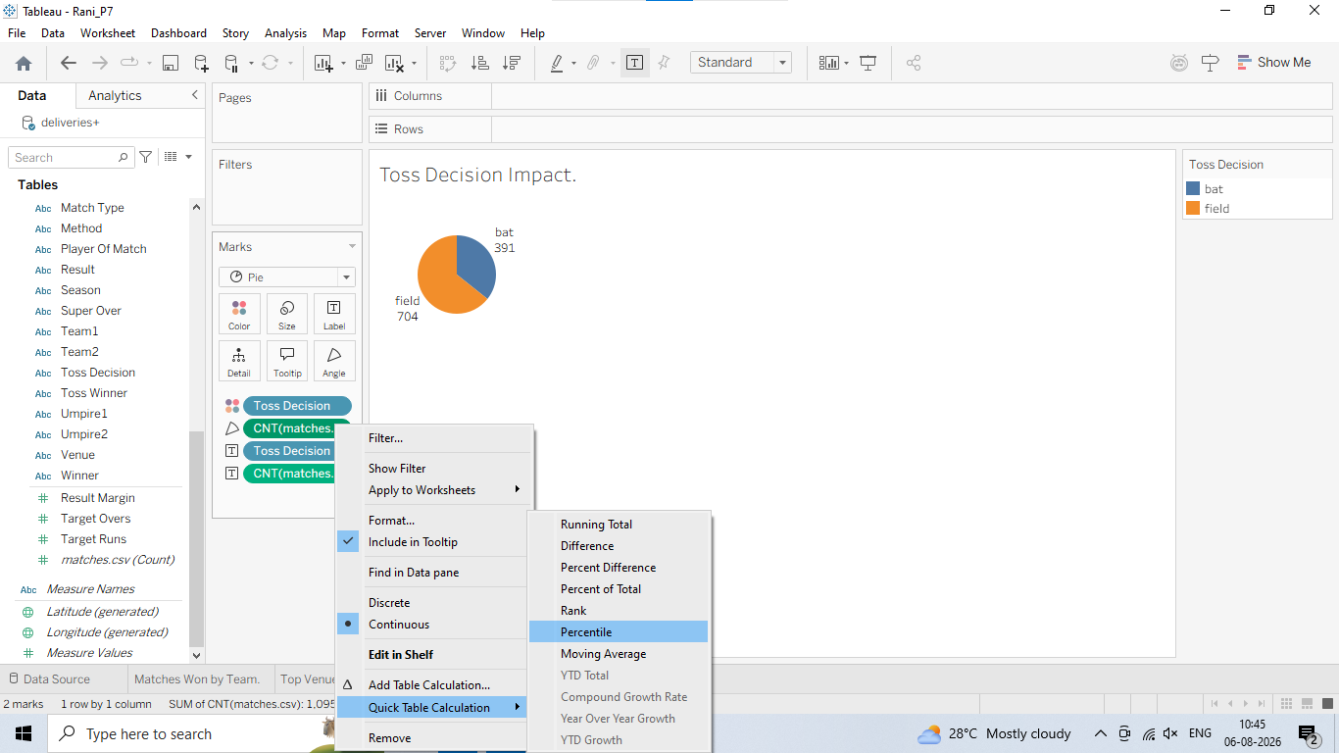

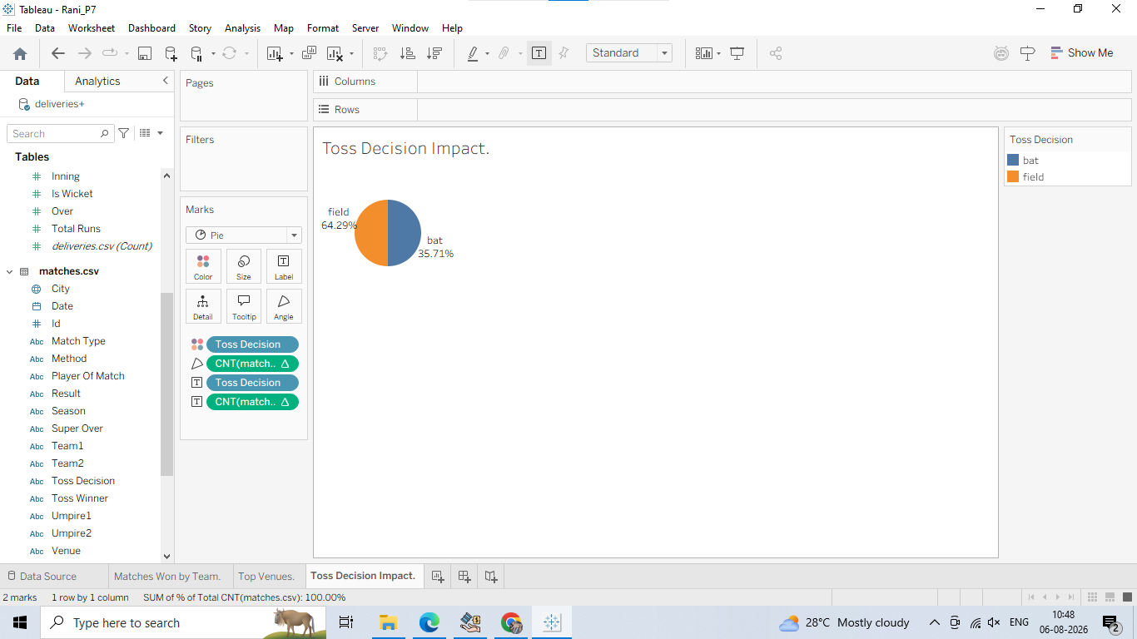

Step 4: Assemble the Dashboard Layout
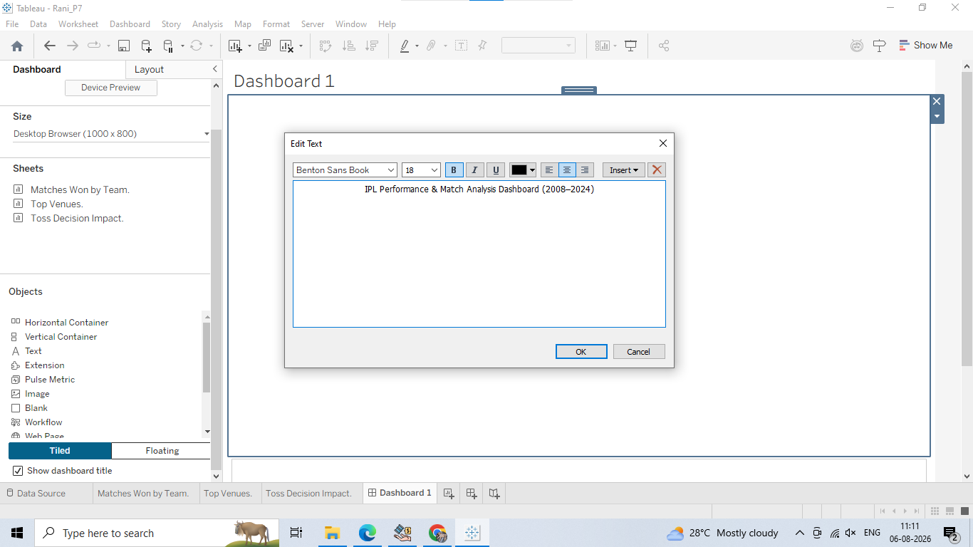
6. Drag your three sheets into the layout:
Drag Matches Won by Team into the top/left area.
Drag Top Venues next to or below it.
Drag Toss Decision Impact to the side panel

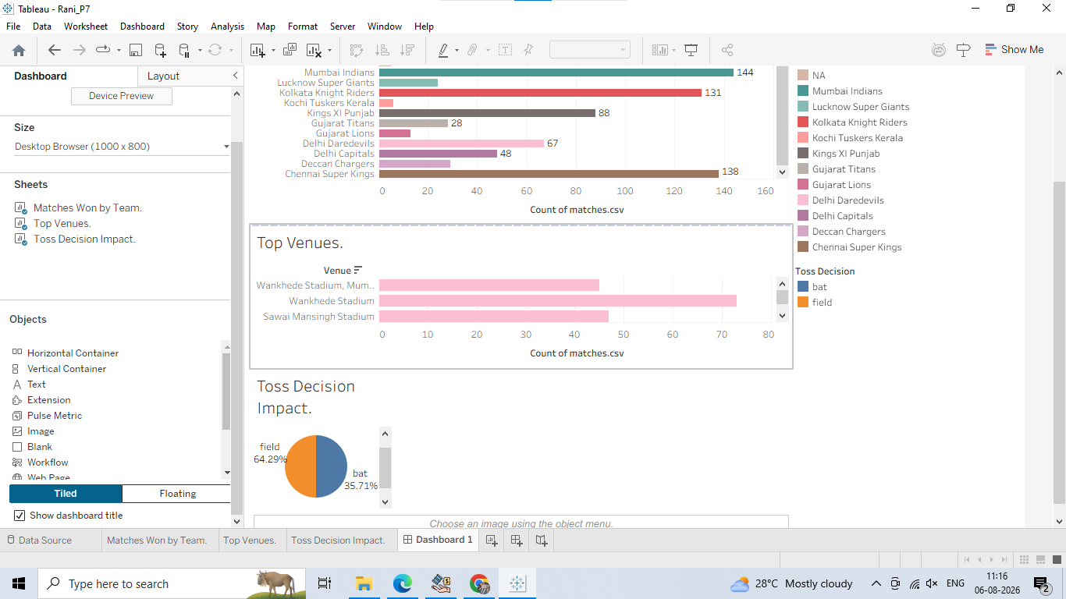
B: Add filters and interactive controls
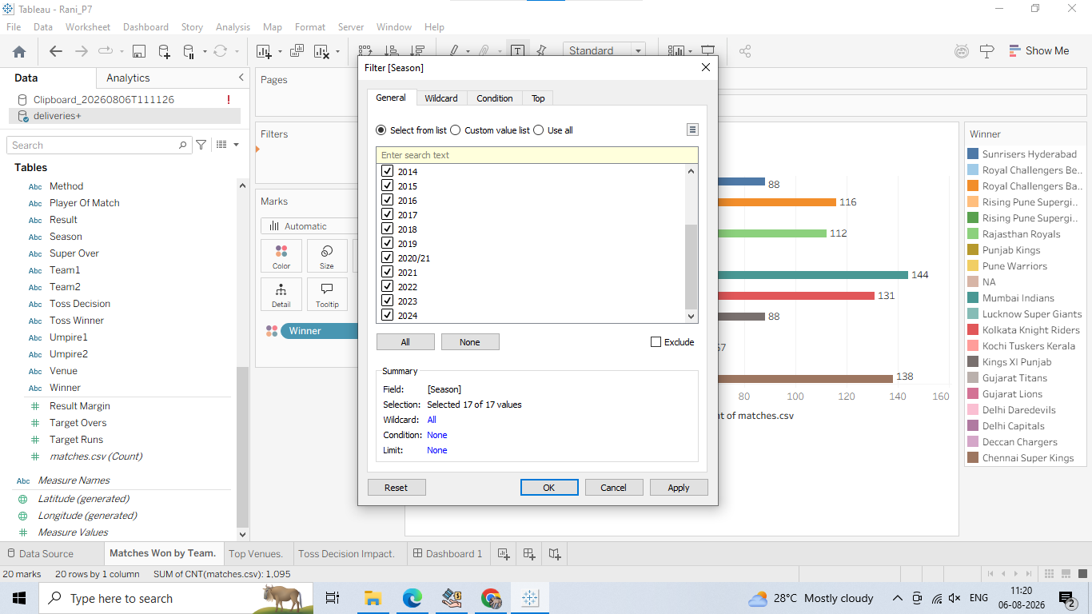

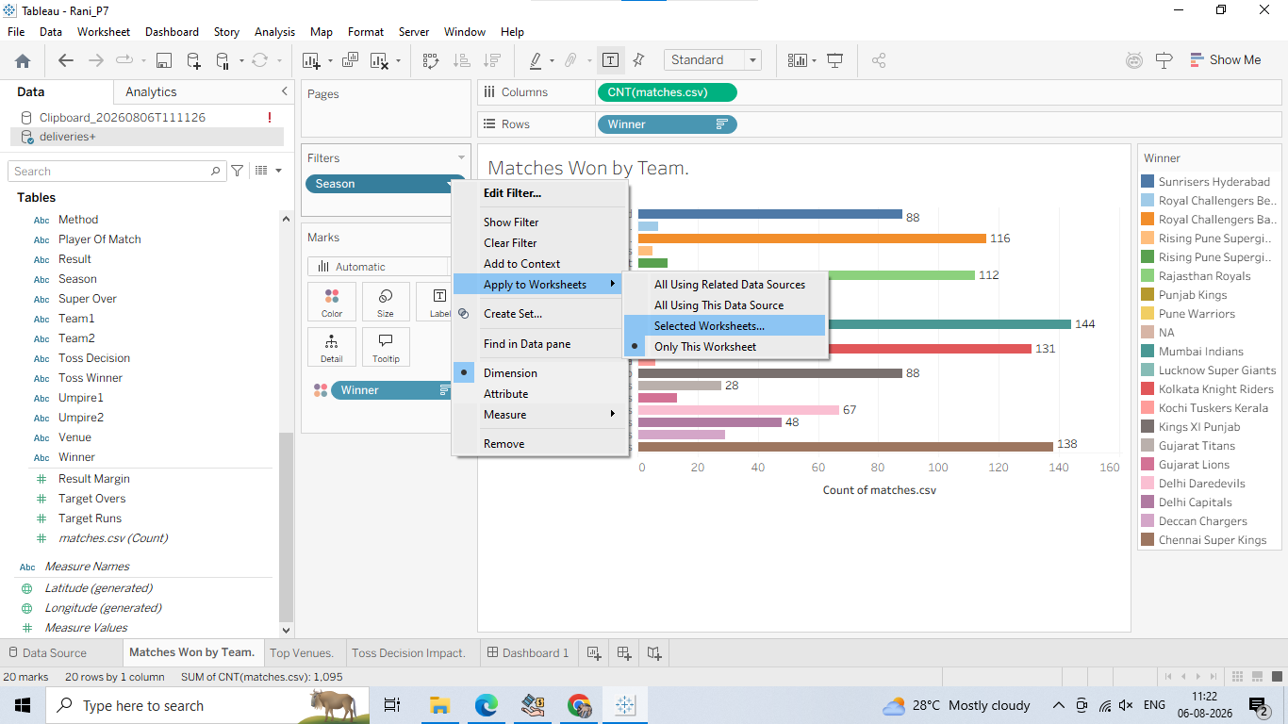

Step 2: Add Filters to the Dashboard View

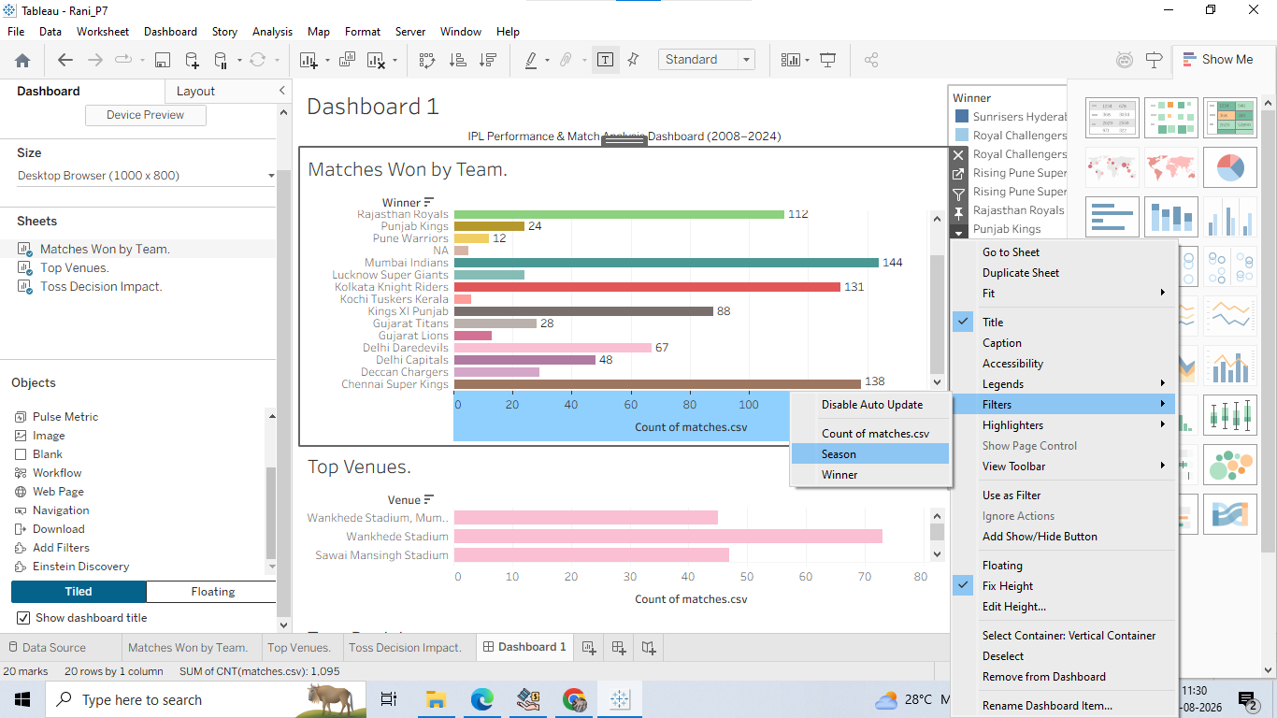
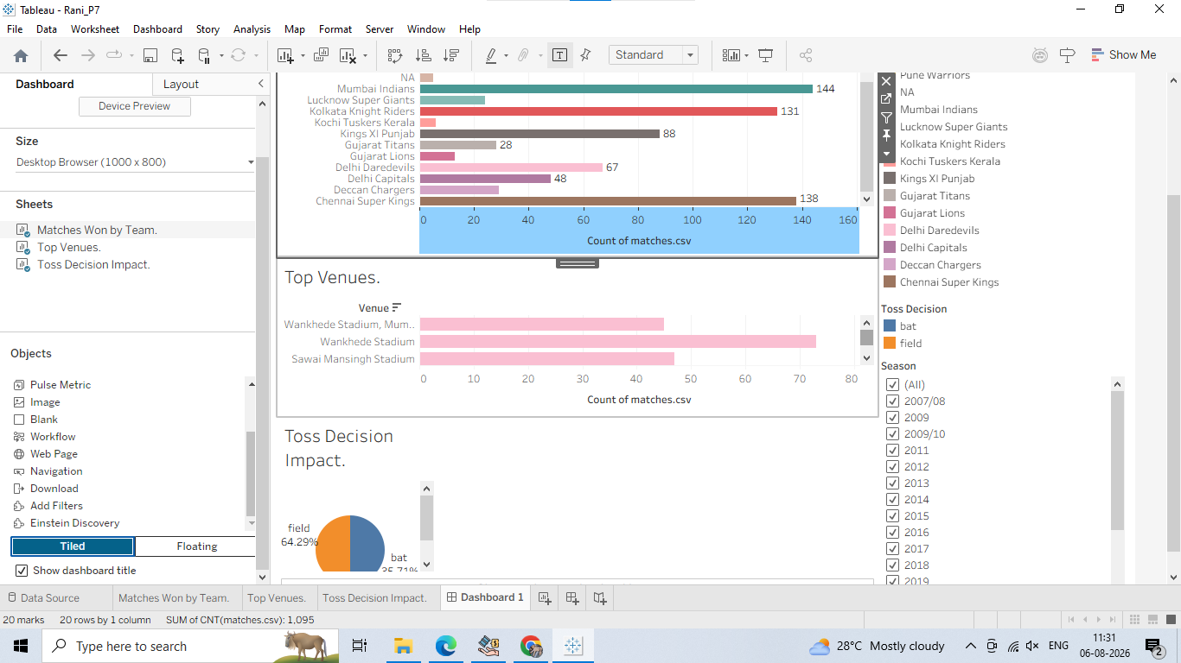

Step 3: Customize Filter Styles for User-Friendly Interactivity
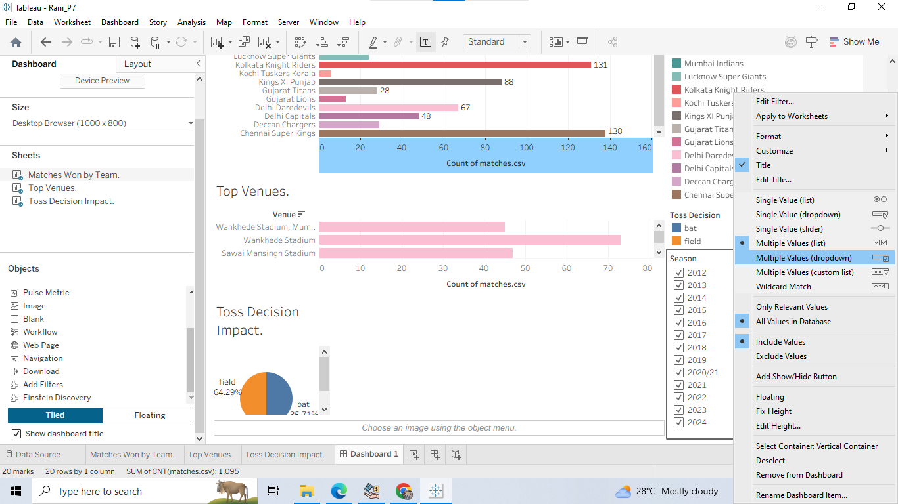
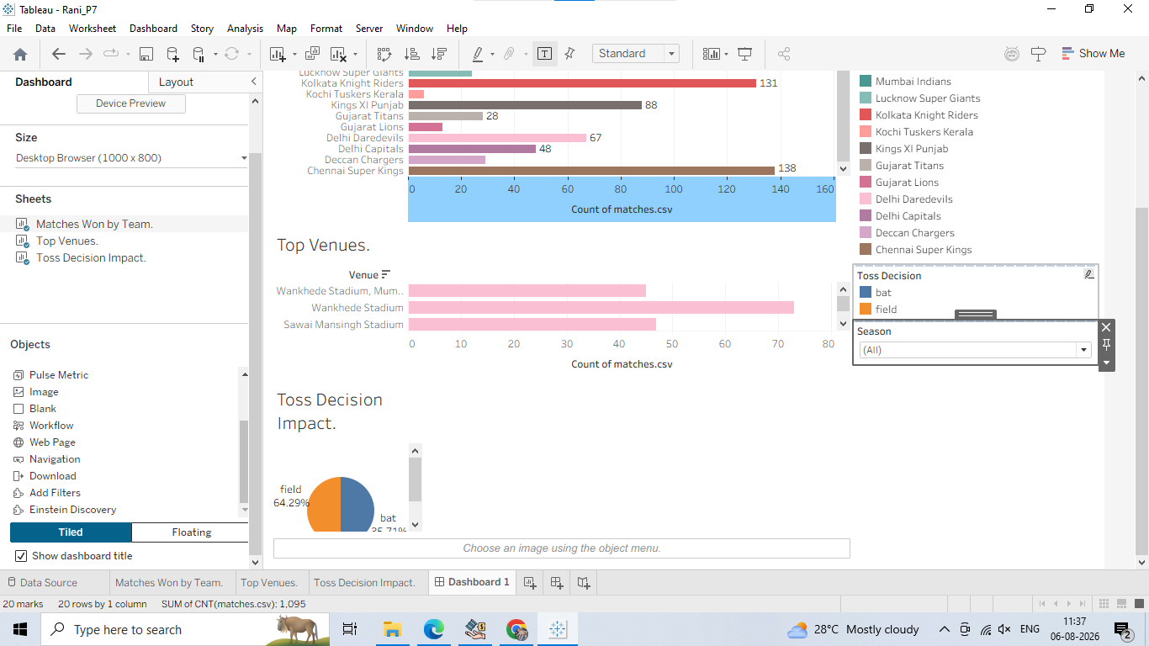
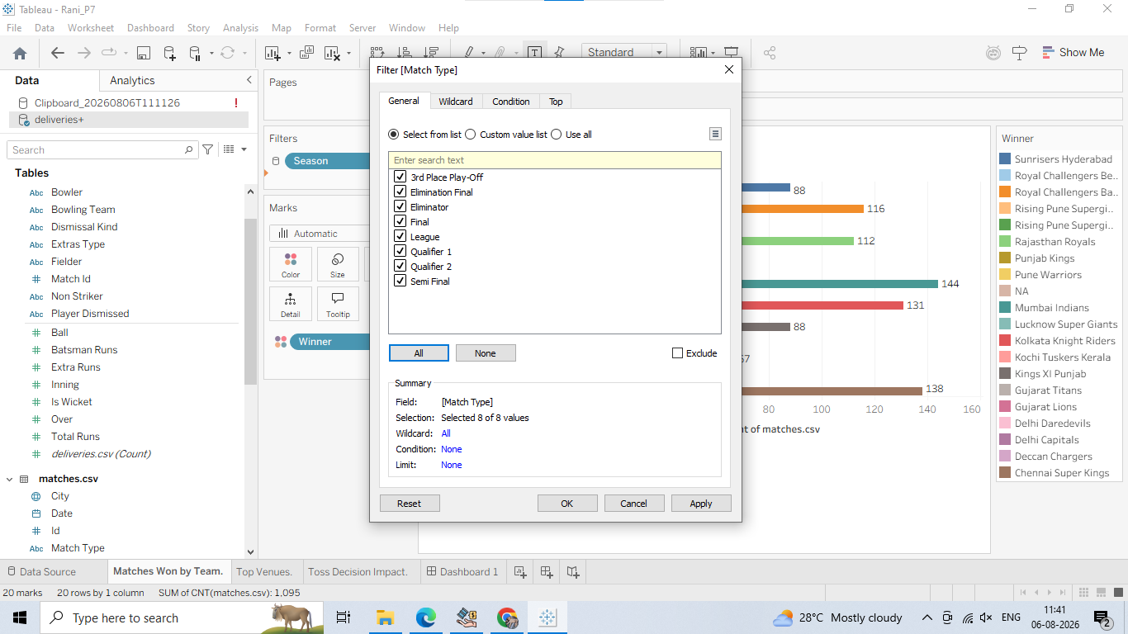

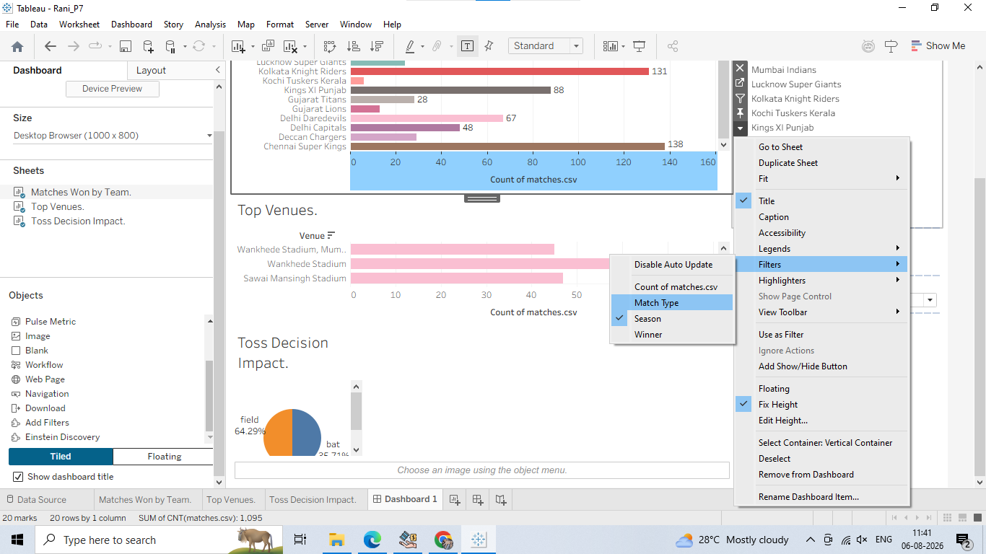

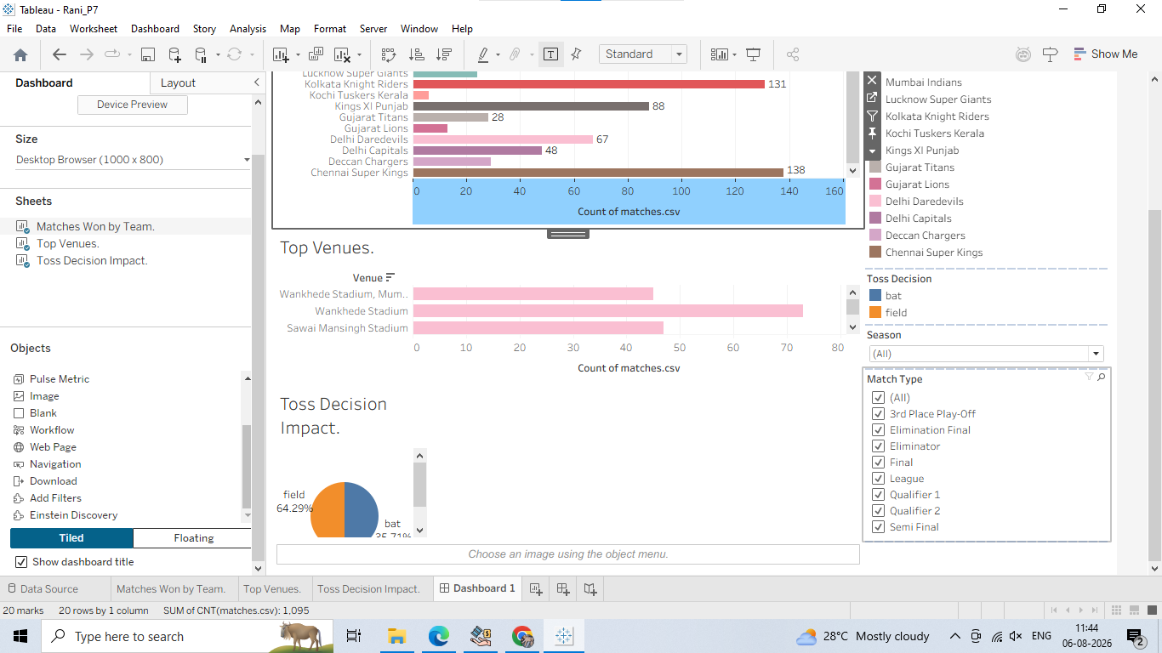

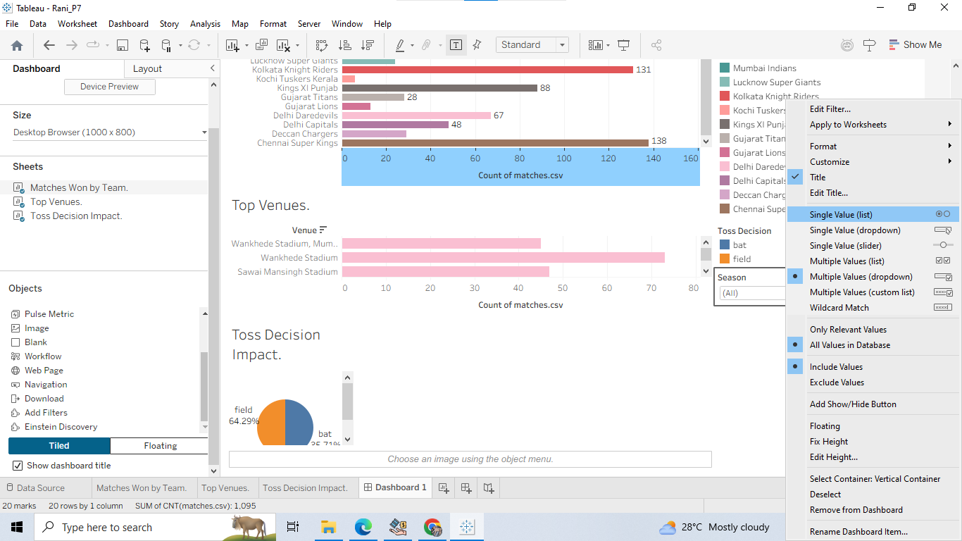

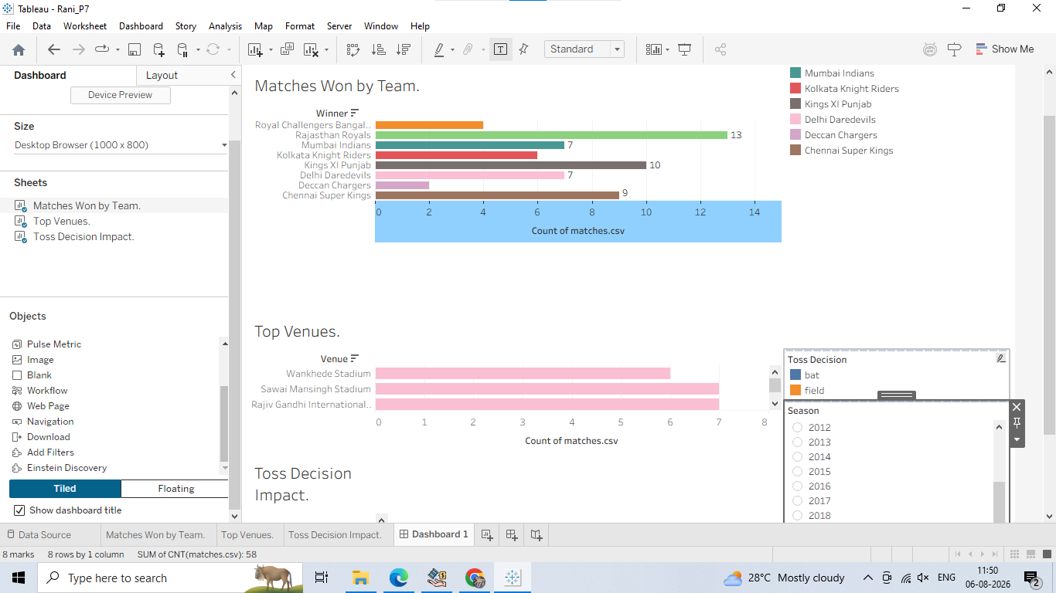
City or Toss Decision - set as a Multiple Values (Dropdown)
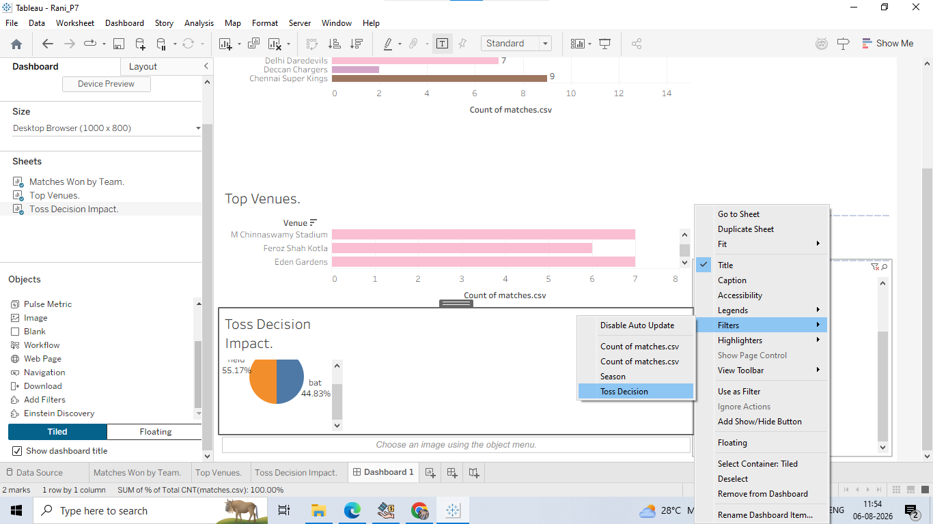

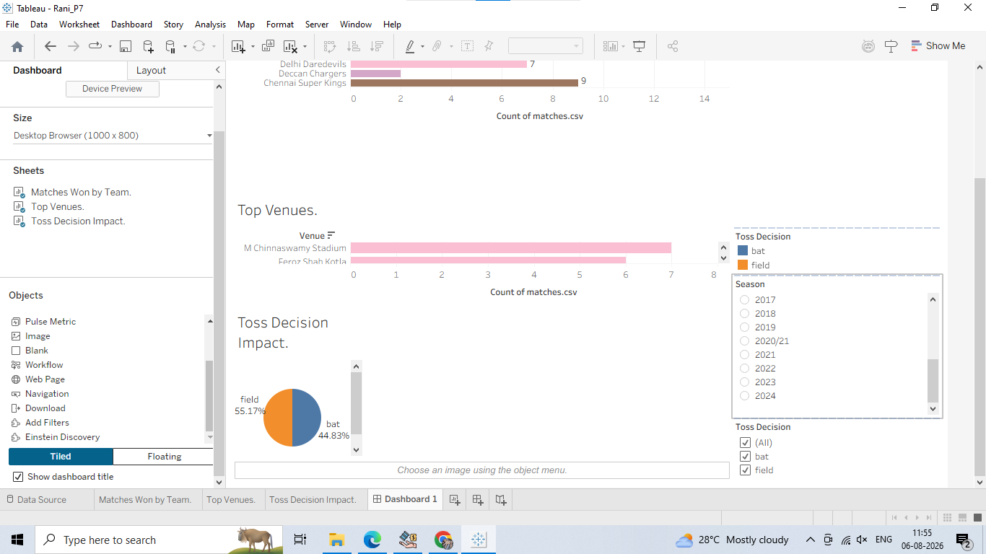
Step 4: Add a Target Runs Range Slider (Interactive Measure Control)
1. Go to the Top Venues sheet.
2. Drag Target Runs to the Filters card.
3. Choose Range of Values and click OK.

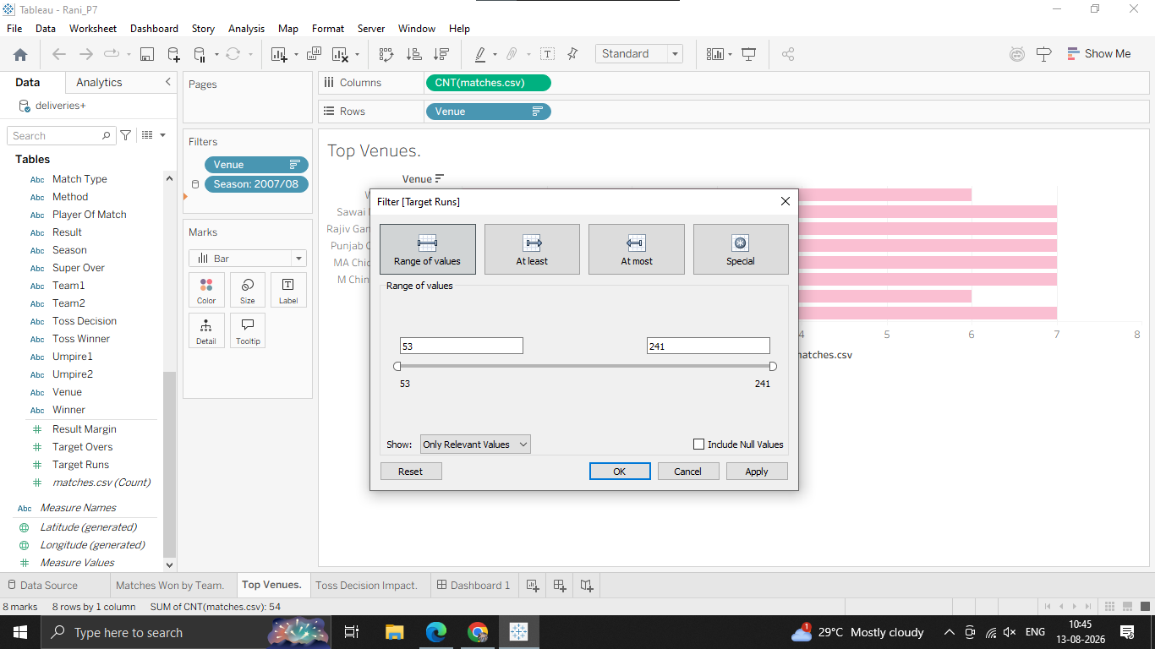

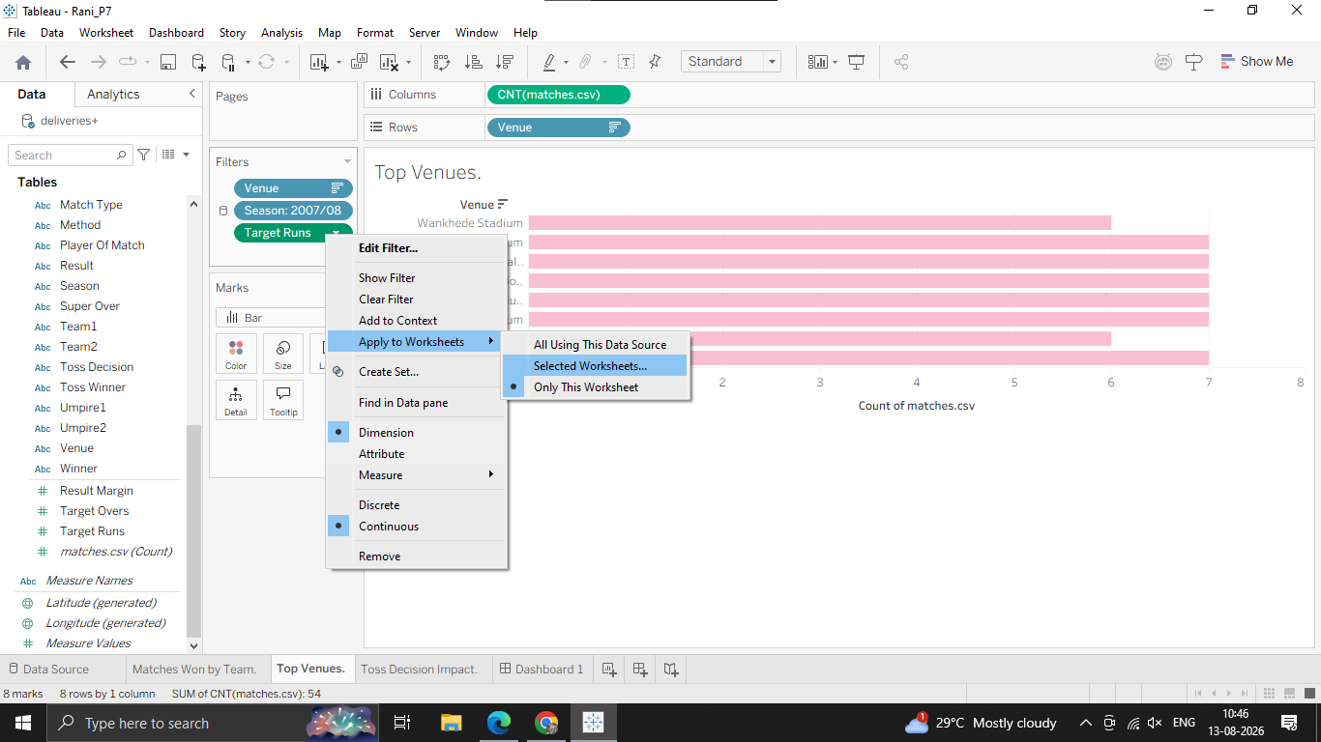

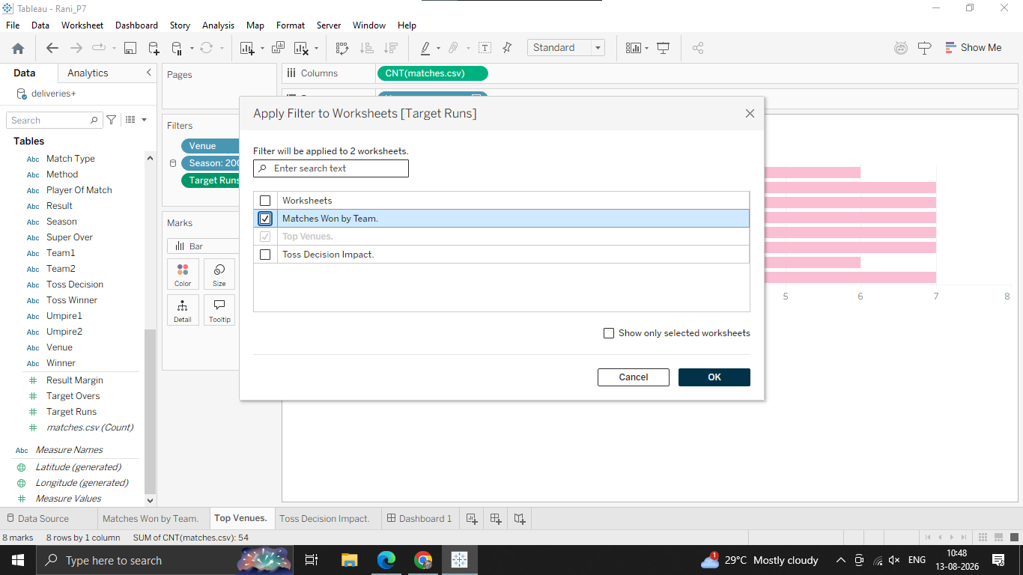

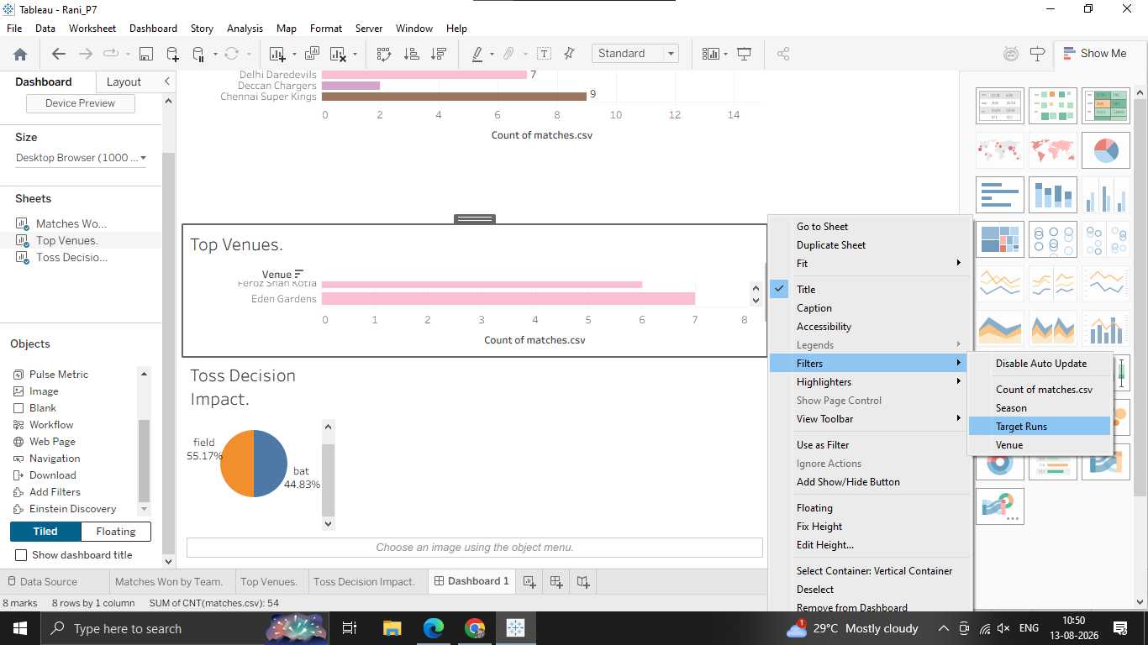
Step 1: Use a Sheet as a Quick Filter (The Easy Method)
1. Click on the Matches Won by Team chart box on your dashboard to select it.
2. Look at the small vertical toolbar that pops up on the top right side of the sheet border.
3. Click the Use as Filter icon (it looks like a small funnel symbol).

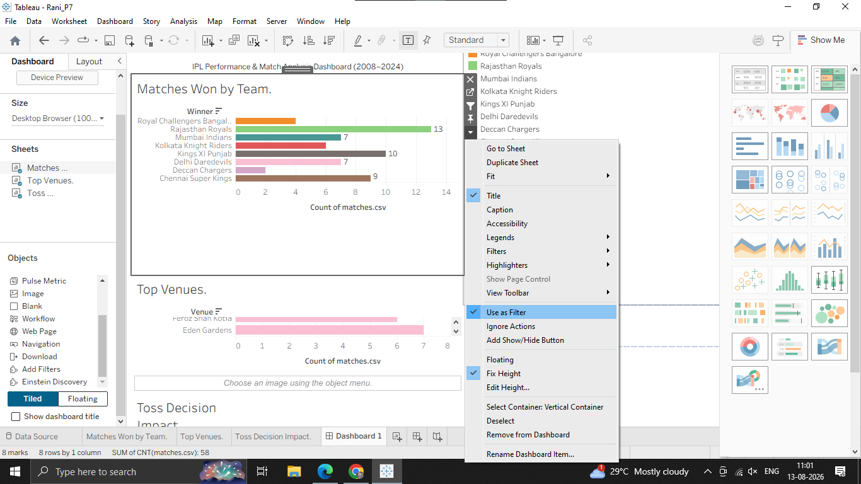

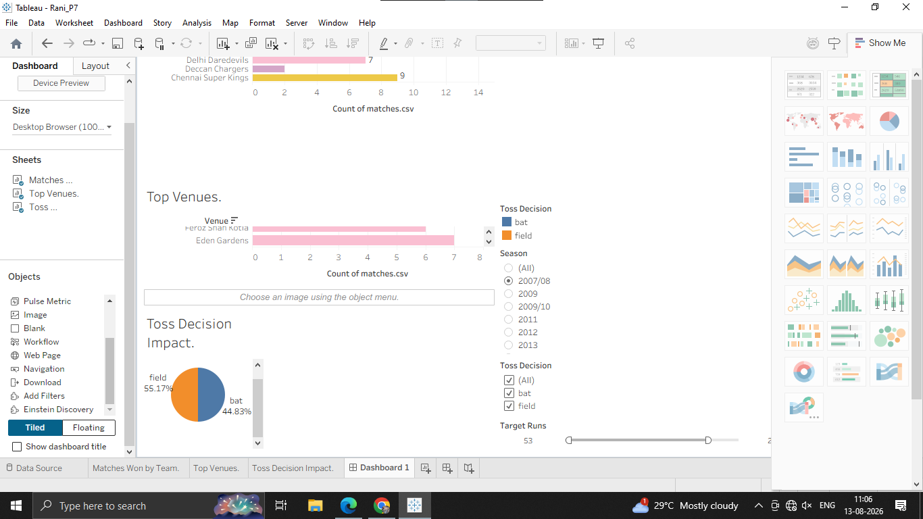
Step 2: Set Up an Explicit Highlight Action via the Dashboard Menu

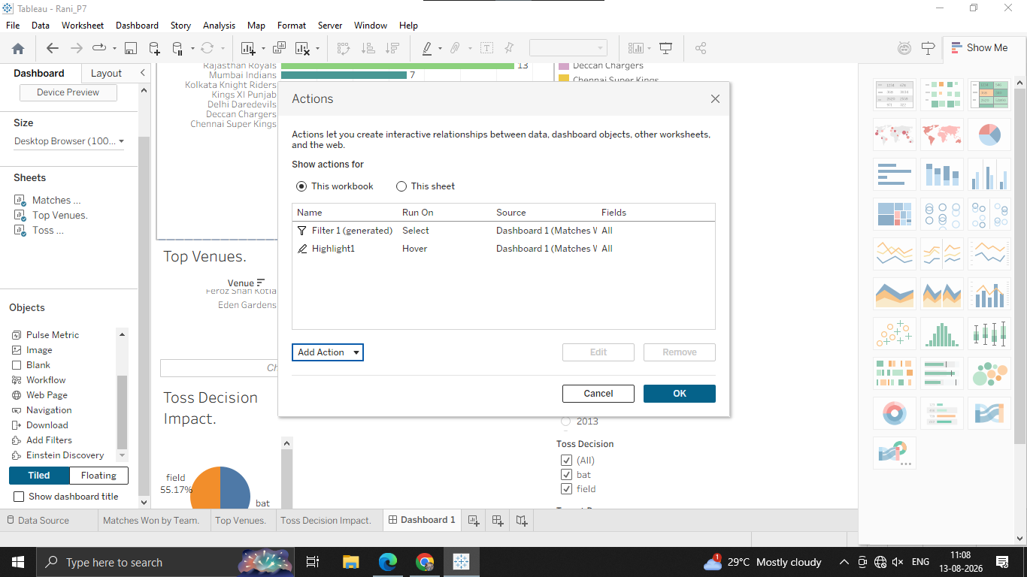

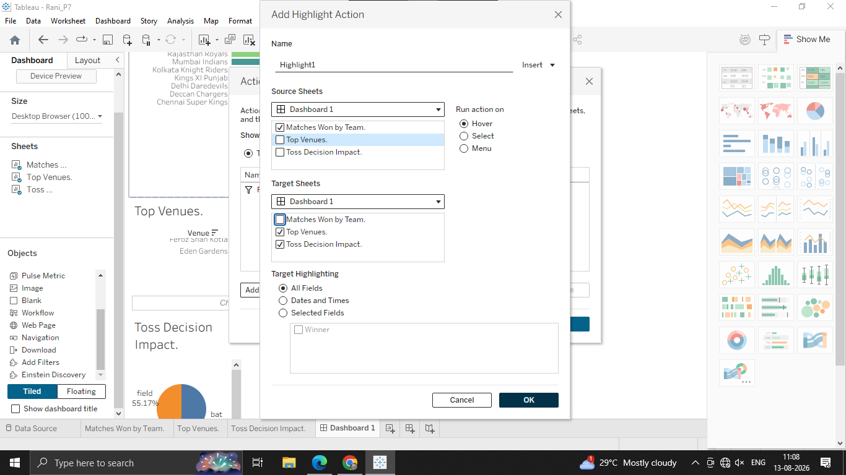
Step 3: Test Your Actions
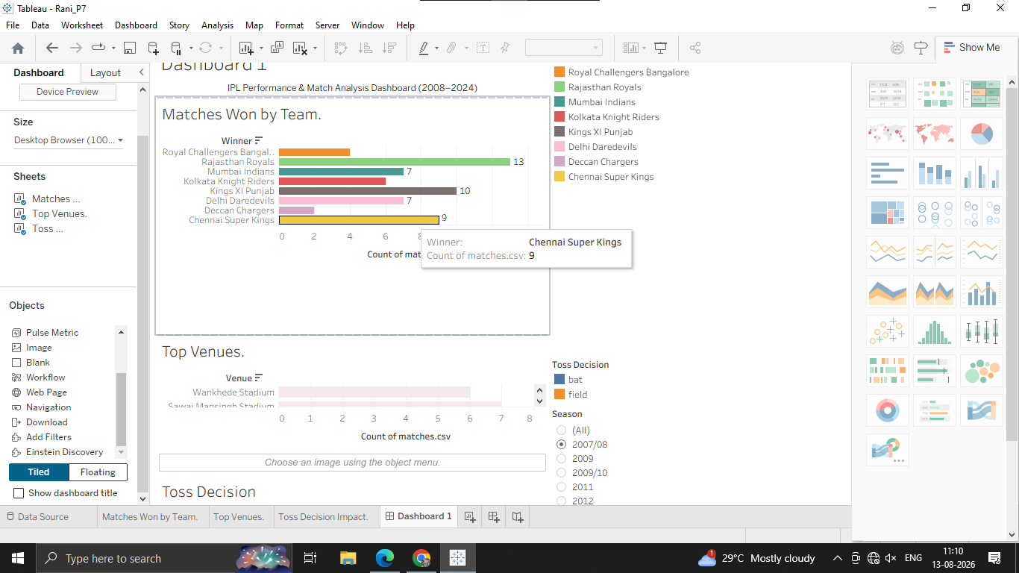

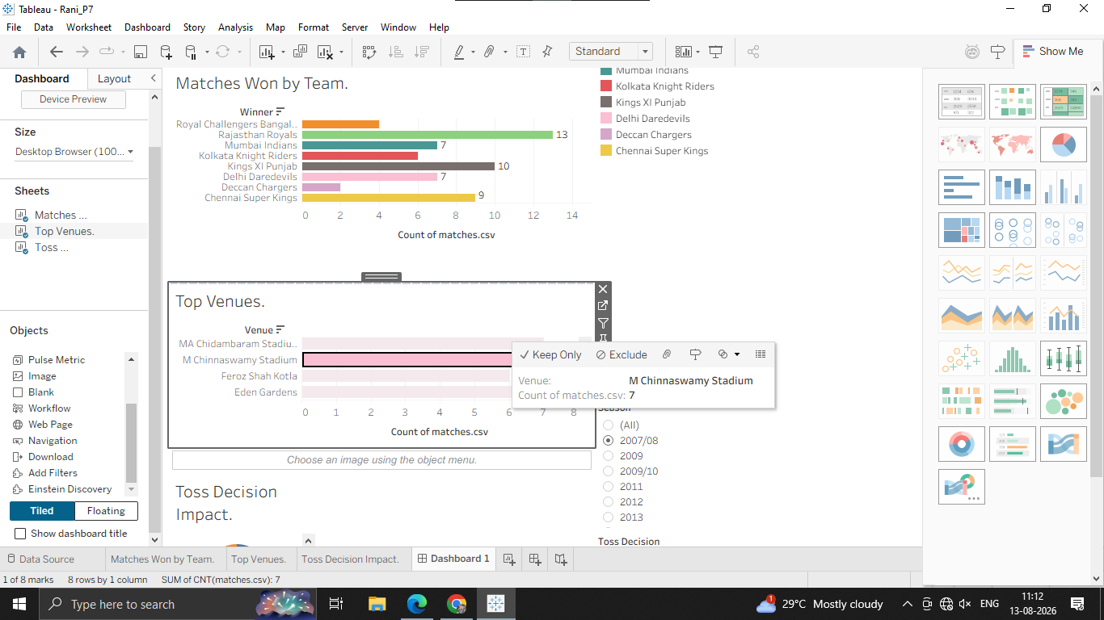
D: Use URL and set actions for interactivity
Task 1: Create a Set Action (Dynamic Team Comparison)
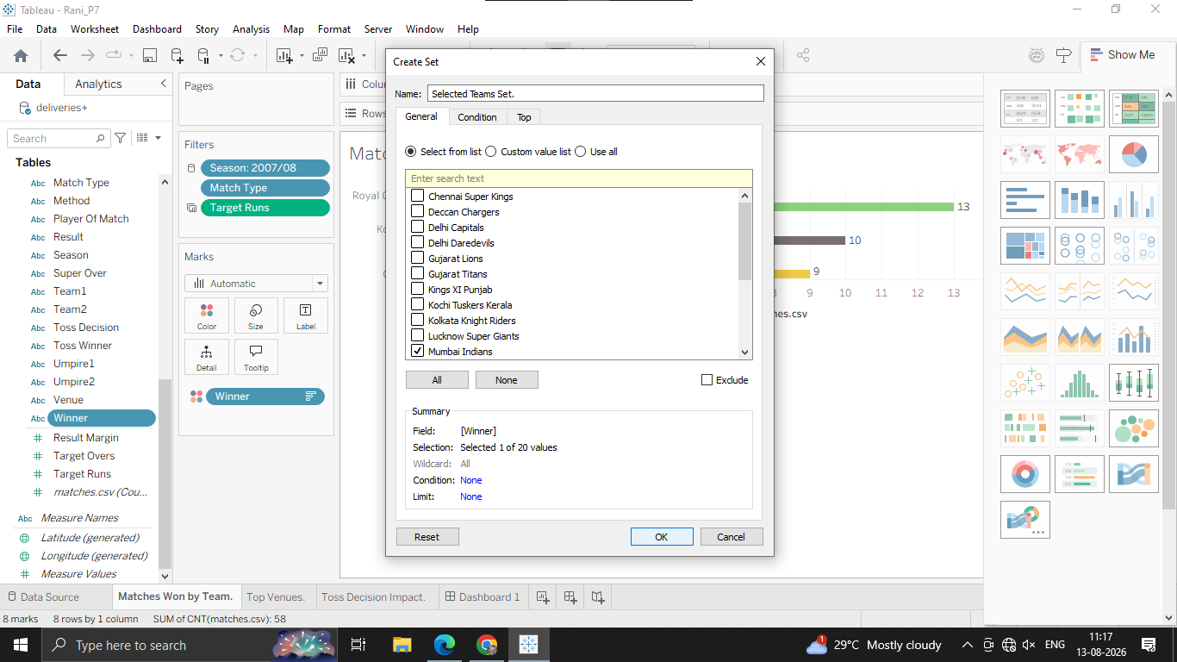
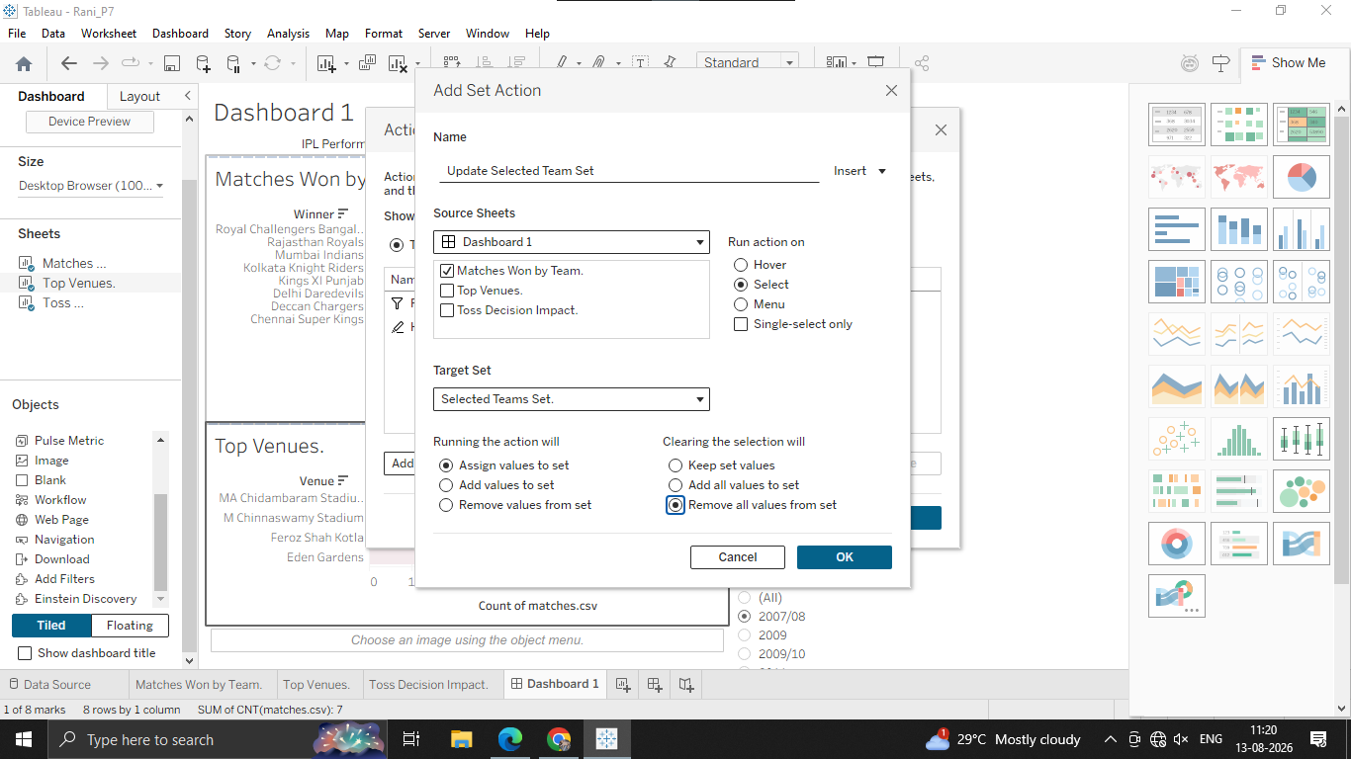

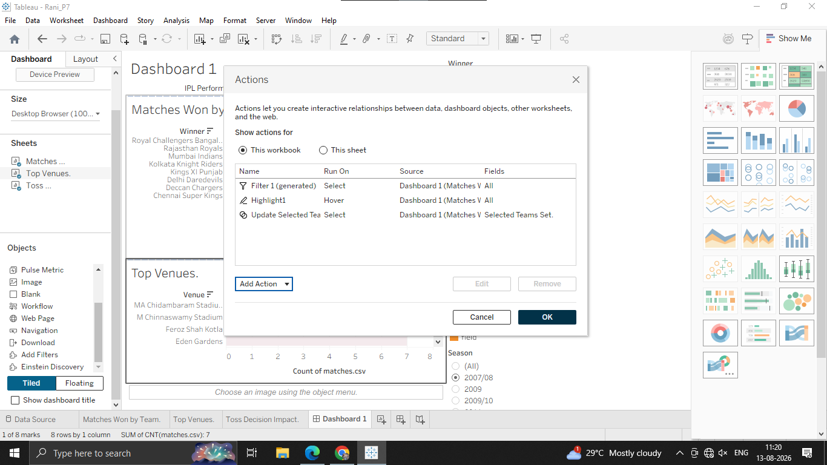

Task 2: Create a URL Action (External Link to Wikipedia / ESPNcricinfo)
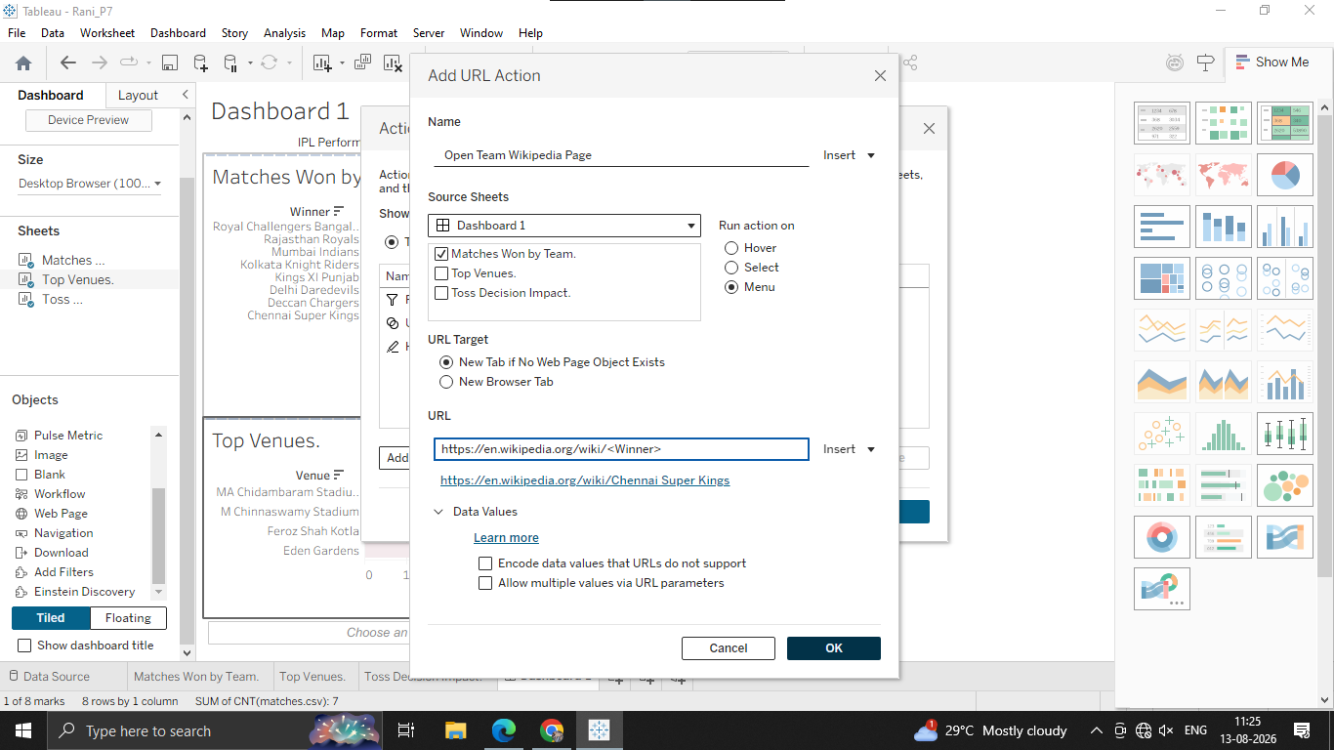
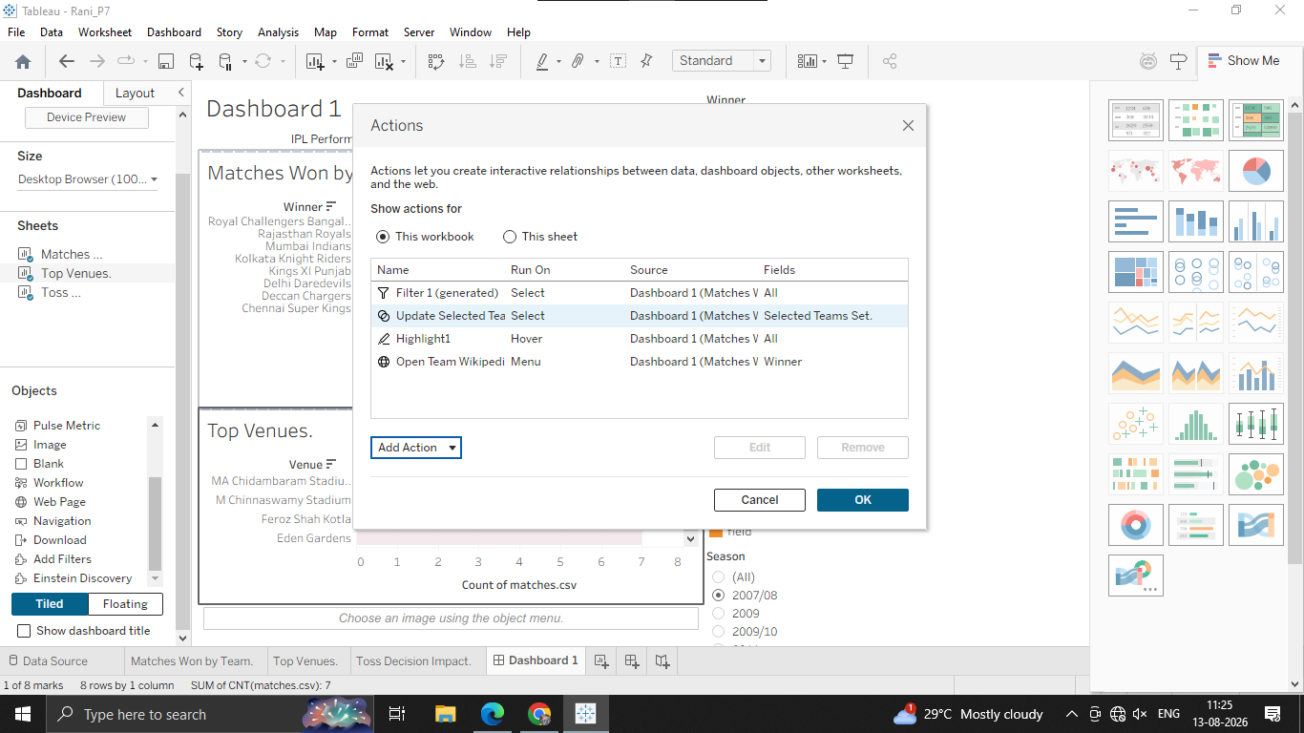

E: Create dynamic dashboards using parameters
Step 1: Create a Parameter for Dimension Swapping
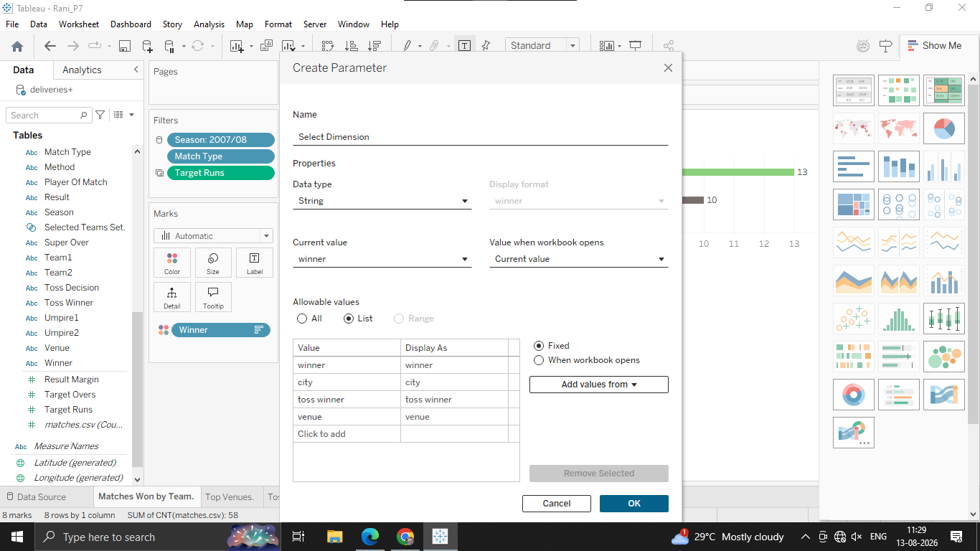
Step 2: Create a Calculated Field to Link the Parameter
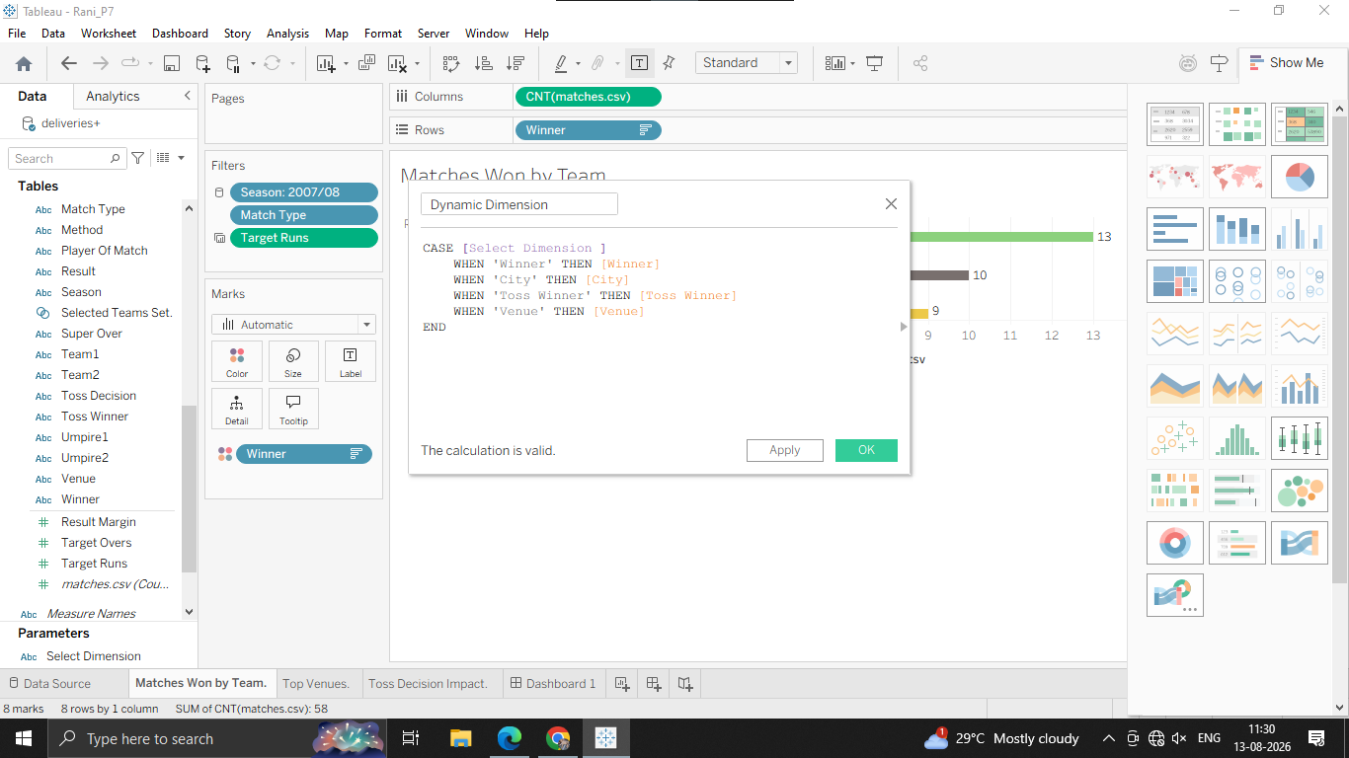

Step 3: Replace the Fixed Field with the Dynamic Field
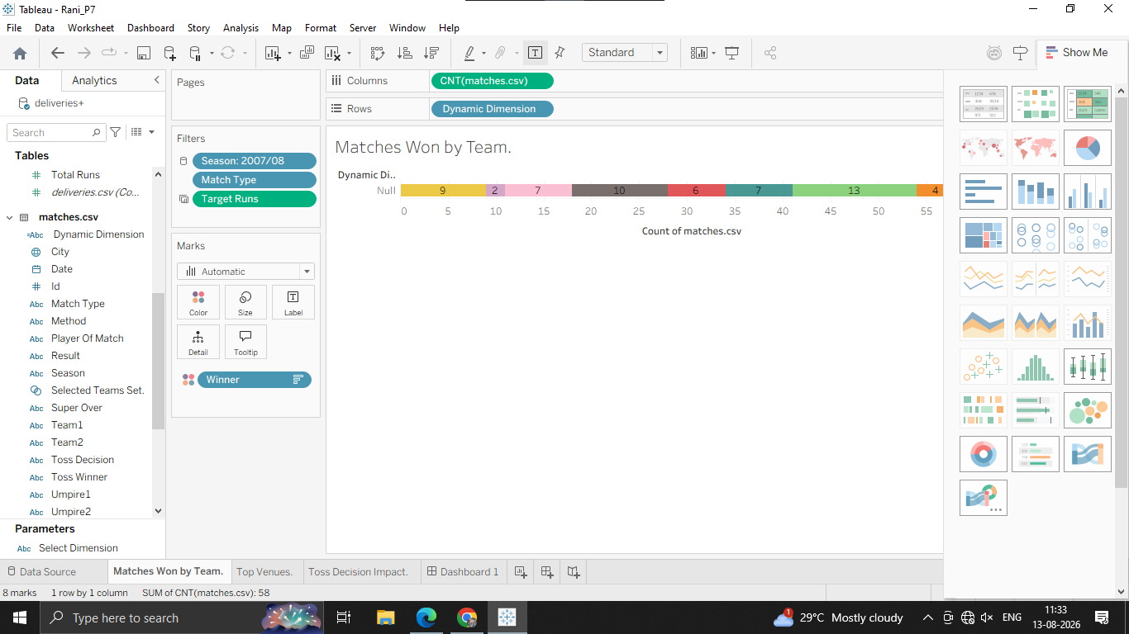
Step 4: Display the Parameter Control on the Dashboard

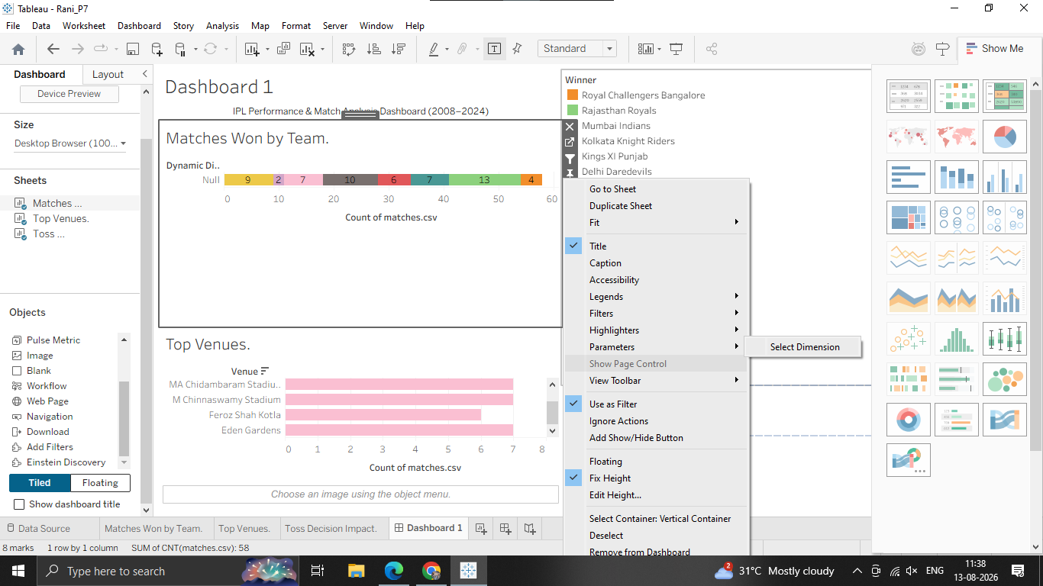
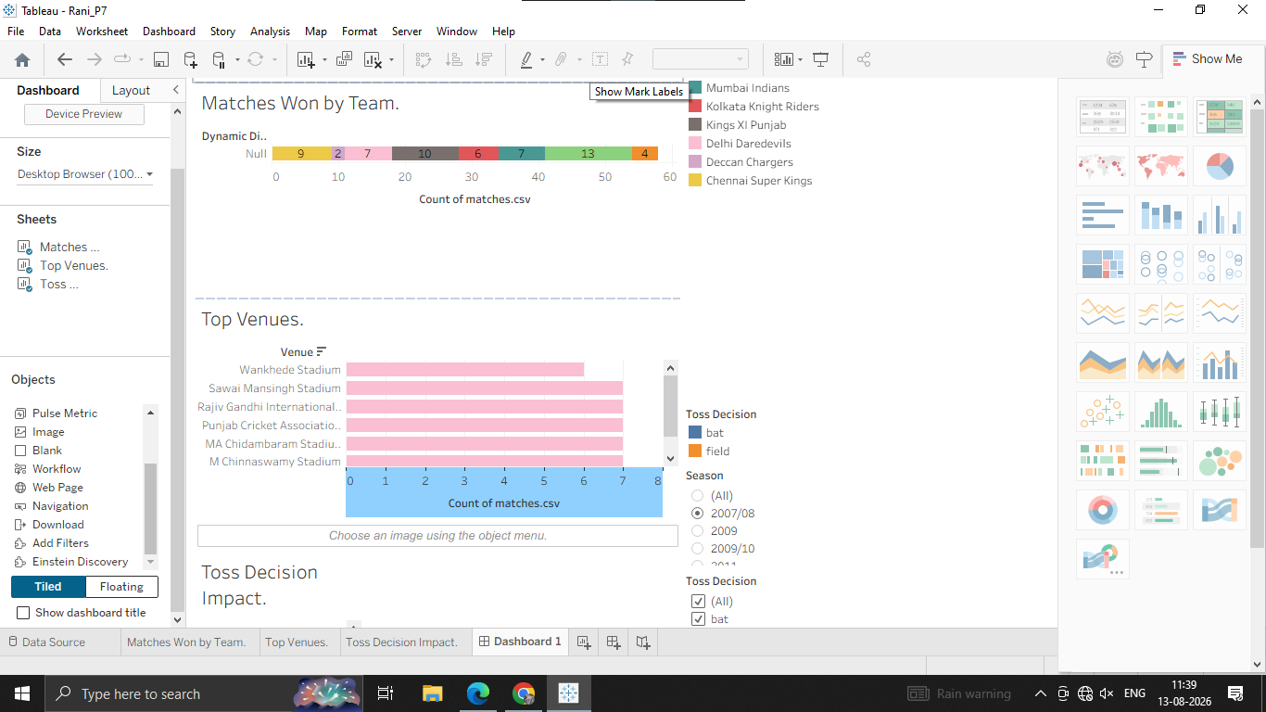
F: Design dashboards for multiple devices
Step 1: Open the Device Designer Panel
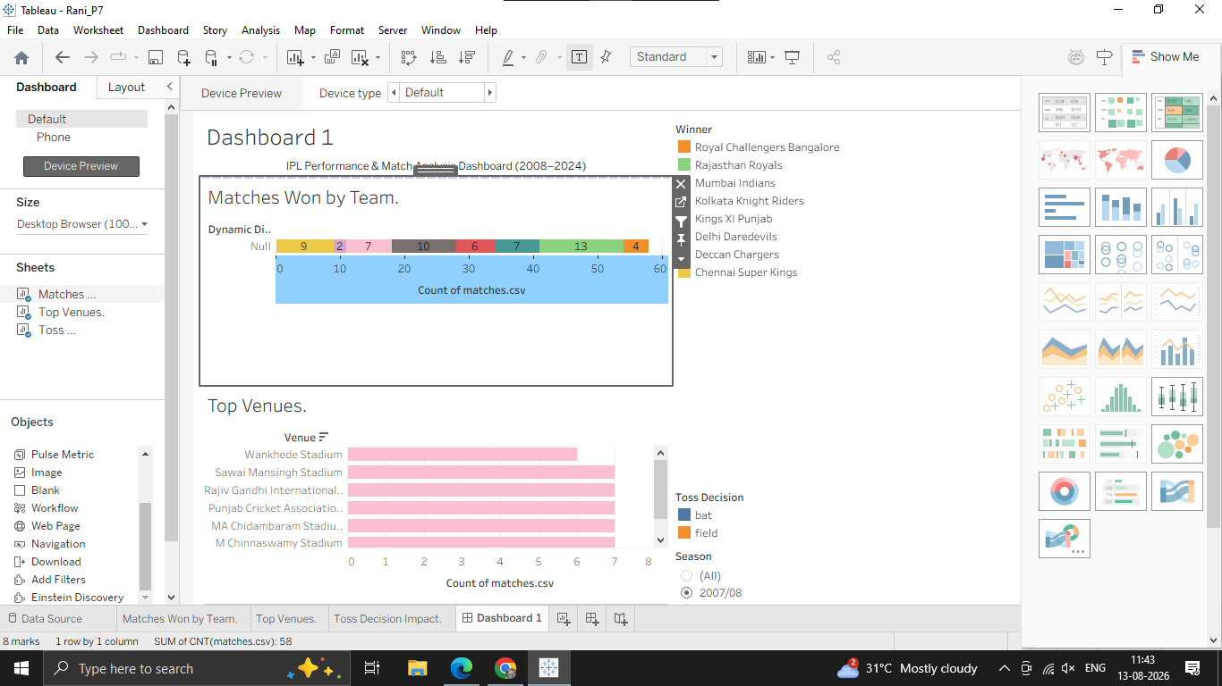

Step 2: Add a Phone Layout
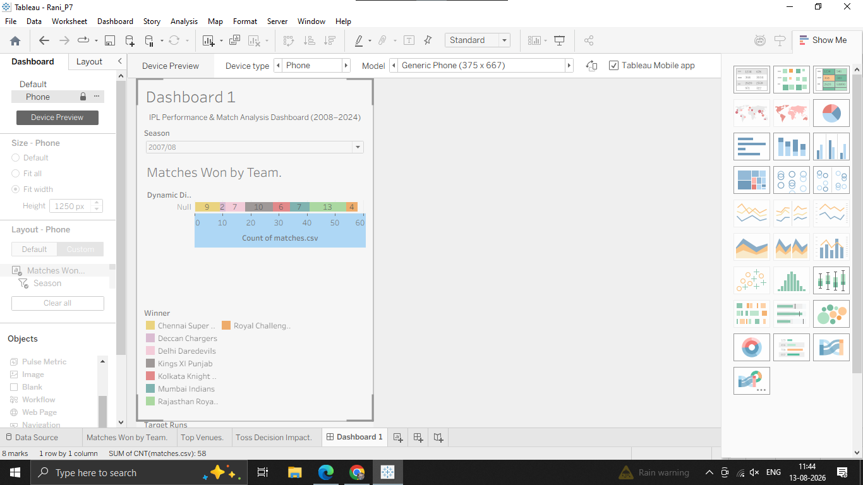Step 3: Customize the Phone Layout for Vertical Scrolling
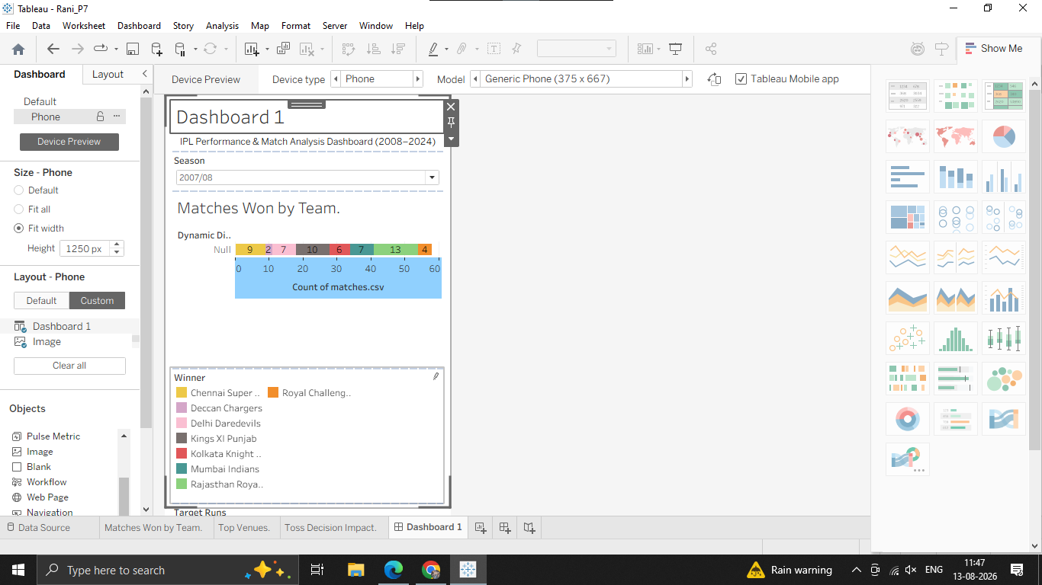

Step 4: Add a Tablet Layout (Optional)
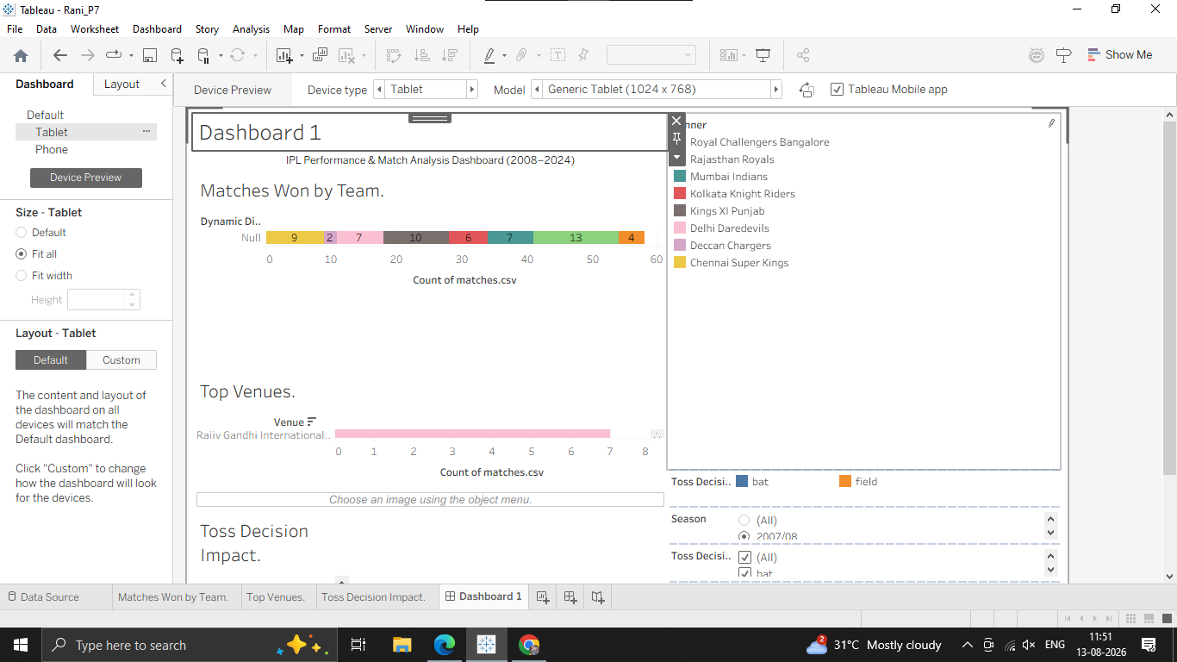
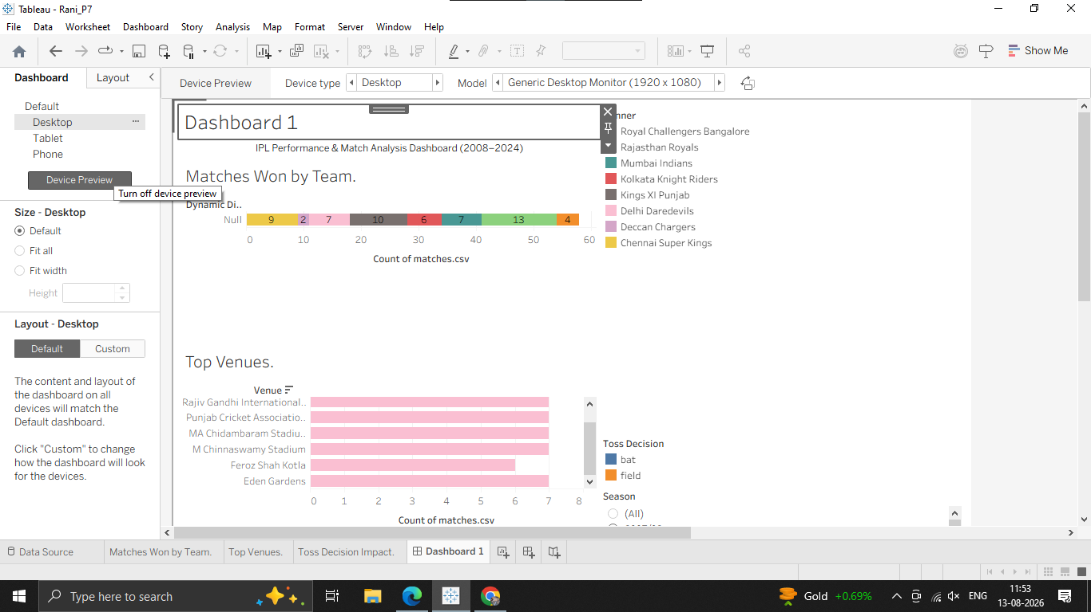

G: Build a complete data story using Story feature
Step 1: Create a New Story Workspace
