PASSWORD CHECKER
Git Collaboration and Continuous Integration — Group Project Report

Team members
Rania Rahoui — Member A, password rule checks and project page
Yasmine Boutchiche — Member B, password strength scoring
Kamelia Magdoline Milha — Member C, weak-pattern detection
Repository: github.com/rania-rahoui/GitLab_Assignment2_PasswordChecker
Date: October 25, 2026
Project objective: Build a Python password checker while demonstrating branching, commits, pull requests, peer review, merge conflict resolution, automated tests, and GitHub Pages deployment.

1. Project overview
The Password Checker evaluates passwords using basic rule checks, a strength score, and weak-pattern detection. The project was developed collaboratively in a public GitHub repository with separate contributions from the three members. The final repository includes source files, tests, a GitHub Actions workflow, documentation, and a project page.

2. Team responsibilities
Rania Rahoui: implemented basic password rules (minimum length, uppercase, lowercase, digit, and special character), contributed repository documentation and GitHub Pages content, and merged project pull requests.
Yasmine Boutchiche: implemented password strength scoring from 0 to 5 with Weak, Medium, or Strong labels, added scoring tests, responded to review feedback, and resolved the README merge conflict.
Kamelia Magdoline Milha: implemented detection of common passwords, repeated characters, and sequences, added tests, and demonstrated a failing CI run followed by a corrected passing run.

3. Repository organization and integration
The main branch contains password_checker/ for application logic, tests/ for automated verification, .github/workflows/ for continuous integration, docs/ for the published project page, and configuration files such as pytest.ini and requirements.txt. The screenshot shows 24 commits, three contributors, and a successful GitHub Pages deployment after PR #7 was merged.
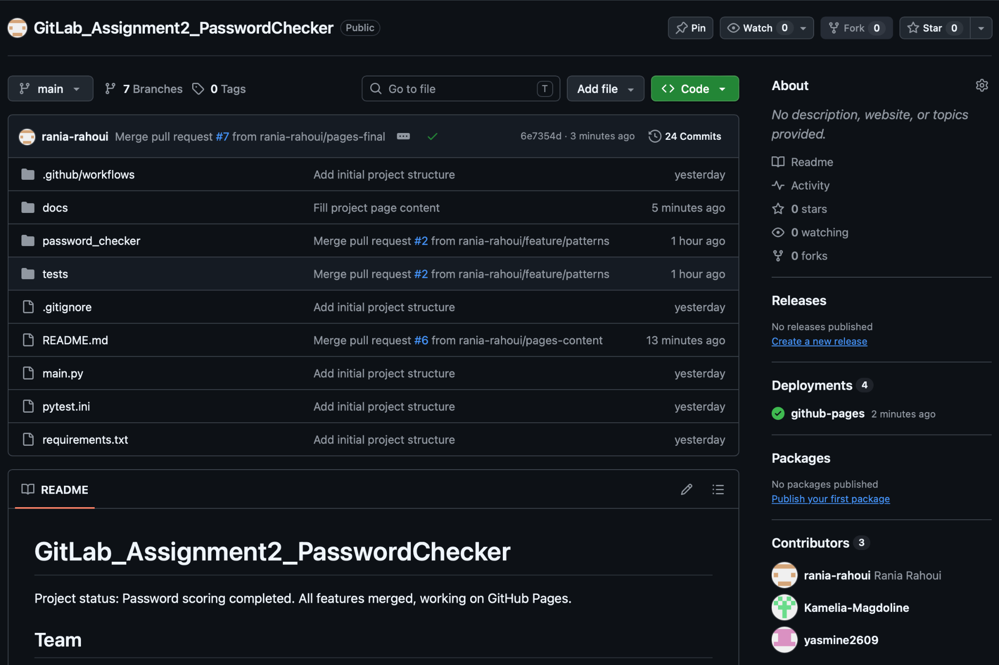
Figure 1. Final public repository on main.

4. Feature branches and pull requests
Members developed changes in dedicated branches and submitted pull requests for review before integration into main. Yasmine submitted her scoring feature in PR #3. Kamelia submitted the pattern-detection feature in PR #2. Rania submitted project-page updates through PRs #6 and #7. The README status changes were integrated after a deliberate merge-conflict exercise through PR #5.

5. Peer review and review protection
The scoring pull request initially showed two successful automated checks but could not be merged because at least one approving review was required. This demonstrates the separation between automated validation and human review.
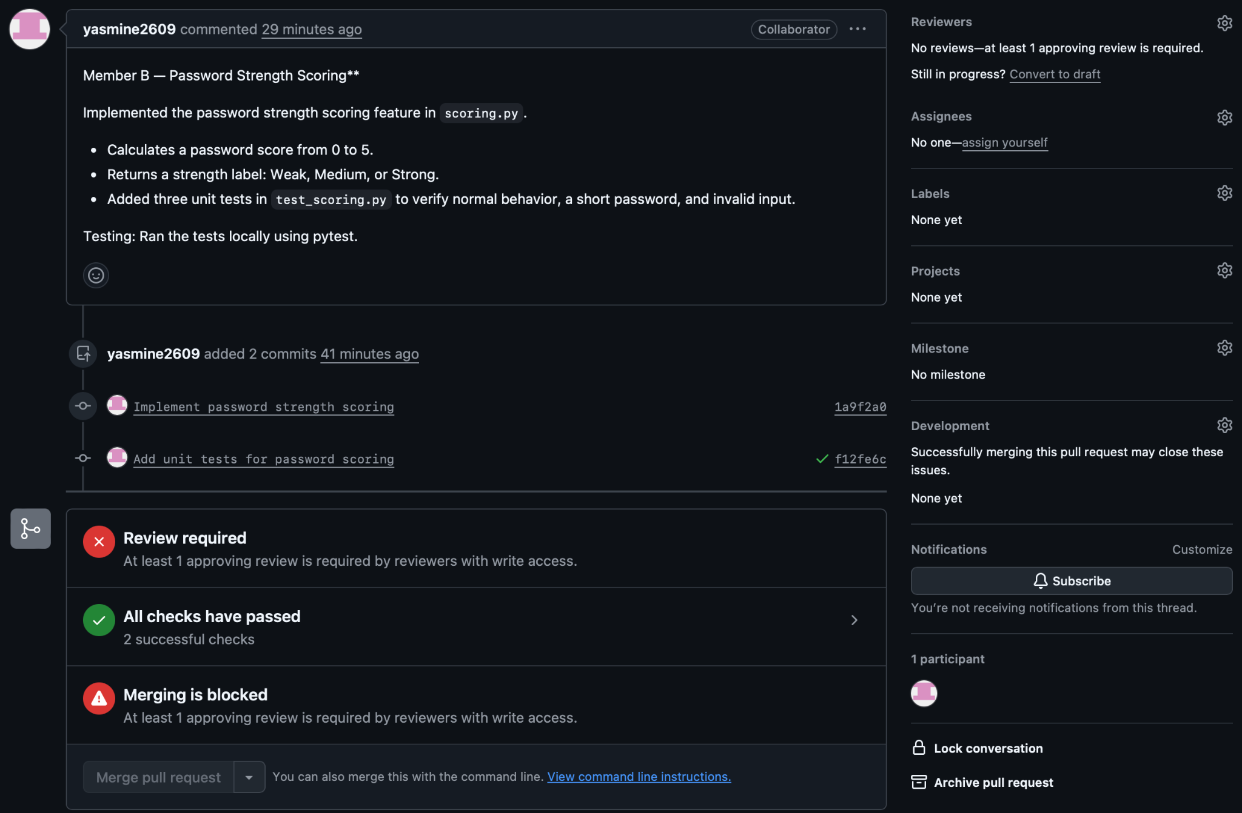
Figure 2. Pull request blocked pending approval despite passing checks.

6. Responding to review feedback
After review, Yasmine extended tests/test_scoring.py on the same feature branch with a test for the Weak label. The added assertion checks that check_strength("abc") returns (1, "Weak"). The update complemented the existing strong-password, short-password, and invalid-input tests.
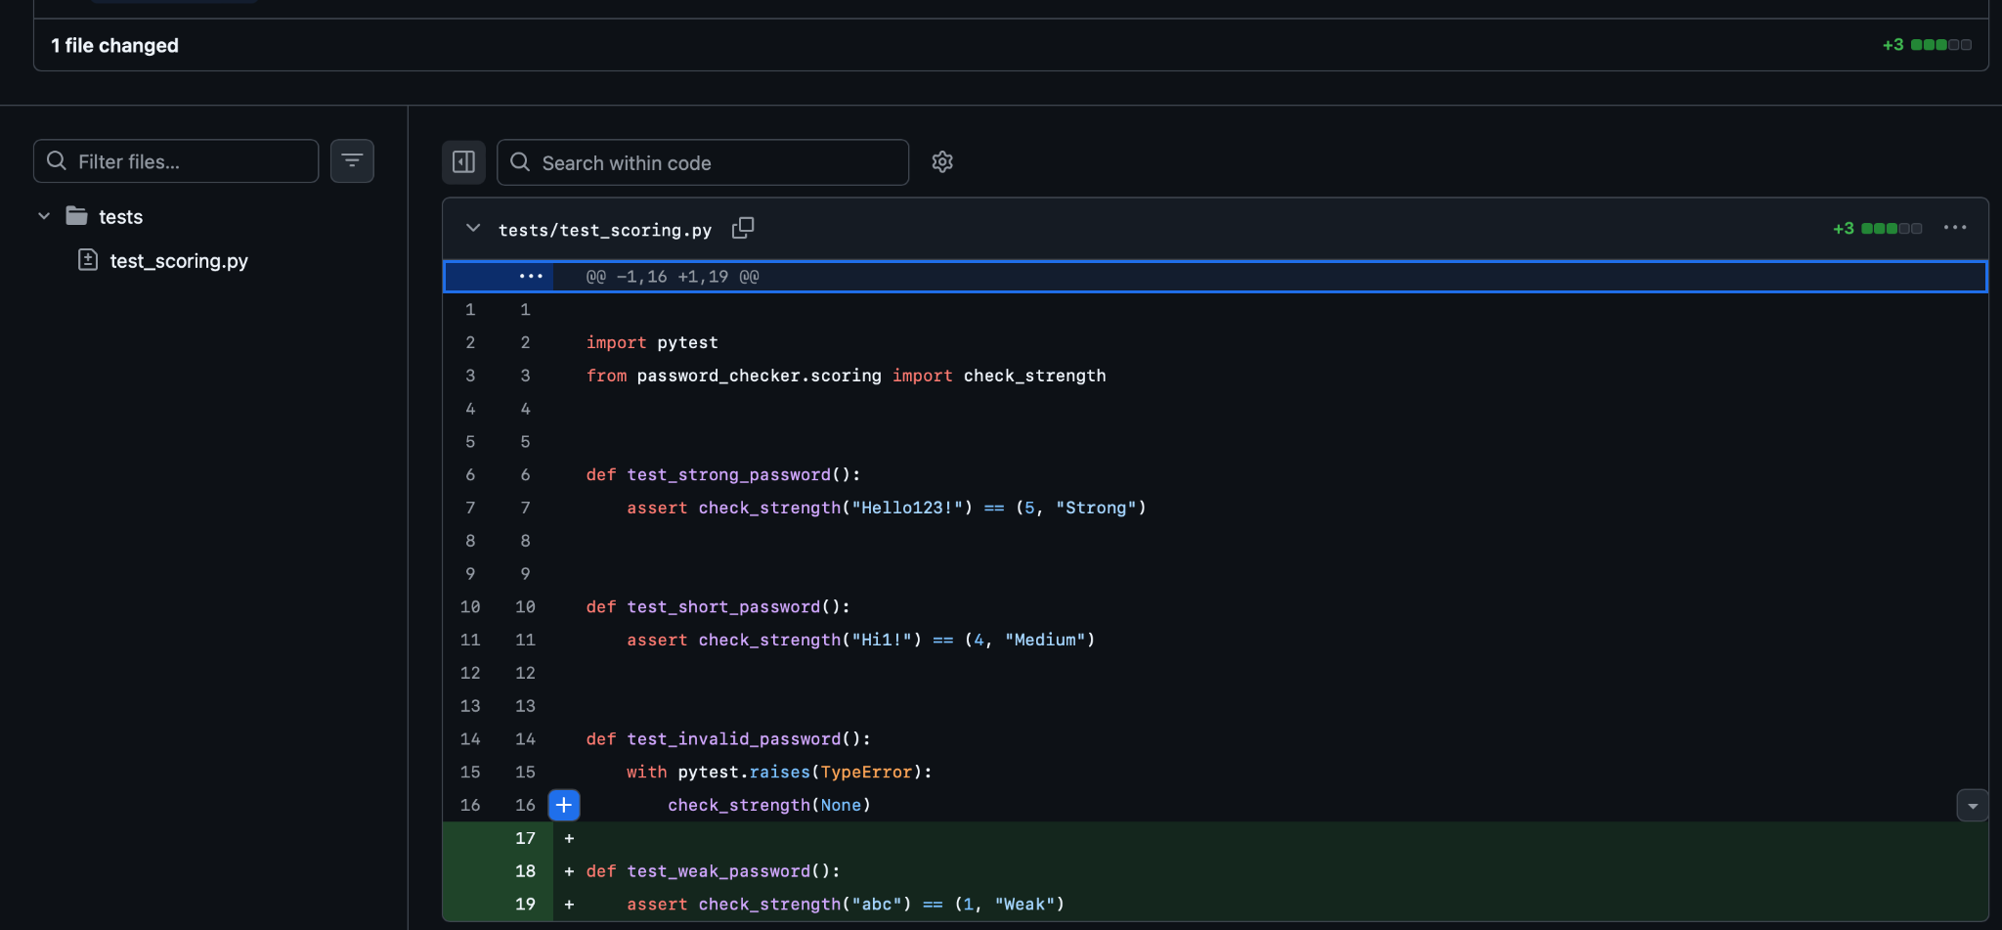
Figure 3. Additional Weak-password unit test.

7. Testing the integrated project
The team ran the test suite with pytest. The captured terminal output reports 11 passed, including tests for password patterns, rule checks, scoring, and setup. This confirms the test suite passed in the environment shown.
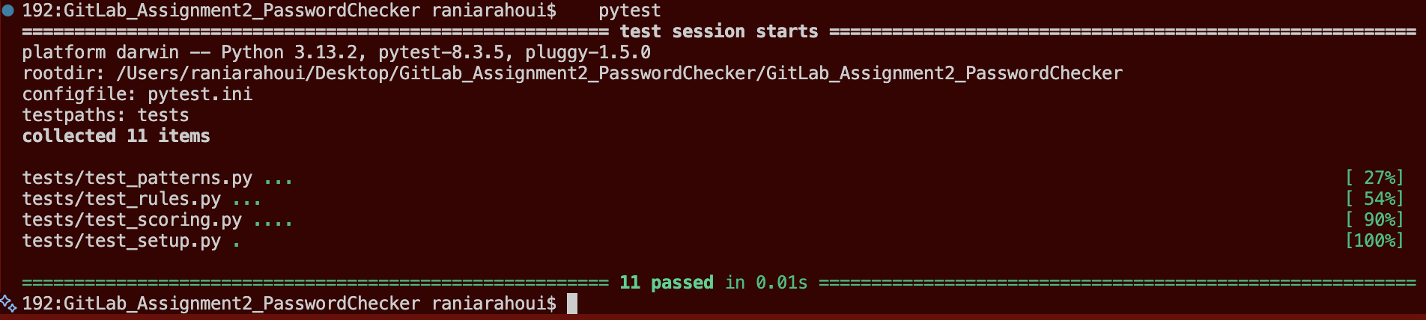
Figure 4. Local pytest output: 11 passed.

8. Continuous integration: failure and recovery
GitHub Actions provided automated checks on commits and pull requests. Kamelia deliberately introduced a failing test in a commit labeled “Trigger Test Failure for CI”, then corrected it in “Fix test and pass CI”. The commit history displays the failed status followed by successful checks.
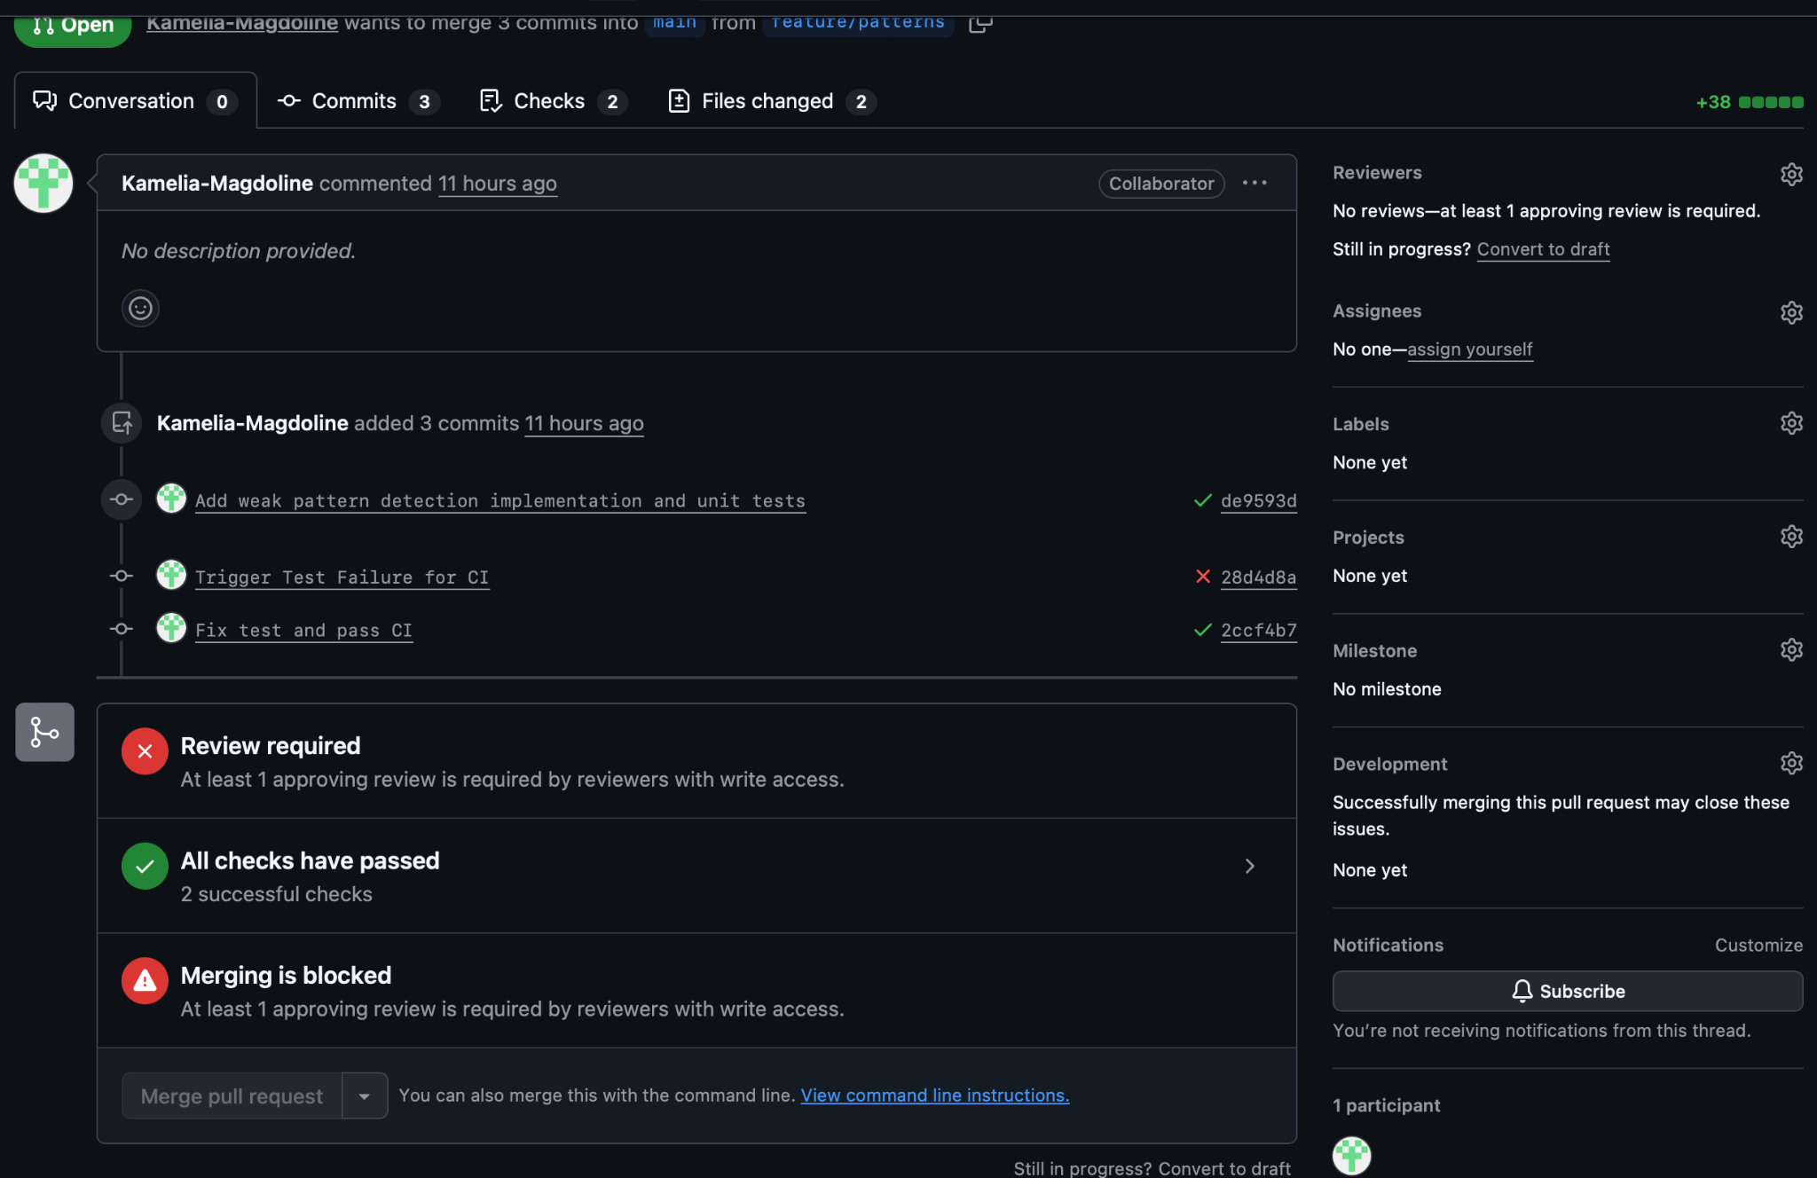
Figure 5. Failed CI commit followed by passing correction.

9. Merge conflict and resolution
The group performed a deliberate README conflict exercise. Rania updated the project-status line in status-a and merged it into main. Yasmine independently changed the same line in status-b. When main was merged into status-b, Git reported a conflict in README.md. Yasmine edited the file to keep the intended combined status, removed the conflict markers, staged the resolved README, committed the resolution, pushed status-b, and opened PR #5. After peer approval, the pull request was merged into main.
Resolution workflow: edit README.md → remove conflict markers → git add README.md → git commit -m "Resolve README merge conflict" → git push origin status-b → review and merge PR #5.

10. GitHub Pages deployment
The team configured GitHub Pages to publish project documentation. The Actions view shows three successful pages build-and-deployment runs on main. The screenshots document the page before and after content was completed.
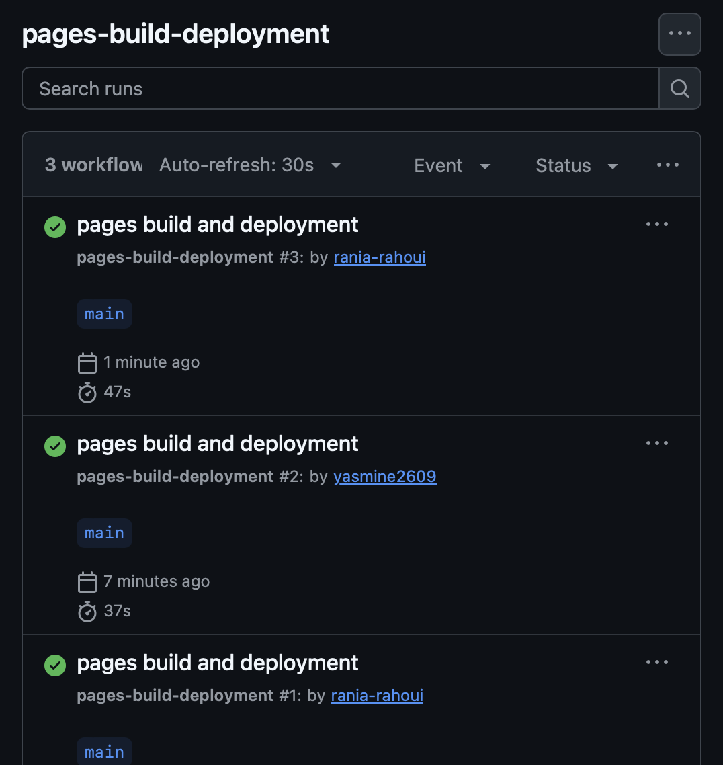
Figure 6. Successful GitHub Pages deployments.

11. Published project page: before and after
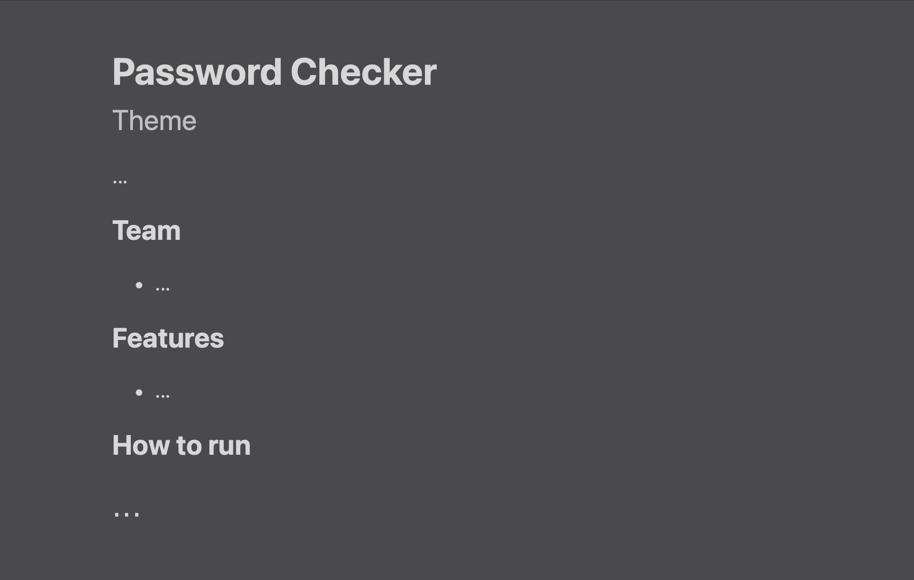
Figure 7. Earlier page with placeholder content.
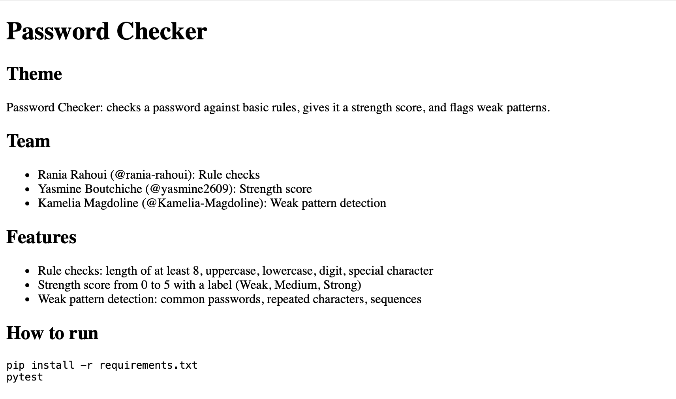
Figure 8. Updated page with project purpose, team, features, and test instructions.

12. Final results and lessons learned
The group integrated three complementary features: rule checking, password strength scoring, and weak-pattern detection. The complete local test run shown in the evidence passed all 11 tests. Pull requests required an approving review, and the team practiced responding to feedback, fixing a CI failure, and resolving a Git merge conflict. The project documentation was deployed through GitHub Pages.

