


SW332 Project – Final report

Student Name | Student ID
Lamyaa Alotaibi | 445009159
Raghad Alsemaih | 445009154
Shahad Alotaibi | 445009167
Layan Ahmad | 445009155
Rania Farhan | 445009163  Spirnt 1
Student name | Her work
Rania farhan | Backend+retrospecrtive+sprint backlog
Raghad Alsemaih | UI designer+ Sprint review
Lamyaa Alotaibi | Scrum Master + Sprint Planning
Shahad  Layan | Product Owner+ Burndown Char+ Reports  Frontend Developer+ Sprint Backlog Update+ product backlog update

Introduction
Event Hub is an event ticket booking and management application that makes it easy for users to
discover and reserve tickets for various events. The app provides a simple and secure way to
browse events, book tickets, and receive real-time notifications. It aims to create a seamless
connection between event organizers and attendees through an efficient and user-friendly digital
experience.

The goal of this project
Is to develop an integrated Event Management Platform that allows users to browse, create, and
book events easily, while providing organizers with tools to manage events, venues, and
performance analytics efficiently.

Sprint Planning Report
Sprint Planning Report
Sprint: 1. Date: 19 October. Product: Event Hub.
1. Sprint Goal:
Statement: Deliver core event management functionalities including user registration, event browsing, event creation, event booking, event approval, and issue tracking.

- 2. Selected Product Backlog Items (with Acceptance Criteria):
- User Story 1:
  - Title: As an Event Enthusiast, Event Organizer sign up using my email, phone number, name, and password, and select my category (Event Enthusiast or Event Organizer) I can create a personalized account and access features that match my role.
  - Description: This feature allows users to register using their personal details and choose their role to get a tailored experience.
  - Acceptance Criteria:
- Must allow sign-up using email, phone number, name, and password.
- Must allow user to select role (Event Enthusiast / Event Organizer).
- System should validate input fields.
- System should store user details securely.

- User Story 2:
  - Title: As an Event Enthusiast, Event Organizer, Admin, Support Team log in using my registered email or phone number and password I can securely access my account and use the website according to my role.
  - Description: Users, Admin and Support Team can log in with their registered accounts to securely access the system based on their role.
  - Acceptance Criteria:
- Login must support email or phone number + password.
- Authentication must be secure.
- Display error message for invalid data.

- User Story 3:
  - Title: As an event enthusiast I want to browse and search for events by category, date, or location so that I can easily find events that match my interests.
  - Description: Event Enthusiasts can search and browse events based on filters to find events they are interested in.
  - Acceptance Criteria:
- The system must support filter events by category, date, location.
- Search results should display event details.
- System must return accurate matching results.
- Clear option must be available.

- User Story 4:
  - Title: As an Event Organizer I want to create and publish my events on the website so that I can reach more people and promote my event.
  - Description: Event Organizers can create and publish event listings to promote their events.
  - Acceptance Criteria:
- “Create Event” Form must to enter event details (title, date, location, description, image).
- Events must go to admin approval before publishing.

- User Story 5:
  - Title: As an Event Enthusiast l want to Book event tickets online so that I can save time and avoid waiting in lines.
  - Description: Users can book tickets online to avoid physical queues and save time.
  - Acceptance Criteria:
- Booking button available on event page.
- Ticket details saved in user account.
- Confirmation message on the website after booking.

- User Story 6:
  - Title: As an Admin I want to Review and approve events created by organizers so that I can verified and appropriate events are published on the website.
  - Description: Admins review and approve events to ensure only appropriate events are published.
  - Acceptance Criteria:
- “Manage Events” page must show pending event requests.
- Admin can approve or reject events.
- Notification on website sent to organizer after decision.
- Approved events become visible to users.

- User Story 7:
- Title: As an Admin, I want to View all support issues so that I can monitor user problems and ensure they are handled properly.
- Description: This feature allows the admin to access a list of all issues reported by the Support Team.
  - Acceptance Criteria:
- The admin can access a dedicated page showing all submitted issues.
- Each issue must show username, subject, status, priority, and date.
- Issues must be displayed in a clean, readable table.
- The page should load even if no issues exist (show “No issues”).

- User Story 8:
  - Title: As a Support, I want to View all user issues and update their status so that I can manage and resolve user complaints efficiently.
- Description: This feature enables Support Team members to view all user-reported issues in the system and update their status as they work on resolving them.

- Acceptance Criteria:
- The Support member can see a table listing all issues (ID, user, subject, status, priority, created date).
- The Support member can change the issue status from a dropdown (Open, In Progress, Closed).
- When pressing Update, the new status is saved in the database successfully.
- The page loads all issues sorted by newest first.

- User Story 9:
  - Title: As an Event Enthusiast I want to view, download, and manage my booked tickets so that I can easily access them during events or share them if needed.
  - Description: Users can view booked tickets easily and open them whenever they wanted.
  - Acceptance Criteria:
- “My Tickets” page must have all the tickets the user has been booked.
- Each ticket displays clear details (event name, date, number of tickets , status,etc ).
- View ticket as a QR Code is available and works efficiently.
- All actions correctly update the database

- User Story 10:
  - Title: As an Event Enthusiast, I want to receive email and SMS notifications for any updates to my booked events so that I stay informed about any schedule changes or details.
  - Description: Users receive notifications about any updates related to their booked events.
  - Acceptance Criteria:
- System sends notification automatically on the website.
- Must notify event time changes, cancellations, or important updates.
- Notifications must be clear and timely.

- User Story 11:
  - Title: As an Event Enthusiast l want to Discover different events based on my interests so that I can attend events that match what I enjoy.
  - Description: Users can see events recommended based on their preferences.
  - Acceptance Criteria:
- Recommended events appear on the homepage.
- Must be updated regularly.

- User Story 12:
  - Title: As an Admin, I want to manage users, via Dashboard and event data so that I can ensure the system is running smoothly and securely.
  - Description: Admins can manage user accounts and events efficiently using a dashboard.
  - Acceptance Criteria:
- Admin dashboard includes user list and event list.
- The admin can access and manage all events.
- All updates save correctly in the database.
- The dashboard loads quickly and functions reliably.

- User Story 13:
  - Title: As an Event Organizer, I want to manage attendees and view booking analytics so that I can monitor event performance and attendance trends.
  - Description: Event organizers can track attendee numbers by seeing the total bookings.
  - Acceptance Criteria:
- Organizer Dashboard shows total bookings and number of events.
- Data updates in real-time.

3. Sprint Backlog Breakdown (Tasks):
- User Story 1 - [As an Event Enthusiast, Event Organizer sign up using my email, phone number, name, and password, and select my category (Event Enthusiast or Event Organizer) I can create a personalized account and access features that match my role.]:
- Task 1: Design a registration form with fields for name, email, phone number, password, and user category and Focus on creating a clear and simple layout for users.
- Assigned to: Rania Farhan.
- Estimated Effort: [2 SP/6 hours]
- Task 2: Add input validation to check correct data format and prevent empty fields and Connect the signup form to the database to store user information securely.
- Assigned to: Rania Farhan.
- Estimated Effort: [3 SP/5 hours]

- User Story 2 - [As an Event Enthusiast, Event Organizer, Admin, Support Team log in using my registered email or phone number and password I can securely access my account and use the website according to my role.]:
- Task 1: Creat a login page with fields for email/phone and password for easy access to there account.
- Assigned to: Rania Farhan.
- Estimated Effort: [2 SP/5 hours]

- Task 2: Link the login form to the authentication system to verify user data and Add redirection so each user type (Admin, Organizer, Enthusiast, Support) gets the correct dashboard.
- Assigned to: Rania Farhan.
- Estimated Effort: [3 SP/6 hours]

- User Story 3 - [As an event enthusiast I want to browse and search for events by category, date, or location so that I can easily find events that match my interests.]:
- Task 1: Built an event browsing page with filters for category, date, and location and make sure the design is supports quick searching.
- Assigned to: Rania Farhan.
- Estimated Effort: [3 SP/7 hours]

- Task 2: Connect the search bar and filters to the event database and ensured search results display correct and complete event details.
- Assigned to: Rania Farhan.
- Estimated Effort: [2 SP/7 hours]

- User Story 4 - [As an Event Organizer I want to create and publish my events on the website so that I can reach more people and promote my event.]:
- Task 1: Design a form for organizers to enter event details such as title, date, description, and image and focus on making the form clear and easy to fill.
- Assigned to: Shahad Alotaibi.
- Estimated Effort: [2 SP/7 hours]

- Task 2: Link the event form to the database so that event details are saved properly.
- Assigned to: Shahad Alotaibi.
- Estimated Effort: [2 SP/3 hours]

- Task 3: Add a function that sends each event to the admin for approval before publishing and display event status (Pending, Approved, or Rejected) for organizers.
- Assigned to: Shahad Alotaibi.
- Estimated Effort: [3 SP/5 hours]

- User Story 5 - [As an Event Enthusiast l want to Book event tickets online so that I can save time and avoid waiting in lines.]:
- Task 1: Creat a booking page where users can reserve event tickets that includ event details , seats options and ticket type.
- Assigned to: Rania Farhan.
- Estimated Effort: [2 SP/5 hours]

- Task 2: Send a confirmation message after successful booking and stor booking records in the user’s account for easy access.
- Assigned to: Layan Ahmad.
- Estimated Effort: [3 SP/7 hours]

- User Story 6 - [As an Admin I want to Review and approve events created by organizers so that I can verified and appropriate events are published on the website.]:
- Task 1: Design a review page where the admin can see all pending event requests and Display event details clearly for easy decision-making.
- Assigned to: Lamyaa Alotaibi.
- Estimated Effort: [2 SP/6 hours]

- Task 2: Creat a backend function to retrieve all pending events from the database and ensure the data loads quickly and updates when event status changes and then but them in the Admin Event Review page so that the admin can see them.
- Assigned to: Lamyaa Alotaibi.
- Estimated Effort: [3 SP/7 hours]

- Task 3: Add buttons to update the event status and dropdown list for the admin to approve or reject each event and after update the event status update automatically after each decision.
- Assigned to: Lamyaa Alotaibi.
- Estimated Effort: [3 SP/6 hours]

- Task 4: Creat a feature to send an alert to organizers after approval or rejection and ensur alerts include event name and admin decision details.
- Assigned to: Layan Ahmad.
- Estimated Effort: [2 SP/4 hours]

- Task 5: Test the full approval process to confirm that only verified events are published and ensure rejected events are not visible to users on the website .
- Assigned to: Lamyaa Alotaibi.
- Estimated Effort: [2 SP/5 hours]

- User Story 7 - [As an Admin, I want to View all support issues so that I can monitor user problems and ensure they are handled properly.]:
- Task 1: Build an Admin page that displays all complaints (user, subject, description, status, created date).
- Assigned to: Layan Ahmad.
- Estimated Effort: [2 SP/3 hours]

- Task 2: .Create a backend query that retrieves all complaints from the support_issues table.
- Assigned to: Shahad Alotaibi.
- Estimated Effort: [3 SP/6 hours]

- Task 3: Add role validation so only Admin and support can access the page and the Admin can view all complaints the support reported.
- Assigned to: Shahad Alotaibi.
- Estimated Effort: [2 SP/5 hours]

- Task 4: Connect the page to the navigation bar so Admin can access “Support Issues” directly and sort the issues by newest first.
- Assigned to: Shahad Alotaibi.
- Estimated Effort: [2 SP/4 hours]

- User Story 8 - [As a Support, I want to View all user issues and update their status so that I can manage and resolve user complaints efficiently.]:
- Task 1: Create backend query to fetch all issues assigned to the support dashboard.
- Assigned to: Shahad Alotaibi.
- Estimated Effort: [3 SP/6 hours]

- Task 2: Display issues in a table with columns (ID, User, Subject, Status, Priority, Created).
- Assigned to: Shahad Alotaibi.
- Estimated Effort: [2 SP/4 hours]

- Task 3: Add a dropdown for updating issue status.
- Assigned to: Shahad Alotaibi.
- Estimated Effort: [3 SP/5 hours]

- Task 4:Implement POST request to update the issue’s status in the database.
- Assigned to: Shahad Alotaibi.
- Estimated Effort: [3 SP/5 hours]

  - User Story 9 - [As an Event Enthusiast I want to view, download, and manage my booked tickets so that I can easily access them during events or share them if needed.]:
- Task 1: Built a page that lists all the tickets a user has booked and ensure that all tickets contains ticket details.
- Assigned to: Lamyaa Alotaibi.
- Estimated Effort: [2 SP/5 hours]

- Task 2: Connect the page to the database to show each user’s active and past tickets and ensur the data updates automatically after each new booking.
- Assigned to: Rania Farhan.
- Estimated Effort: [3 SP/7 hours]

- Task 3: Enabled users to view a QR Code in the My Ticket page it self.
- Assigned to: Lamyaa Alotaibi.
- Estimated Effort: [2 SP/4 hours]

- Task 4: Add a feature to cancel booked tickets before the event date and updat the database automatically when a ticket was canceled.
- Assigned to: Rania Farhan.
- Estimated Effort: [2 SP/6 hours]

- Task 5: Test all ticket functions: view and cancel.
- Assigned to: Lamyaa Alotaibi.
- Estimated Effort: [2 SP/4 hours]

  - User Story 10 - [As an Event Enthusiast, I want to receive email and SMS notifications for any updates to my booked events so that I stay informed about any schedule changes or details.]:
- Task 1: Add a function to send notifications to users about event changes and the notifications will be in the website .
- Assigned to: Shahad Alotaibi.
- Estimated Effort: [2 SP/6 hours]

- Task 2: sends updates to all booked users whe changes in event details (time, date , etc.) happens Automatically.
- Assigned to: Shahad Alotaibi.
- Estimated Effort: [3 SP/5 hours]

- User Story 11 - [As a nEvent Enthusiast l want to Discover different events based on my interests so that I can attend events that match what I enjoy.]:
- Task 1: Built an advanced search bar with filters (category , location,etc ) and ensur search results are accurate and fast.
- Assigned to: Layan Ahmad.
- Estimated Effort: [3 SP /6 hours]
- Task 2: Add a recommendation feature that suggests events based on previous activity updated recommendations regularly to show new events.
- Assigned to: Layan Ahmad.
- Estimated Effort: [3 SP /8 hours]

- User Story 12 - [As an Admin, I want to manage users, via Dashboard and event data so that I can ensure the system is running smoothly and securely.]:
- Task 1: Design the dashboard to show users, events, and system statistics and focus on a clean and easy-to-navigate layout for the admin to work with easily.
- Assigned to: Raghad Alsemaih.
- Estimated Effort: [3 SP /6 hours]

- Task 2: Test all admin actions to confirm they work correctly.
- Assigned to: Raghad Alsemaih.
- Estimated Effort: [2 SP/5 hours]

- Task 3: Check that all dashboard data matches the actual database records.
- Assigned to: Raghad Alsemaih.
- Estimated Effort: [1 SP /1 hours]

- User Story 13 - [As an Event Organizer, I want to manage attendees and view booking analytics so that I can monitor event performance and attendance trends.]:
- Task 1: Creat a page that view (total bookings , number of events) to the organizers to see the attendees for each event.
- Assigned to: Layan Ahmad.
- Estimated Effort: [3 SP/5 hours]

- Task 2: Connect attendee information to the main event database and ensure data updates automatically when users book and also maintain data accuracy between event and attendee records.
- Assigned to: Layan Ahmad.
- Estimated Effort: [3 SP/3 hours]

- Task 3: it is a feature that display event analytics such as(total bookings , number of events) in the organiser dashboard and this analytics is Designas a cards to make data easy to read and understand and Helps organizers track event performance and audience engagement.
- Assigned to: Layan Ahmad.
- Estimated Effort: [3 SP /2 hours]

4. Sprint Capacity and Velocity for sprint1:
- Team Capacity: 500 person-hours.
- Estimated Velocity: [96 SP/500 Hours = 0.2 SP/ hour].
Any Factors Affecting Capacity: [Minor delays occurred due to integration between frontend and backend components and there No official holidays affected the sprint schedule.]

5. Risks and Impediments for sprint 1:
- Identified Risks:
- Integration Challenges: Possible issues during merging frontend and backend components could cause delays.
- Data Accuracy: Inconsistent data between user and event databases may affect system reliability.
- Communication Gaps: Misalignment between the a and support team can lead to confusion in issue tracking.
- Testing Time: Limited time for comprehensive testing of all modules may leave minor bugs unresolved.
- Mitigation Strategies:
- Schedule early integration sessions to detect and fix errors before final submission.
- Assign one team member to verify data consistency across all modules.
- Conduct short daily check-ins to align tasks and report progress.
- Prioritize testing critical functionalities before focusing on minor UI issues.

6. Definition of "Done"for our product:
The Definition of “Done” establishes a comprehensive and unified standard that ensures all work completed during the sprint meets the required quality benchmarks before being considered complete. This shared understanding among team members eliminates ambiguity about when a task or feature is truly finished, and guarantees that every deliverable is production-ready, thoroughly tested, properly documented, and approved by the Product Owner. By defining clear completion criteria across code quality, testing, documentation, deployment, and acceptance, the team maintains consistency, transparency, and high standards throughout the development process.​​​​​​​​​​​​​​​​
- Code:
This section defines the programming standards that the written code must adhere to.

- Code follows established coding standards and naming conventions (HTML, php,CSS and JavaScript).
- Code is reviewed by at least one team member before merging.
- There are no syntax errors, warnings, or unused variables.

- Testing:
This section outlines the comprehensive testing requirements that must be conducted on all developed features

- Unit tests are completed for all main features (login, sign up, booking, admin approval).
- Integration testing is done to confirm the frontend and backend communicate correctly.
- The system is tested across browsers and devices to ensure full responsiveness.
- All acceptance criteria of the user story have been verified by the Product Owner.

- Documentation:
This section includes all types of documentation required to document the completed work.
- All relevant project documentation has been updated, including both technical and user documentation.
- Technical documentation covers system architecture, database schema, and API used in the Event Hub website.
- User documentation covers (FAQs, Live Chat with support team and interface instructions) that the user used it in the Event Hub website.
- Any changes in system flow or data structure have been clearly recorded for future reference.
- Version history and update logs are maintained for transparency and tracking of project evolution.

- Deployment:
This section defines the requirements for successfully deploying developed features to the testing or staging environment.
- The developed features are successfully deployed to the testing or staging environment.
- The deployment process has been verified to ensure no errors or missing components.
- All dependencies and configurations required for deployment are documented and reusable for future releases.
- The build runs smoothly without breaking existing features or causing system downtime.

- Acceptance:
This section outlines the criteria for final acceptance by the Product Owner. ​​​​​​​​​​​​​​​​
- The Product Owner has reviewed and approved the completed features after testing and validation.
- All acceptance criteria defined in the user stories have been fully met.
- The team has confirmed that the sprint is ready for release.

Sprint Backlog

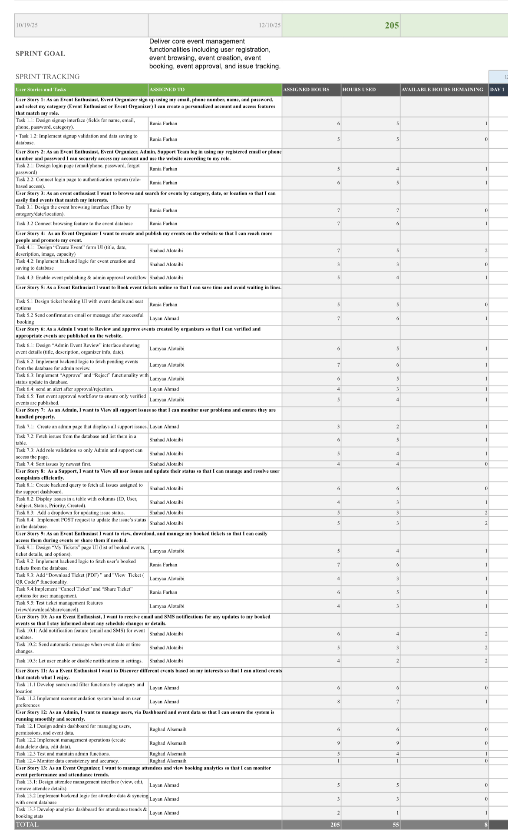

Sprint Review Report

Sprint Review Report
Sprint: 1 Date: Friday 31/10/2025
Product: Event Hub Application
Sprint Goal: Goal: Produce main event management functionalities including user registration, login, event browsing, event creation and ticket booking.
I. Sprint Goal Achievement and Completed Work:
- 1.1 Sprint Goal Review:
  - Sprint Goal Achieved: Yes
  - Achievement Details: Our team efficiently executed the main functions of the Event Hub Application, including role-based registration and login, event browsing features, and event creation and approval.
- 1.2 Completed Work Demonstration:
  - The Development Team demonstrated the following completed Product Backlog items:
  - User Story 1:
As an Event Enthusiast or Event Organizer, I want to sign up using my email, phone number, name, and password and select my role so that I can create a personalized account and access features that match my role.
  - User Story 2:
As an Event Enthusiast, Event Organizer, Admin, or Support Team member, I want to log in using my registered email or phone number and password so that I can securely access my account and use the platform based on my role.
  - User Story 3:
As an Event Enthusiast, I want to browse and search for events by category, date, or location so that I can easily find events that match my interests.
  - User Story 4:
As an Event Organizer, I want to create and publish my events on the website so that I can reach more people and promote my event.
  - User Story 5:
As an Event Enthusiast, I want to book event tickets online so that I can save time and avoid waiting in lines.
  - User Story 6:
As an Admin, I want to review and approve events created by organizers so that only verified and appropriate events are published on the platform.
  - User Story 7:
As a Support Team member, I want to log and track recurring issues so that I can report them to the admin or development team for fixing.
  - User Story 8:
As a Support Team member, I want to receive and respond to user inquiries or complaints so that I can help users quickly and improve satisfaction.
  - User Story 9:
As an Event Enthusiast, I want to view, download, and manage my booked tickets so that I can easily access them during events or share them if needed.
  - User Story 10:
As an Event Enthusiast, I want to receive email and SMS notifications for updates to my booked events so that I stay informed about any schedule changes or important details.
  - User Story 11:
As an Event Enthusiast, I want to discover different events based on my interests so that I can attend events that match what I enjoy.
  - User Story 12:
As an Admin, I want to manage users and event data through a dashboard so that I can ensure the system runs smoothly and securely.
  - User Story 13:
As an Event Organizer, I want to manage attendees and view booking analytics so that I can monitor event performance and attendance trends.

  - Key functionalities and features demonstrated:

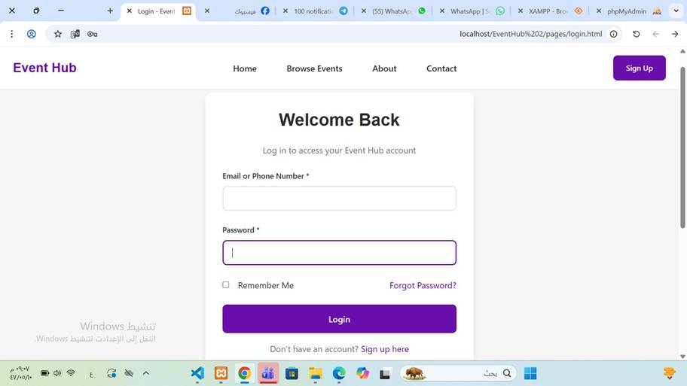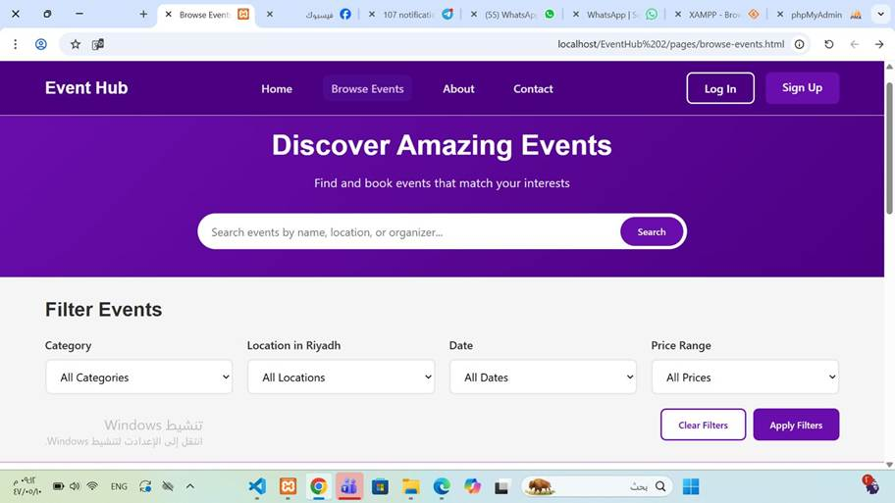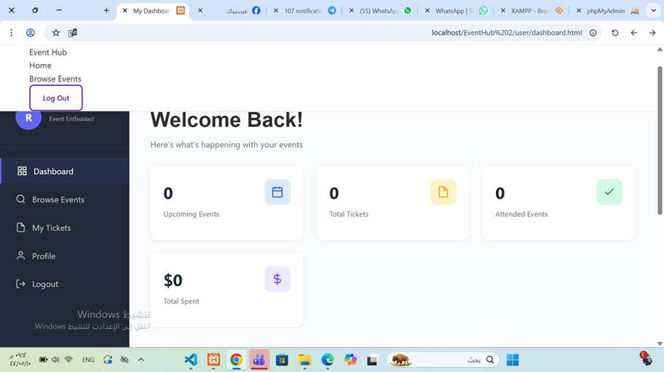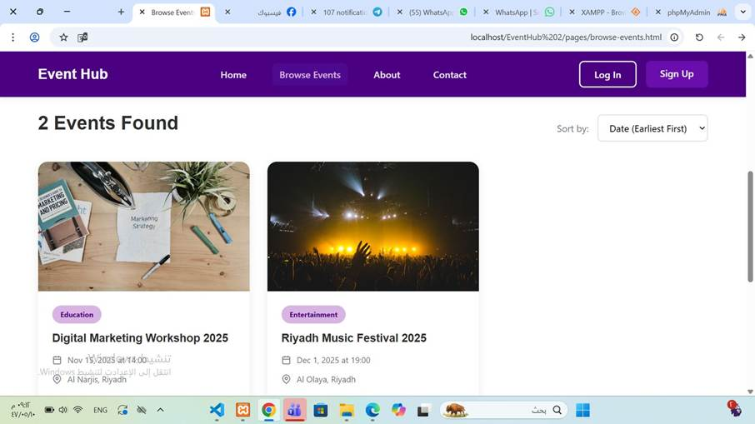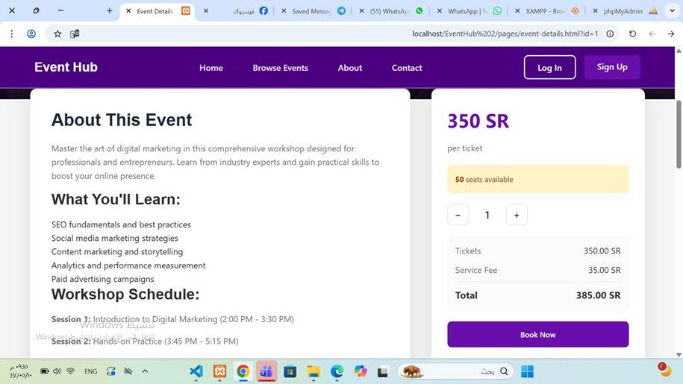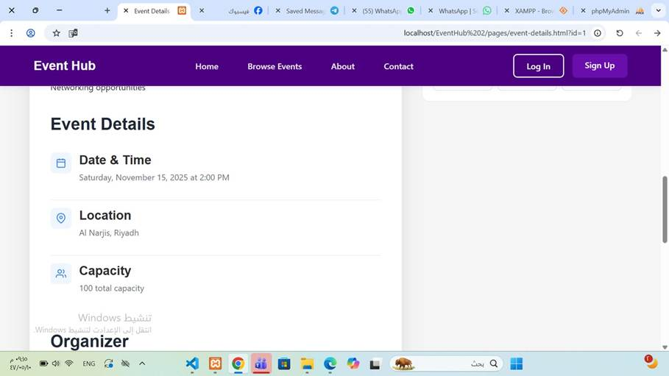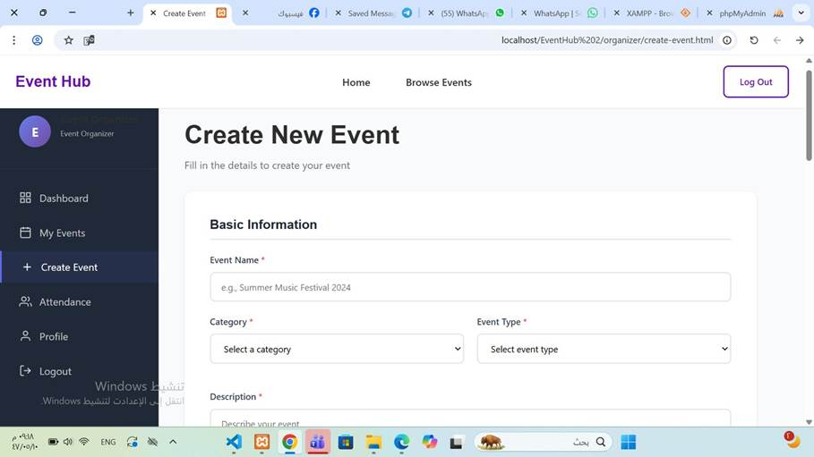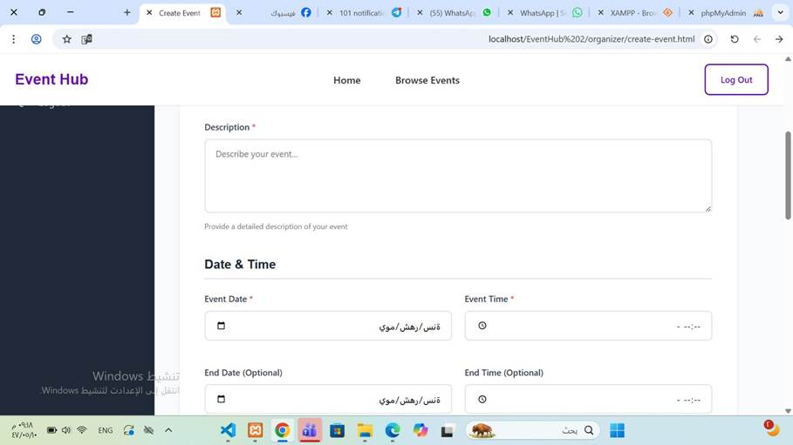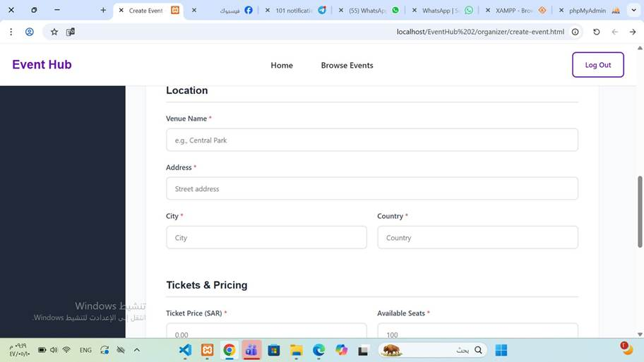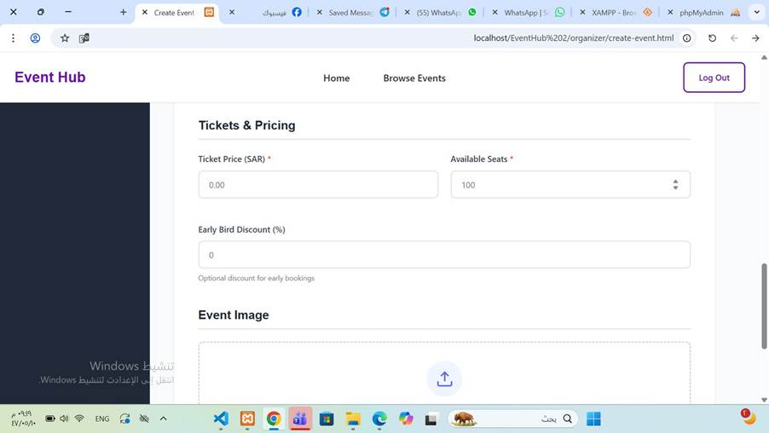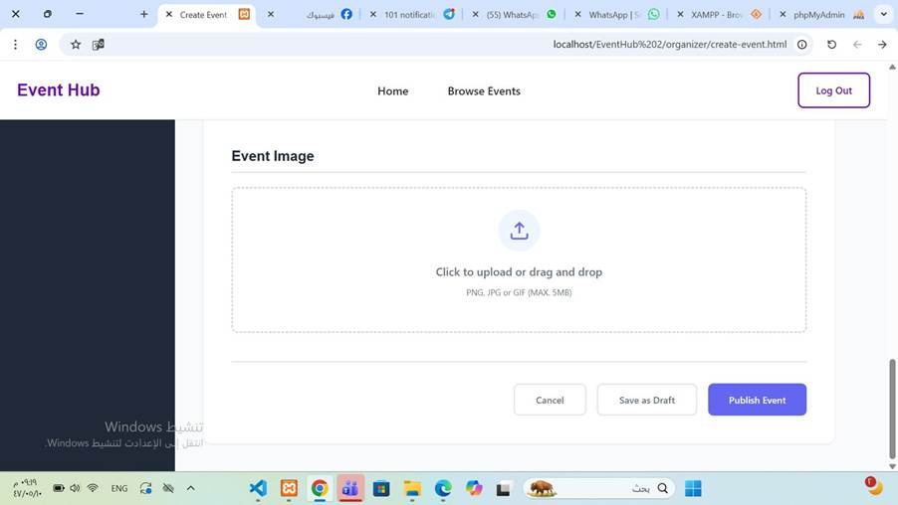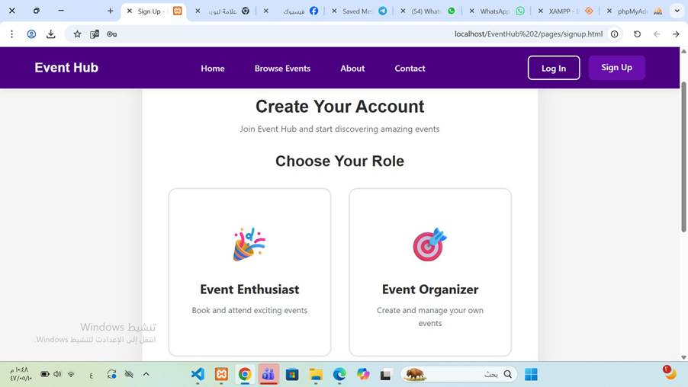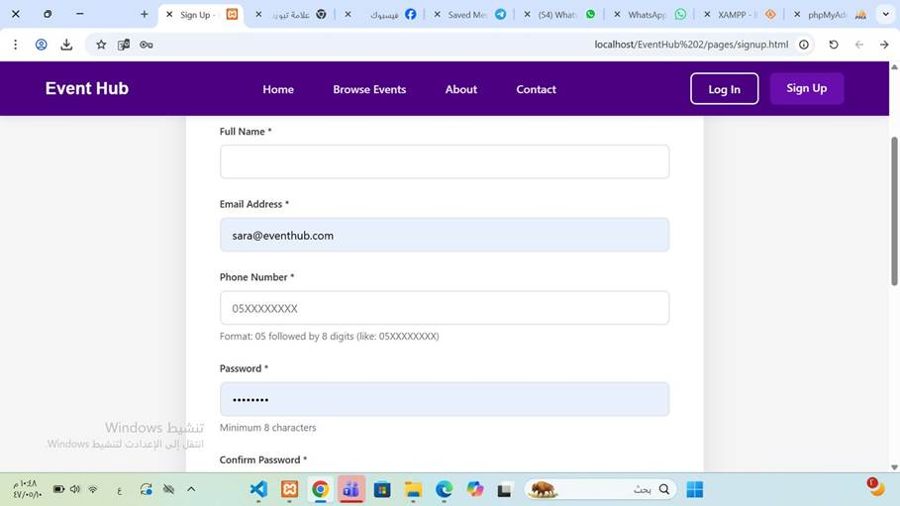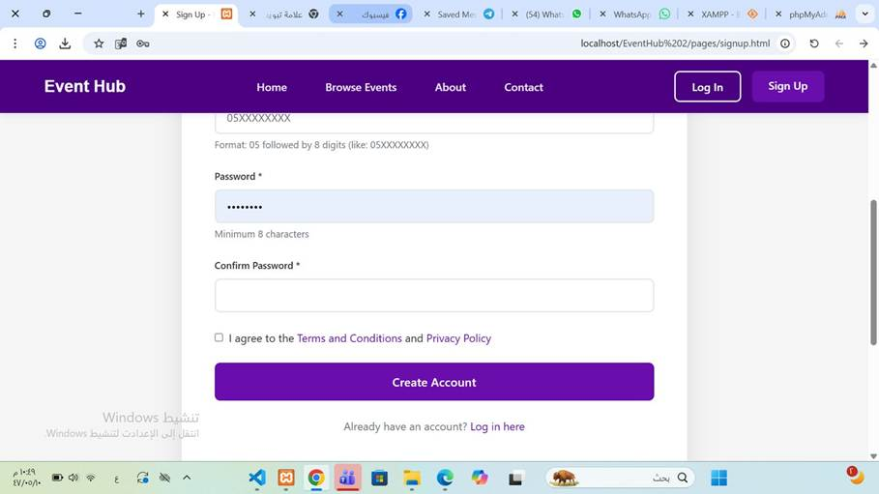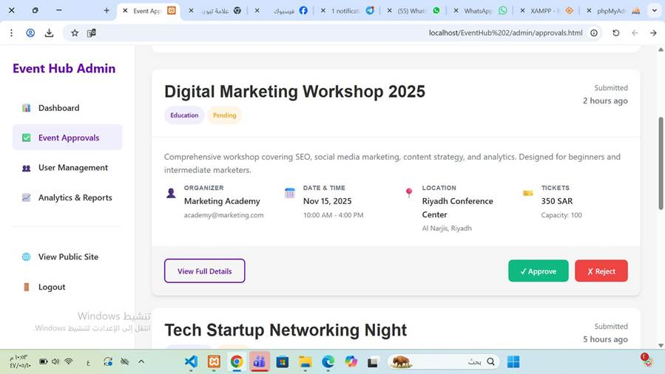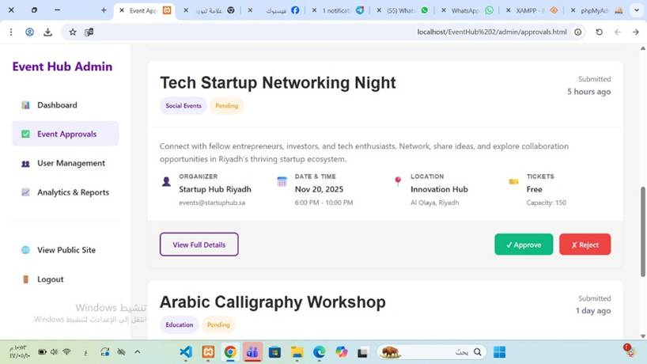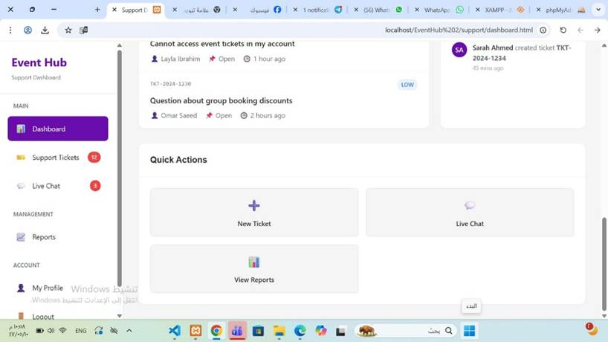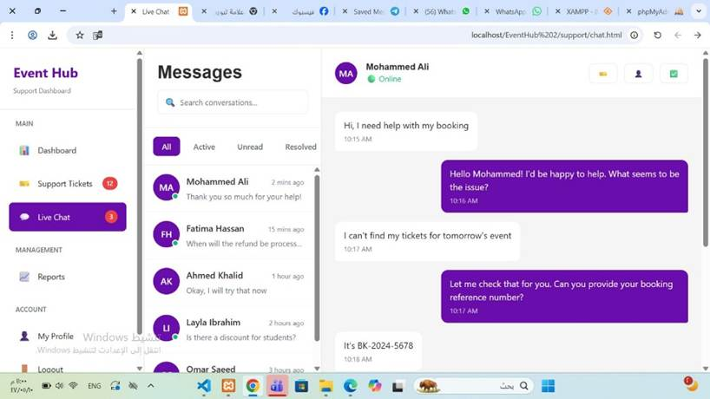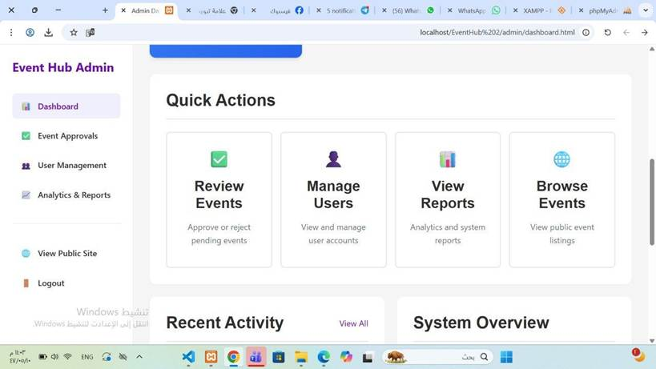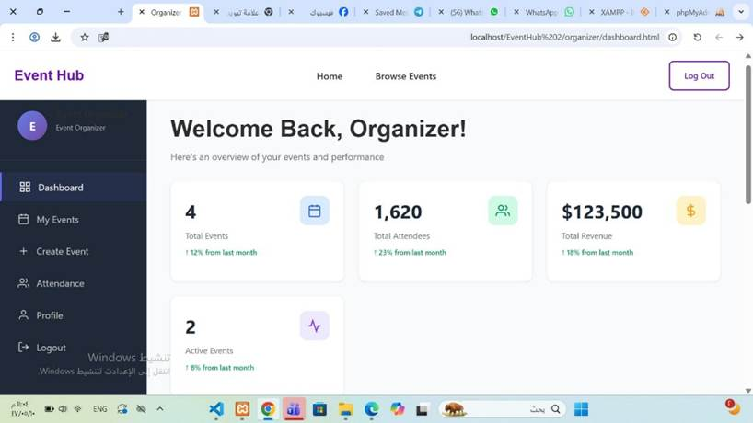
  - Any questions from stakeholders were addressed during the demonstration.
No questions from stakeholders during the demonstration.
- 1.3 Acceptance Criteria Verification:
  - Verification of Acceptance Criteria: All acceptance criteria for the demonstrated items were met. No issues found.
  - II. Product Increment and Stakeholder Feedback:
- 2.1 Product Increment Discussion:
  - Current State of Product Increment: The current product increment achieved the demonstrated product goals and provides value to the customer by implementing the main functions of the product.
  - Alignment with Product Goal: This increment provides the main functions of the intended product The features implemented in this sprint is the foundation of the Event Hub system, supporting our vision to provide an unified and efficient platform for discovering, organizing, and managing events.
  - Value to Users/Customers: the features implemented improve user convenience, Application usability, and trustworthiness in the event management process, which improves the user experience for all intended users.
- 2.2 Stakeholder Feedback:
  - Key Feedback Received:
Category | Feedback | Explanation
Usability | Require clearer filters in event browsing and visual layout to make it more friendly. | Enhance search clarity and UX.
Usability | support team dashboard navigation must be more organized. | facilitate support team issues management and make it faster.
Functionality | users ability to view and manage their own booked tickets in a unified place. | this feature will be implemented in the next sprint.
Functionality | Organizers wants simple way to view attendee numbers for each event. | add Basic analytics in future sprints.
Business Value | Stakeholders recommended adding notifications for event changes. | This increases reliability and keeps users updated.
  - Next Steps Based on Feedback:
Next Step | Description | Related User Story
Improve the browsing function | clearer layout and filtering choices. | User Story 3
Add 'My Tickets' page for users | Allow users to manage tickets in one place. | User Story 9
add analytics in organizer dashboard | show attendance and performance analytics. | User Story 13
Implement notification system | Send SMS/email event changes. | User Story 10
clear support dashboard navigation | Organize issue tracking and filtering. | User Story 7 & 8

- 2.3 Product Backlog Review:
  - Product Backlog Adjustments: the user story planned before related to the Venue Manager role has been deleted, as this role was determined to be out of scope for the current release. The team was focusing on main platform users functions (Event Enthusiasts, Event Organizers, Admin, Support Team) that provides more value to the user at this stage.
" As a Venue Manager, I want to manage venue availability and bookings so that I can avoid schedule conflicts and organize events efficiently"

  - Newly Discovered Work: New work was added is the role-based login and sign-up system instead of the venue manager user story.
III. Progress and Next Sprint Planning:
- 3.1 Progress Toward Product Goal:
  - Contribution to Product Goal: This increment provides the main functions of the intended product The features implemented in this sprint is the foundation of the Event Hub system, supporting our vision to provide an unified and efficient platform for discovering, organizing, and managing events.

  - Impediments: limited test data that affects UI testing and the need to redesign interface layouts, These issues were solved through excellent collaboration.
- 3.2 Next Sprint Planning Preview:
  - Potential Items for Next Sprint: executing “My Tickets” page, complete the notification system, improved analytics for event organizers, enhancing page layouts for improved usability, and prepare organized testing data.
- 3.3 Action Items:
  - Action Items:
- Product Owner (Shahad) to update the Product Backlog according to stakeholder feedback by 31/10/2025.
- UI/UX Designer (Raghad) to enhance event browsing and dashboard interface during Sprint 2.
- Frontend Developer (Layan) to integrate the make UI screens effectively functional during Sprint 2.
- Backend Developer (Rania) to prepare test data and make data handling more safe and efficient by 1/11/2025.
- Scrum Master (Lamyaa) to monitor team progress and provide good communication through during Sprint 2.

  - IV. Summary and Closing:
- 4.1 Summary of Key Takeaways:
  - Key Takeaways: The sprint released the main features of the Event Hub platform including registration, login, event browsing, and event creation.
  - Stakeholder feedback underlines the must to improve usability and represent main features like ticket management and notifications.
  - The team showed strong progress and communcation, with clear goals for the next sprint.

  - Team Accomplishments:
- meet the Sprint Goal.
- solve design alignment issues among roles and streamlined and keeping the most prioritized once by removing the Venue Manager feature.
- showed excellent problem solving and communication throughout development and testing.

- 4.2 Next Steps:
  - Thank You:
Thank you to all participants and stakeholders for their collaboration, time, and feedback during this sprint.
  - Next Sprint Planning: next sprint planning will be on Sunday, 02/11/2025 at 7:00 PM.

Sprint Retrospective Report
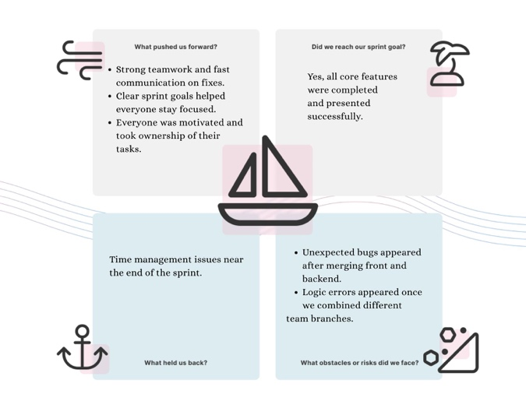

Burn Down Chart
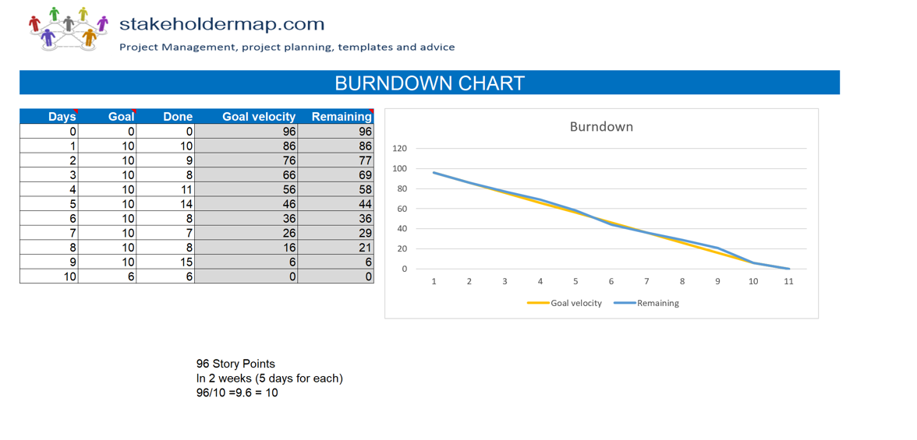

Product Backlog
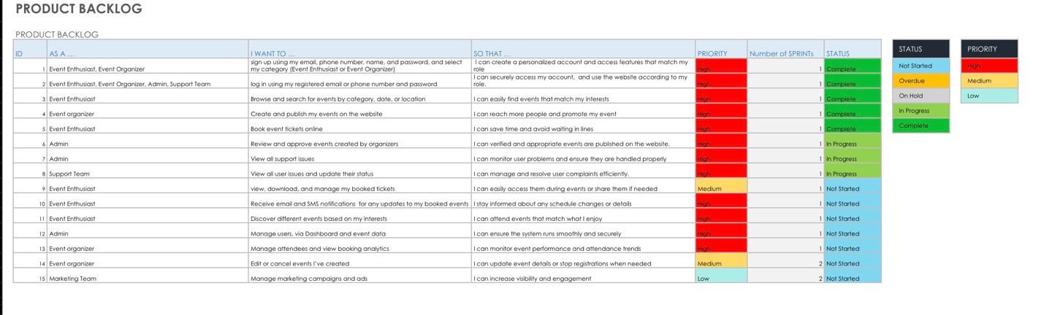
SPRINT 2:
Student name | Her work
Rania farhan | Backend+retrospecrtive+sprint backlog+product backlog
Raghad Alsemaih | UI designer+ Sprint review
Lamyaa Alotaibi | Scrum Master + Sprint Planning
Shahad  Layan | Product Owner+ Burndown Char+ Reports Frontend Developer+ Sprint Backlog Update+ product backlog update
Sprint Planing Report
Statement: Sprint: 2. Date: 2 November. Product: Event Hub.
1. Sprint Goal:
Statement: Improve the overall user experience by enhancing event management, allowing event organizers to edit or cancel their own events, enabling the marketing team to create and display promotional campaigns on the platform, and providing a secure password reset feature for all users. This will help increase engagement, maintain data accuracy, and ensure a safer and more reliable system for everyone.
- 2. Selected Product Backlog Items (with Acceptance Criteria):
- User Story 1.1:
  - Title: As an Event Organizer, I want to edit my events so that I can update event details.
  - Description: Give organizers full control to update their own events to maintain accuracy and avoid irrelevant listings.
  - Acceptance Criteria:
- User can see only the events they created listed with edit option.
- User can edit event fields without affecting other events.
- Database must be updated successfully after editing an event.
- UI must refresh automatically after edit.
- Success and error messages must be displayed clearly.

- User Story 1.2:
  - Title: As an Event Organizer, I want to delete my event so that I can stop registrations when needed.
  - Description: Give organizers full control to remove their own events to maintain accuracy and avoid outdated listings.
  - Acceptance Criteria:
- User can see only the events they created listed with delete option.
- Deleting an event must validate booking rules and not break data integrity.
- Database must be updated successfully after deleting an event.
- UI must refresh automatically after delete.
- Success and error messages must be displayed clearly.

- User Story 2:
  - Title: As a Marketing Team member, I want to to manage the official Instagram account so that I can promote events and increase audience engagement.
  - Description: Allow the marketing team to increase event reach and engagement through social media marketing by managing and publishing promotional content on Instagram.
  - Acceptance Criteria:
- Marketing team must have full access to the Instagram account.
- All content must follow the platform’s official branding guidelines.
- The team must be able to publish posts, stories, and reels.
- A weekly posting schedule must be created and followed.
- Engagement metrics (likes, saves, followers, reach) must be monitored.
- Account credentials must be stored securely and shared only with authorized team members.

- User Story 3:
  - Title: As Event Enthusiast, Event Organizer, Admin, Support Team I want to click the “Reset Password” link under the login button so that I can r open the reset page and change my password.
  - Description: Provide a safe recovery method for users who lose access to their accounts.
  - Acceptance Criteria:
- User must enter their email to request a reset link.
- A unique, secure token must be generated and emailed.
- Token must expire after a specific time and be usable only once.
- User must be able to set a new password using the token.
- System must notify users of success or invalid/expired token.
3. Sprint Backlog Breakdown (Tasks):
- User Story 1.1 - [As an Event Organizer, I want to edit my events so that I can update event details.]:
- Task 1: Add an “Edit Event” button to the event page visible only to the creator of the event.
- Assigned to: Rania Farhan..
- Estimated Effort: [3 SP/5 hours]

- Task 2: Modify UI fields allowing the organizer to update event data (title, price, capacity, category, date, etc.).
- Assigned to: Rania Farhan.
- Estimated Effort: [5 SP/6 hours]

- Task 3: Save updated event data into the database without breaking current bookings.
- Assigned to: Raghad Alsemaih.
- Estimated Effort: [4 SP/5 hours]

- User Story 1.2 - [As an Event Organizer, I want to delete my event so that I can stop registrations when needed.]:

- Task 1: Add a delete button for the event; visible only to the event organizer.
- Assigned to: Rania Farhan.
- Estimated Effort: [2 SP/4 hours]

- Task 2: Validate before deletion to ensure that removing the event does not violate booking rules or corrupt data.
- Assigned to: Rania Farhan.
- Estimated Effort: [1 SP/1 hours]

- Task 3: Refresh the UI to remove the event after deletion without leaving broken UI components and delete the event data from the database without breaking current bookings.
- Assigned to: Raghad Alsemaih.
- Estimated Effort: [5 SP/4 hours]

- User Story 2 - [As a Marketing Team member, I want to to manage the official Instagram account so that I can promote events and increase audience engagement.]:
- Task 1: Add a dedicated Instagram section to the homepage to display social media content.
- Assigned to: Shahad Alotaibi.
- Estimated Effort: [2 SP/2 hours]

- Task 2: Add a clickable link to the Instagram account styled according to the brand theme.
- Assigned to: Layan Ahmad.
- Estimated Effort: [1 SP/1 hours]

- Task 3: Ensure the link opens externally and is compatible across all browsers and devices.
- Assigned to: Layan Ahmad.
- Estimated Effort: [1 SP/1 hours]

User Story 3 - [As Event Enthusiast, Event Organizer, Admin, Support Team I want to click the “Reset Password” link under the login button so that I can r open the reset page and change my password.]:
- Task 1: Create the UI form where the user enters their email to request a password reset.
- Assigned to: Layan Ahmad.
- Estimated Effort: [3 SP/5 hours]

- Task 2: Generate a secure reset token and save it in the database linked to the user.
- Assigned to: Lamyaa Alotaibi.
- Estimated Effort: [4 SP/4 hours]

- Task 3: Implement the page where the user enters their new password using the reset link.
- Assigned to: Layan Ahmad.
- Estimated Effort: [3 SP/4 hours]
- Task 4: Verify the token, update the password in the database, and show a success message.
- Assigned to: Shahad Alotaibi.
- Estimated Effort: [4 SP/4 hours]
4. Sprint Capacity and Velocity for sprint2:
- Team Capacity: 750 person-hours.
- Estimated Velocity: [41 SP/750 person-hours = 0.05 SP/ person-hours.].
- Any Factors Affecting Capacity: [Minor delays occurred due to integration between frontend and backend components and there No official holidays affected the sprint schedule. ]

4. Sprint Capacity and Velocity for both sprints:
- Team Capacity: 1250 person-hours.
- Estimated Velocity: [137 SP/2 sprint = 69 SP/ sprint].
- Any Factors Affecting Capacity: [Minor delays occurred due to integration between frontend and backend components and there No official holidays affected the sprint schedule. ]

5. Risks and Impediments for sprint 2:
- Identified Risks:
- Password Reset Security: Token generation and validation vulnerabilities may lead to unauthorized account access or security breaches.
- Email Delivery Failures: Password reset emails may not reach users due to spam filters or email service issues, preventing account recovery.
- Event Data Integrity: Editing or deleting events with existing bookings may cause data inconsistencies or broken database references.
- External API Dependencies: Instagram integration may face downtime or access restrictions, disrupting marketing campaigns.
- Database Transaction Conflicts: Concurrent event edits or deletions may cause race conditions and data corruption.
- Testing Time Constraints: Security-critical features like password reset require extensive testing, which may be challenging within sprint timeline.
- Mitigation Strategies:
- Implement secure token generation with 1-hour expiration and single-use validation to prevent unauthorized access.
- Test email delivery system thoroughly and use reliable service providers with monitoring capabilities.
- Add validation rules to prevent event deletion with active bookings and use database transactions for data consistency.
- Test Instagram integration in isolated environment and create backup marketing strategies for API failures.
- Implement database locking mechanisms during edit/delete operations to prevent concurrent access issues.
- Prioritize testing of security features first and conduct peer code reviews before deployment.​​​​​​​​​​​​​​​​

6. Definition of "Done"for our product:
The Definition of “Done” establishes a comprehensive and unified standard that ensures all work completed during the sprint meets the required quality benchmarks before being considered complete. This shared understanding among team members eliminates ambiguity about when a task or feature is truly finished, and guarantees that every deliverable is production-ready, thoroughly tested, properly documented, and approved by the Product Owner. By defining clear completion criteria across code quality, testing, documentation, deployment, and acceptance, the team maintains consistency, transparency, and high standards throughout the development process.​​​​​​​​​​​​​​​​
- Code:
This section defines the programming standards that the written code must adhere to.

- Code follows established coding standards and naming conventions (HTML, php,CSS and JavaScript).
- Code is reviewed by at least one team member before merging.
- There are no syntax errors, warnings, or unused variables.

- Testing:
This section outlines the comprehensive testing requirements that must be conducted on all developed features

- Unit tests are completed for all main features (login, sign up, booking, admin approval).
- Integration testing is done to confirm the frontend and backend communicate correctly.
- The system is tested across browsers and devices to ensure full responsiveness.
- All acceptance criteria of the user story have been verified by the Product Owner.

- Documentation:
This section includes all types of documentation required to document the completed work.
- All relevant project documentation has been updated, including both technical and user documentation.
- Technical documentation covers system architecture, database schema, and API used in the Event Hub website.
- User documentation covers (FAQs, Live Chat with support team and interface instructions) that the user used it in the Event Hub website.
- Any changes in system flow or data structure have been clearly recorded for future reference.
- Version history and update logs are maintained for transparency and tracking of project evolution.

- Deployment:
This section defines the requirements for successfully deploying developed features to the testing or staging environment.
- The developed features are successfully deployed to the testing or staging environment.
- The deployment process has been verified to ensure no errors or missing components.
- All dependencies and configurations required for deployment are documented and reusable for future releases.
- The build runs smoothly without breaking existing features or causing system downtime.

- Acceptance:
This section outlines the criteria for final acceptance by the Product Owner. ​​​​​​​​​​​​​​​​
- The Product Owner has reviewed and approved the completed features after testing and validation.
- All acceptance criteria defined in the user stories have been fully met.
- The team has confirmed that the sprint is ready for release.

Sprint Review
Sprint Review Report
Sprint: 2 Date: Thursday 20//11/2025
Product: Event Hub Application
Sprint Goal: Improve the overall user experience by enhancing event management, allowing event organizers to edit or cancel their own events, enabling the marketing team to create and display promotional campaigns on the platform, and providing a secure password reset feature for all users. This will help increase engagement, maintain data accuracy, and ensure a safer and more reliable system for everyone.
I. Sprint Goal Achievement and Completed Work:
• 1.1 Sprint Goal Review:
o Sprint Goal Achieved: Yes
o Achievement Details: Our team enhanced user experience by allowing event organizers to edit and cancel their events, the marketing team to create and display promotional campaigns and implementing secure password reset feature.
• 1.2 Completed Work Demonstration:
o The Development Team demonstrated the following completed Product Backlog items:
• User story 1.1: As an Event Organizer, I want to edit my events so I can update event details.

• User story 1.2 As an Event Organizer, I want to delete my events so I stop registrations when needed

• User Story 2 As a Marketing Team I want to Manage marketing campaigns and ads so that I can increase visibility and engagement

• User Story 3 Event Enthusiast, Event Organizer, Admin, Support Team I want to reset my forgotten password so that I can regain access to my account securely

o Key functionalities and features demonstrated:

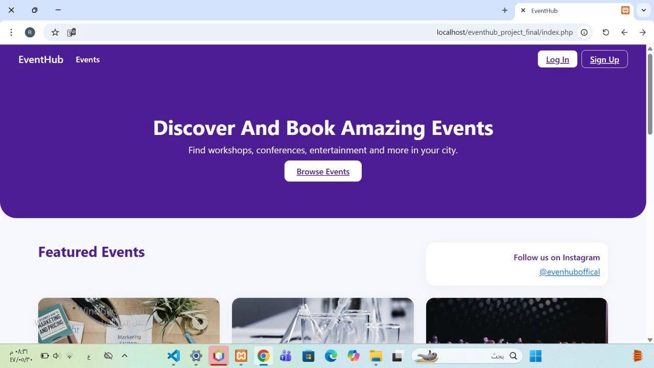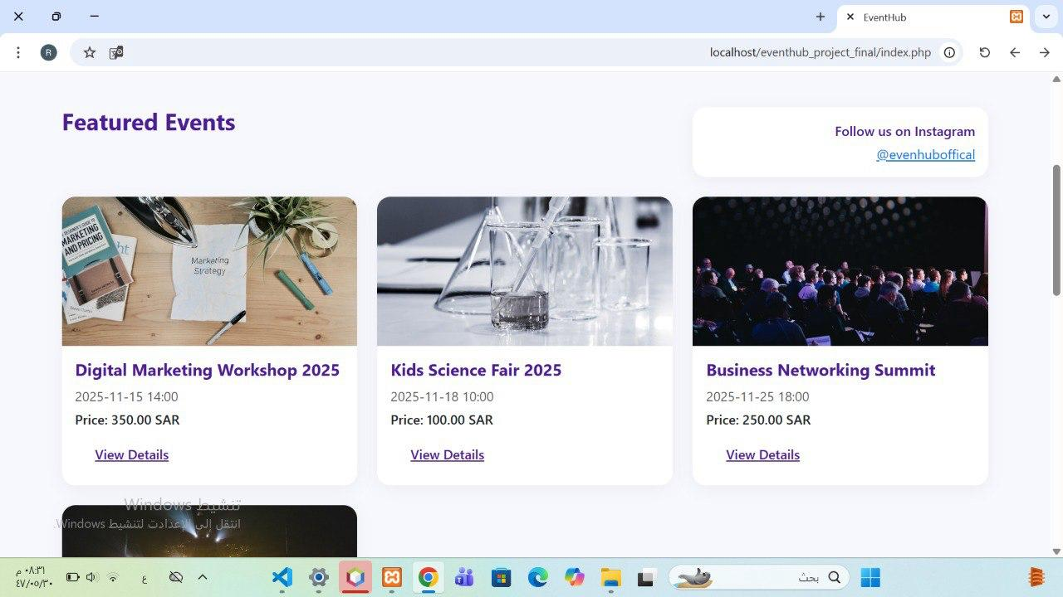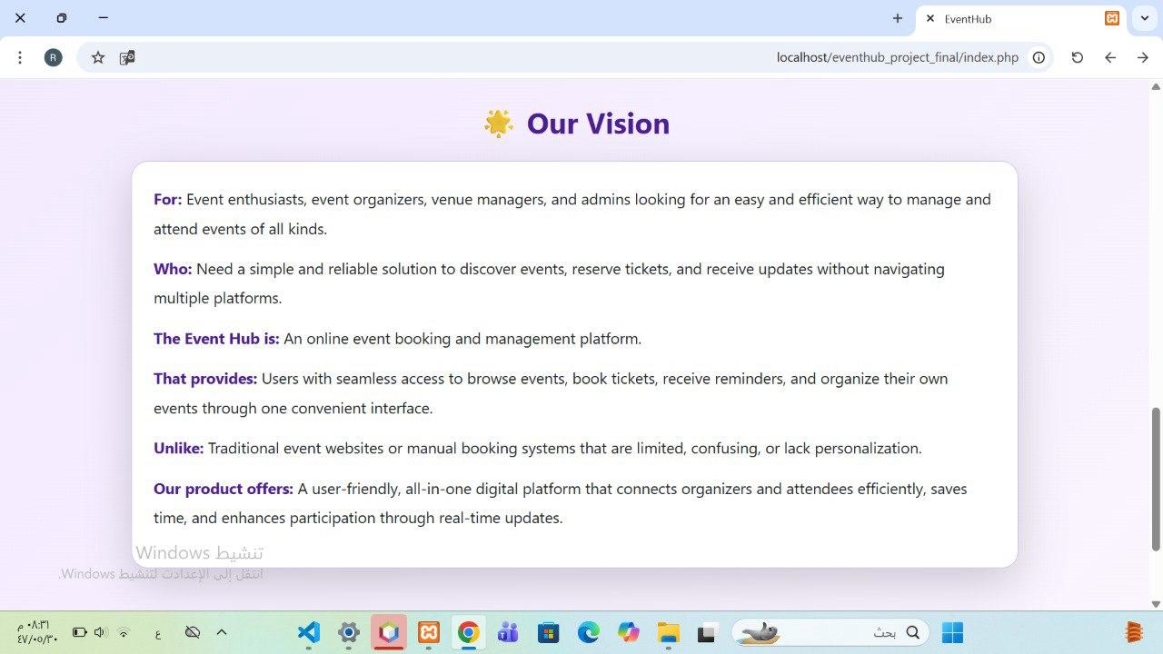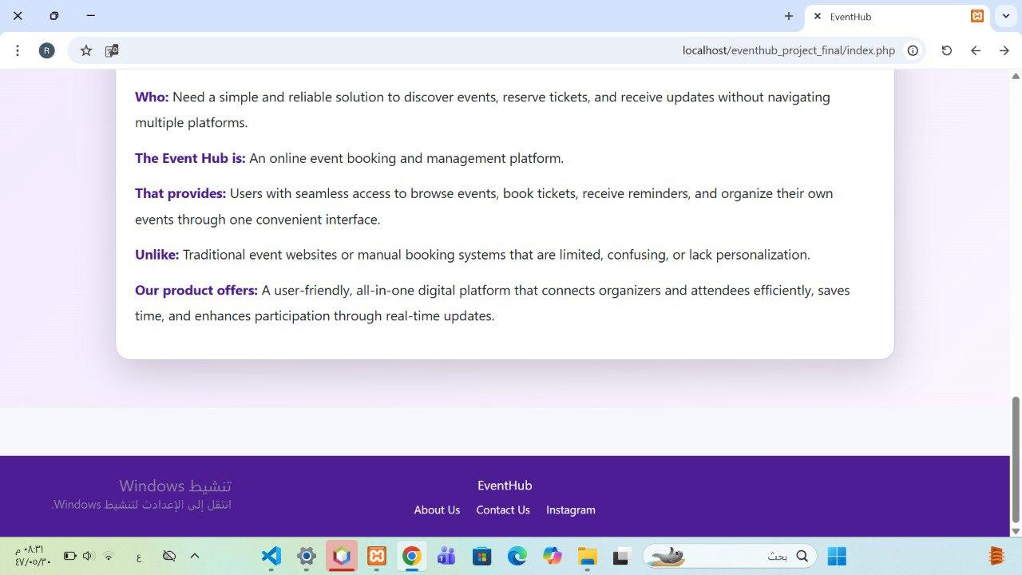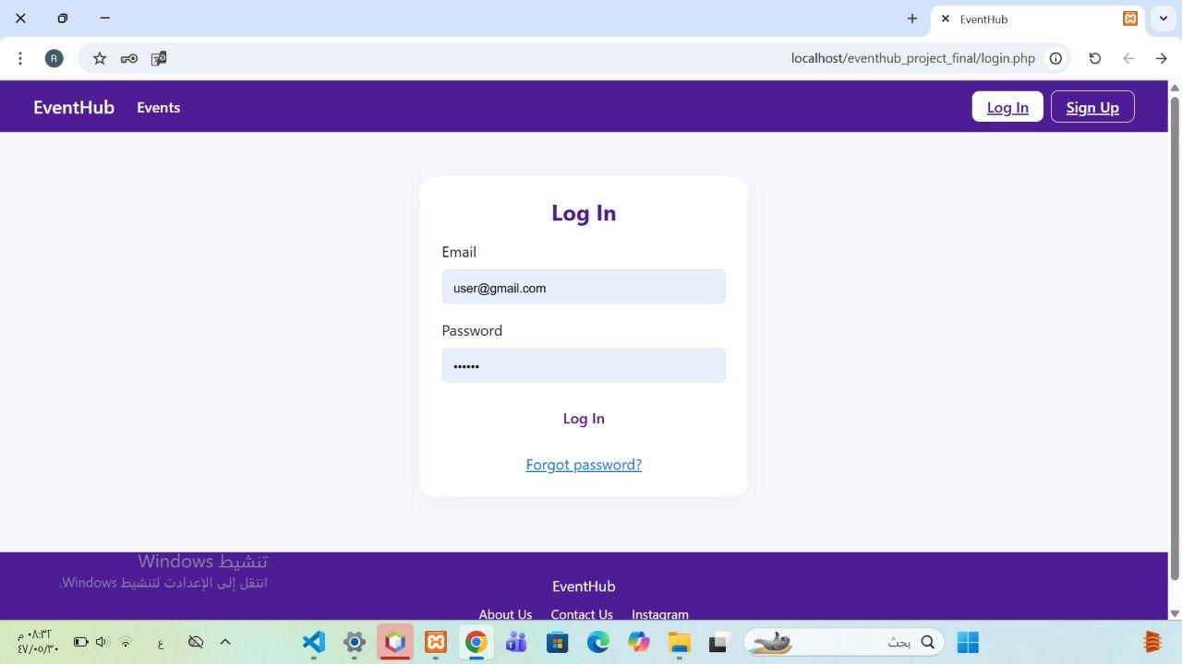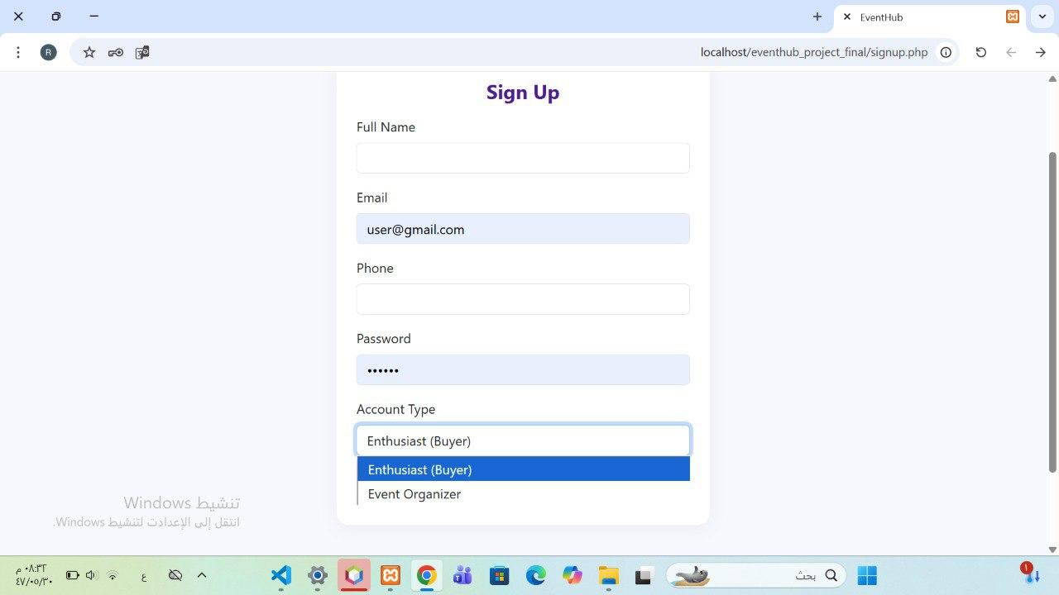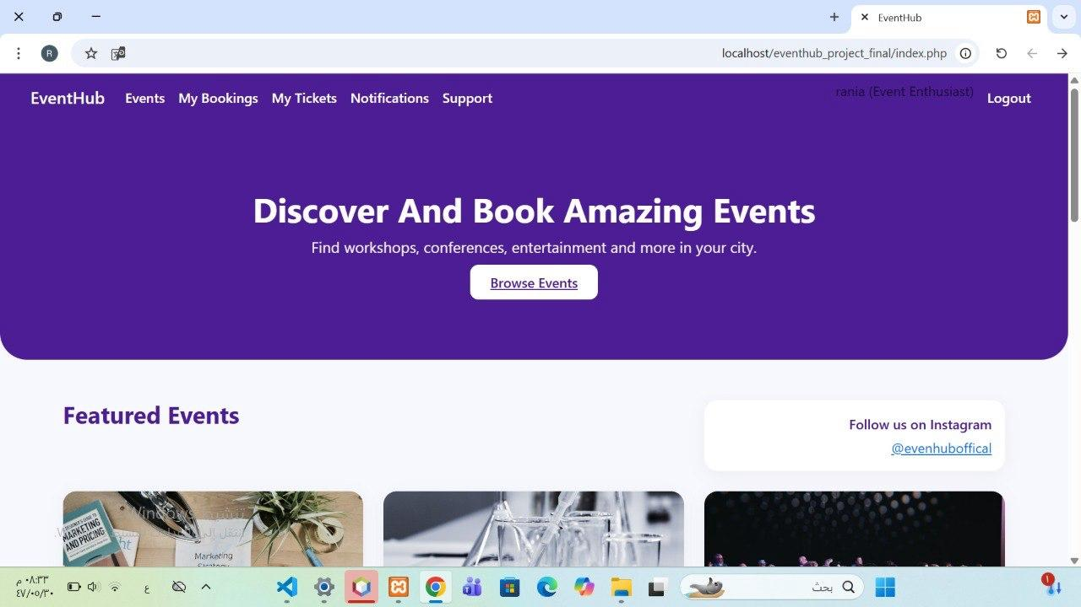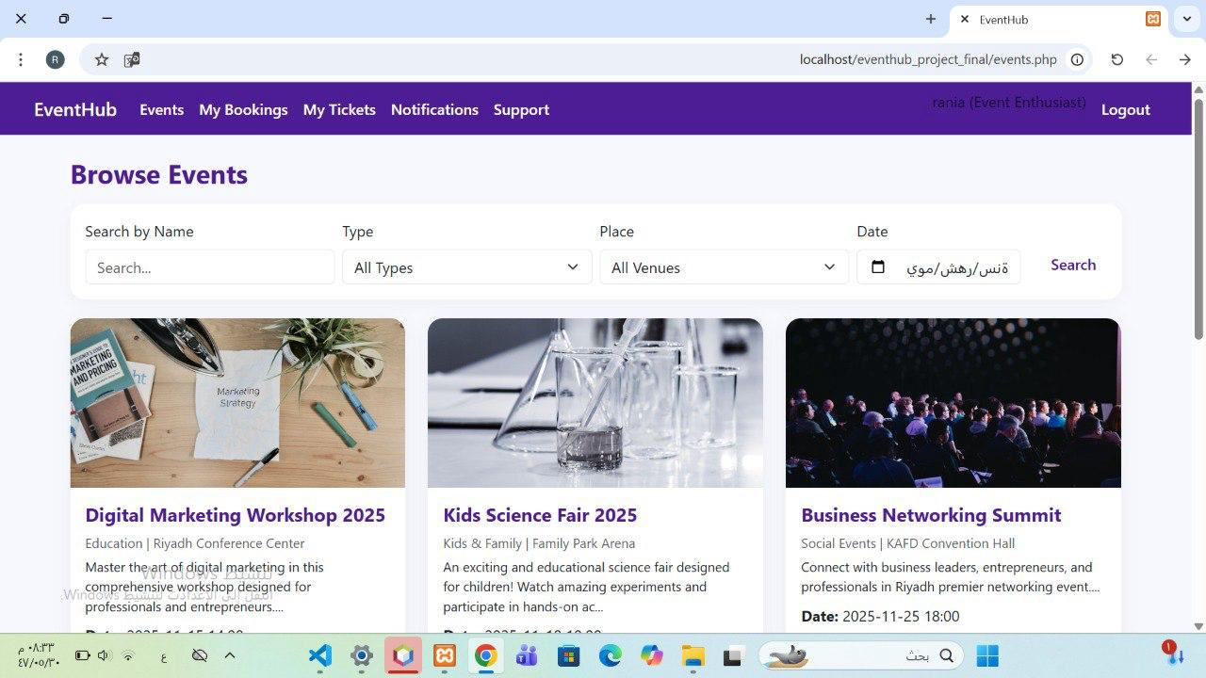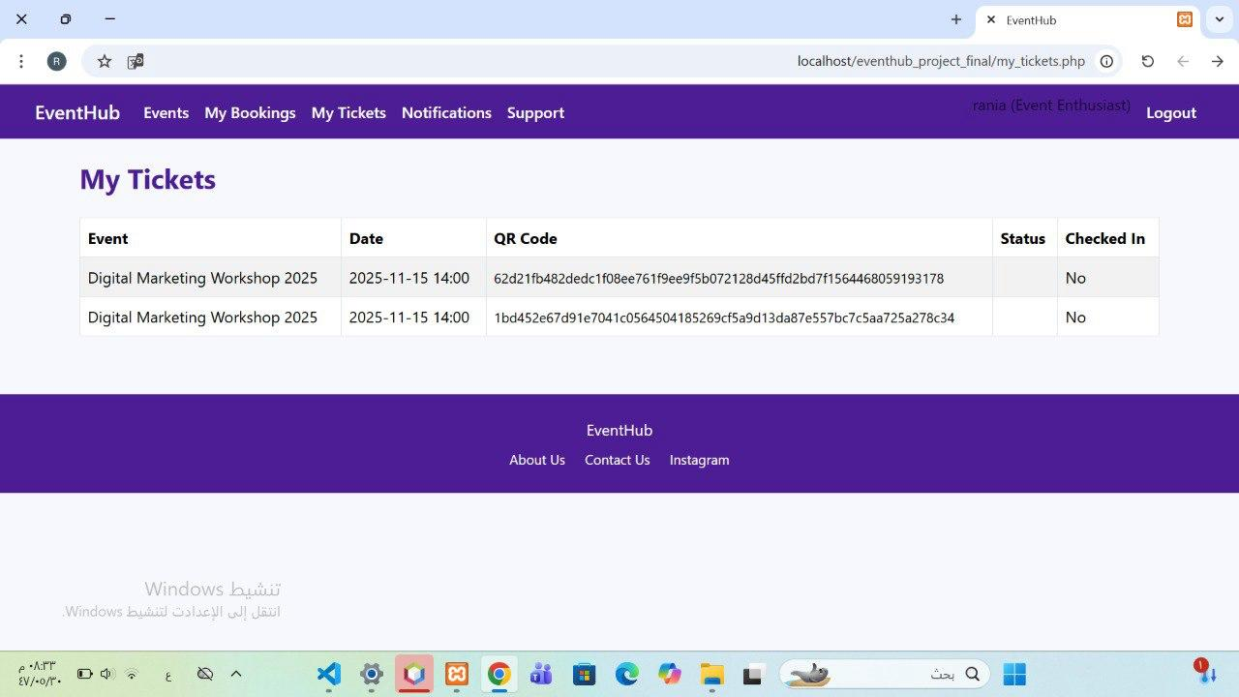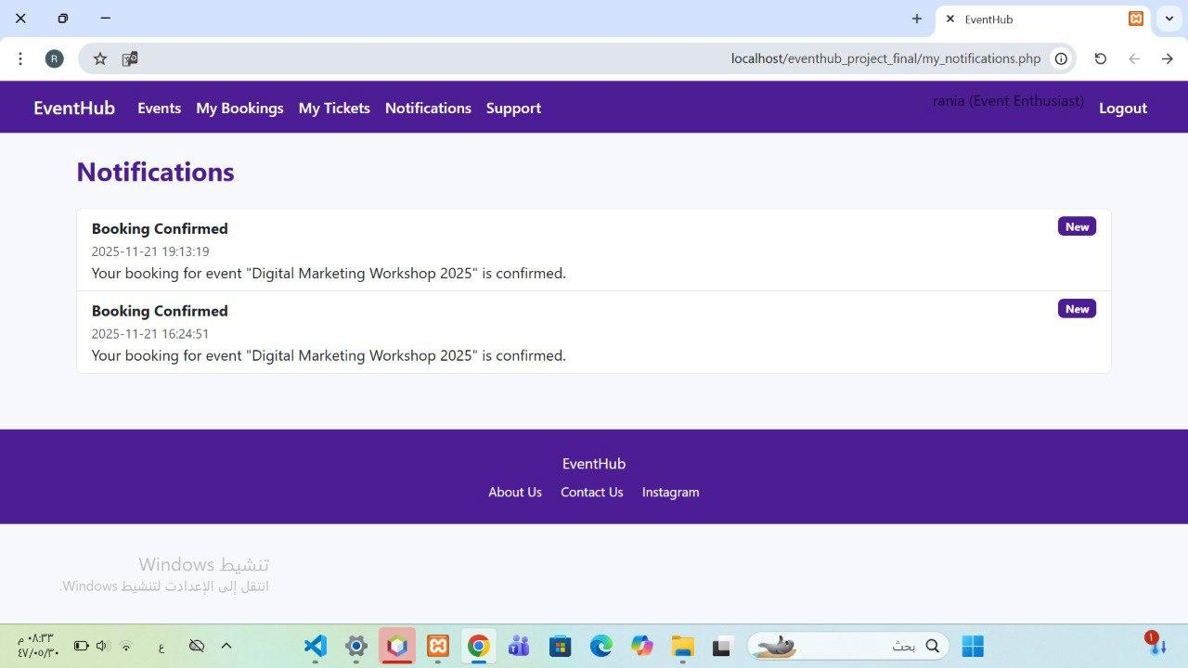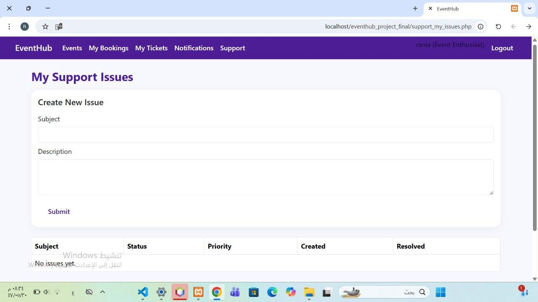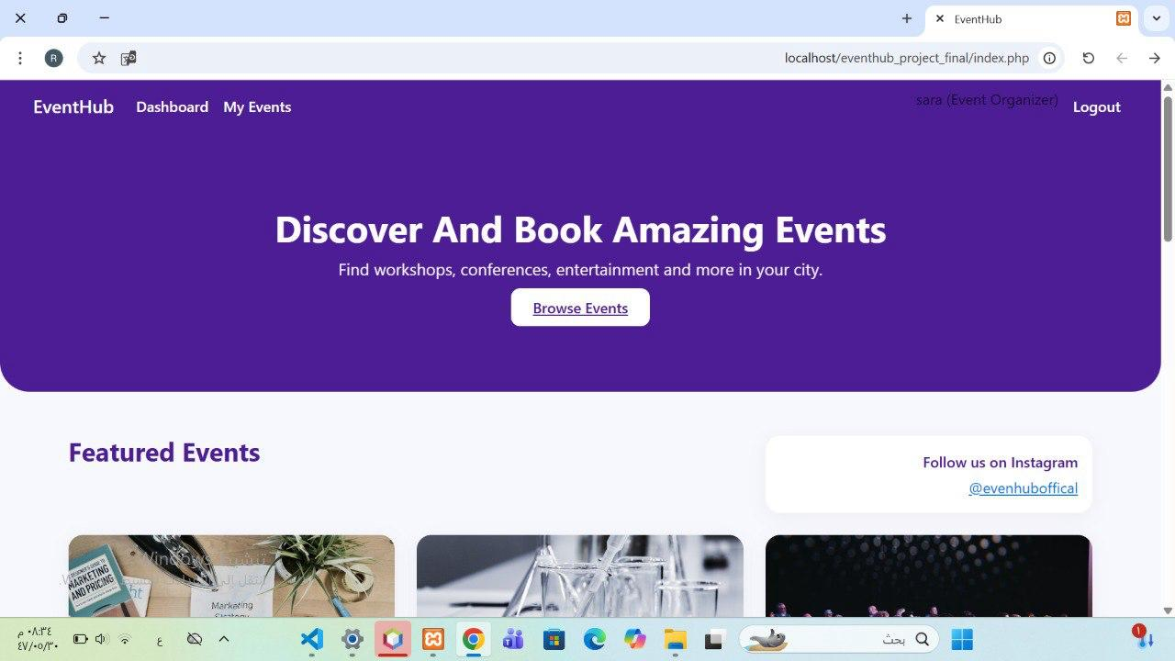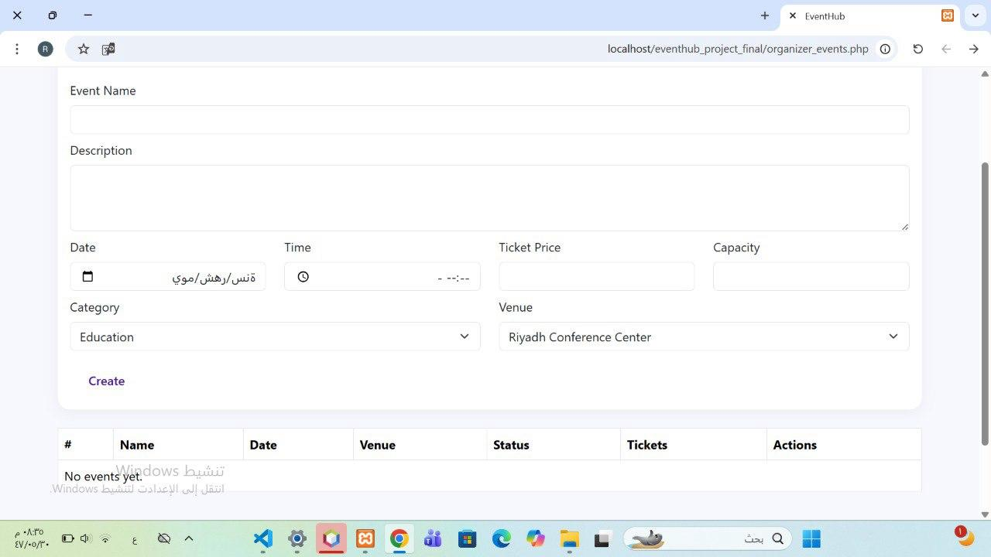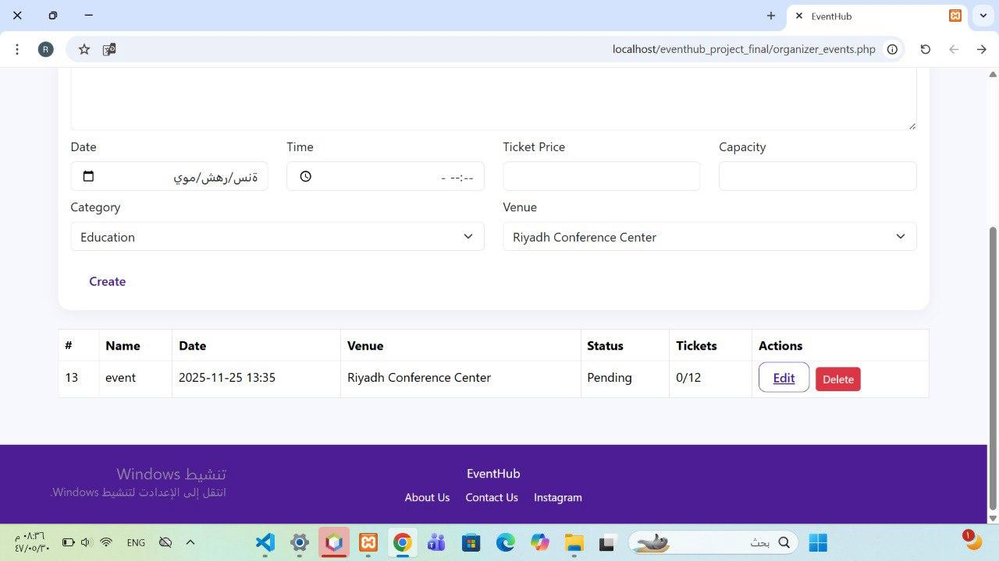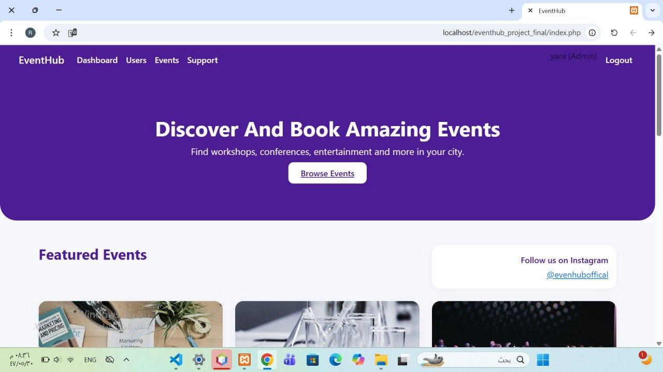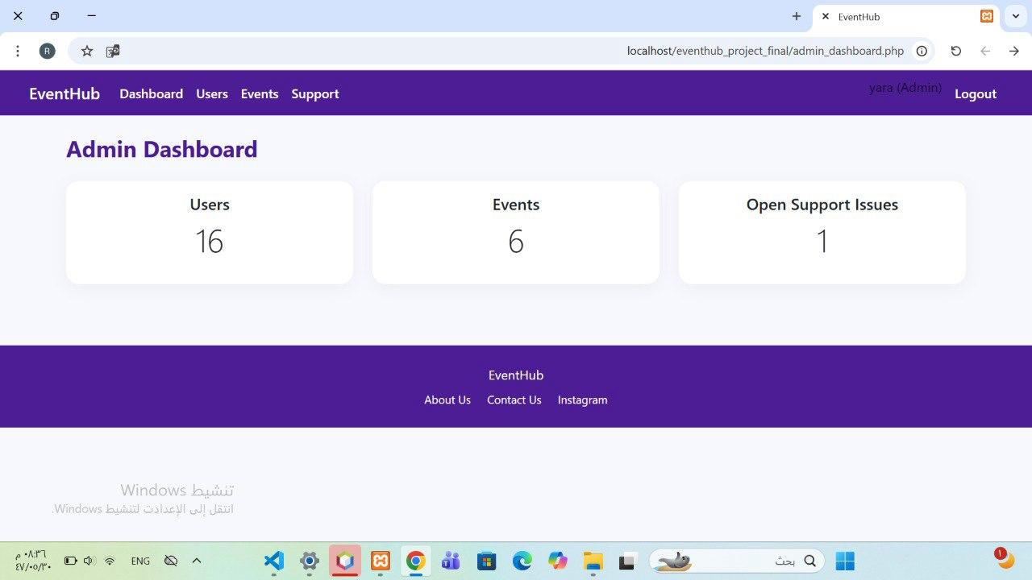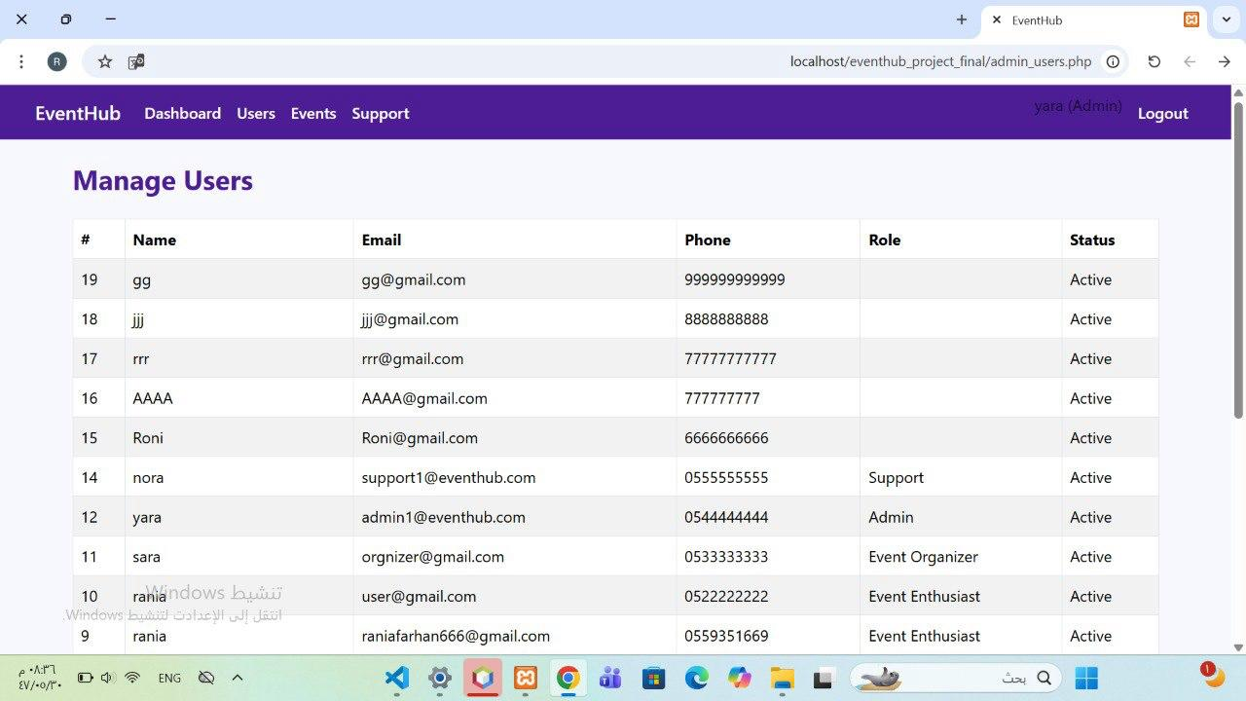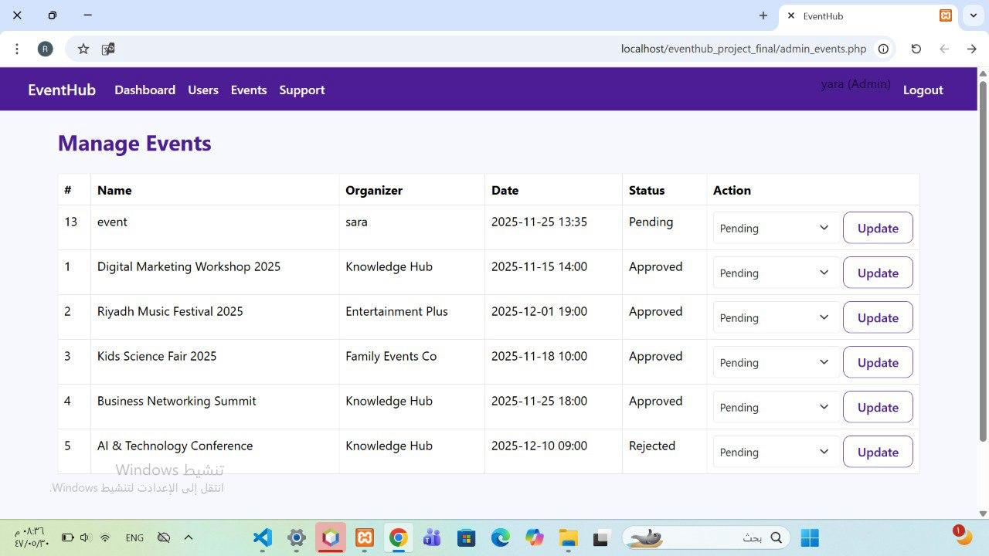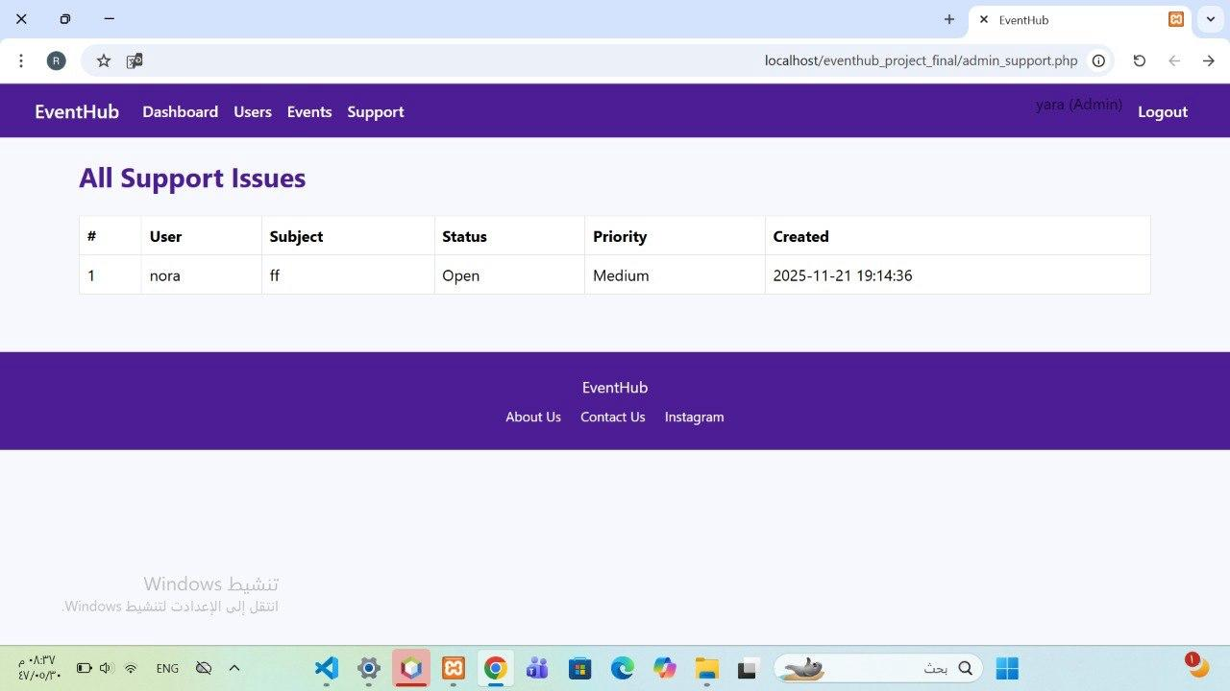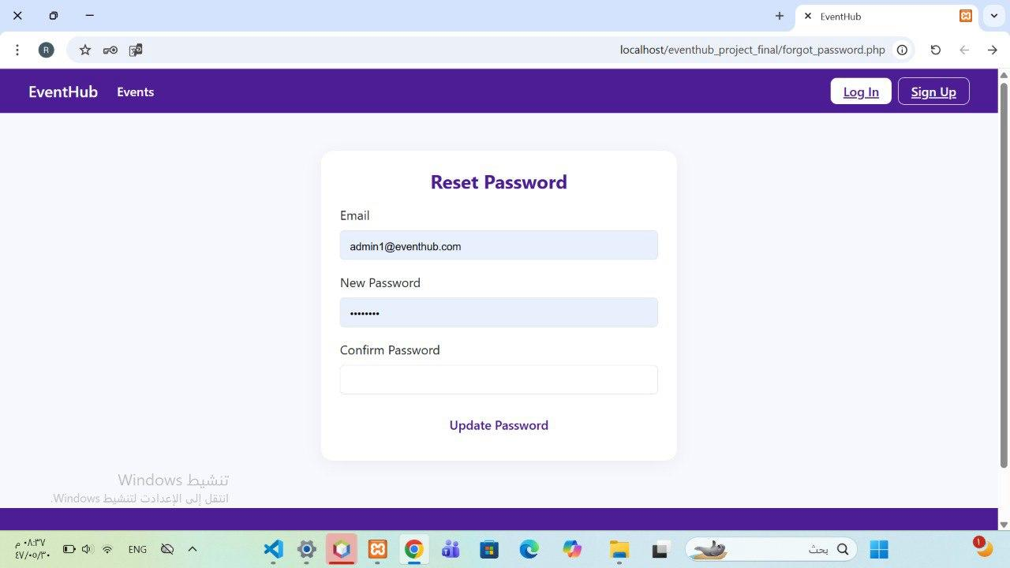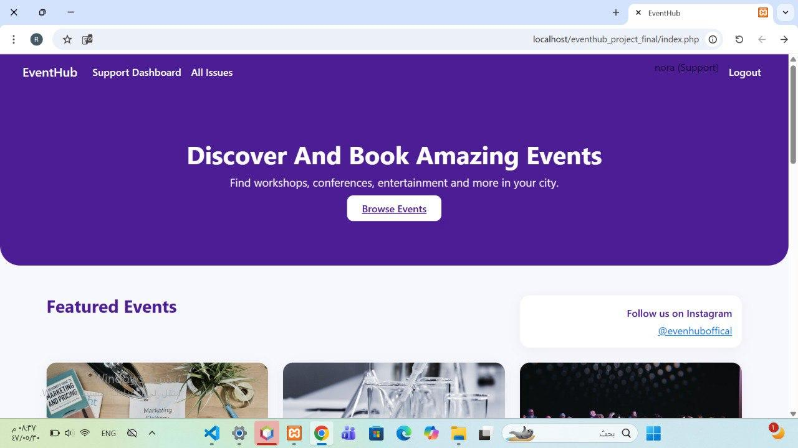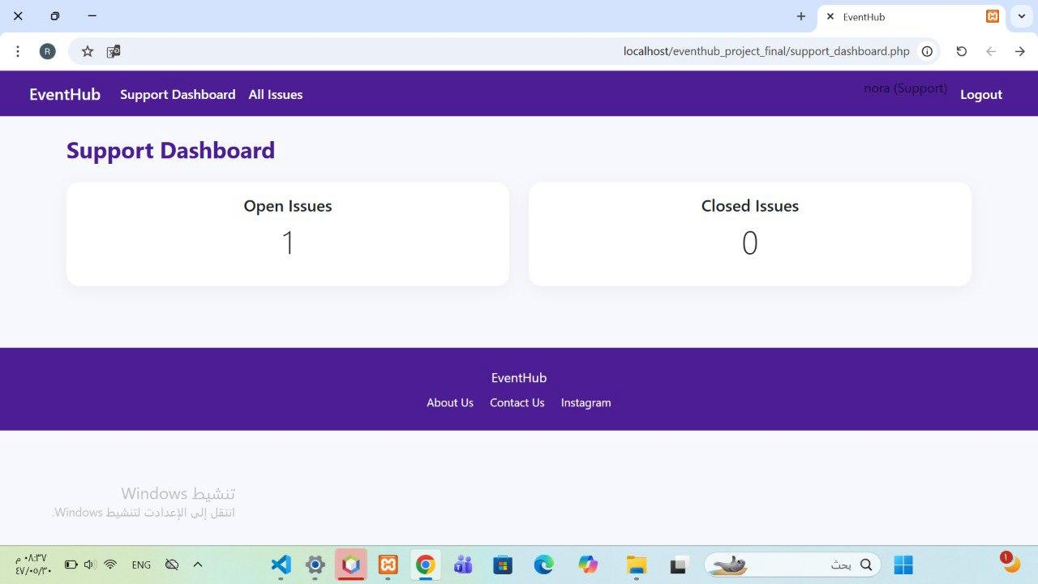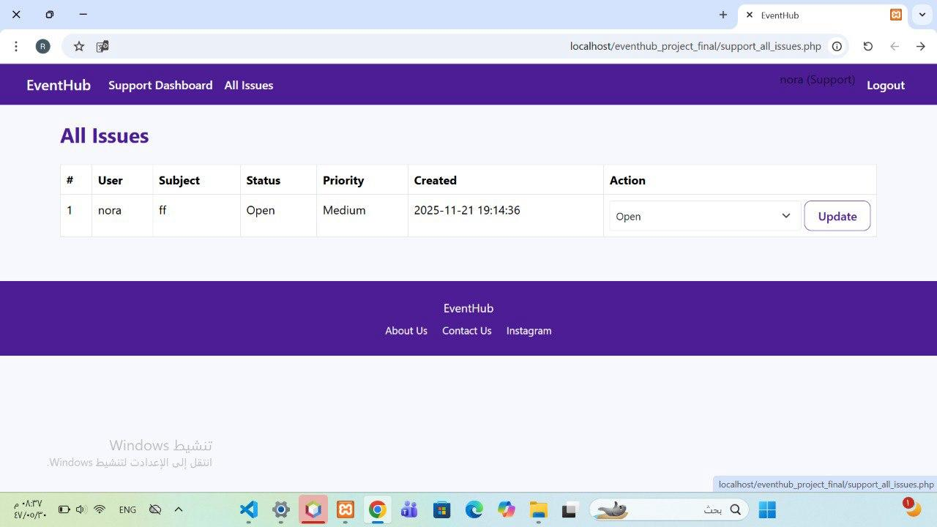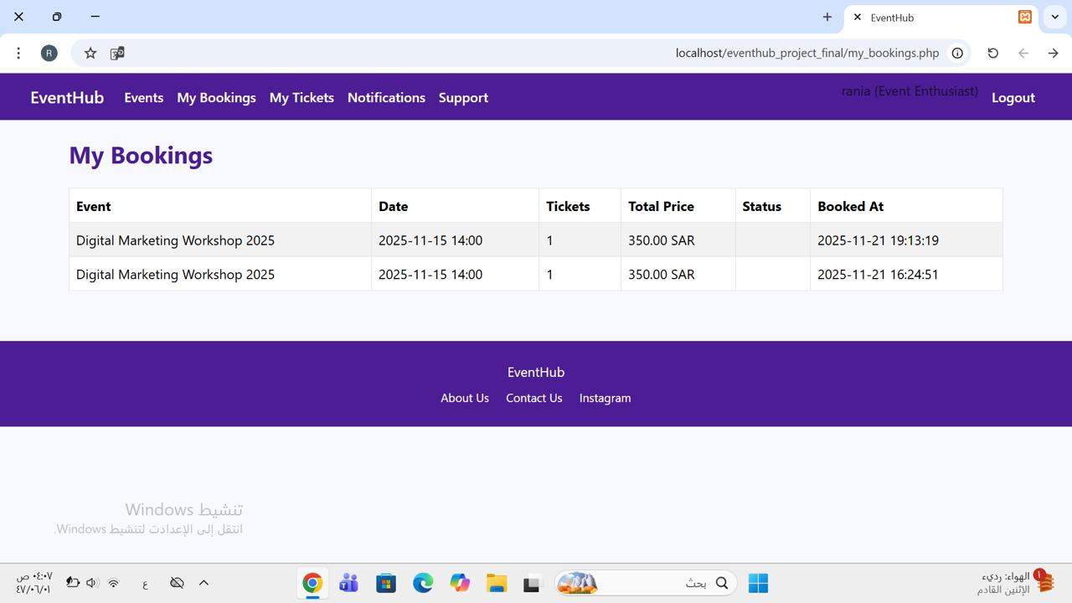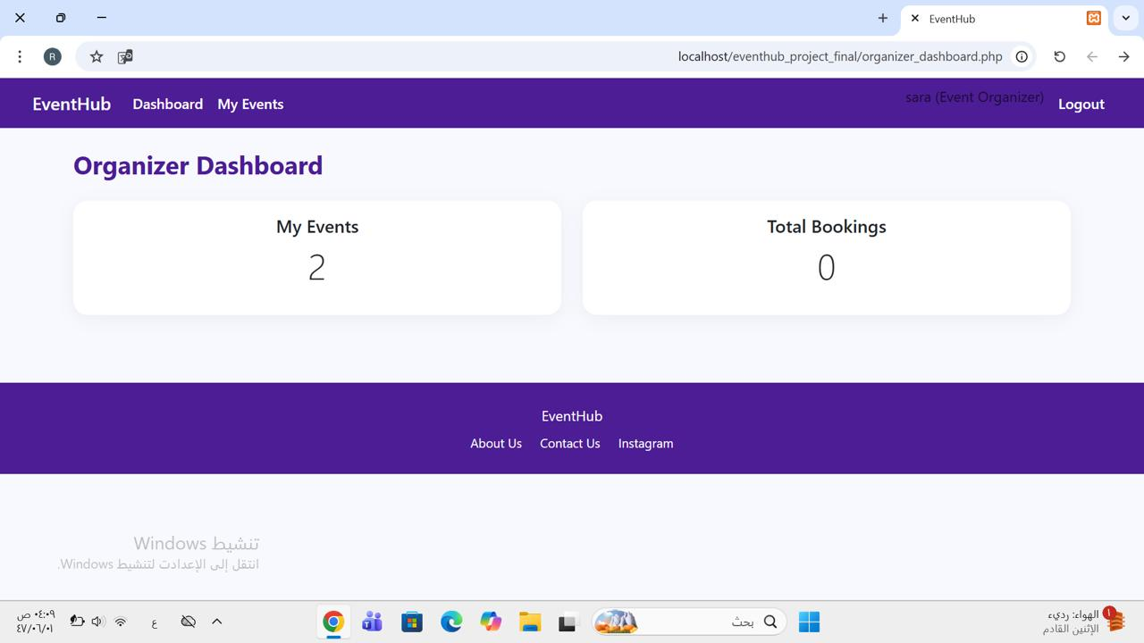

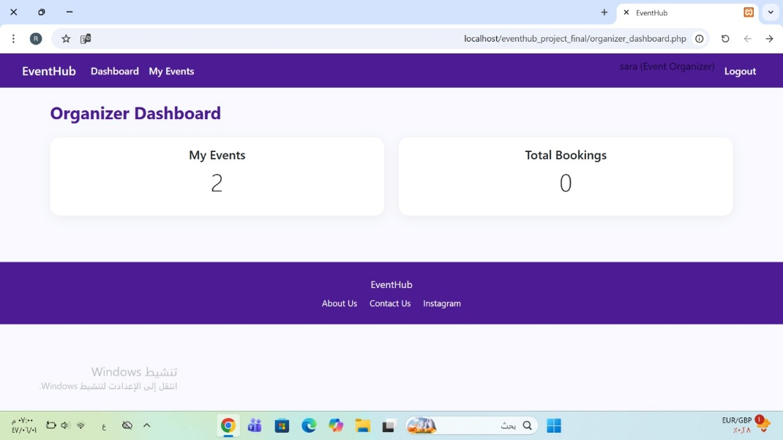

o Any questions from stakeholders were addressed during the demonstration.
No questions from stakeholders during the demonstration.
• 1.3 Acceptance Criteria Verification:
o Verification of Acceptance Criteria: All acceptance criteria for the demonstrated items were met. No issues found.
o II. Product Increment and Stakeholder Feedback:
• 2.1 Product Increment Discussion:
o Current State of Product Increment: The current product increment achieved the demonstrated product goals and provides value to the customer by enhancingthe main functions and providing better user experience in EvenetHub.
o Alignment with Product Goal: This final increment enhances the main functions of the intended product The features implemented in this sprint is the providing a better user experience in the Event Hub system, supporting our vision to provide an unified and efficient platform for discovering, organizing, and managing events.
o Value to Users/Customers: the features implemented improve user experience, and Application usabilitywhich improves user satisfaction.
• 2.2 Stakeholder Feedback:
o Key Feedback Received:
Category | Feedback | Explanation
Usability | Some users see that reset password instructions are long. | facilitate it to reduce complains
o Next Steps Based on Feedback:
Next Step | Description | Related User Story
Shorten reset steps | Make instructions more abstract. | User Story 3
• 2.3 Product Backlog Review:
o Product Backlog Adjustments: there was someadjustments done.
• Newly Discovered Work: Reducing the number of interfaces for better connection and integration.
one additional user story was added to the backlog:

• User Story 16:
Event Enthusiast, Event Organizer, Admin, Support Team I want to reset my forgotten password so that I can regain access to my account securely.

• User Story 14 was split into two separate stories to align with the INVEST criteria. The original story:
As an Event Organizer, I want to edit or cancel events I created, so that I can update event details or stop registrations when needed.

• After refinement:
• ​User Story 14.1:
As an Event Organizer, I want to edit my events so I can update event details.
• ​User Story 14.2:
As an Event Organizer, I want to delete my events so I stop registrations when needed.

III. Progress and Next Sprint Planning:
• 3.1 Progress Toward Product Goal:
o Contribution to Product Goal: This final increment enhances the main functions of the intended product The features implemented in this sprint is the providing a better user experience in the Event Hub system, supporting our vision to provide an unified and efficient platform for discovering, organizing, and managing events.

• Impediments: The large number of interfaces was an impediment when integrating with the database and connecting the new Sprint 2 components.
• 3.2 Next Sprint Planning Preview:
o Potential Items for Next Sprint: this is the final sprint.
• 3.3 Action Items:
o Action Items:
• Product Owner (Shahad) to final review of the Product Backlog.
• UI/UX Designer (Raghad) to do a final UI/UX review.
• Frontend Developer (Layan) to do a final frontend test.
• Backend Developer (Rania) to do a final backend test.
• Scrum Master (Lamyaa) to do a final review to definition of done.

o IV. Summary and Closing:
• 4.1 Summary of Key Takeaways:
o Key Takeaways: The sprint released features for better user experience in the Event Hub platform including edit and cancel events, create and display promotional campaigns and password reset.
o Stakeholder feedback underlines the must to improveusability.
o The team showed strong progress and communcationwith clear goals.

o Team Accomplishments:
• meet the Sprint Goal.
• Reducing the number of interfaces for better connection and integration.
• showed excellent problem solving and communication throughout development and testing.

• 4.2 Next Steps:
o Thank You:
Thank you to all participants and stakeholders for their collaboration, time, and feedback during thefinal sprint

Sprint Backlog
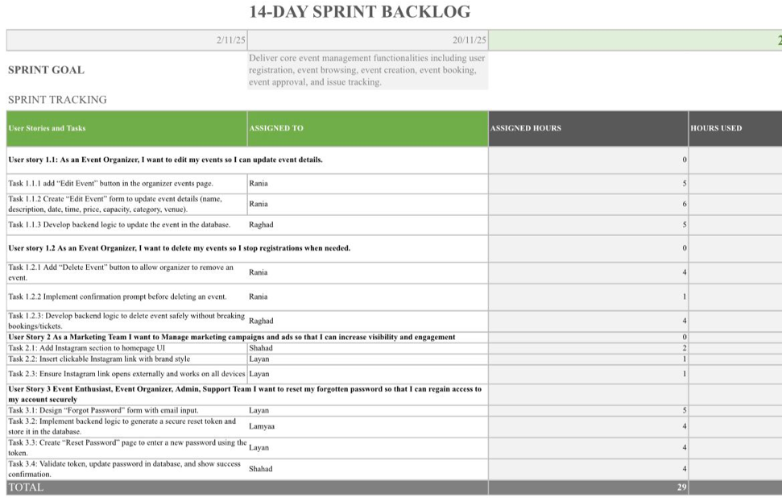
Product backlog
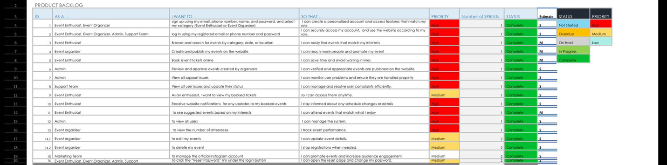

Retrospective

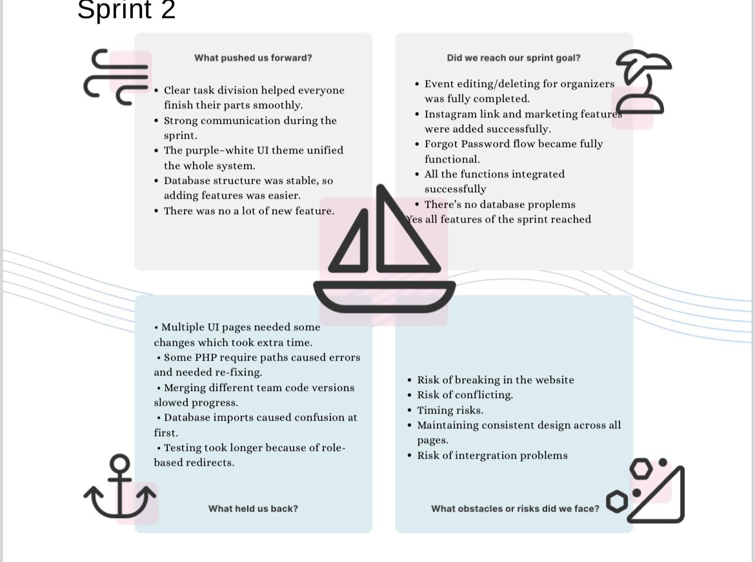
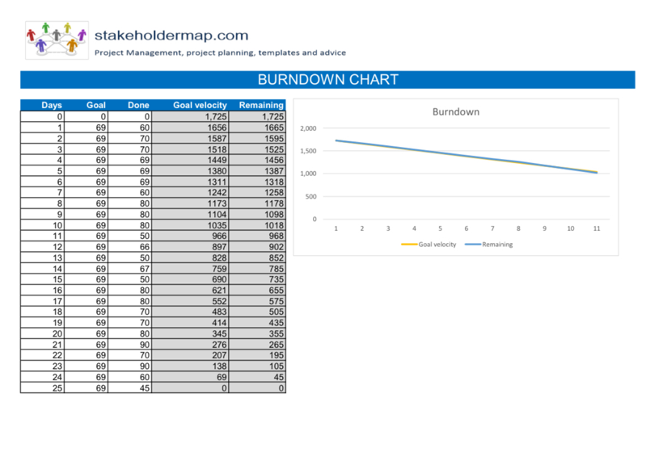
Burn Down Chart

GitHub Link:

https://github.com/LamyaaAlotaibi/EventHub

