
Rasd
Digital Footprint Observatory for Platform Economy
SW 413 – Data Exploration and Visualization
Dr. Motasem Alsawadi
Name | ID | Roles and Responsibilities
Aljawharah almutlaq | 445009164 | - Prepared the report.  - Prepared the presentation.  - Validated the dataset.
Rania Farhan | 445009163 | - Monitored the project workflow.  - Collected the dataset.  - Contributed to data analysis.  - Implemented the dashboard.  - Developed the web-based prototype.  - Implemented the data processing logic and analytical indicators.
Raghad Alsemaih | 445009154 | - Monitored the project workflow.  - Collected the dataset.  - Contributed to data analysis.
Shatha alghamdi | 445009170 | - Collected the dataset.  - Implemented the dashboard.
Lamyaa Alotaibi | 445009159 | - Prepared the report.  - Managed the project's source code on GitHub..  - Prepared the presentation.

- Project idea and problem statement
Executive Overview:
Rasd is an analytical tool for businesses that allows organizations to assess the degree of dependency that restaurants have on digital delivery platforms for food. The tool takes the raw data collected from restaurants and generates actionable rules that can be used for research, planning, and decision-making.

Business Problem:
The restaurant industry increasingly relies on digital food delivery platforms such as Jahez, HungerStation, Talabat, and Mrsool as important sales and distribution channels.
This increase in the number of users has also expanded the digital economy and has raised questions for businesses about how to determine the overall size of the activity on an app-based food delivery system, as well as to calculate the number of independent contractors engaged in these activities.

Customer reviews, ratings and images are typically stored in very large CSV and JSON files; however, because there are such large datasets, extracting any significant information from a CSV or JSON file manually can take too long, making this way of extracting data impractical.

Proposed Solution:
To solve the problem Rasd was created to be an analytic tool that automates the process of analyzing data. The program takes the uploaded dataset (what is uploaded) and processes the data to make it analyzable. In addition, the program will read the data, analyze it for review and restaurant images, then produce output that describes the level of digital activity and reliance on the platform.

As input to the activity level, Rasd uses Google Gemini model [4] to analyze the images, then combines those results with the text derived findings of analysis to produce insight on the level of activity. All the insights from the Google Gemini models are then compiled and are displayed for end users in a dashboard format that permits ease of access and organization.

Business Value:
The project creates a reusable solution that helps to mitigate manual analysis workload and increase consistency and repeatability of results. It provides users with the flexibility to upload additional datasets without changing the system and enables future research or business investigations to utilize the existing system.

- Objectives of the project
The project aims to achieve the following objectives:

- Build a web-based analytics tool for restaurant data.
- Accept input files in CSV and JSON formats.
- Prepare uploaded data through automated cleaning and preprocessing.
- Identify delivery-related terms within customer reviews.
- Analyze restaurant images using the Google Gemini model [4].
- Produce business indicators, including the Digital Activity Score, Platform Dependency Index, Estimated Gig Workers, and Activity Gap.
- Categorize restaurants according to their level of reliance on delivery platforms.
- Present the findings in an interactive dashboard.
- Allow the same application to process new datasets without code changes.
- Deliver clear, data-based insights for researchers and decision-makers.

- Dataset and data sources
The prototype uses restaurant review datasets collected from Google Maps and stored in CSV format [6]. The datasets contain public restaurant-related information, including restaurant names, addresses, ratings, number of reviews, customer review text, and photo links.
Two datasets were used during development and testing. A small testing dataset was first used to validate that the prototype can read uploaded files and analyze both reviews and images correctly. The final demonstration and dashboard results were based on the main dataset, restaurants_reviews_delivery_demo_v5.csv.
The main dataset contains 438 records and was used to test the analysis process on a wider sample of restaurants. The main columns used by the system are name, address, rating, reviews_count, review, and photo. These columns support the main purpose of the project because customer reviews can contain textual signals related to delivery activity, while photo links can provide visual signals such as delivery bags, couriers, or motorcycles.
Before analysis, the system applies data cleaning and preprocessing. This includes removing empty values, duplicated reviews, and very short or noisy review text. This step improves the quality of the analysis and ensures that the generated indicators are based on meaningful data.

- Explanation of the workflow and project stages in order
There were many sequentially linked stages in the Rasd project. The function of each individual stage is to convert the original restaurant data into useful features for the users by using them for their purpose.

Stage 1: Data Collection

This project uses a variety of restaurant datasets; primarily, they are CSV formatted with some data also being recorded in JSON format. The dataset contains the following types of data: name of the restaurant, customer rating, review text, date of review, and image link. All of these records will be used to provide the primary dataset used for analysis by the system.

Stage 2: Data Upload

When the user uploads a dataset via the application interface, the system checks the file type and validates the existence of the required columns before commencing with the processing step.

Stage 3: Data Reading

When your uploaded file is processed, the application will read through the dataset and automatically detect the important fields - including but not limited to; restaurant name, review text, rating(s), and image URLs. As a result, you are able to use different datasets without any manual setup in the system.

Stage 4: Data Cleaning and Preparation

Before performing analysis, the uploaded data goes through a cleaning and preprocessing operation. During this stage, the system will remove any blank rows, delete any duplicate records, and handle missing values. These steps help improve the quality of the data set and ensure that the results obtained will be accurate and reproducible. The cleaning of data is performed using Python standard libraries such as csv, json, and re [1], [2].

Stage 5: Review Analysis

The customer reviews are reviewed for terms/phrases related to delivery services. The system will look for keywords that indicate delivery action, such as mentioning drivers or referencing delivery platforms. The results of this step provide an initial estimate for how much each restaurant has used digital mediums.

Stage 6: Image Analysis

The Google Gemini model is used to analyze photos of restaurants [5]. The model analyzes visual clues like delivery bags, delivery driver uniforms, motorcycles, and the logo of the delivery platform. The results from the analysis of the photos and the analysis of the reviews are put together to improve the overall evaluation.

Stage 7: Indicator Generation

Once the image and text analyses have been performed, the indicators that summarize the results calculated. These include: the Digital Activity Score, Platform Dependency Index, Estimated Number of Gig Workers, and Activity Gap Indicators. The indicators indicate the overall relationship between the restaurant and the delivery platforms in question.

Stage 8: Restaurant Classification

According to the calculations of the indicators, every restaurant has been categorised into one of three levels of dependency (low, medium, and high) which makes it easier for users to make comparisons between the restaurants and comprehend the results.

Stage 9: Dashboard Display

The final results are displayed in an interactive web dashboard built using Flask and Chart.js [3], [5]. This dashboard includes summary-level metrics, tables, and graphical representation of all the output from the analyses, allowing users to examine and interpret the analyses easily and efficiently.

Stage 10: Reusability

You can utilize the application previously discussed for additional data analysis by uploading new files. Once you have done so, the application will process each file in its entirety without requiring any code changes whatsoever.

- Explanation of the prototype and how it works
Rasd was developed as a web-based analytical prototype using Python and Flask [1], [3]. The prototype allows users to upload restaurant datasets in CSV or JSON format through a simple web interface. After the file is uploaded, the system reads the dataset and extracts the required fields, such as restaurant name, address, rating, review count, review text, and photo URLs.
The prototype then prepares the data for analysis by cleaning the review text and removing weak or duplicated entries. After preprocessing, the user can select a restaurant from the uploaded dataset and start the analysis process.
The system analyzes the data using two main approaches. The first approach is text-based analysis, where the system searches customer reviews for delivery-related keywords such as delivery, courier, Jahez, HungerStation, Talabat, Mrsool, مندوب, توصيل, and جاهز. These keywords help identify textual evidence of digital delivery platform activity.
The second approach is image-based analysis. The prototype uses the Google Gemini model to analyze restaurant-related images and detect possible visual indicators of delivery activity, such as delivery bags, delivery riders, courier uniforms, or motorcycles [4]. This allows the system to use visual evidence in addition to text-based evidence.
After completing the analysis, Rasd combines the text and image results to generate business indicators such as Digital Activity Score, Platform Dependency Index, Estimated Gig Workers, Registered Workers, Activity Gap, and Gap Level. These indicators are displayed in an interactive dashboard with visual charts to help users understand the level of platform dependency for each restaurant [5].

- Screenshots of the project
This section presents screenshots from the Rasd prototype. Figures 1 to 5 show the detailed analysis for a selected restaurant, including dataset upload, main indicators, data cleaning, activity gap details, detected keywords, and final analysis summary. Figures 6 to 10 show comparison results across the analyzed restaurants using tables and charts.

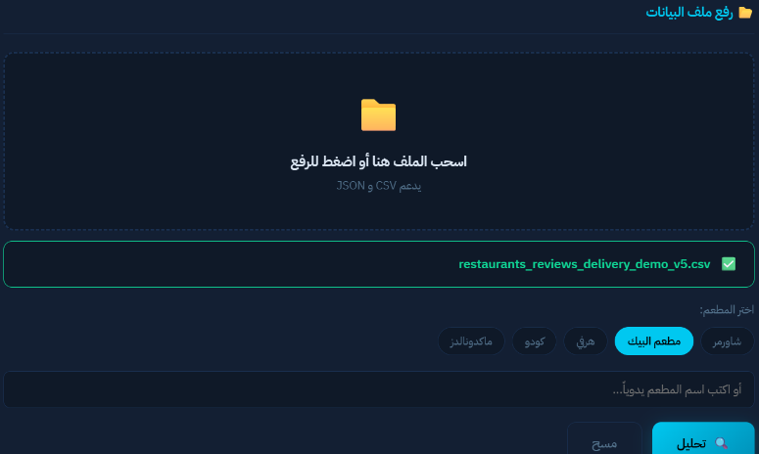 | 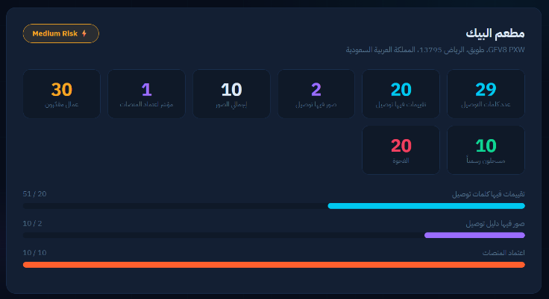
Figure 1: Dataset Upload and Restaurant Selection Interface. The user uploads the CSV dataset and selects a restaurant for analysis. | Figure 2: Main Dashboard Indicators for AlBaik Restaurant. The dashboard summarizes estimated gig workers, platform dependency, delivery-related reviews, image signals, and activity gap.

 | 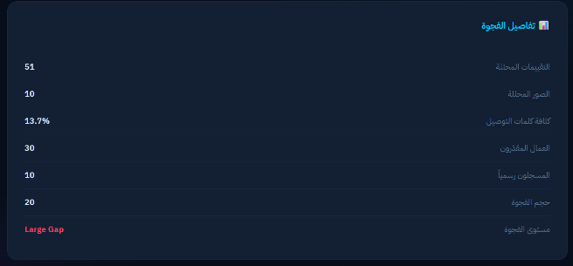
Figure 3: Data Cleaning Report. The report shows the number of total reviews, cleaned reviews, removed entries, duplicated reviews, empty reviews, and very short reviews. | Figure 4: Activity Gap Details. The dashboard compares estimated gig workers with registered workers and identifies the size and level of the gap.

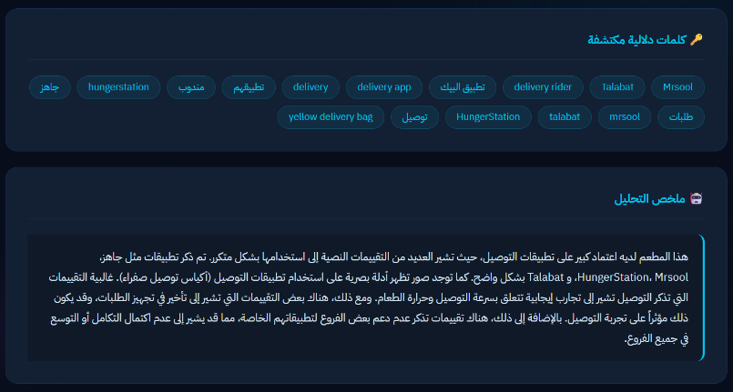 | 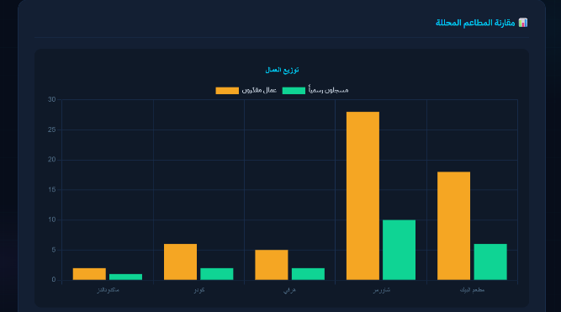
Figure 5: Detected Keywords and Final Analysis Summary. The system displays delivery-related keywords and provides a written summary of the restaurant’s platform dependency. | Figure 6: Estimated and Registered Workers Comparison Across Restaurants. The chart compares the estimated gig workers with the officially registered workers for the analyzed restaurants.

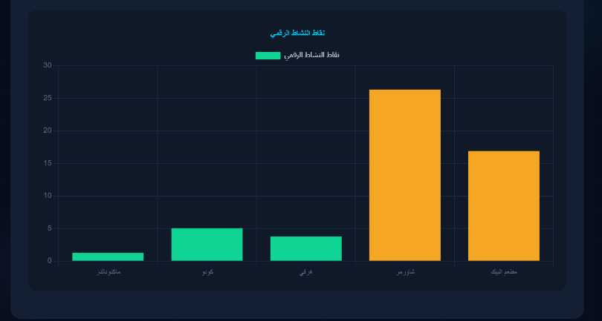 | 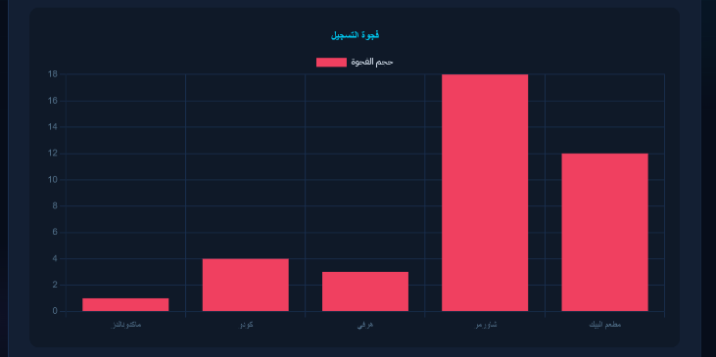
Figure 7: Digital Activity Score Comparison Across Restaurants. The chart shows the digital activity score for each analyzed restaurant, where higher scores indicate stronger delivery platform activity. | Figure 8: Registration Gap Comparison Across Restaurants. The chart shows the gap between estimated gig workers and registered workers for each analyzed restaurant.

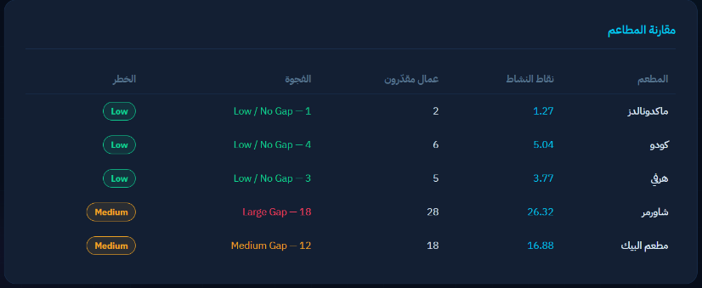 | 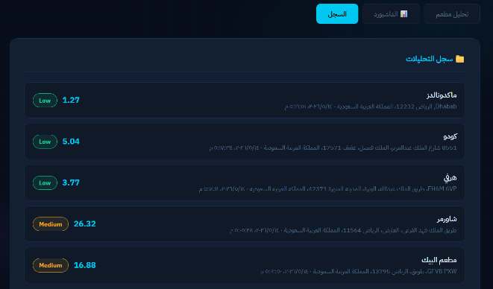
Figure 9: Restaurant Comparison Table. The table summarizes the analyzed restaurants by digital activity score, estimated gig workers, activity gap, and risk level. | Figure 10: Analysis History of Selected Restaurants. The history section lists the five analyzed restaurants with their digital activity score and risk level.

- Project link
The source code and all supporting files for Rasd are available in the GitHub repository provided below. The repository includes the prototype implementation, datasets, and all components required to run and evaluate the system.

- https://github.com/LamyaaAlotaibi/Rasd

- Results, observations, and improvements made
The prototype was tested using five selected restaurants: McDonald’s, Kudu, Herfy, Shawarmer, and AlBaik. The dashboard generated comparison results for digital activity score, estimated gig workers, registration gap, and risk level.
The results showed that Shawarmer had the highest digital activity score among the analyzed restaurants, with a score of 26.32. AlBaik also showed a medium risk level with a digital activity score of 16.88. In contrast, McDonald’s, Kudu, and Herfy showed lower digital activity scores and were classified as low risk.
For AlBaik restaurant, the system detected delivery-related keywords in customer reviews, including Jahez, HungerStation, Talabat, Mrsool, delivery, courier, and مندوب. The dashboard also detected visual delivery evidence in the images, such as delivery bags. This supports the project idea of combining text-based and image-based signals to estimate platform dependency.
The comparison results also showed a registration gap between estimated gig workers and registered workers. Shawarmer had the largest gap, followed by AlBaik. This indicates that some restaurants may have higher delivery platform activity than what is reflected by registered worker numbers.
Several improvements were made during testing. The dataset was adjusted to include clearer delivery-related image samples, and the prototype was tested on multiple restaurants to generate comparison charts. These improvements made the dashboard results clearer and more useful for presentation and analysis.
- Challenges faced and how they were handled
One challenge was dealing with unstructured review text. Customer reviews may include different languages, spelling variations, informal writing, emojis, duplicated comments, or very short text. This was handled by applying data cleaning and preprocessing before running the analysis.
Another challenge was that not all images in the dataset clearly show delivery activity. Some images may show food, menus, or restaurant interiors instead of couriers, delivery bags, or motorcycles. This was handled by separating text-based analysis from image-based analysis and by using image analysis only when clear visual evidence is available.
A further challenge was making the prototype flexible enough to process new datasets without modifying the source code. To address this, the system was designed to work with common columns such as name, review, rating, address, reviews_count, and photo. This makes the prototype more reusable for different restaurant datasets.
Finally, the image analysis process depends on an external AI model, which requires internet access and API availability. To reduce the impact of this limitation, the prototype still provides text-based analysis results even if image analysis is limited or unavailable.

- Conclusion

Rasd has developed a web-based prototype to thoroughly analyse how much restaurants depend on digital food delivery platforms. The prototype consists of a system that receives datasets from restaurants and allows CSV and JSON formatted data to be uploaded, automatically cleaning and preprocessing the data, conducting text analyses of the customer reviews to identify delivery related keywords, and using the Google Gemini model to identify visual attributes of delivery activity from images of the restaurant. The outputs of these analyses are used to generate business metrics such as a Digital Activity Score, Platform Dependency Index, Estimated Number of Gig Workers, and Activity Gap, and classify the restaurant based on the level of dependency on the delivery platforms. The information generated is provided to the users via an interactive dashboard for use in conducting research, planning, and making decisions. The project has met the goals of the project by reducing manual effort, increasing the quality of work, and producing a reusable solution to enable the analyses of future restaurant datasets, without the need to modify the source code.

References
- [1] Python Software Foundation, “Python Documentation.” [Online]. Available: https://www.python.org/doc/

- [2] Python Software Foundation, “Python Standard Library: csv, json, and re.” [Online]. Available: https://docs.python.org/3/library/

- [3] Pallets Projects, “Flask Documentation.” [Online]. Available: https://flask.palletsprojects.com/

- [4] Google, “Gemini API Documentation.” [Online]. Available: https://ai.google.dev

- [5] Chart.js, “Chart.js Documentation.” [Online]. Available: https://www.chartjs.org/docs/latest/

- [6] Google, “Google Maps.” [Online]. Available: https://www.google.com/maps

