Question 3

Git link

<https://github.com/raniadlang/webservicedemo>

commands

1>git init

2>git satus

3>git add –A

4>git commit –m “initial version commit”

5>git remote origin <remote repository url>

6>git push origin master

7>git pull origin master

1. Local repository

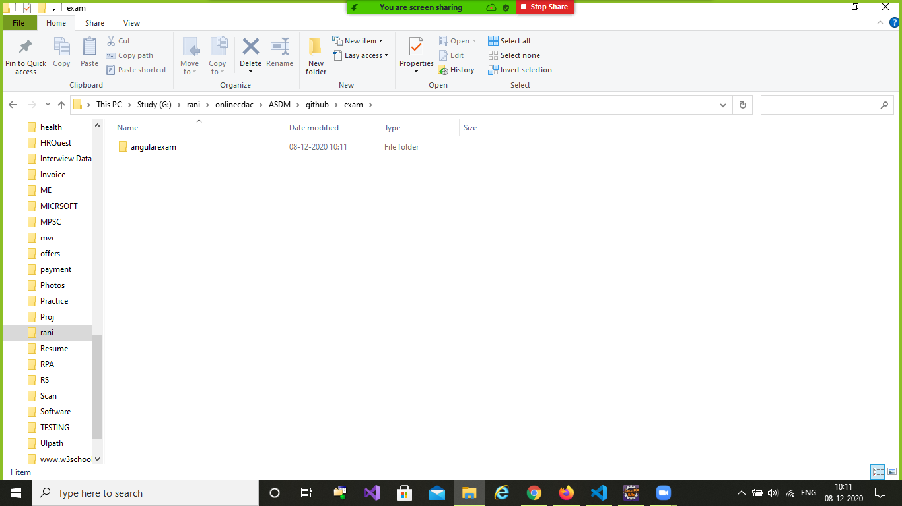

2>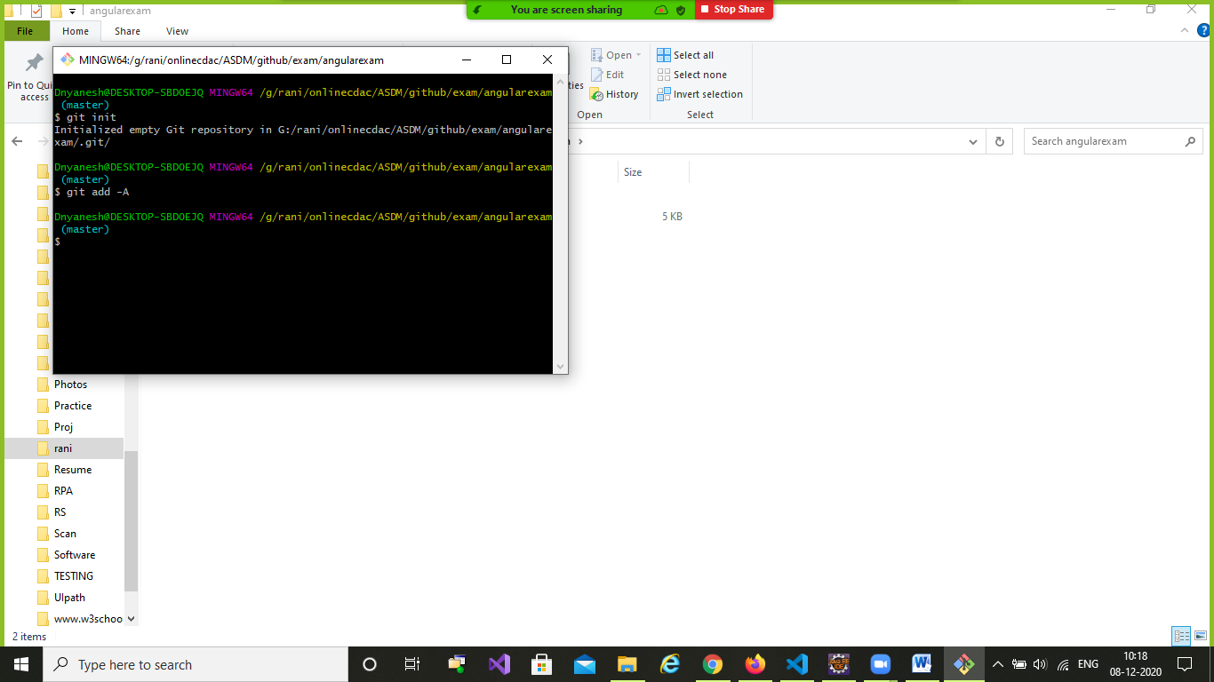

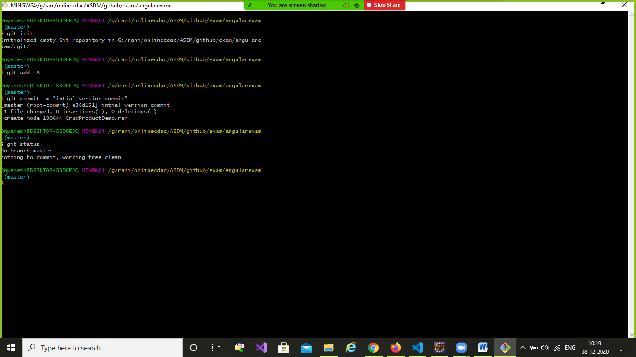

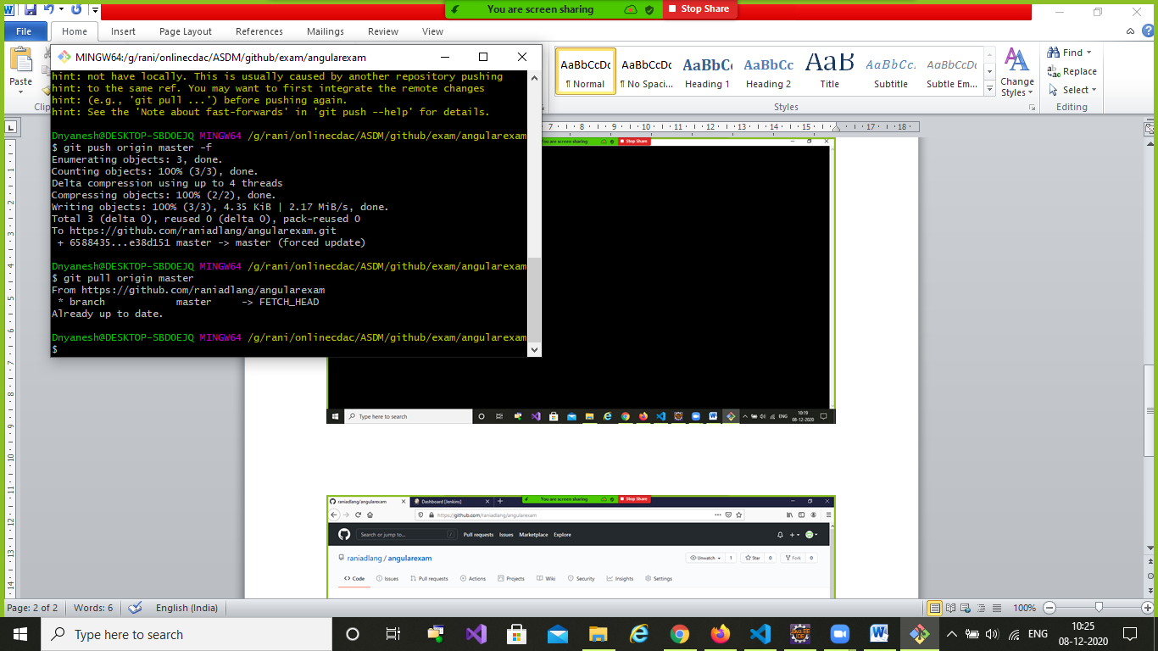

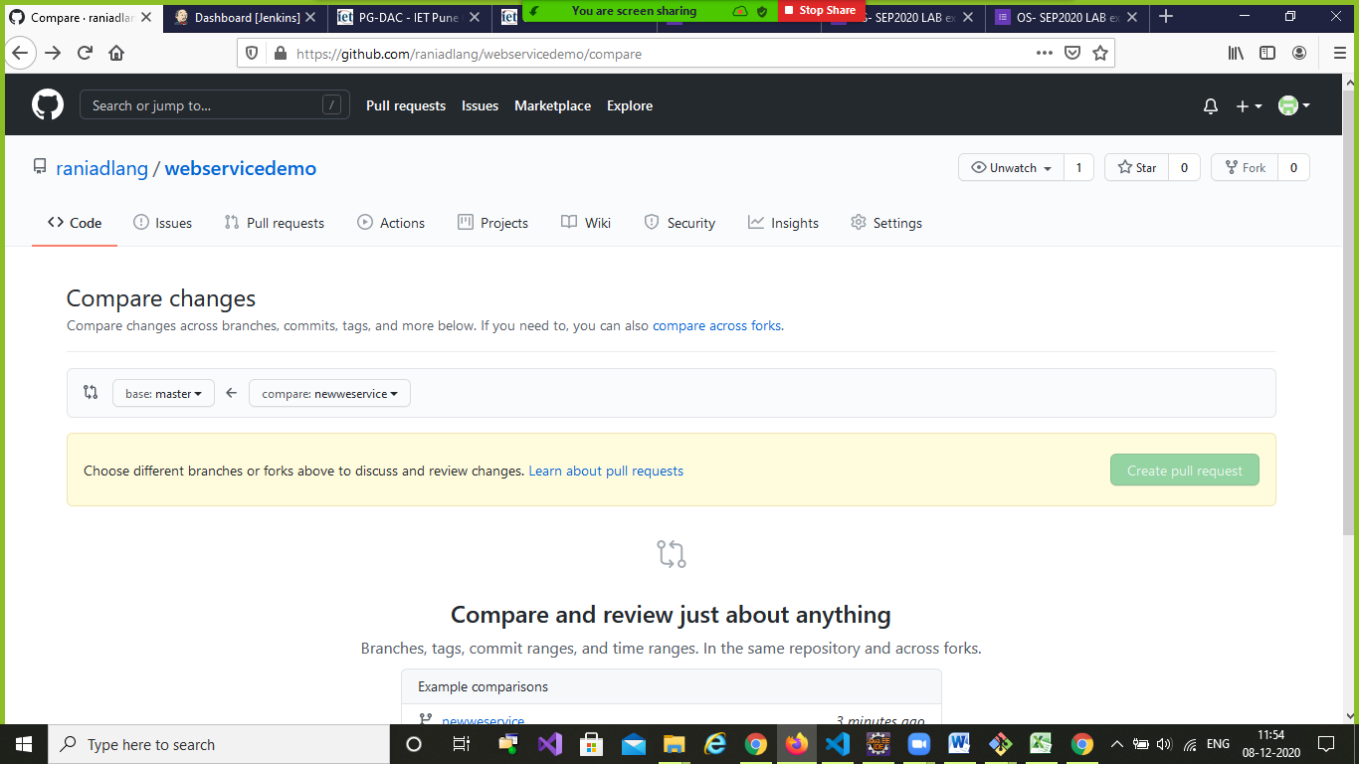

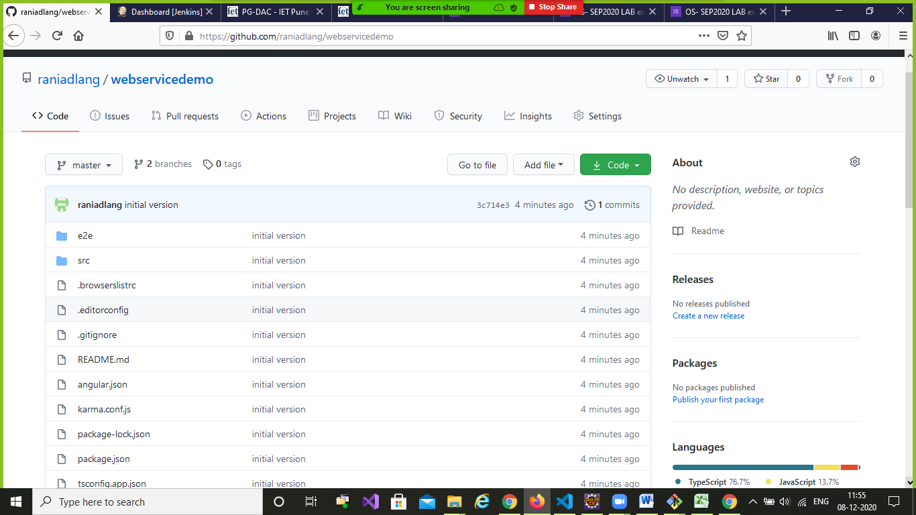

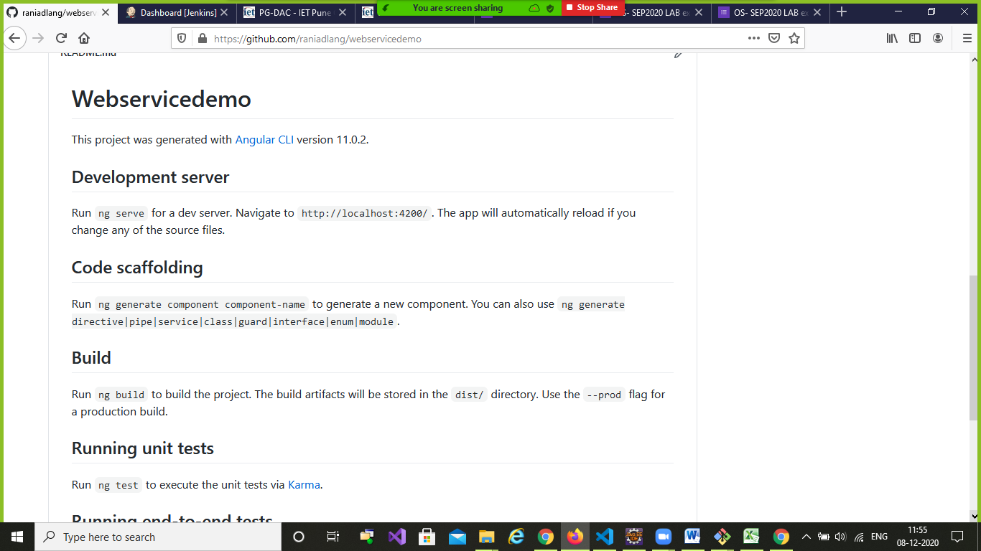

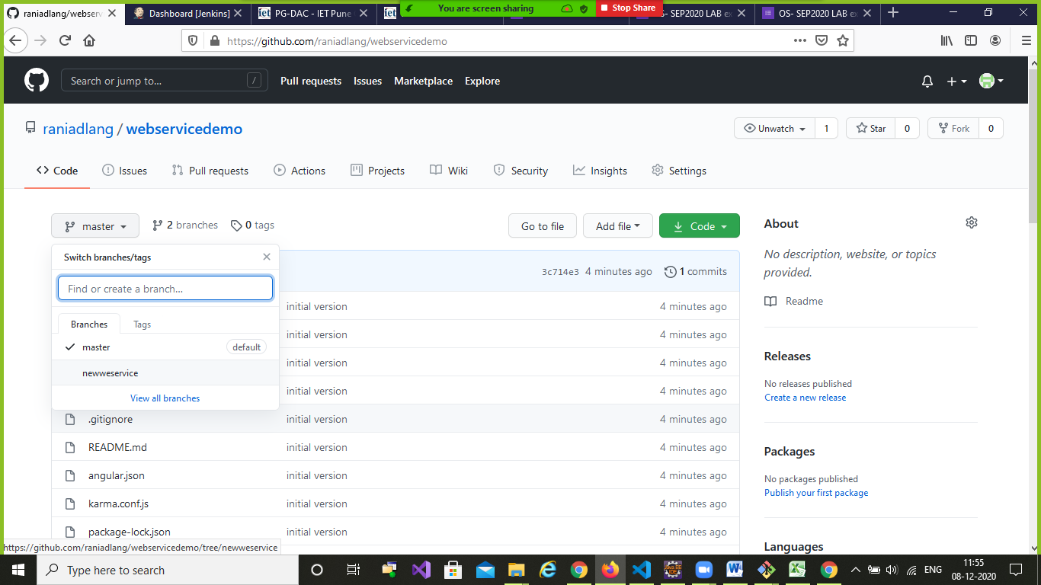

https://github.com/raniadlang/webservicedemo

https://github.com/raniadlang/webservicedemo