2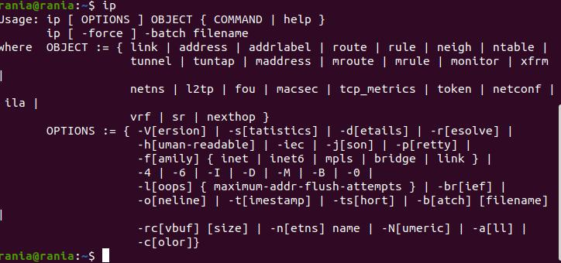. Display the network settings of all active interfaces.

# ifconfig

3. Display the network setting of all interfaces both active

inactive.

# ifconfig-a

4. Bring your interface down.

# ifdown wlol

5. Configure your network card to have static IP.

# vi /etc/sysconfig/network-scripts/ifcfg-Ethernet_connection_1

# systemctl restart network.service

6.Bring your interface up.

# Ifup wlol

7. Verify your network setting using ifconfig command

# ifconfig 0. Reconfigure your network card using system-config-network

utility to have static IP.

# vi /etc/sysconfig/network-scripts/ifcfg-Ethernet_connection_1

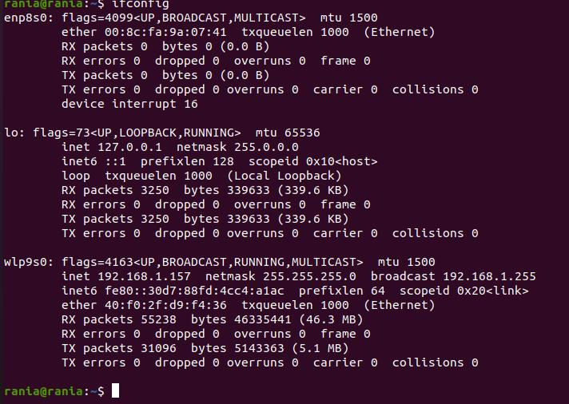

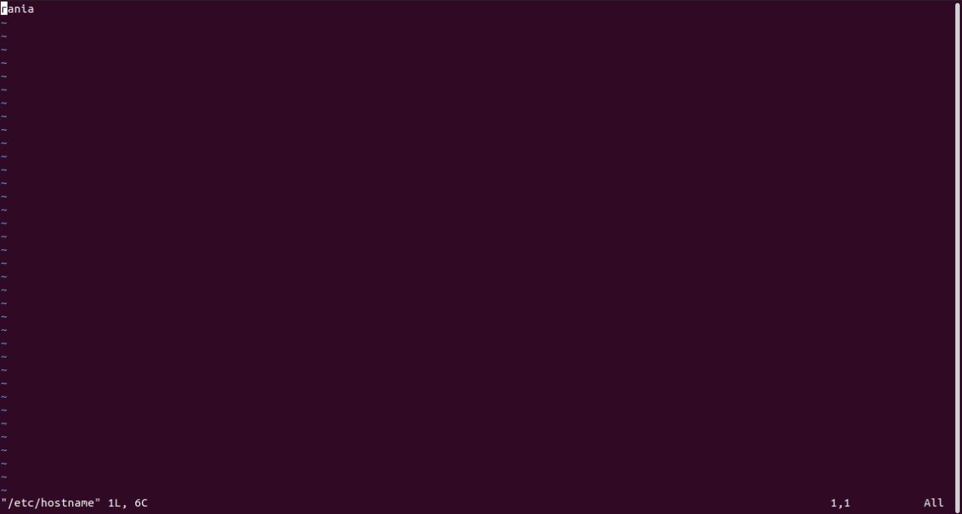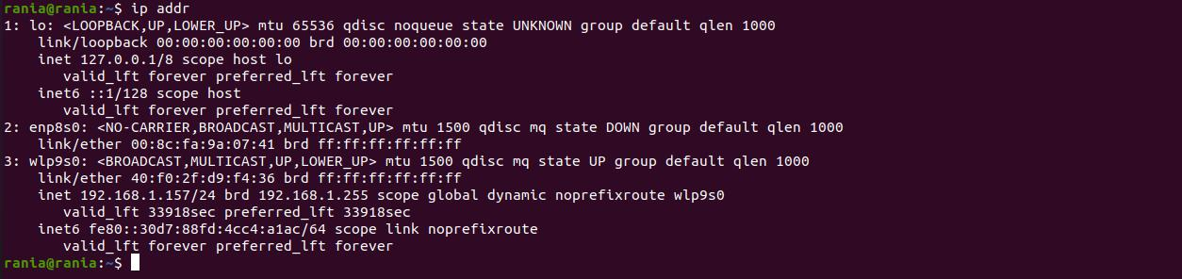

13. Check the present value of proc/sys/net/ipv4/icmp_echo_ignore_all

0

14. It should be 0, change it to 1 which will prevent other hosts

from successfully pinging your host while not affecting your ability

to ping them.

# echo 1 > /proc/sys/net/ipv4/icmp_echo_ignore_all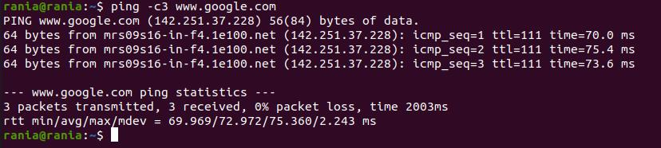

Colleague failed to ping me

16. Reboot and try the last step. What happened? Why?

the value of /proc/sys/net/ipv4/icmp_echo_ignore_all returns to 0; as

the change in proc is temporally not permanent because it is in RAM.

17. Edit /etc/sysctl.conf and put the following line at the bottom:

net.ipv4.icmp_echo_ignore_all=1

Using yum

20. Attempt to run the command gnuplot. You should find that it is notinstalled.

rania@rania:~$gnuplot

bash: gnuplot: command not found...

21. Search for the plotting packages.

rania@rania:~$ yum search gnuplot

22. Find out more information about the gunuplot package.

rania@rania:~$ yum info gnuplot

23. install gnuplot pakage

rania@rania:~$sudo yum install gnuplot

24. Attempt to remove the gnuplot package, but say no

How many packages would be removed

rania@rania:~$ sudo yum remove gnuplot

3 pakage

25. Attempt to remove the gunplot-common package but say no

How many packages would be removed

rania@rania:~$ yum remove gnuplot-common

3 pakages

Using rpm

26. List all installed packages in your system.

rania@rania:~$ rpm -aq

27. View the files in the initscripts package

rania@rania:~$ rpm -ql initscripts

28. Get general information about bash rpm.

rania@rania:~$ rpm -q bash

29. Have the files from the pam package changed since it was installed.

rania@rania:~$ rpm -v pam

30. Which installed packages have gnome in their names?

rania@rania:~$ rpm -aq | grep "gnome"

31. Install any uninstalled package from RH Enterprise Linux cds Done

32. Search for software resemble the Photoshop software other than

Gimp and install it.