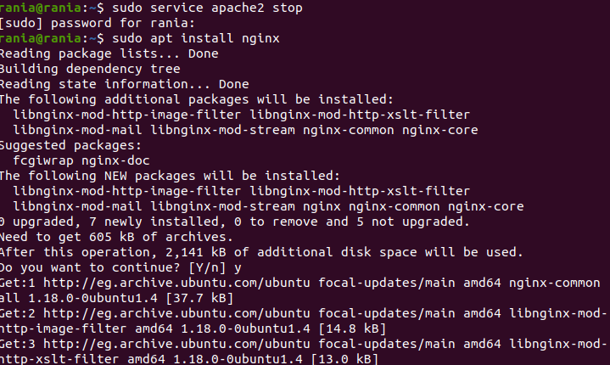



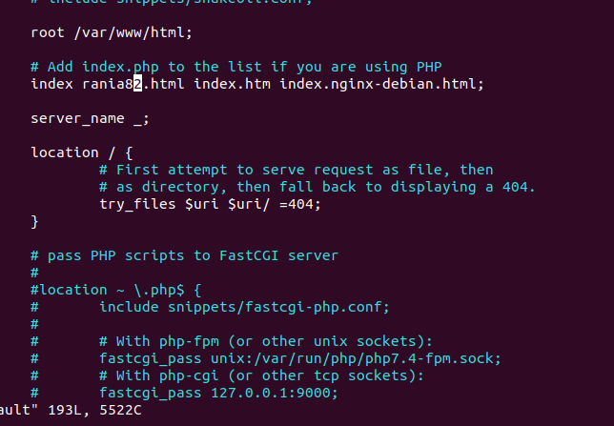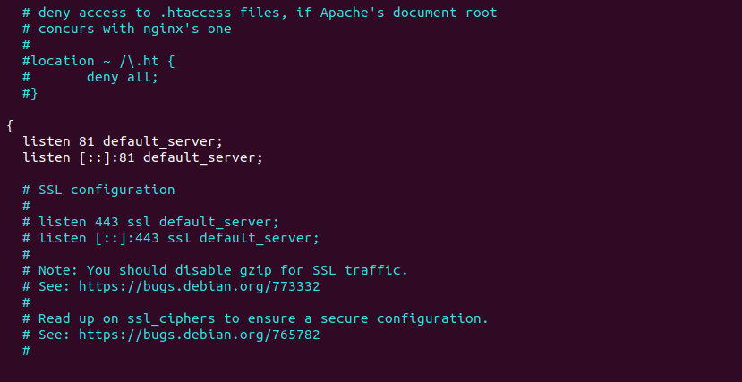

• Tell me the main differences between Apache & Nginx

|  |  |  |
| --- | --- | --- |
|  | Apache | Nginx |
| 1 | Apache is an open-source web server. | Nginx is a web server. It is also used as a reverse proxy server which revives the request from client and send the request to proxy server. |
| 2 | It is mostly used for Unix, Linux, Windows and Solaris platforms. | It is mostly used for Unix like systems, and does not completely support Windows. |
| 3 | It was developed by Apache group and initially released on 25 March 1999. | It was developed by Nginx.inc and initially released on 4 October 2004. |
| 4 | Apache is written in C and XML. | Nginx is written in C language. |
| 5 | It is designed for web server. | It is designed for proxy server as well as web server. |
| 6 | In heavy web traffic, it cannot support multiple requests. | It can support multiple client requests with limited hardware resources. |
| 7 | In Apache, modules are dynamically fixed that make it more complex. | In Nginx, modules cannot be loaded dynamically as there is a core software in which they are complied . |
| 8 | It follows multi-Threaded approach to process client requests. | It follows Event-Driven approach to process client requests. |
| 9 | In Apache, there is a dynamic content in web server itself. | It does not support provide dynamic content. |
| 10 | Apache’s performance for static content is lower than that of Nginx. | Nginx’s performance of static content is two times faster than that of Apache as it can simultaneously run thousands of connections and it uses less memory comparatively. |
| 11 | Less security provided as compared to Nginx and also the codebase is very high. | It provides better security with a smaller codebase. |
| 12 | Complex configuration system as compared to Nginx. | It has relatively simpler configuration system. |