chi square task

Rania Ahmed

October 11, 2019

library(knitr)

tutorial <- read.csv(file.choose(), header = T)  
attach(tutorial)  
View(tutorial)

newdata <- data.frame(tutorial[tutorial$Drug != "None", ])  
y <- table(newdata$Drug, newdata$PARITY)  
y

##   
## multi primi  
## None 0 0  
## oral nifedipine 7 18  
## parenteral labetalol 5 20

x <- hist(y)  
curve(dchisq(x, df=1078), col="green", add = T)

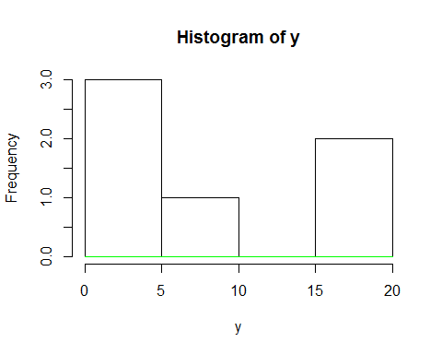

chisq.test(y)

## Warning in chisq.test(y): Chi-squared approximation may be incorrect

##   
## Pearson's Chi-squared test  
##   
## data: y  
## X-squared = NaN, df = 2, p-value = NA

# when chi- squared test records error we will apply fisher test

fisher.test(y)

##   
## Fisher's Exact Test for Count Data  
##   
## data: y  
## p-value = 0.7416  
## alternative hypothesis: two.sided

# p-value is more than 0.05 so we fail to reject null hypothesis and there is no significant differience between two drugs.